Ben
Weekly Relays User Guide
TOPICS LEGEND
 |  | WEEKLY RELAYS |  | March 7, 2019
YOUR DEPARTMENT NEWS |  |  | UTMB NEWS
OEA  Please join me in congratulating Dr. Era Buck on becoming the new Medical Education Scholarship Research and Education (MESRE) section rep for the Southern Group on Educational Affairs. She will be introduced in her new role during the upcoming SGEA meeting in Orlando.  OED  OED’s next Teaching Skills Workshop is Monday/Tuesday (March 18th – 4 pm & 19th – 12 pm) in MMN 1.102. Dr. Vicki Freeman will be giving her workshop, “Writing Multiple Choice Questions.” Please click this link to register: https://utmb.us/384  Dr. Marconi Monteiro and Sarah Dolezal are hosting a PBL facilitator workshop on Monday, March 18th, from 12-1 pm in MMN 1.102.  Employee Spotlight  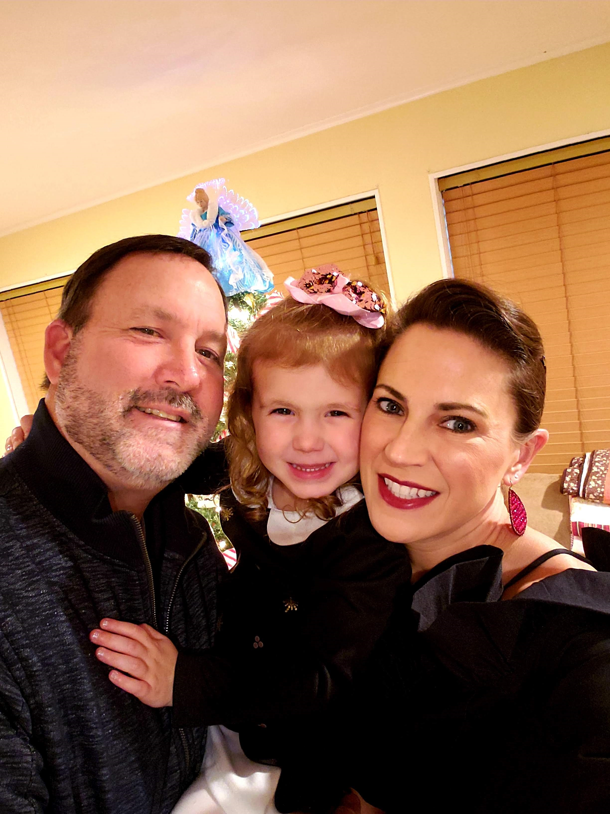  Lori DeWillis, BS, MBA  Assistant Administrator  School of Medicine  What are some of your work responsibilities?  I have a plethora of responsibilities that include, but are definitely not limited to business operations management and analysis, strategic and tactical business planning, project management and coordination, and assisting with departmental strategic planning and various HR related topics  Tell us something personal about yourself.  In March 2019, I will hit my 15 year mark with UTMB and 2 years with Academic Affairs. I have a 3 year old daughter, 4 dogs and 1 cat and I've been married a whopping 5 years!!  Fun Fact  I am a Needville Bluejay and I married a Toronto Blue Jay!! |  |  | UT System Board of Regents approves leases for Angleton Danbury expansion:  UTMB and the Angleton Danbury Hospital District have been working together since 2014 to improve access to health care in Brazoria County. As a continuation of those efforts to further expand our services in the area, the hospital district recently purchased 177 acres of land and an existing building near the intersection of Highway 288 and Highway 35, which is an easily accessible location in that community. In late February, The University of Texas System Board of Regents authorized UTMB to lease the approximately 21,000-square-foot building and the acreage from the hospital district. The current plan is to renovate the building to house outpatient clinics. While there is no specific time frame for opening a clinic facility at that location, UTMB is evaluating which services and specialties will best serve the current and future health care needs of the area.  UTMB Neuroscience Critical Care Unit recognized with silver-level Beacon Award of Excellence:  UTMB’s Neuroscience Critical Care Unit on the Galveston Campus has been recognized with the silver-level Beacon Award for Excellence by the American Association of Critical-Care Nurses. The Beacon Award for Excellence lauds hospital units that employ evidence-based practice to improve patient and family outcomes. Established in 2003, AACN’s award recognizes top U.S. hospital units that meet standards of excellence in recruitment and retention; education, training and mentoring; research and evidence-based practice; patient outcomes; leadership and organizational ethics; and creation of a healthy work environment. Award criteria—which measure systems, outcomes and environments against evidence-based national criteria for excellence—provide a mechanism to initiate patient safety efforts. To learn more about the award, visit www.aacn.org/beacon.  Successful Det Norske Veritas (DNV) Comprehensive Stroke Center reaccreditation survey:  UTMB’s Galveston Campus had a successful Comprehensive Stroke Center reaccreditation survey by Det Norske Veritas (DNV), validating UTMB’s commitment, expertise and readiness to care for victims of complex strokes. According to DNV, “the Comprehensive Stroke Center Certification encompasses the full spectrum of stroke care—diagnosis, treatment, rehabilitation and education—and establishes clear metrics to evaluate outcomes. Comprehensive stroke centers are typically the largest and best-equipped hospitals in a given geographical area that can treat any kind of stroke or stroke complication.”
TOPICS  LEGEND | PATIENT CARE EDUCATION & RESEARCH INSTITUTIONAL SUPPORT CMC
AROUND UTMB (Use the legend above to quickly find items of interest to your team)
UTMB Health Clear Lake Campus Hospital ribbon-cutting:  Join us March 20 from 4 to 6 p.m. for a ribbon cutting at the new UTMB Health Clear Lake Campus, located at 200 Blossom St. in Webster (site of the former Bay Area Regional Medical Center). The event is being hosted by the League City Regional Chamber of Commerce. The Clear Lake Campus Hospital is scheduled to open March 30.  Rudkin elected president, Olson named president-elect of Shine Academy:  Laura Rudkin, PhD, professor and chair, Preventive Medicine and Community Health, has been elected president of the UT System Kenneth I. Shine Academy of Health Science Education. The academy is both a service organization and honorific body that recognizes and utilizes faculty excellence to serve UT System in all aspects of health science education, educational scholarship and leadership. Dr. Rudkin, who has been a member of the Shine Academy since 2013, will serve a one-year term. Gayle Olson, MD, professor, Obstetrics and Gynecology, is president-elect and will serve as president following Dr. Rudkin’s term.  REDUCE YOUR USE SUSTAINABILITY INFO SERIES  Repurpose gently used or excess items with UTMB’s Swap Shop:  UTMB’s Swap Shop has become a staple at UTMB’s annual Earth Day celebration, but it’s also available most Friday afternoons from 1:30-3:30 p.m. during Surplus Properties’ (https://www.utmb.edu/supplychain/surplus/faq.asp) weekly open house. Held at the Materials Management Warehouse on the Galveston Campus, the open house events are temporarily suspended when the department is in an auction period; however, during those times, individuals can take advantage of the online swap shop available at (https://www.utmb.edu/swapshop/listings.asp). Offering members of the UTMB community an easy way to donate excess materials and supplies that can potentially be upcycled or repurposed by others for business purposes only, the Swap Shop accepts many usable, clean items that don’t have an inventory tag. For more information, visit https://www.utmb.edu/swapshop/.  BEST CARE  Preventing ‘Wrong patient’s blood in tube’ events:  The FDA estimates that 414 blood transfusion errors occur annually in the U.S., and, according to one study, nearly 80 percent of these errors were related to bedside or labeling errors. In 2018, 27 cases of “wrong patient’s blood in tube” events were identified at UTMB. These were instances where, had the error not been caught, the wrong blood would have been administered to the wrong patient, with potentially catastrophic consequences. To help ensure the standard guidelines for specimen labeling and handling are followed in UTMB inpatient units and clinics, printed color copies of the standard guidelines will be distributed; they should be visibly displayed for staff to reference. All teams involved in specimen handling should review and follow the guidelines for every patient, every time. Deviating from the proper steps may lead to a medical error, and failing to properly identify the patients and label specimens at the time they are drawn and in the presence of the patient can have dire consequences. An article is also included in the packet, “Mismatched Blood Kills Patient at Inova Fairfax,” describing a real-life worst-case scenario.  REMINDER  Inpatient AHRQ Culture of Safety survey:  As part of our ongoing effort to ensure a safe healing environment for patients, we ask that every clinical faculty and staff member who works in an inpatient care setting participate in this year's Agency for Healthcare Research and Quality (AHRQ) Culture of Safety Survey. The confidential survey tool will be open through March 22; it, and the survey should take no more than 10 minutes to complete. Once all results are returned, they will be shared to address opportunities for improvement. Please take the survey at https://utmb.us/36y. Information on the survey may be accessed at http://intranet.utmb.edu/QHS. |  |  | GALVESTON CAMPUS  Construction notice:  Beginning March 25, 11th Street between Market and Mechanic streets will be closed through the end of May to allow for the extension of the new sidewalk between the new Health Education Center building and the School of Nursing/School of Health Professions building. Vehicular traffic will be permitted to enter 11th Street to access parking spaces, but no through-traffic will be allowed. Entrances will remain open for delivery vehicles.  REMINDERS  2019 Mondays in March series continues:  UTMB’s annual Mondays in March series continues March 11 at noon in the Levin Hall Main Auditorium on the Galveston Campus. The remaining schedule for this year’s sessions is:  - March 11: Health Care: Evolution or Revolution?  - March 18: The Academic Foundation  - March 25: A Look Ahead with Executive Leadership  For more information about this year’s series or to view the March 4 “The Case for Growth” panel discussion, visit https://www.utmb.edu/mondays-in-march.  Naturally Slim:  The last day to apply for the Naturally Slim 2019 spring session is March 15. Naturally Slim is an online program that teaches you how to lose weight while eating the foods you love and is available at no cost to all UT SELECT medical plan members age 18 and above, including employees, retirees, spouses and dependents. Those selected for the program will be notified on March 22, and the session begins April 1. Apply today at www.naturallyslim.com/livingwell.
DID YOU KNOW?
In 2019, UTMB’s Regional Maternal and Child Health Program is marking 30 years since it saw its first patients. Dedicated to improving the lives of women and their families by providing health care, counseling and education, the program has an extensive network of community-based clinics and nutrition program sites. With more than 150,000 patient visits each year, the program offers prenatal care and family planning along with breast and cervical cancer screenings. For more information, visit https://www.utmbhealth.com/services/rmchp/.

Dr. Ojo to present at Best Care Lunch & Learn:
Please join the rest of UTMB Health System on March 8 at noon to hear Dr. Olugbenga Ojo present on CMC’s role in the Best Care initiative entitled, “Harnessing Patient Safety and Changing the Paradigm towards a Patient Centered Healthcare Delivery Model.” This session summarizes CMC’s Herculean “Best Care” efforts at Hospital Galveston and in our units. The Best Care Lunch and Learns will broadcast live on campus TV Channel 53. For those with access to HD cable channels, it will be broadcast live on IPTV Channel 51. To view the Lunch & Learn via a Polycom-equipped conference room please video dial conference ID: 4090711 or confirm the room location via email to vpleasan@utmb.edu.
To view the broadcast on a computer (speakers required) please click on the link below: https://hdstream.utmb.edu/VEMSWeb/Widgets/EmbedPlayerControllerWidget.html?ver=6.3.7.6&autoplay=true&contentID=6. CMC viewers please access the following webcast link: http://sdstream.utmb.edu:8080/stream.

Annual compliance training deadline:
Annual compliance training is due to be completed by ALL employees by March 31.

