Ben
Weekly Relays User Guide
TOPICS LEGEND
 |  | WEEKLY RELAYS |  | April 4, 2019
YOUR DEPARTMENT NEWS |  |  | UTMB NEWS
Academic Affairs  Congratulations Dr. Mouton on your well-deserved achievement! You will be missed!  Southern Group on Educational Affairs 2019 Annual meeting  - Dr. Ainsworth, Dr. Buck and Dr. Szauter all had posters at the SGEA meeting  - Professional Behavior as an Entrustable Professional Activity - Including a Standardized Patient Perspective (Ainsworth / Szauter)  - Assessing Humanism: Applying the ICARE Scale (Buck, Fehsenfeld, Holden, Szauter)  - Patterns of Substance Use Documentation following Curricular Change (Szauter, Schatte, Miller)  - Congratulations to Dr. Levine who was awarded the 2019 SGEA Career Educator Award.  Office of Educational Development  Please join us as we celebrate our Scholars in Education completing their 20-month cohort on Tuesday, April 9th from 1-5 pm at the Levin Hall Dining Room. Refreshments and cake will be served.  Physician Assistant Studies  Former faculty from the UTMB Physician Assistant Program made a visit to the program’s new office suite on Wednesday, April 3. From left to right: Bruce Niebuhr, Dennis Blessing, Lodie Massey, Karen Stephenson, and Barbara Lyons.  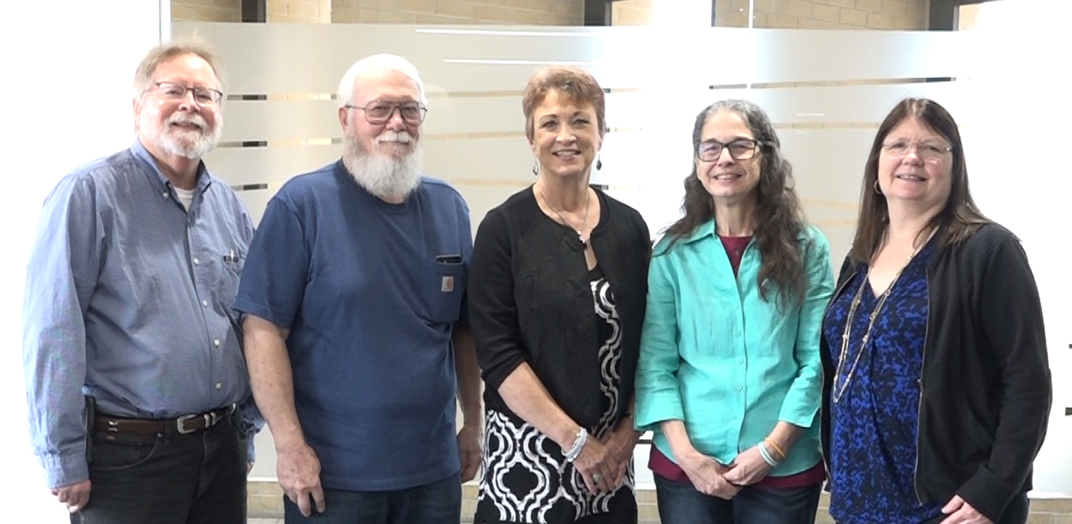  Student Affairs  The SOM Student Affairs has multiple events planned for the weekend of April 5th – 7th.  - April 5th the Office of Special Programs is sponsoring the Colors of Medicine on UTMB Campus. The event provides an opportunity for premedical applicants to speak one-on-one with deans, faculty, and staff. Student leaders from the Latin Medical Student Association (LMSA) and the Student National Medical Association (SNMA) will be on hand to talk about medical school experiences.  - April 5th – 7th the Office of Recruitment is sponsoring the Early Medical School Acceptance Program (EMSAP) for undergraduate students learning about medical school interviews and what is expected during the medical school application process.  - April 6th the Office of Recruitment is hosting the 2019 PreMed Conference on UTMB Campus. Workshops include becoming a more competitive applicant; curriculum, navigating the admissions application; life in medical school and other various activities and workshops. Over 200 attendees are expected.  Employee Spotlight  Richard Caroll, PhD  Assistant Dean Medical School Admissions & Recruitment  Student Affairs & Admissions  Associate Professor  Preventive Medicine & Community Health  Adjunct Associate Professor  Department of Nutrition & Metabolism, Health Professions  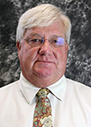  What are some of your work responsibilities?  Supervise medical school admissions and recruitment activities.  Tell us something personal about yourself.  I have been at UTMB for 32 years. My wife Shannon retired from UTMB after 28 years. I am originally from Plainville Indiana. I have two sons Michael and Ian. I enjoy golf and woodworking.  Fun Fact  I was a member of the Indiana University Music School performing group "The Singing Hoosiers" for five years while at Indiana University. |  |  | Mouton named Executive Vice President, Provost and Dean of the UTMB School of Medicine: Charles P. Mouton, MD, MS, has been named Executive Vice President, Provost and Dean of UTMB’s School of Medicine. He will assume his new role, which includes overseeing UTMB’s four schools, on April 8. Dr. Mouton has served as dean ad interim for the School of Medicine since August of last year, after joining UTMB in 2017 as vice dean for academic affairs and professor of family medicine. Prior to UTMB, Dr. Mouton held a number of leadership and faculty roles at Meharry Medical College. An experienced and collaborative physician, scientist, educator and leader, Dr. Mouton is well-versed in the need for research and clinical priorities to align for the good of those we serve. In a recent Town Hall, he shared his vision for how UTMB can break new ground in training the next generation of caregivers and scientists to work in interprofessional teams and with emerging technology to meet the evolving needs of patients. Congratulations to Dr. Mouton in his new role at UTMB. For more information about Dr. Mouton and his appointment, visit https://www.utmb.edu/president/communications.  Dr. Rebeca Wong appointed to national council: Rebeca Wong, PhD, was recently appointed to the National Institutes of Health’s National Advisory Child Health and Human Development Council. The council is charged with advising, consulting with and making recommendations to the National Institute of Child Health and Human Development director on matters relating to research and research support activities and functions. Dr. Wong is director of UTMB’s WHO/PAHO (World Health Organization/Pan American Health Organization) Collaborating Center on Aging and Health, professor of Sociomedical Sciences in Preventive Medicine and Community Health, and a senior fellow of the Sealy Center on Aging.  President’s Cabinet Award applications due May 31: The President’s Cabinet Awards committee is seeking proposals for the 2019 President’s Cabinet Awards. The theme of this year’s awards, “UTMB Health—The Community and Beyond: Working Together for our Future,” recognizes the shared interests of the university, the surrounding community and beyond promoting a vibrant and supportive environment. Projects that mobilize the creativity, ingenuity and dedication of UTMB students, staff and faculty to benefit the community are especially encouraged. Applications are available online at https://development.utmb.edu/file/pcapp.pdf and should be turned in no later than 4:30 p.m., May 31. For information on where to submit proposals, visit www.utmb.edu/cabinet.
TOPICS  LEGEND | PATIENT CARE EDUCATION & RESEARCH INSTITUTIONAL SUPPORT CMC
AROUND UTMB (Use the legend above to quickly find items of interest to your team)
GALVESTON CAMPUS  Hospital Parking Garage construction will impact accessibility ramps, stairs: As part of the hospital accessible route project, the stairway located at the southwest corner of the Hospital Parking Garage will be closed beginning this week as the area undergoes work. During this time, the accessibility ramp leading to R. Waverley Smith Pavilion will be open and accessible.  Simultaneously, on the north side of the facility, the ramp leading to Jennie Sealy Hospital will be closed for renovations; however, the nearby stairs will be available. Individuals needing ramp access into the hospital are encouraged to take the elevators on the northside of the garage down to the ground level, where they can then access the tunnel to the Jennie Sealy ground-floor elevators. To help individuals find their way during this phase of the project, signage will be available onsite.  CMC-Pearl User Desktop: Now that Pearl 9.2 has been deployed, the CMC Pearl desktop will automatically default to the User Desktop. The IT group is working on the standard operating procedure and will schedule Skype training sessions during the month of April. The target go-live date is May 1. There are distinct advantages to directing users to the desktop, but it does require that all patients to all departments be checked in and out in real time, and reminders will need to have the person who is performing the service entered on them.  CMC-Employee annual training: Congratulations to all CMC employees for doing their part to complete annual online training. As of April 1, we are at 97% compliance! |  |  | CMC-Annual TB-screening: All UTMB CMC health care workers are required to participate in annual TB (tuberculosis) screening from May 1 until May 31. This institutional requirement is a condition of employment and continued employment for all health care workers. The TB skin testing standard operating procedure (SOP) may be found on the ICN Homepage of the CMCWEB and should be referred to for complete details. The pharmacy will automatically ship tuberculin to each unit the week of April 15. If additional supplies are needed after the initial shipment is received, requests should be sent to utmbcmc.pharmacyRX4employee@utmb.edu. If you have any questions or need assistance with shipments, please speak with Melissa Duncan (mkduncan@utmb.edu or 936-437-5360). As a reminder, unit-based staff cannot use TB skin test (tuberculin) that is already in stock for patient use. This would be a violation of the federal 340B pricing program. The supply sent for employee use will be clearly marked as such and the supplies for patients and employees must be kept separately. If you have any questions regarding the TB SOP or program, please contact CMC Employee Health at cmcemphl@utmb.edu.
DID YOU KNOW?
UTMB’s economic impact throughout Southeast Texas and across the state is significant. In FY2018, that impact included a $2.25 billion budget, enrollment of more than 3,350 students and more than 13,100 employees. Of those employees, 2,067 were in the Academic Enterprise, 4,501 in the Health System, 3,242 in Correctional Managed Care and 1,658 in Institutional Support roles. The total number of employees also included 611 residents, 126 post-docs, 971 faculty members and 12 research fellows. For more statistics on UTMB, download the FY18 Data Reference Card available as a PDF at https://www.utmb.edu/business/.

