Ben
Weekly Relays User Guide
TOPICS LEGEND
 |  | WEEKLY RELAYS |  | May 9, 2019
YOUR DEPARTMENT NEWS |  |  | UTMB NEWS
Employee Spotlight  Catherine Hale  - Administrative Coordinator  Educational Affairs  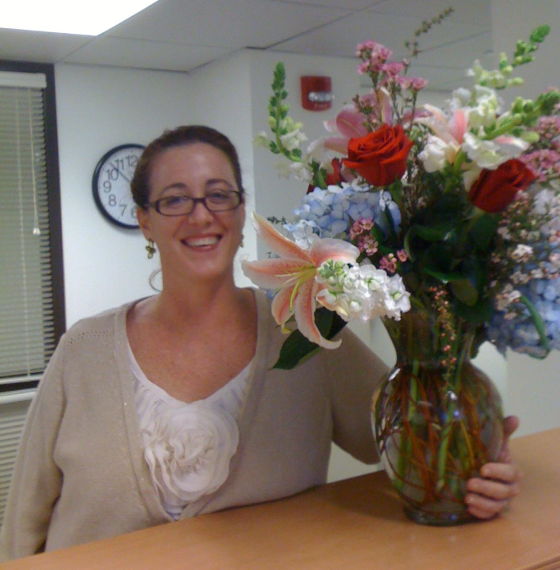  What are some of your work responsibilities?  Most of my work is related to tasks associated with the SOM curriculum. I support the Curriculum Committee and the LCME Accreditation Oversight Committee. I am in the process of building a curriculum map, which, when complete, I envision as a “mirror” of the actual SOM curriculum. This map will be used to find gaps and redundancies in the curriculum and make adjustments when necessary. I currently process the inventory for OEA, OED, IMO and OCE but soon I will share that responsibility with the secretaries in each of those departments. I am also the overall coordinator for the ten Scholarly Tracks.  Tell us something personal about yourself.  I have been at UTMB since 2006 and have worked mostly in Educational Affairs. I was born in California and also lived in Hawaii and Maryland. I have one grown daughter who is married and is an American Sign Language interpreter in Houston. When she came to visit me at the office I made she and Alma sign while I filmed them on my phone. What are mothers for right?  Fun Fact  Everyone close to me knows this. I love rain and cold weather. I think we have far too much hot sunny weather here. |  |  | School of Nursing achieves milestone with licensing exam pass rate:  The UTMB School of Nursing has achieved a milestone, with a 100 percent national exam pass rate for the 122 students who tested in the second quarter of 2019. A passing score on the National Council Licensure Examination (NCLEX) is required for the licensure of nurses in the United States and Canada. The SON’s year-to-date pass rate is 99.21 percent. This is a great example of UTMB faculty members’ outstanding efforts to train the next generation of health care providers. Congratulations to all.  UTMB faculty members honored with UT System STARs Awards:  Two UTMB faculty members have been announced as recipients of UT System STARs Awards. The STARs Program provides funds for the purchase of equipment and renovation of facilities, as required to retain or recruit outstanding faculty in academic institutions. Congratulations to Yingzi Cong, PhD, professor of Microbiology & Immunology, and Pathology; and Lorraine S. Evangelista, PhD, RN, CNS, FAHA, FAAN, who will join UTMB School of Nursing on July 1 as associate dean for nursing research and scholarship.  REMINDER  2019 Employee Service Day Ceremony:  All members of the UTMB community are invited to the 2019 Employee Service Day ceremony on May 22 at noon in the Levin Hall Main Auditorium on the Galveston Campus. See https://hr.utmb.edu/tod/serviceday/ for a complete list of honorees and remote viewing options.  UTMB’s Epic System set for upgrade:  As part of UTMB Information Services’ continuous efforts to improve features and functionality for users, the UTMB Epic System will be upgraded on June 1. The system will be unavailable on June 1 from 10 a.m. until 4 p.m. During this timeframe, all Epic users must follow established downtime procedures. The Shadow Read Only (SRO) version of Epic will still be available. Information Services will share more details as the upgrade date approaches. In addition, the Epic 2019 Upgrade website will be launched soon and users are encouraged to visit and take full of advantage of the training information and videos that will be posted once it’s live.
TOPICS  LEGEND | PATIENT CARE EDUCATION & RESEARCH INSTITUTIONAL SUPPORT CMC
AROUND UTMB (Use the legend above to quickly find items of interest to your team)
DID YOU KNOW?
This week, UTMB held a ribbon-cutting ceremony for its new Biocontainment Care Unit, a state-of-the-art facility to provide care for patients with high-containment pathogens such as Ebola. The unit, located on the Galveston Campus, has six specially outfitted hospital rooms segregated from the rest of the patient treatment areas that feature special ventilation systems to prevent any pathogens to escape via the airflow. UTMB is staffing the biocontainment unit with 58 handpicked health care workers who train quarterly and are on call to respond to an outbreak of a highly infectious disease, should one occur. Construction of the unit began in October 2017, cost approximately $17 million and was funded by the U.S. Department of Health and Human Services, the Texas Department of State Health Services and UTMB.

