Ben
Weekly Relays User Guide
TOPICS LEGEND
 |  | WEEKLY RELAYS |  | June 13, 2019
YOUR DEPARTMENT NEWS |  |  | UTMB NEWS
Office of Clinical Simulation  Amy Shanks, Darlene Self and Dr. Karen Szauter attended the Association of Standardized Patient Educators annual meeting. They participated in multple presentations.  POSTERS:  - Changing the Converstation: An Analysis of Interview Content in Longitutidinal Encounters. (Amy Shanks )  - Using the ASPE Standards of Best Practice for Detailed Programmatic Review. (Darlene Self)  - What do Students Say when a Patient Discloses Opioid Use? (Dr. Karen Szauter )  ORAL RESEARCH PRESENTATION:  - Communicating Diagnoses: Do Students Share What They are Thinking (Co-presented by Amy Shanks and Darlene Self)  WORKSHOP  - Making Ethical Decisions in Research Involving Data Generated from Learners and SPs (Dr. Karen Szauter )  INVITED PRESENTATION  - A Review of the Literature - Innovativve Applications of SP Methodology 2018 (Dr. Karen Szauter)  Office of Educational Development  Erin Ortiz will be leaving OED effective June 21st. We are grateful for her contributions to the team and wish her well on her new adventure!  Please, stop by the office to say:  Academic Enterprise  UTMB Employee Advisory Council  cordially invites you to an  Academic Enterprise Town Hall  A Conversation with Staff  and  Dr. Charles P. Mouton, EVP, Provost  and Dean of the School of Medicine  Wednesday, June 26, 2019  12:00 – 1:00 pm  Levin Hall Main Auditorium  Submit questions or topics of discussion to https://www.utmb.edu/eac/contact-us  by Friday, June 21, 2019.  The UTMB Employee Advisory Council  will be providing popcorn.  (managers please encourage employees  in your area(s) to attend)  Employee Spotlight  Norma Alicia Pérez, MD, DrPH  - Director, Career Counseling & Special Projects  Office of Student Affairs & Admissions  - Assistant Professor  Department of Internal Medicine – Geriatrics & Preventive Medicine & Community Health  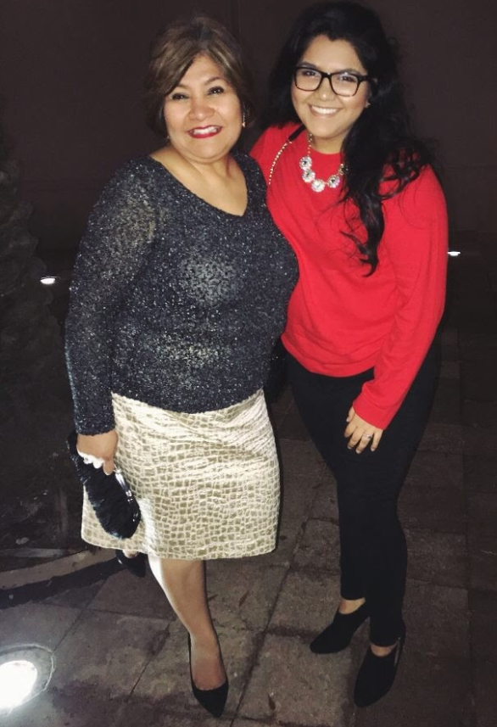  What are some of your work responsibilities?  These last six months, I've been busy refining the medical School Advising Program housed in the Office of Career Counseling in the Office of Student Affairs and Admissions. The program is tailored to provide medical students, years one through four, with the necessary resources to succeed in medical education and career development. I recruit and train faculty advisors for the program. In addition to overseeing the Office of Special Projects, I assist with all Student Affairs activities.  Tell us something personal about yourself.  I was recruited by the Sealy Center on Aging to direct the Texas City Project back in 2004. Once I completed the 5-year project, I was recruited by the Office of Student Affairs and Admissions to open the Hispanic Center of Excellence. I provided faculty development opportunities for minority junior faculty, recruited promising minority undergraduates and provided career development opportunities to all students in the School of Medicine. I recently transitioned to play a more active role in the Office of Student Affairs.  I love to cook and spend time with my family; I come from a very close-knit family. I have one child, Andrea Alejandra Pérez. She is now my best friend and is officially a senior at Abilene Christian University. She is an IT major and a Criminal Justice minor. Her passion is to hopefully work for the FBI in cyber security or digital forensics.  Fun Fact  At the age of five, I took piano classes, playing Johann Sebastian Bach until I was 15. I also play the flute, which was not forced on me. |  |  | Clark named chair of University of Texas System Employee Advisory Council:  Last week, Tilly Clark, assistant director of UTMB’s Special Use Facilities and the current chair of UTMB’s Employee Advisory Council, was elected chair of UT System’s EAC, beginning in FY2020. Clark, who has worked at UTMB for more than 28 years, was elected to lead the group during this year’s annual systemwide EAC meeting, which was hosted by UTMB June 4-5 in Galveston. The UT System EAC is a representative advisory group that meets with the Board of Regents to present information and make recommendations regarding issues of importance to the employees of UT System. The mission of the EAC is to provide a forum for communicating ideas and information between employees, the Board of Regents, and the executive officers of UT System. To learn more about the UT System EAC, visit https://www.utsystem.edu/sites/employee-advisory-council.  SHP announces new Doctor of Occupational Therapy program:  The School of Health Professions has received approval to transition its Occupational Therapy master’s degree program (MOT) to a Doctor of Occupational Therapy (OTD) degree program. The new program will begin this fall with 60 students. Graduates will be eligible to take the national certification examination and apply for licensure required for practice in most states. Occupational Therapy is a health and wellness rehabilitation profession, helping individuals who need specialized assistance to perform activities required in daily life. UTMB's Occupational Therapy program has been rated No. 1 in Texas and No. 14 in the nation by U.S. News & World Report. Learn more about UTMB’s OT program at https://shp.utmb.edu/OccupationalTherapy/.  PeopleSoft FMS outage scheduled for June 21-24:  UTMB is upgrading its PeopleSoft financial management system (FMS). To prepare for this upgrade, a system outage is scheduled from 5 p.m., June 21 until 8 a.m., June 24. During the outage, users will not be able to access:  - eProcurement / Purchasing  - Inventory  - Travel & Expense  - Accounts Payable  - Grants/Commitment Control  - Asset Management  - UTMB Internal Services  - General Ledger
TOPICS  LEGEND | PATIENT CARE EDUCATION & RESEARCH INSTITUTIONAL SUPPORT CMC
AROUND UTMB (Use the legend above to quickly find items of interest to your team)
Excellence in Clinical Teaching Awards:  This year, five faculty members were selected for the Excellence in Clinical Teaching Award. This award recognizes the fundamental concept, exemplified by Sir William Osler, that the development of outstanding physicians occurs primarily in clinical settings (ambulatory or inpatient). Each recipient of the award will receive $7,000 for support of his or her professional development and/or teaching programs and will be recognized during the John P. McGovern Academy’s Annual Oration. The 2019 Awardees are:  - Dr. Aakash H. Gajjar—assistant professor, Department of Surgery  - Dr. Michael S. Miller—assistant professor, Department of Psychiatry and Behavioral Sciences  - Dr. Harold S. Pine—associate professor, Department of Otolaryngology  - Dr. Dawnelle Schatte—associate professor, Department of Psychiatry and Behavioral Sciences  - Dr. Maurice Willis—clinical professor, Department of Internal Medicine (Hematology/Oncology)  For more information, visit https://www.utmb.edu/osler/awards/excellence-in-clinical-teaching-award.  ANGLETON DANBURY CAMPUS  REMINDER—UTMB community, Angleton Danbury Auxiliary invited to CT Suite guided tour:  Enjoy a guided tour of the new state-of-the-art CT suite on June 21 from 2-4 p.m. and learn more about the new technology on the Angleton Danbury Campus. For more information, contact Tonya Visor at tfvisor@UTMB.EDU. |  |  | CMC—Notice on compliance training courses:  UTMB recently added two courses to its annual employee compliance training: Intellectual Property and Hazard Communication. CMC employees, however, are not required to take these courses. If you notice that either of these courses has been added to your UTMB Learning Plan, please inform your manager and he or she will contact Human Resources to have them removed.  CMC—KPIs, technical competencies can be added to ePerformance system:  ePerformance has opened up for input of Key Performance Indicators (KPIs) and technical competencies by managers. CMC leadership will distribute a completion timeline for all employees in the near future.  REMINDER—CMC—Emergency Classification and Acknowledgement Forms:  All UTMB-CMC employees should have completed their Emergency Classification and Acknowledgement Forms online. If you have not already done so, please complete these immediately.
DID YOU KNOW?
UTMB’s Information Services recently published its FY18 Annual Report. In addition to providing a wealth of information related to the department’s support of UTMB’s mission areas, the report also included some interesting facts and figures. For instance, UTMB received more than 3 million emails and sent more than 1.2 million emails in Fiscal Year 2018. During this same period, Information Services received 124,951 Service Desk telephone requests and 39,694 Service Desk email requests; conducted 2,010 training classes; and trained more than 12,000 employees. You can browse the full report at https://www.utmb.edu/is.

