Ben
Weekly Relays User Guide
TOPICS LEGEND
 |  | WEEKLY RELAYS |  | July 4, 2019
YOUR DEPARTMENT NEWS |  |  | UTMB NEWS
Academic Affairs  Since March 7 – July 3, 2019, the following people have been awarded AAA Awards!!! This is AWESOME!  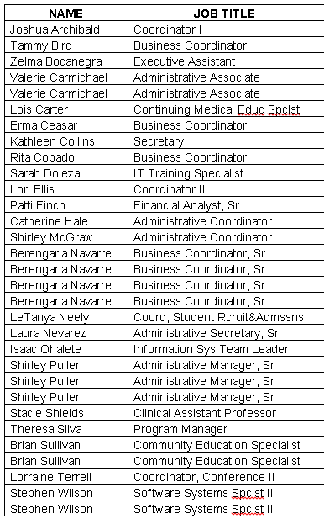  Instruction Management Office  Poverty Simulator needs Volunteers  Through the new META Course we are doing a Poverty Simulator for all incoming first year medical students this year. We will repeat the activity three times in July in Levin Hall Dining Room to get all of the students through the simulation, and we are looking for a total of 60 volunteers to help out with this. It is a great opportunity to help students prepare for difficulties their future patients will face with affording prescriptions, healthy food, healthcare, transportation and housing.  If anyone would like to help, here is the link to sign up to volunteer:  https://www.signupgenius.com/go/805094FA8AC2DA7FF2-meta  Thank you for your consideration,  Dr. Dawnelle Schatte  Contact: Email: Mary M. Mallini For: Instruction Management Office Phone: 409-747-1730 |  |  | Congratulations to UTMB recipients of the 2019 UT System Regents’ Outstanding Teaching Awards:  Two UTMB faculty members have been selected to receive the Regents’ Outstanding Teaching Award, which recognizes extraordinary performance and innovation in education at the 14 UT System academic and health institutions.  - M. Kristen Peek, PhD, is professor, vice chair for education and graduate program director for Population Health Sciences in the Department of Preventive Medicine and Community Health. She is also associate dean for academic affairs in the Graduate School of Biomedical Sciences, holder of the John Sealy Distinguished Chair for MD/PhD Combined Degree Studies in honor of Dr. Truman G. Blocker, and director ad interim of the MD-PhD Combined Degree Program.  - Dawnelle Schatte, MD, is associate professor and director of undergraduate education in the Department of Psychiatry and Behavioral Sciences. She is the Faculty Development Team chair for the Academy of Master Teachers. Schatte is also a distinguished fellow of the American Academy of Child and Adult Psychiatry and the American Psychiatric Association.  Please join us in thanking Drs. Peek and Schatte for their outstanding work, and congratulating them on this well-deserved recognition. Read the full UT System news release at https://utmb.us/3eh.  Start saving on products and services you use every day:  The LifeMart Employee Discount Program is now open to all UTMB employees and retirees. Create your personal account today at https://bit.ly/2FDZ7sO for members-only savings and discounted rates on groceries, travel, entertainment and much more. Access to the site and thousands of nationally recognized products and services is available 24 hours, 7 days a week through any web-enabled device.  REMINDERS  Employee Benefits Fairs:  Stop by one of UTMB’s Employee Benefits Fairs to learn more about annual enrollment and the insurance, retirement and wellness programs available for the 2019–2020 plan year. Fairs will be held:  - July 9 – Angleton Danbury Campus  - July 10 – Galveston Campus  - July 11 – League City Campus  - July 12 – Clear Lake Campus  See https://hr.utmb.edu/hrbbc/benefits/annual_enrollment/ for details.
TOPICS  LEGEND | PATIENT CARE EDUCATION & RESEARCH INSTITUTIONAL SUPPORT CMC
AROUND UTMB (Use the legend above to quickly find items of interest to your team)
Creating a welcoming environment:
Please remember to help create a warm and welcoming atmosphere for our patients and visitors by using the staff elevators in our hospitals, especially when transporting carts and supplies. In general, staff should use the staff elevators when possible to help ensure the public elevators that are designated for patients and visitors are always accessible; when using the public elevators, please yield the elevators to patients and visitors when space is limited, and especially yield to individuals in wheelchairs who may need extra space to enter and exit the elevator.
DID YOU KNOW?
Across UTMB, there are 116 employees who work in UTMB Property Services, a department in Business Operations & Facilities (BOF). The Property Services crew includes 98 technicians who maintain UTMB’s 10.5 million gross square feet of facilities that are part of operations. You can read more about Property Services—and the 10 facilities operations technicians who keep our Clear Lake Campus running—in this month’s issue of Impact, available on newsstands now and online at https://utmb.us/3eg.

