Ben
Weekly Relays User Guide
TOPICS LEGEND
 |  | WEEKLY RELAYS |  | July 11, 2019
YOUR DEPARTMENT NEWS |  |  | UTMB NEWS
Employee Spotlight  Come on now…  Please submit your information and upload your information via this link:  https://webforms.utmb.edu/frevvo/web/tn/forms/user/giflynn/app/_M2ECYBTmEempUclRFxPosw/formtype/_dn1HoASZEempsq_jYOb_6Q/popupform.  Thank you! |  |  | Best Care Update:  UTMB has received its results for the third period of the 2019 Vizient Quality and Accountability Study. UTMB currently ranks No. 11 among the study’s 93 participating comprehensive academic medical centers. Although the data collection period for the FY19 study is complete (July 2018 through June 2019), for UTMB to be in the Top 10 in FY20, we need to improve patient satisfaction, length of stay and 30-day readmission rates. The relaunch of the Commit to Sit program will help improve Patient Centeredness. Participation in Progression of Care Rounds and a focus on safe care transitions by following 5-2-1 will help improve length of stay and 30-day readmissions. UTMB will receive its final FY19 ranking in fall 2019. Please visit the Best Care website for more complete details on each period ranking for the 2019 study at http://intranet.utmb.edu/best-care.  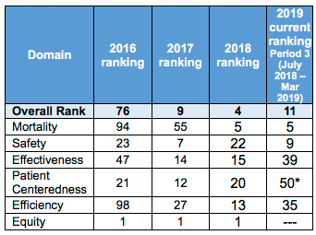  SAVE THE DATE—Donna K. Sollenberger retirement reception set for July 25:  Please plan to attend Donna K. Sollenberger’s retirement reception July 25 from 4-6 p.m. in the Levin Hall Foyer on the Galveston Campus. Please RSVP to Erin McEldowney with University Events at events@utmb.edu or (409) 747-6735.  AE town hall video and Q&A now online:  The Employee Advisory Council, with Dr. Charles P. Mouton, hosted an Academic Enterprise town hall on June 26. The video from the event, as well as answers to questions that were submitted via the EAC website, have all been posted online. Thanks to all who attended, engaged with the poll questions and shared feedback. View the video and Q&A here: https://www.utmb.edu/eac/town-hall-questions-answers/last-town-hall-questions-and-answers  Annual Benefits Enrollment:  The annual enrollment period for the 2019–2020 benefits plan year is July 15 to 31. During this period, you may make changes to your benefits elections, add or remove dependents, and/or enroll in a flexible spending account.  - You will need the personal identification number provided to you by the Office of Employee Benefits to access the My UT Benefits online system. Your PIN will be delivered by email on July 15.  - No action is necessary if you do not want to make any changes to your coverage for the upcoming plan year; however, employees interested in a flexible spending account must actively enroll each year.  - Your annual enrollment elections and new rates are effective Sept. 1.  See https://hr.utmb.edu/hrbbc/benefits/annual_enrollment/ for more annual enrollment information, including an employee resource guide and a benefits cost worksheet.  Emergency Classification and Acknowledgement Form:  Each year, UTMB’s employees are expected to complete an Emergency Classification and Acknowledgement Form and to have it approved by their supervisor. Please take a few minutes today to fill out this form if you have not already done so. The form is used to designate your classification during emergencies. To access the form and other emergency planning information, please see https://hr.utmb.edu/relations/emergency/.  REMINDER  President’s Town Hall set for July 18:  Please plan to attend Dr. Callender’s next Town Hall July 18 at noon in the Levin Hall Main Auditorium on the Galveston Campus. Online viewing options will be available. To submit a question, visit https://www.utmb.edu/eac/contact-us. For more information, visit https://www.utmb.edu/president/town-hall.
TOPICS  LEGEND | 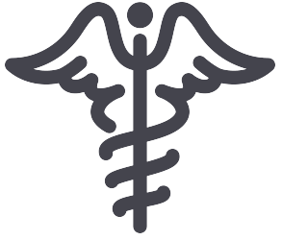  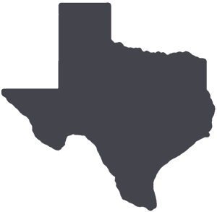  PATIENT CARE EDUCATION & RESEARCH INSTITUTIONAL SUPPORT CMC
AROUND UTMB (Use the legend above to quickly find items of interest to your team)
IACUC electronic protocol form training available:
The Institutional Animal Care and Use Committee (IACUC) administrative office will offer training sessions to introduce the new IACUC electronic protocol form. Those who should attend include researchers and delegates who complete and submit animal care and use protocols and those who intend on submitting new protocols and/or have triennial renewals upcoming. Please sign up for one of the upcoming sessions of “Introduction to the UTMB IACUC Protocol eForm” at http://research.utmb.edu/register. The office will also offer training for small groups/departments; contact Allan Silva at (409) 266-9402 or afsilva@utmb.edu to schedule.

DID YOU KNOW?
UTMB Alerts is our institution’s method of communicating with faculty, staff and students during severe weather conditions or other emergency events that have the potential to threaten safety or impact business operations. Employees and students are automatically enrolled in the UTMB Alerts notification system, using basic directory information such as a UTMB email address or phone number. But to receive UTMB Alerts notifications on a mobile device, a few extra steps are required. Here’s how:

- Point your web browser to the UTMB Directory (https://intranet.utmb.edu/directory/) and search for your own name.
- Once you’ve located your contact information in the directory, click on the middle button in the blue bar titled, “Edit My Alert Info.”
- On the next screen, log in with your UTMB username and password.
- On the My Profile page, click on “Edit” in the top right-hand corner of the white box.
- Add your mobile device number in the “Mobile Phone” and “Text Message” fields.
- Click the blue “Save” bar and then exit.

It is strongly recommended that you enter your mobile contact information to ensure you get emergency messages quickly on a device that is (nearly) always close by. For a screencast that outlines the steps to signing up your mobile device for UTMB Alerts, visit https://utmb.us/2vf.
.

