Ben
Weekly Relays User Guide
TOPICS LEGEND
 |  | WEEKLY RELAYS |  | July 18, 2019
YOUR DEPARTMENT NEWS |  |  | UTMB NEWS
Employee Spotlight  Crystal Carpenter  Community Education Specialist  Office of Clinical Education – Educational Affairs  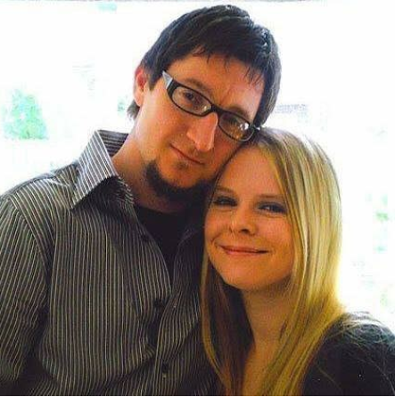  What are some of your work responsibilities?  I coordinate affiliation agreements for the School of Medicine for our students who wish to complete off site electives. I am the coordinator for the SCOPE program.  Tell us something personal about yourself.  I have worked for UTMB for a year and a half. I am originally from Houston. I have 2 children, a Boxer puppy named Harley and a Maltipoo named Boomer. I love to cook, travel, listen to music and lounge by the pool.  Fun Fact  Before working at UTMB I worked for a psychiatric community clinic where I was part of a crisis response team for 8 years. I also worked for 2 of the 8 years on a grant at the UTMB ED here in Galveston where I completed psychiatric crisis assessments and facilitated telemedicine appointments with psychiatrists for patients in crisis. I also provided Mental Health First Aid for youth training in the community to raise awareness for mental health. |  |  | Monthly financial update—Results as of June 30, 2019:  UTMB Results:  NOTE: As discussed last month, UT System implemented a change in the way Tuition Revenue Bond (TRB) proceeds will be reported going forward, causing UTMB’s financials to appear less favorable than our actual performance. The overall impact of this reporting change to the adjusted margin is $11.8 million through June 30, 2019.  For the month of June, UTMB’s adjusted margin (including the Clear Lake Campus) was a loss of $11.1 million, which was $6 million worse than planned. Excluding the impact of the new TRB reporting requirements, UTMB’s adjusted margin for the month of June was a loss of $10 million, which was $4.8 million worse than planned.  UTMB’s fiscal-year-to-date adjusted margin for June (including the Clear Lake Campus) was a loss of $40 million, which was $3.2 million worse than the planned loss of $36.8 million. Excluding the TRB impact, however, UTMB’s year-to-date adjusted margin was a loss of $28.1 million, which was $8.7 million better than planned.  Clear Lake Campus Results  As a reminder, we are continuing to monitor the financial performance of the Clear Lake Campus, both independently and also as part of overall UTMB results through the remainder of FY19. The following information relates only to the Clear Lake Campus:  - For the month of June 2019, Clear Lake Campus had an adjusted margin loss of $2.8 million, which was $1 million better than planned.  - Fiscal year-to-date, Clear Lake Campus had an adjusted margin loss of $32.9 million, which was $4.7 million better than planned.  Thank you for your ongoing efforts to manage expenses and improve the efficiency of our work to ensure the long-term success of UTMB’s mission.  Increased eligibility and funding for UTMB’s tuition reimbursement program:  UTMB promotes the professional growth and development of employees through its tuition reimbursement program. Starting in FY20, this program will be open to all employees pursuing a graduate or undergraduate degree that will affect their ability to advance within the university, and the maximum reimbursement amount for course credits and related fees will be $5,000 per fiscal year. Employees must work 30 hours or more per week, have completed six months of employment at UTMB and be in good standing to be eligible for the program. More information about the program, including the application process and reimbursement guidelines, is available online at https://hr.utmb.edu/hrbbc/benefits/tuition/.
TOPICS  LEGEND | PATIENT CARE EDUCATION & RESEARCH INSTITUTIONAL SUPPORT CMC
AROUND UTMB (Use the legend above to quickly find items of interest to your team)
SAVE THE DATE—Reception welcoming Drs. Timothy Harlin and Charles Mouton:
Please plan to attend the reception welcoming Dr. Timothy Harlin, the incoming executive vice president and chief executive officer for the UTMB Health System and Dr. Charles Mouton to his new role of executive vice president, provost and dean of the School of Medicine. The event takes place July 30 from 4-6 p.m. in the Levin Hall Dining Room on the Galveston Campus. Please RSVP to Amanda Simpson, Office of University Events, at events@utmb.edu or (409) 747-6735.

DID YOU KNOW?
Open enrollment for the 2019-2020 benefits plan is underway until July 31. New for the coming plan year:

- The monthly premiums for UT SELECT Medical plans will increase by 5 percent.
- The monthly premiums for UT SELECT Dental Plus plans will increase by 5 percent.
- The annual maximum for UT FLEX Health Care Reimbursement Account will increase to $2,700.
- Starting Sept. 1, you will have around-the-clock access to virtual doctor visits with a $0 copay through MDLIVE via your phone, mobile app or online video.
- A 90-day supply of maintenance medications will now be covered through Express Scripts home delivery, Walgreens and University of Texas pharmacies at the same cost or less than three 30-day supplies at a non-preferred retail pharmacy.
To view or update your current coverage, simply log in to the My UT Benefits online system. Please note that you will need the personal identification number provided to you by the Office of Employee Benefits to access the system. For more annual enrollment information, including the new features listed above, see https://hr.utmb.edu/hrbbc/benefits/annual_enrollment/.

