Ben
Weekly Relays User Guide
TOPICS LEGEND
 |  | WEEKLY RELAYS |  | August 29, 2019
YOUR DEPARTMENT NEWS |  |  | UTMB NEWS
Educational Affairs  Dr. Ainsworth and Dr. Szauter are in Vienna at the AMEE conference (Association for Medical Education of Europe). They presented the following posters on Monday, August 27th:  Szauter K., Schatte D., Miller M. –  Student Recognition of  Prescription Opioid Misuse  Ainsworth M., Szauter K. –  Interventions for Medical Student  Unprofessional Behavior  Office of Educational Development  OED is excited to begin the academic year with a full complement of Senior Medical Educators. Drs. Monteiro, West, Everling and Buck look forward to providing faculty development, instructional design and program evaluation to advance teaching and learning at UTMB. Please reach out to us if you need training or project consultation.  Employee Spotlight  Holly West, MPAS, DHEd, PA-C  Senior Medical Educator  Office of Educational Development  Adjunct Assistant Professor  Department of Obstetrics and Gynecology  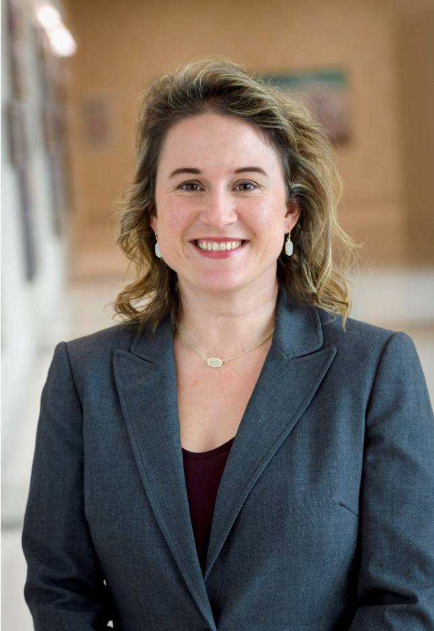  What are some of your work responsibilities?  Curriculum development and design; provide expertise to support effective learner assessment; provide faculty development to improve teaching and learning; collaborate on educational research to advance the scholarship of education.  Tell us something personal about yourself.  I am from San Antonio and a graduate of the UTMB Physician Assistant program. I have been in the UT System for 15 years and at UTMB since 2008. My husband and I have a 6 year old named Eli and we live in League City. I love to watch Eli play sports, spend time with family, and do fun crafts.  Fun Fact  Both my father, a physician, and brother, a PA, practice here at UTMB--we kept medicine and UTMB in the family! |  |  | Retail food service Labor Day holiday hours: The holiday hours for retail food service vendors are as follows:  Galveston  John Sealy Hospital  - Subway will be open from 8 a.m. to 11:30 p.m.  - Café on the Court, Chick-fil-A and Starbucks will be closed  Jennie Sealy Hospital  - Einstein Bros. Bagels will be open from 6:30 a.m. to 2 p.m.  - Hospital Lobby vending machines will remain open 24/7 with healthy options  Clinical Services Wing (CSW):  - Sixth Floor Staff Lounge SmartMarket will remain open 24/7 with healthy options  Moody Medical Library:  - Starbucks will be closed  Health Education Center  - Gourmet Burger Grill will be closed  League City Campus  - Einstein Bros. Bagels will be closed  - Vending machines will remain open 24/7  Angleton Danbury Campus  - Bayou Café will be closed  Clear Lake Campus  - The Grill will be open from 8 a.m. to 1 p.m.  - Starbucks will be closed  - Vending machines will remain open 24/7  Physician Assistant Studies Program celebrates commencement: The Physician Assistant Studies Program held its commencement ceremony Aug. 23, awarding Master of Physician Assistant Studies degrees to 89 graduates. This was the program’s inaugural commencement ceremony, as it transitioned to the School of Medicine from the School of Health Professions at the beginning of the 2018-2019 academic year. Ruth Ballweg, MPA, PA-C, professor emeritus at the University of Washington MEDEX Northwest School of Medicine, was the keynote speaker. Robert Beach, MD, professor emeritus in UTMB’s Department of Internal Medicine, Division of Nephrology and Hypertension, was selected by students to serve as grand marshal. Congratulations to all the graduates!
TOPICS  LEGEND | PATIENT CARE EDUCATION & RESEARCH INSTITUTIONAL SUPPORT CMC
AROUND UTMB (Use the legend above to quickly find items of interest to your team)
Sports Injury Clinic starts Aug. 31 UTMB is offering a youth and school sports injury clinic beginning Aug. 31 from 8:30 to 10:30 a.m. at the League City Campus, Suite 1.211 (use the front clinic entrance). The sports medicine team is trained to treat a full range of sports injuries, from strained muscles and twisted ankles to knee and shoulder pain. The sports injury clinic will be held every Saturday from Aug. 31 until Nov. 9. For more information, call (832) 505-1200 or visit https://www.utmbhealth.com/sports.

REMINDER
MDLive available to UT Select and UT CONNECT ACO members Sept. 1: Starting Sept. 1, members in the UT SELECT Medical plan and the UT CONNECT ACO Medical plan will have 24/7/365 access to virtual visits provided by Blue Cross and Blue Shield of Texas (BCBSTX) and powered by MDLIVE. There is a $0 copay, and you won’t have to leave the comfort of your own home to talk to a doctor. For more information, read the UT System employee benefits blog at https://utmb.us/3hd.

DID YOU KNOW?
Federal Work Study (FWS) is a federal financial aid program for UTMB students who have applied and qualified for federal aid. Students can work up to 20 hours per week and can perform a variety of different jobs as part of the program, which was established by the Higher Education Act of 1965. In FY19, 82 students participated in the program, earning $162,000 working in 30 different UTMB departments and in roles in the local community, including as tutors in the Galveston Independent School District, office aides, intramural sports assistants and lab assistants. For UTMB departments interested in learning more about the program and having a student employee join your team at no cost to your department, email Anita Hendrix at ahendrix@utmb.edu.

