Ben
Weekly Relays User Guide
TOPICS LEGEND
 |  | WEEKLY RELAYS |  | Dec. 12, 2019
  YOUR DEPARTMENT NEWS |  |  |   UTMB NEWS
Office of Educational Development  The First Teaching Skills Workshop of 2020:  Two Sessions | Choose One:  Monday, January 6, 2020 4:00 pm to 5:00 pm  Tuesday, January 7, 2020 12:00 pm to 1:00 pm  Location: Mary Moody Northern Bldg. Room 1.102  Mayer’s Cognitive Theory of Multimedia Learning:  Using Cognitive Science to Inform Your Teaching  Presenter: Virginia Niebuhr, PhD  Department of Pediatrics/SOM  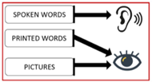  Register now by clicking this link: https://utmb.us/3oc  **************************************  Congratulations to Dr. Levine & Dr. Schatte for your recent publication in the most recent Teaching and Learning in Medicine  The Facilitator Instrument for Team-Based Learning (FIT)  Ruth E. Levine, Peggy Hsieh, P. Adam Kelly, Lisa Carchedi, Jennifer Gibson, Paul Haidet, Paul Koles, Lindsey Pershern, Dawnelle Schatte, Brenda Talley, Dwight Wolf & Britta Thompson  Pages: 82-90 | DOI: 10.1080/10401334.2019.1646653  Academic Affairs  Thank you to everyone who helped make our first annual Academic Affairs Holiday Potluck Luncheon a huge success! A fabulous time was had by all!  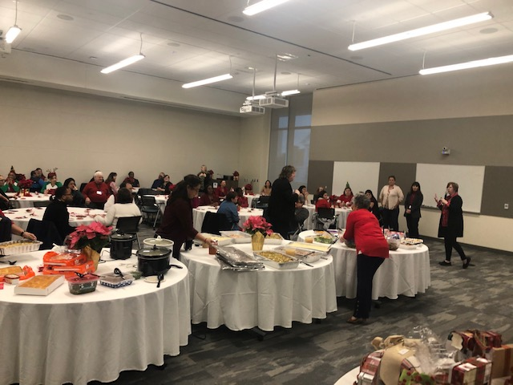  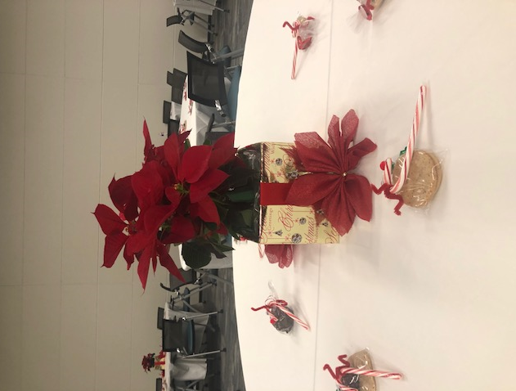    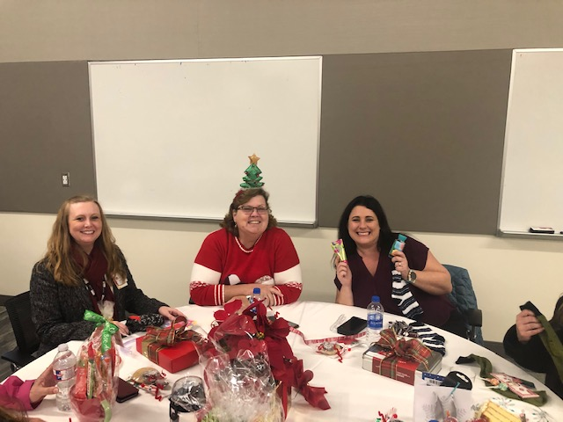  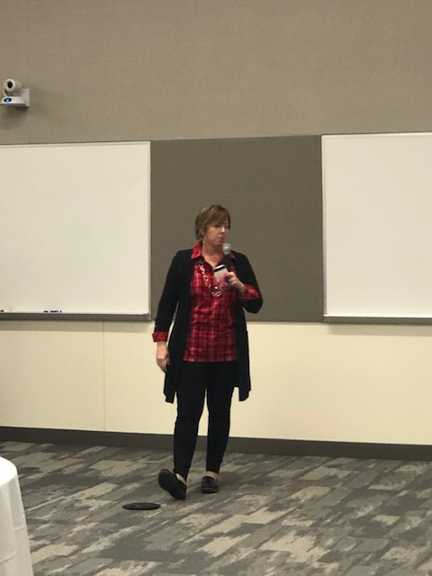  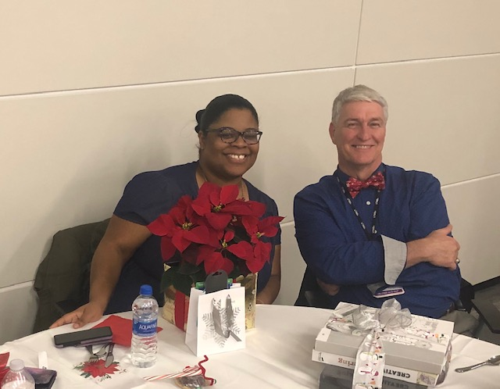    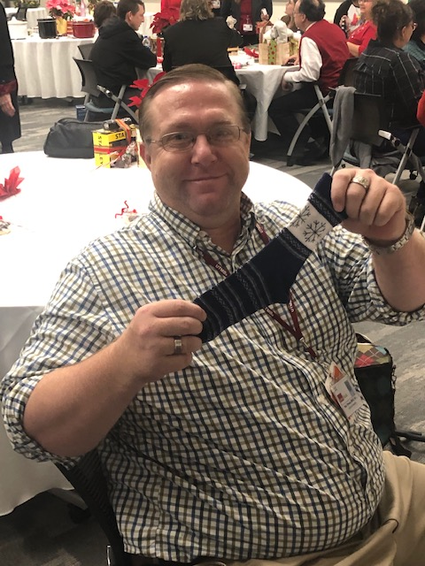  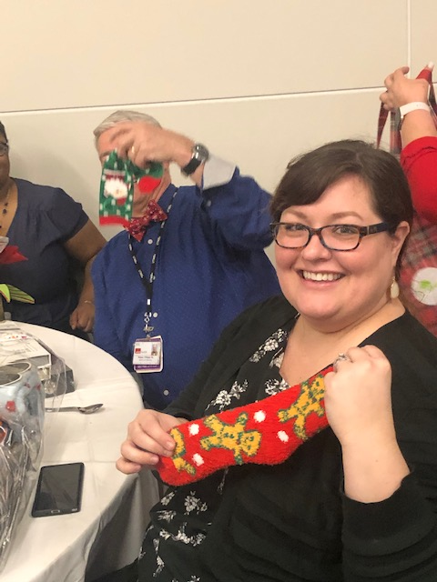          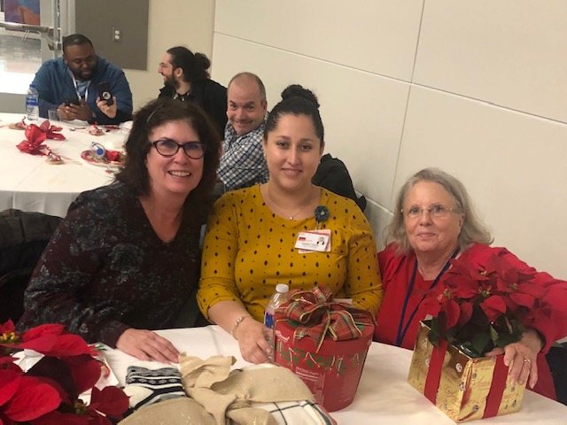  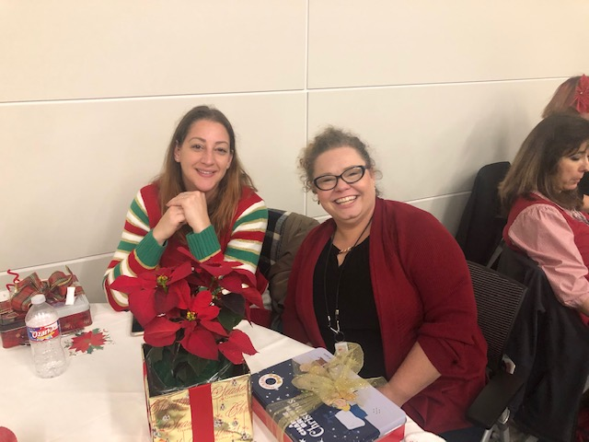  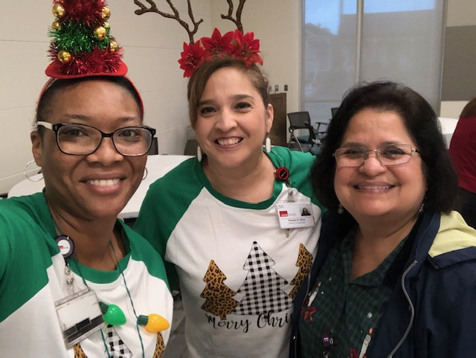    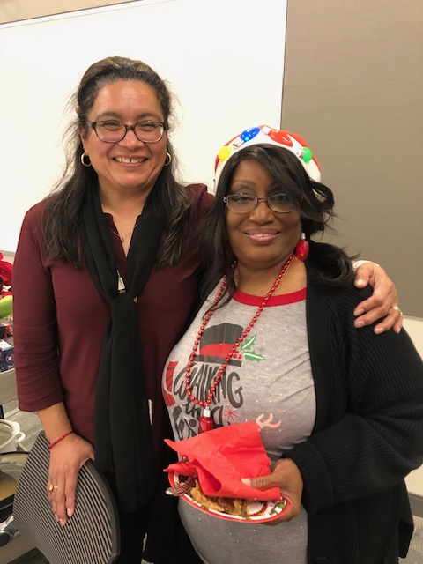      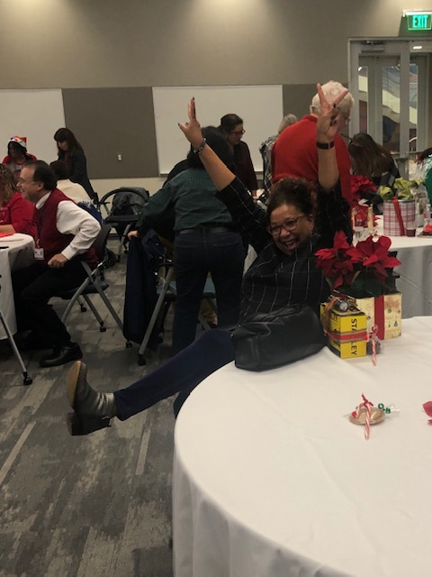    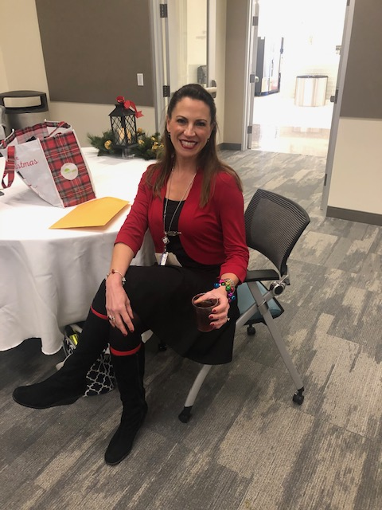  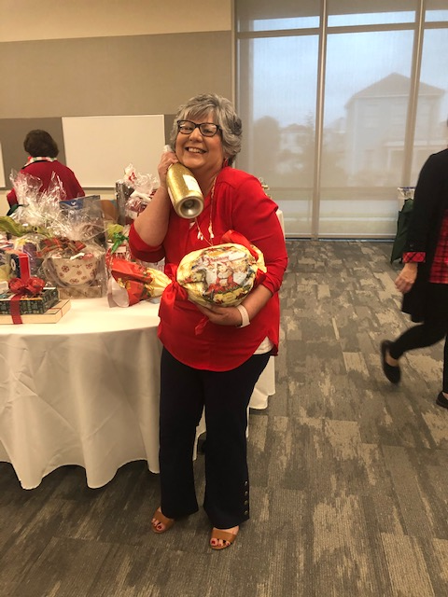  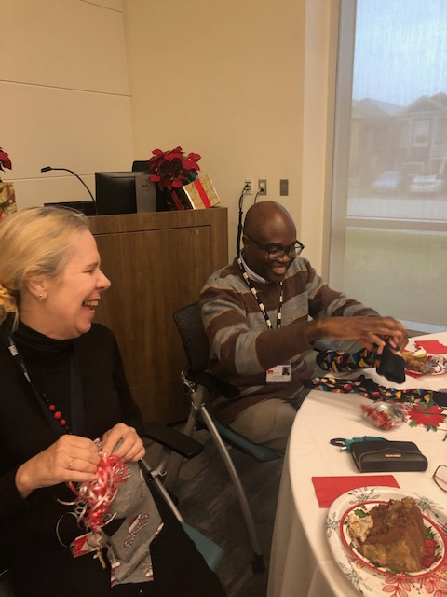  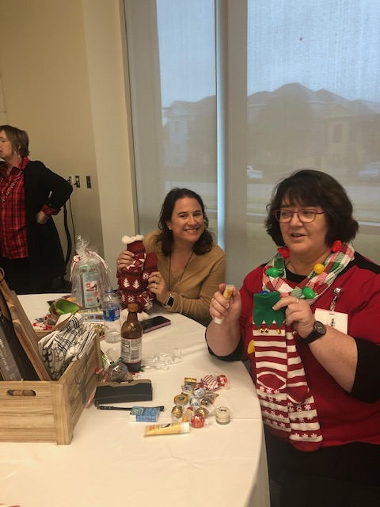  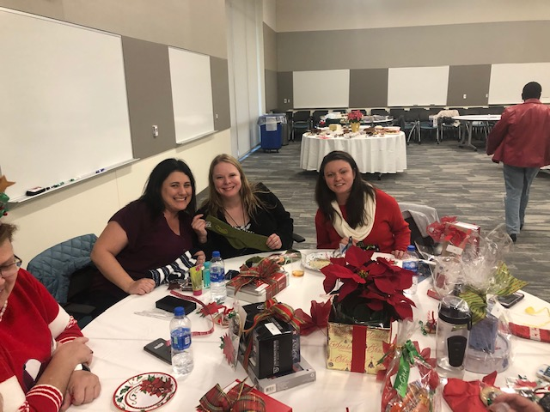   |  |  | Celebrate the legacy of Dr. Martin Luther King Jr.:  All members of the UTMB community are invited to the 2020 Dr. Martin Luther King Jr. Service Award Ceremony and Luncheon on Jan. 14 from 11:30 a.m. to 1 p.m. in the Levin Hall Dining Room on the Galveston Campus. The event will feature a keynote address from Eugene A. Lewis. Jr., retired chief of police and community leader, and the presentation of the annual community service award. Email events@utmb.edu or call (409) 747-6735 by Jan. 9 to reserve your seat.  Chris Toomes joins UTMB as vice president of supply chain:  Chris Toomes joined UTMB as vice president of supply chain on Nov. 18. In this role, Chris will report to Cheryl A. Sadro, chief financial officer, and will be responsible for strategic sourcing, contracting, value analysis, procurement, supply chain operations and supply chain data management. Chris comes to UTMB from Becton Dickinson, where he most recently served as national IDN (Integrated Delivery Network) director focused on the development and design of new hospital supply chain systems and processes. Please join us in welcoming Chris to the UTMB community.  IN CASE YOU MISSED IT  Dec. 4 Town Hall meeting online:  The President’s Town Hall from Dec. 4 is now available online. During the latest Town Hall, UTMB President ad interim Dr. Ben Raimer discussed a variety of topics, including financial results, a review of The Road Ahead and an update on UTMB’s strategic direction. Watch the Town Hall at https://utmb.us/3or.  MyStar/Campus Solutions extended outage starts Dec. 12:  Information Services is upgrading MyStar/Campus Solutions, which will be unavailable to students and UTMB employees for an extended period of time beginning on Dec. 12 at 5 p.m. The outage is expected to last through 10 p.m. on Dec. 13. Information Services regrets any inconvenience this upgrade may cause. For more information, contact ais.incidentmanagement@utmb.edu or the UTMB Service Desk at (409) 772-5200.
OPICS  LEGEND |         PATIENT CARE EDUCATION & RESEARCH INSTITUTIONAL SUPPORT CMC
AROUND UTMB (Use the legend above to quickly find items of interest to your team)
Kudos to Galveston pediatric care group for closing most gaps during the 2019 DSRIP President’s Pediatric Push:  The Pediatric Primary Care team at the Island East clinic in the Primary Care Pavilion will be recognized by Interim President Dr. Ben Raimer at a January lunch for going above and beyond to meet their Delivery System Reform Incentive Payments (DSRIP) metrics before the calendar year’s end. Examples of measures include immunization rates, weigh assessment and counseling, and tobacco use among adolescents, to name a few. DSRIP metrics are part of the Texas 1115 Medicaid Transformation Waiver and part of UTMB’s overall Population Health initiative, which is focused on projects designed to improve quality of patient care and care coordination. You can learn more about Population Health at UTMB by visiting http://intranet.utmb.edu/population-health/home.  FOR EMPLOYEES WHO WORK IN GALVESTON  UTMB community encouraged to participate in Vision Galveston survey:  As the largest employer in Galveston County, UTMB is part of the steering committee for Vision Galveston, a grassroots project aimed at defining the future for the city of Galveston. Vision Galveston is conducting an online survey to better understand the island community’s housing situation. The survey is open to anyone who works in Galveston, and the information collected will be used to identify new housing options and possible policy changes. The last day to provide input is Dec. 20. Please take a few minutes to complete the survey at https://www.surveymonkey.com/r/HousingStudyUTMB  CMC-Happy holidays:  On behalf of Dr. Murray and UTMB Correctional Managed Care’s senior leadership team, we want to wish everyone a safe and happy holiday season.  New Patient Event Reporting System now live:  UTMB’s new Patient Event Reporting System, RLDatix, was implemented on Dec. 10 in response to feedback from staff for a more streamlined system. The tool, which replaced Juvo, will gather reports on patient safety, quality concerns and patient feedback. A reporting system alone, however, will not achieve a Culture of Safety. Currently, UTMB averages about 400 entries per month, which is modest for an organization of our size. All employees are empowered to report anything and everything that has the potential to lead to unsafe conditions that could reach a patient. Our goal is to learn from these near misses and proactively improve our health care system to reduce patient harm. Reporting is valued! To notify Patient Safety of any issues with the new system, please call (409) 772-4775 or ptsafety@utmb.edu. (Please note that file managers may still need to access Juvo through Dec. 31 to complete any outstanding report actions; Juvo will no longer be accessible after this date.) |  |  | Holiday retail service hours:  The holiday hours for retail food service vendors are as follows:  Galveston Campus  Health Education Center  - Gourmet Burger Grill will be closed from Dec. 23 – Jan. 3  Moody Medical Library  - Starbucks will be closed from Dec. 23 – Jan. 3  John Sealy Hospital  - Starbucks will be closed from Dec. 23 – Jan. 3  - Café on the Court will be closed Dec. 22-25 and Dec. 31 – Jan. 1  - Subway will remain open at regular business hours  Jennie Sealy Hospital  - Einstein Bros. Bagels will remain open at regular business hours  - Vending machines and SmartMarket will remain open 24/7  League City Campus  - Coffee Shop will be closed on Dec. 24 – 26 and Dec. 31 – Jan. 1  - Vending machines will remain open 24/7  Angleton Danbury Campus  - Bayou Café will be open on Dec. 25 from 7 a.m.– 10 a.m. and closed on Jan. 1  Clear Lake Campus  - Starbucks will be closed Dec. 21 – Jan. 1  - The Grill will be open Dec. 21 – Jan. 1 from 8 a.m. – 1 p.m.  - Vending machines will remain open 24/7
DID YOU KNOW?
On Dec. 17, the Auxiliary of Angleton Danbury Campus will host its 500th blood drive. The Auxiliary began its partnership with the Gulf Coast Blood Center in 1973, and in 1983 began monthly blood drives on the Brazoria County campus. The Auxiliary, and the seven members who have served as blood drive chairpersons over the years, have collaborated with the Gulf Coast Blood Center to collect 44,658 donations that have saved approximately 134,000 lives in the 26 Texas counties served by the center. The 500th blood drive will take place from noon to 7 p.m. in the POB II Auditorium. At 2 p.m., the Gulf Coast Blood Center will recognize the Auxiliary for this historic and impressive achievement. For more on the Auxiliary’s blood drives, visit https://www.youtube.com/watch?v=ciCvUQJltGQ&feature=youtu.be.

