Ben
Weekly Relays User Guide
TOPICS LEGEND
 |  | WEEKLY RELAYS |  | Feb. 13, 2020
  YOUR DEPARTMENT NEWS |  |  |   UTMB NEWS
Office of Educational Development  OED is kicking off a new 5-month Faculty Development series called TED Masterclass.  This program will help faculty develop their presentation skills to create and deliver TED-style talks. To learn more, drop by a come-and-go informational session: March 5th between 12-1 or 4:30-5:30 in Mary Moody Northen 1.102  ~~~~~~~~~~~~~~~~~~~~~~~~~~~~~~~~~~~~~~~~~  Teaching Skills Workshop  February 18, 2020  Get in the Game! Involving you Audience with Online Quiz Tools    Register today by clicking this link: https://utmb.us/3qq  Location: Mary Moody Northen (MMN) Room 1.102  Choose a session:  Tuesday, February 18, 2020  12:00 pm to 1:00 pm  or  4:00 pm to 5:00 pm  Presenter: Misha Syed, MD, MEHP    Office of Academic Affairs    Don’t forget to sign up for the Chili Cook-Off on Tuesday, February 25th!  ~~~~~~~~~~~~~~~~~~~~~~~~~    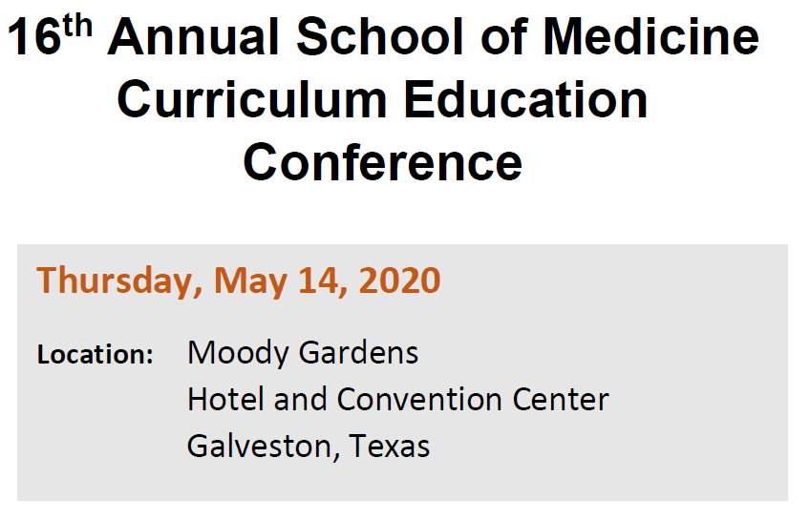 |  |  | Bay Colony Pediatrics No. 1 in Galveston County for HPV vaccination rate: Bay Colony Pediatrics ranked No. 1 in Galveston County in 2019 for the human papillomavirus vaccination rate and are in the Top 10 percent statewide, according to the Texas Department of Health and Human Services. Almost every person who is sexually active will get HPV at some time in their life without HPV vaccination. About 14 million Americans, including teens, become infected with HPV each year. While most HPV infections will go away on their own, infections that don’t go away can cause certain types of cancer. Despite the protection the HPV vaccine offers, uptake of the vaccine lags behind other adolescent vaccines. In 2018, only 43.5% of Texas teens received a complete series of the HPV vaccine.  UTMB Police seek information, remind community to remain vigilant following recent arrest on Galveston Campus: On Feb. 12, UTMB Police received a report of an unaffiliated male acting suspiciously on campus. The person has been identified and arrested, and there is no current danger to anyone or the campus; however, If you have been approached, followed or have any information that may be helpful to this investigation, please contact UTMB Police at (409) 772-1011. For more information and a list of safety tips, visit https://utmb.us/3sj.  Retail food service hours for Presidents’ Day holiday:  Retail food service vendors will operate at their regular business hours on all campuses on Presidents’ Day, Feb. 17, with two exceptions on the Galveston Campus:  Moody Medical Library  - Starbucks will be closed  Health Education Center  - Gourmet Burger Grill will be closed  REMINDER  You’re Invited—UTMB Clear Lake Campus Pediatric Inpatient Unit and Emergency Department: UTMB employees are invited to help celebrate the opening of the new Pediatric Inpatient Unit and Emergency Department on the UTMB Clear Lake Campus on Feb. 18 from 4 to 6 p.m. The new unit, a collaboration between UTMB and Children’s Memorial Hermann, is located on the 8th floor of the Clear Lake Campus Hospital, 200 Blossom St. in Webster. Remarks will take place at 4:15 p.m., and a reception and tours will follow. RSVP for the event by emailing events@utmb.edu or calling (409) 747-6735.
TOPICS  LEGEND |         PATIENT CARE EDUCATION & RESEARCH INSTITUTIONAL SUPPORT CMC
AROUND UTMB (Use the legend above to quickly find items of interest to your team)
Patient Centeredness Tip of the Week: An important part of patient-centered care is to acknowledge our patients as individuals by considering their needs and values while engaging them in decisions on their plan of care. Simple ways to acknowledge our patients include: 1) Greeting patients by name, 2) Introducing ourselves and our role when we enter their room and 3) Sitting down, if possible, so that we can make eye contact while conversing. These actions help demonstrate we are present for our patients and that we are genuinely listening to their questions and concerns.
User Desktop: It is important for patient safety to ensure that the User Desktop is being used properly. Please remember, all reminders need to be in the ToDo User’s name and old reminders need to be closed or deleted (including from other units). The provider’s list of reminders for the day should only reflect what they are to do that day. Second, patients need to be checked into the clinic when they arrive in the clinic; they need to be checked out of the clinic when their appointment is completed and the provider indicates that the patient can leave. The patient should be checked out when they depart after their appointment EVEN IF THE NOTE HAS NOT BEEN COMPLETED. The completed note will be processed through Chart Completion. In addition, it is recommended that all users (including providers) close their own reminders as they complete their work, in order to keep their schedule (their list of reminders) current and accurate. Please see the User Desktop SOP for further guidance.
DID YOU KNOW?
Since 1995, UTMB has been home to the World Reference Center for Emerging Viruses and Arboviruses (WRCEVA), which houses more than 6,700 virus strains. Originally founded as part of an effort by the Rockefeller Foundation in the early 20th century to understand viral ecology, epidemiology, and pathogenesis, the WRCEVA’s mission is to collect, catalog, maintain, and distribute emerging viruses, arboviruses and associated reagents to researchers working on vaccines, cures and diagnostics around the world. The center recently obtained the novel coronavirus, COVID-19, from the Centers for Disease Control and Prevention. Consistent with its mission, the center is working to share the sample with the appropriate research communities. For more information on the WRCEVA’s work, visit https://www.utmb.edu/wrceva.

