Ben
Weekly Relays User Guide
TOPICS LEGEND
 |  | WEEKLY RELAYS |  | April 16, 2020
YOUR DEPARTMENT NEWS |  |  | UTMB NEWS
Office of Academic Affairs  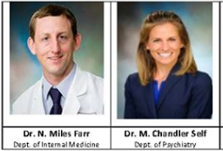  Congratulations to Drs. Farr and Self for receiving the 2020 Excellence in Clinical Teaching Award! Congratulations to them both on an honor that is well-deserved  Office of Student Affairs & Admissions  Colors of Medicine – Virtual  A Premed Confab in a Time of Social Distancing  Saturday, April 25, 2020 from 1pm to 3pm  Website: https://www.utmb.edu/specialprogams/mhgp  Registration: https://tinyurl.com/utmbcom2020  UTMB School of Medicine's (SOM) Office of Student Affairs and Admissions' (OSAA) Special Programs, Recruitment and Academic Support and Career Counseling teams invite premedical students to discussions on the admissions process and academic requirements, updates from TMDSAS and AAMC, and advice on becoming a more competitive applicant or re-applicant. The Colors of Medicine medical students will be hosting a panel to discuss attending the oldest medical school in Texas, housing, finances, life on the island, their journeys into medicine, and if all they do is study.  Host: Dr. Norma Pérez  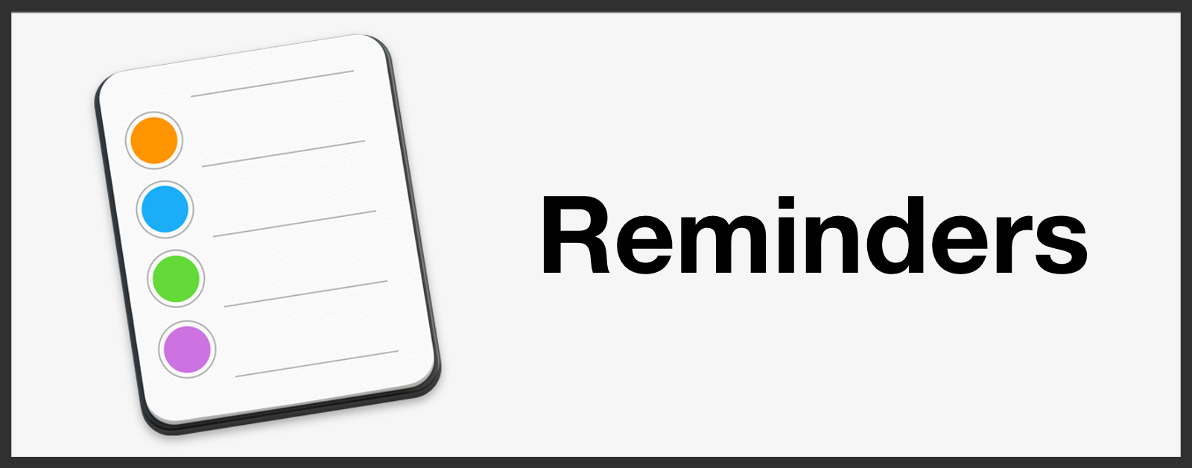  - Complete Mandatory Compliance Training  - Report COVID 19 related illness or COVID 19 positive testing to Employee Health; even if you did not seek treatment at UTMB  - Complete Conflict of Interest Forms (from the announcement page)  UTMB’s Annual Conflicts of Interest Research Disclosure Period Requirements - Deadline Extended  Per institutional policy, all employees who conduct or oversee research activities must submit a disclosure disclosing all financial interests that occurred during calendar year 2019. If these activities will occur in 2020, you must submit a request for approval. Both tasks must be completed by April 30, 2020.  This applies to:  All faculty engaged in research and all individuals who, regardless of title or position, are responsible for the design, conduct, or reporting of research, such as principal investigators, co-investigators, faculty agents, research techs, research nurses, staff, fellows, and administrators who participate in the research process;  Members of institutional research review related committees (e.g., IRB or IACUC); and  Staff members who negotiate or execute research agreements on behalf of UTMB. |  |  | *BREAKING NEWS*  From Dr. Raimer: A message to our UTMB Family: In this message, President ad Interim Dr. Ben Raimer addresses the financial hardships facing UTMB as a result of the COVID-19 pandemic and the steps we're taking to close the gap. To read the full message and watch the video visit: https://utmb.us/40n.  Monthly financial update—Results as of March 31: For the month of March, UTMB’s adjusted margin was a loss of $20.5 million, which was $17.7 million worse than planned. Year-to-date was worse than planned by $20.2 million with an adjusted margin loss of $67.4 million. UTMB’s overall results, as with most health care organizations, were impacted negatively by COVID-19. Please ensure you continue to manage expenses during this difficult time. While the next few months may be challenging, your efforts are essential to the continued long-term success of UTMB’s mission.  Best Care update: UTMB has received the results of the second period of the 2020 Vizient Quality and Accountability Study. UTMB currently ranks No. 42 among the study’s 98 participating comprehensive academic medical centers. Our ranking has slipped in most domains. The current data does not reflect the COVID-19 pandemic, which was officially declared in January. We continue to submit our data to Vizient during the pandemic; however, no official decision has been reached about the study for this year. This experience will surely transform health care in many ways, but it is important that we keep an eye on the future as we prepare for a gradual, phased and safe return to normal operations. Thank you to all UTMB employees for their commitment to safe, quality patient care during COVID-19.  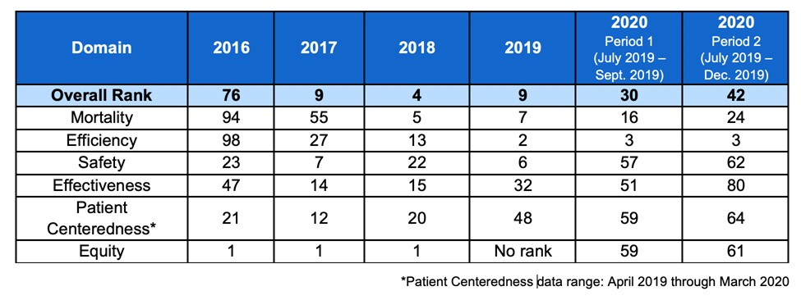Elevate your emotional fitness with UT System Spring Wellness Challenge: The UT System Spring Wellness Challenge, Work of Art, begins May 4 and is open to all UT SELECT medical plan members and dependents age 18 and above. The challenge will help you focus on your emotional fitness during this difficult time and learn skills that foster resilience and boost happiness. Living an emotionally healthy life is an art, but the habits that lead to long-term success are grounded in science: enhancing mindfulness, sharing gratitude, increasing optimism and strengthening connections – even when separated by distance. Participants will be able to complete personalized activities and create virtual art through the Living Well online platform or mobile app. Register for the challenge starting April 20 at www.utlivingwell.com.
OPICS  LEGEND | PATIENT CARE EDUCATION & RESEARCH INSTITUTIONAL SUPPORT CMC
AROUND UTMB (Use the legend above to quickly find items of interest to your team)
COVID-19: Novel coronavirus updates  COVID-19-related Emergency Leave: UTMB has enhanced its emergency leave benefit to help meet the needs of our workforce during the COVID-19 pandemic. The benefit became effective April 1, 2020, and provides eligible employees up to 80 hours of paid leave for qualifying COVID-19-related reasons. See Dr. Raimer’s April 10 message for more details, including a summary document and frequently asked questions.  Updated COVID-19 testing instructions: Just a reminder that our testing instructions for COVID-19 were recently updated. UTMB Laboratory Services and the Galveston National Lab (GNL) have been working together to develop and increase testing capacity. The following are important updates to our testing information. Click here for complete instructions on testing.  - UTMB Lab Services is performing testing in different laboratory sections on the Galveston Campus (Microbiology Lab, Molecular Diagnostic Lab and Biocontainment Lab).  - ID Now Molecular SARS-CoV-2 (COVID-19) Testing is now available at all campus labs, including Angleton Danbury, Clear Lake and League City, for authorized patient groups—this includes ED patients, pre-surgical/pre-procedure patients (including transplant), health care workers, first responders (e.g., EMTs, firemen and police) or obstetric patients.  - UTMB Lab Services has increased the sensitivity of ID Now Molecular Testing by using a direct swab technique. For this rapid molecular test, do not place the swab in transport media. Please click here for new Rapid Test collection requirements.  - The GNL has developed a higher sensitivity testing system: the new SARS-CoV-2 (COVID-19) method, which was implemented April 10, 2020.  Please visit the Healthcare Team section of UTMB’s COVID-19 website for more information: https://www.utmb.edu/covid-19/health-care-workers.  COVID-19 website:  Given the rapidly evolving nature of the COVID-19 spread, you can find the latest information regarding UTMB’s institution-wide response online at www.utmb.edu/covid-19.  2020 Excellence in Clinical Teaching Awards: The John P. McGovern Academy of Oslerian Medicine has announced the recipients of its 2020 Excellence in Clinical Teaching Awards. This award recognizes the fundamental concept, exemplified by Sir William Osler, that the development of outstanding physicians occurs primarily in clinical settings. This honor is accompanied by a monetary award to support professional development and/or teaching programs. Congratulations to:  - Dr. N. Miles Farr: Internal Medicine  - Dr. Alexis McQuitty: Anesthesiology  - Dr. M. Chandler Self: Psychiatry and Behavioral Sciences  - Dr. Sifrance Tran: Surgery |  |  | Weekly Wellness Recap:  In an effort to promote resiliency and wellness, Weekly Relays is now including a recap of the week’s previous wellness tips. Shared by the UTMB RISE (Resilience in Stressful Events) Task force each day, these tips are just one way we can all work to stay emotionally healthy during the COVID-19 pandemic.  - Take breaks: Don’t skip breaks at work. At home, allow yourself to unwind and do something fun or relaxing. Resist feeling guilty.  - Stay updated but not over-saturated: Rely on trusted sources of information (UTMB COVID-19 updates, Galveston County Health District, CDC or your local health authority). Avoid over-checking the news and non-credible sources of information.  - Stay hydrated: Be sure to drink around a half of a gallon of high-quality H2O each day. This equals four 16-ounce bottles. Monitor yourself for signs of dehydration. (Thanks to Tyler Morrison and Jeremias Martinez with Rehabilitation Services for today’s tip.)  - Watch for unexpected signs of stress: Headaches, lethargy, back pain, nausea, getting sick a lot, excessive sweating and loss of pleasure in things you used to enjoy doing can all be signs of stress. Take steps to reduce stress. (Thanks to Jeffrey Sanders in Correctional Managed Care for today’s tip.)  - Exercise to reduce stress: Gyms are closed but consider one YouTube workout per day. It’s free, no equipment needed, and it keeps the endorphins flowing! (Thanks to Stuart Jackson in the Health Education Center for today’s tip.)  - Check-up from the neck-up: Identify the emotion you feel three times then release that emotion. For example: “I release being angry,” followed with “I am happy, calm, centered…” (Thanks to Charlene Tipton at Hospital Galveston for today’s tip.)  - Maintain good sleep habits: Avoid large meals, caffeine and alcohol before bedtime. Be consistent. Have the room dark and cool. Adequate sleep helps your immune system too.  For more information on RISE and employee health and wellness, visit https://www.utmb.edu/covid-19/home/prevention-preparedness-wellness/mental-health-wellness.
DID YOU KNOW?
Long known for our exceptional patient care, infectious disease expertise and robust research enterprise, UTMB is demonstrating its leadership in the fight against COVID-19 as well. Through a collaboration between the Galveston National Laboratory and our clinical laboratory, UTMB has implemented voluminous testing capacity throughout our local communities to help slow the spread of the virus and is helping other hospital systems in the Houston area and across the state with their testing. UTMB’s testing program began March 13; as of April 16, the university has conducted more than 10,000 COVID-19 tests. For more detailed testing-related information about UTMB specifically, see the COVID-19 Daily Updates at https://www.utmb.edu/covid-19/daily-updates.

