Ben
Weekly Relays User Guide
TOPICS LEGEND
 |  | WEEKLY RELAYS |  | May 28, 2020
YOUR DEPARTMENT NEWS |  |  | UTMB NEWS
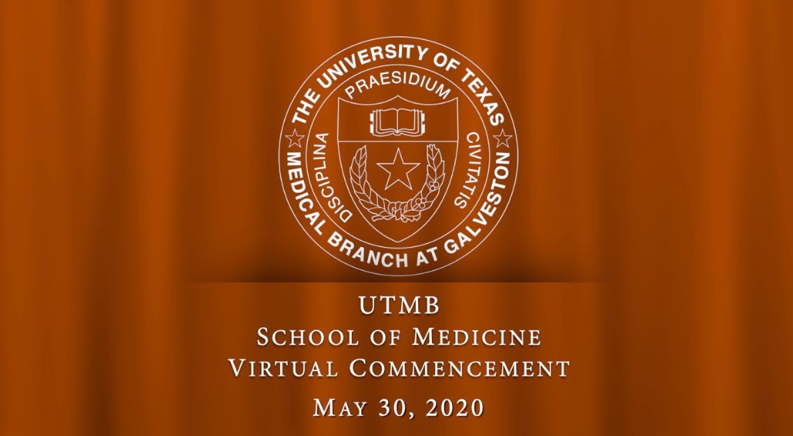  Please join us for the  Virtual Celebration of the  One Hundred and Thirtieth  School of Medicine  MC Commencement  at Ten O’clock in the Morning  on Saturday, May the Thirtieth  at the following link:  https://www.utmb.edu/som/medical-education/commencement-activities  If you have not done so already,  please Add a congratulatory message to the  Kudos Board for our MD Graduates  https://www.kudoboard.com/boards/2020UTMB-SOM-COMMENCEMENT |  |  | School of Nursing celebrates its 2020 graduates:  UTMB’s School of Nursing released a celebratory commencement video May 21 to recognize the achievements of its 584 graduates. The video included words of support from SON and UTMB leaders, student award presentations, and a keynote address by Dr. Ernestine “Tina” Cuellar, SON alumnus, and retired faculty member and associate dean. This year the School of Nursing awarded the following degrees and certificates:  • Adult Gerontologic Acute Care Nurse Practitioner (first cohort to graduate with this specialty) – 41  • Adult Gerontologic Primary Care Nurse Practitioner—23  • Clinical Nurse Leader—6  • Doctor of Nursing Practice—10  • Executive Nurse Leader—15  • Family Nurse Practitioner—86  • Neonatal Nurse Practitioner—19  • Nurse Educator—8  • RN-BSN—37  • Traditional BSN—339  Additionally, two certificates will be completed by August. View the commencement video at https://nursing.utmb.edu/v/2020Commencement.  Kronos upgrade coming soon:  As part of UTMB’s continuous efforts to improve features and functionality for our employees, an upgrade to the KRONOS electronic timekeeping system will occur in July 2020. The implementation teams from Payroll Services, Human Resources, Nursing Service and Information Services have been working to improve the application for everyone. New features will include a mobile application, elimination of Java and Flash dependencies, compatibility with multiple browsers and improvement tools for clock users. Stay tuned for upcoming webinars and webpages to learn how the new changes will affect your role.
OPICS  LEGEND | PATIENT CARE EDUCATION & RESEARCH INSTITUTIONAL SUPPORT CMC
AROUND UTMB (Use the legend above to quickly find items of interest to your team)
New eProcurement approval threshold guidelines:  On May 18, UTMB implemented the following initiatives to assist in addressing our revenue shortfalls and curtailing spending across the institution.  Purchase Order (PO) Requisition:  - All PeopleSoft requisitions greater than $5,000 will route through the normal departmental approval process and each entity vice president of finance will review the final requisition prior to the issuance of a purchase order.  - To expedite the approval process, all requisitions greater than $5,000 should include the proper justification and supporting documentation including:  - Why the purchase is necessary in fiscal year 2020 and,  - A brief description of the mission-critical nature of the purchase  - Requisitions that do not fit the criteria above will be returned to the requisitioner for additional information.  Non-Purchase Orders, Procurement Cards (P-Cards) and Employee Reimbursements:  - All purchases greater than $5,000 made outside of the PO process including Non-Purchase Orders, Procurement Card (P-Card) purchases and employee reimbursements will be routinely reviewed for adherence to UTMB’s purchasing guidelines.  If you need additional information regarding any purchasing process, please contact the Purchasing Department at: purchasing.helpdesk@utmb.edu or please review these helpful links: UTMB’s Procurement Policy 4.5.6, Supply Chain’s Improper Purchase Process Policy 2.90.  Weekly Wellness Tips:  Shared by the UTMB RISE (Resilience in Stressful Events) Task Force, these tips are just one way we can all work to stay emotionally healthy during the COVID-19 pandemic.  - Find your center today. Commit to being mindful today. Consider a period of deep breathing, a moment of progressive relaxation or view a video from the RISE website by our own mindfulness experts here at UTMB.  - Focus on nutrition. Commit to do one or all of these one day or meal a week: eat slowly, avoid distraction during meals and listen to your internal signals of hunger and fullness to avoid overeating.  - Focus on SPIRIT. Look for similarities rather than differences in others; this helps make connections. We all have far more similarities than differences. We all basically want the same things and have the same needs.  - Focus on BODY. Make it convenient to make healthy choices. Keep pre-portioned healthy snacks in your office, breakroom and home. When it’s easy to eat right, you are more likely to do it.  - Focus on MIND. Challenge yourself to see more than one side of an issue. Things are rarely black and white. Empathy becomes easier when we do this.  - Focus on SPIRIT. Make an effort to be mindful, live in the moment and appreciate life’s simple pleasures. When interacting with others, give your full attention.  - Focus on BODY. Do a commercial or work break work-out. For every commercial or work break, mix up a combination of planks, squat jumps, tricep dips, push-ups, mountain climbers, hip bridges and crunches.  Vasilakis named chair-elect of executive committee for UT System Faculty Advisory Council:  Nikos Vasilakis, PhD, professor and vice chair for research in the Department of Pathology, has been elected chair-elect of the Executive Committee of The University of Texas System Faculty Advisory Council (FAC) for FY 2021. The FAC is a selected representative advisory group that works with and on behalf of The University of Texas System. Its mission is to provide a forum for communicating ideas and information between faculty, the Board of Regents and the Executive Officers of UT System. Dr. Vasilakis currently serves as chair of UTMB’s Faculty Senate. To learn more about the UT System FAC, visit https://www.utsystem.edu/sites/faculty-advisory-council. |  |  | Reminder about media inquiries at UTMB:  In order to ensure that every media request to UTMB is catalogued, reviewed and responded to and that faculty and staff have the assistance they need to adequately prepare for an interview, please refer all media inquiries to the UTMB Media Relations team before responding to any questions or agreeing to an interview. As a reminder, UTMB has a long-established media hotline at (409) 772-6397 and a specific mailbox, utmbnews@utmb.edu, where you can refer inquiries. For media inquiries specifically related to Galveston National Lab faculty, research or operations, please contact:  - Connie Holubar at cjholuba@utmb.edu or (903) 880-8217 or Raul Reyes, rareyes@utmb.edu or (409) 771-7841  Regarding media inquiries not related to the Galveston National Lab, please contact any member of the UTMB Media Relations team:  - Raul Reyes at rareyes@utmb.edu; (409) 771-7841  - Christopher Smith Gonzalez at chrissmi@utmb.edu; (979) 777-1537  - Donna Ramirez at d1ramire@utmb.edu; (607) 760-9945  - Kurt Koopmann at kekoopma@utmb.edu; (409) 539-0219
DID YOU KNOW?
UTMB’s researchers have been featured prominently in local, national and international media’s coverage of COVID-19. As of May 27, our researchers have been mentioned in 3,729 news articles since the onset of the pandemic, including numerous times locally in The Galveston County Daily News, The Facts and I45 Now, and nationally and internationally in The New York Times, The Washington Post, CNN, Time, NPR, The Denver Post, Business Insider and numerous other outlets. To read some of these articles, visit the News Highlights page on the UTMB Newsroom website at https://www.utmb.edu/newsroom/news-highlights.aspx.

COVID-19 Novel coronavirus updates:
UTMB’s researchers have been featured prominently in local, national and international media’s coverage of COVID-19. As of May 27, our researchers have been mentioned in 3,729 news articles since the

Planning for safe return of employees and students to our campuses continues:
Follow guidance from your department leadership or school leadership regarding specifics related to your area. In general, employees working on campuses should remember to:
- Practice frequent hand hygiene by washing thoroughly with soap and water or using hand sanitizer
- Practice good social distancing
- Wear a mask in public areas of our campuses, including non-clinical buildings (masks are not required while you are in your personal office or cubicle)
- Stay home if you are sick
Managers have been provided information on how to obtain supplies of hand sanitizer and masks for employees working on our campuses.

Important update regarding COVID-19 Laboratory Tests:
Effective May 21, UTMB Laboratory Services has implemented two separate test orders for ID Now COVID-19 rapid test and COVID-19 PCR molecular test platforms.
- ID Now COVID-19 Rapid Testing: Orderable in Epic as COVID-19 Testing ID Now (LAB 002117). The ID Now COVID-19 test remains available at the ADC, CLC, Galveston and LCC lab locations.
- COVID-19 by PCR Molecular Test: Orderable in Epic as COVID-19 by PCR (LAB 002110)
Click here for updated ordering instructions.
Read more and get additional information on COVID-19 testing.

COVID-19 website:
Given the rapidly evolving nature of the COVID-19 spread, you can find the latest information regarding UTMB’s institution-wide response online at www.utmb.edu/covid-19.

