Ben
Weekly Relays User Guide
TOPICS LEGEND
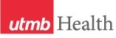 |  | WEEKLY RELAYS |  | Sept. 10, 2020
YOUR DEPARTMENT NEWS |  |  | UTMB NEWS
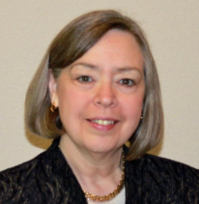  Congratulations to Dr. Buck who is now the new  Director of the Academy of Master Teachers!  Dr. Buck’s three year term began on September 1st.  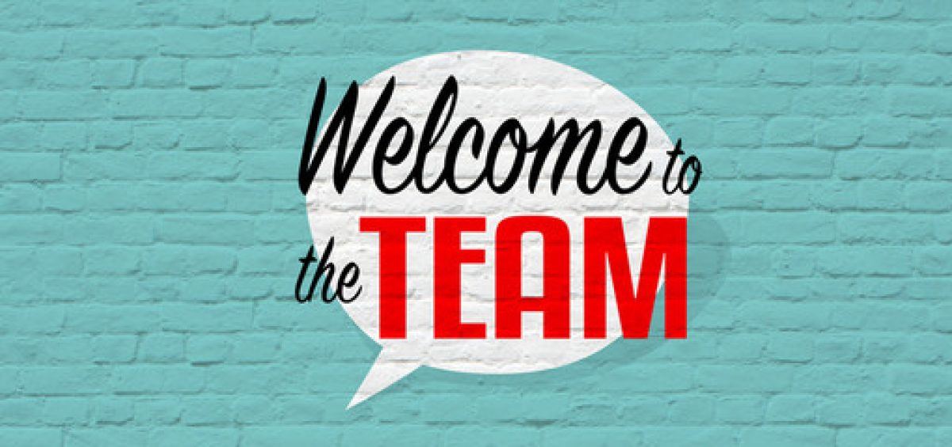  Join us in welcoming Ms. Alicia Simmons  who joined our Instruction Management Office as a Coordinator II on September 5, 2020.  Ms. Simmons comes to IMO with  over 23 years of UTMB experience.  She most recently served in the Office of Educational Outreach-Science Education in working collaboratively with local STEM (Science, Technology, Engineering & Math) programs and high school summer research programs. |  |  | Payroll tax deferral notice: President Trump signed the “Memorandum on Deferring Payroll Tax Obligations in Light of the Ongoing COVID-19 Disaster” on Aug. 8, 2020. The memorandum allows employers to defer the withholding and payment of Social Security tax (6.2%) for a limited group of employees from Sept. 1, 2020, to Dec. 31, 2020. The deferred taxes must be repaid starting Jan. 1, 2021, with total repayment made by April 30, 2021. Due to the potential hardship the repayment requirement may create for employees in 2021 and in accordance with other UT System institutions, UTMB has decided not to implement the payroll tax deferral. The university will continue withholding and submitting the employee’s portion of the Social Security tax as normal. Please visit iUTMB to view the entire Payroll Tax Deferral Notice https://utmb.us/4ch.  New episode of Health Care Unmasked set for Sept. 16: Ever wonder what’s really involved in developing a new vaccine? Curious about clinical trials? UTMB vaccine expert Dr. Alan Barrett and Lori Simon, director of Clinical Research, will join host TJ Aulds to discuss this and more on the next Health Care Unmasked. The conversation is set for noon on Wednesday, Sept. 16, on the i45NOW Facebook page at https://www.facebook.com/i45NOW/.  REMINDER  Virtual Town Hall on Sept. 22: UTMB President ad interim Dr. Ben G. Raimer will host a special livestream-only Town Hall on Tuesday, Sept. 22 at noon. More information on viewing options and topics to be covered will be available soon in Weekly Relays, iUTMB and the I Am UTMB Facebook page. Individuals who have questions for Dr. Raimer are encouraged to submit them at https://www.utmb.edu/eac/contact-us.  COVID-19: Novel coronavirus updates  Incident Command Updates: The final Incident Command Update related to COVID-19 for the time being was released on Wednesday, Sept. 2. Additional communications will be sent at a later date as warranted. Continue to check www.utmb.edu/covid-19 for information relevant to you and your role in our ongoing pandemic response. Also continue to pay attention to specific instructions from your department or school.  New associate vice president to oversee UTMB’s Research Administration: Claudia Delgado, MBA, has been named associate vice president of Research Administration. Delgado joined UTMB in 2018 and has more than 20 years of experience in research administration and other accounting functions within UT System institutions. In this role, she will provide oversight of sponsored programs, research education, project setup, grants and contracts accounting, and the Office of Clinical Research. She had held this AVP role in an interim capacity since December 2019. We appreciate her continued leadership in our Research Enterprise.
OPICS  LEGEND | 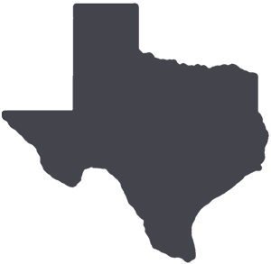  PATIENT CARE EDUCATION & RESEARCH INSTITUTIONAL SUPPORT CMC
AROUND UTMB (Use the legend above to quickly find items of interest to your team)
Oct. 9 deadline set for UTMB’s Technology Commercialization Program: UTMB’s Technology Commercialization Program provides seed funds to support the commercialization of discoveries created at UTMB. The Fall 2020 application cycle is open, with pre-proposals accepted through Oct. 9. Employees, students, staff and trainees may apply for awards ranging from $10,000 to $50,000, with competitive renewal opportunities in the next funding cycle. More information on the application process and pre-application workshops is available at https://utmb.us/4cj.  COVID-19 testing and UTMB students: UTMB is instituting a random COVID-19 testing program of students beginning Sept. 14. The program’s goal is to reduce the risk of a COVID-19 outbreak on campus, as many universities have experienced. Each week, 100 randomly selected students will receive an email with instructions on how and when to be tested. The testing will be at no expense to the student, and the results of individual tests will be completely private in accordance with HIPAA. Students whose work is 100% online and who do not come to campus for classes will be excluded. As a reminder, UTMB has a testing program in place for faculty and staff. More information on that initiative is available at  http://intranet.utmb.edu/covid-19-internal/employee-covid-19-testing.  Expanded access to online consent forms: A new Health Information Management page available at https://www.utmb.edu/him/#fourth now has a complete list of the “6500 Series” Disclosure and Consent forms in both English and Spanish, making it easier and more convenient to access these items. The new page also contains a link to the complete E-Forms catalog (located in MyUTMB). Log in and select E-forms on the left-hand side of the MyUTMB menu. Please check the paper forms in your area on a regular basis to ensure that the most up-to-date versions are being used. Please discard any outdated forms.  Patient Centeredness Focus of the week: The patient centeredness focus for this week is empathy. One patient commented on how staff at Angleton Danbury Hospital took care of patients. He said he told many friends and family during his overnight stay about how wonderful UTMB has become. He was very impressed with the care provided and felt that all staff had paid lots of attention to detail and put a personal touch on his stay. By putting ourselves in the minds of our patients, we get a glimpse of their world and can begin to understand how they feel. Remember that it is not only what you do for our patients; it is also about how you make them feel!  Wel Clear Lake Campus visited by The Joint Commission: On Sept. 8, UTMB’s Clear Lake Campus was visited by The Joint Commission for a one-day extension survey of our new pediatric inpatient unit. The 15-bed unit, opened in Feb. 2020, is a collaboration between UTMB Health and Children’s Memorial Hermann Hospital. Overall, the results of the survey were positive. The surveyor was complimentary of the skill of our staff, the safety and cleanliness of the facility and the level of compassionate care and comfort of our patients. The surveyor did have two potential findings: one regarding crash cart checks and the other around guidelines for reassessment of patients with suicide risk. We will immediately begin to address these areas for improvement. Thank you to all who participated in the survey, and thank you all for everything you do for our patients.  Join us in celebrating World Patient Safety Day Sept. 17: Tune in for a free YouTube live event Sept. 17 to learn about how you can protect yourself as a patient and serve as an advocate for your loved ones who are receiving medical care. The Annual World Patient Safety Day will be celebrated globally to reiterate the importance of health care safety and raise awareness. Featured speakers include President Bill Clinton, founder and chairman of the board of the Clinton Foundation and 42nd President of the United States; Tedros Adhanom Ghebreyesus, PhD, MSc, director general, World Health Organization; Belinda Carlisle, Grammy-nominated musical artist; and Dariush Eghbali, Iranian artist and humanitarian and founder of Ayeneh Foundation. For more information, please visit https://utmb.us/4cn. |  |  | Weekly Wellness Recap: Shared by the UTMB RISE (Resilience in Stressful Events) Task Force, these tips are just one way we can all work to stay emotionally healthy during the COVID-19 pandemic.  This week’s tips focus on coping with continual change to help guide resilience:  - Overcome mental barriers: Focus on the future and not the past when confronting changes and related anxiety. Ask yourself, “In 10 years, how will I want to remember dealing with this?”  - You can adapt: When something changes, our mind goes into battle arguing against that change because we’re wired to crave comfort and certainty. We can override that impulse by trusting in our innate capacity to handle change and adapt to new situations.  - Take action, no matter how small: Small acts may not solve your problem entirely, but they will start the psychological snowball rolling in your mind, steadily restoring your sense of agency, and rekindling that belief that what you do matters.  - Reframe a situation: Try “transformational coping,” to perceive stressful life events less as threats and more as opportunities for personal development. Focus on lessons learned—we all have some.  - Choose courage over powerlessness: This helps us cope and foster empathy and meaning for ourselves and others.  - Practice self-care: Make time for this and stick to it. Everything matters and small steps count—you don’t have to be perfect. Walk 10 minutes. Stretch once a day. Eat one balanced meal. Add one positive sleep habit to your routine.  - Focus on improvement: Change happens, but you can improve how you perceive it and how you deal with it through work on self-awareness. Be open to learning about yourself—strengths as well as areas to improve. We all have both.  - Ask for help when needed: Many people think asking for help suggests they are weak. Research actually shows that asking for help is perceived by others as a strength—not a weakness. We can all use support now and then.  Clear Lake Campus visited by American College of Surgeons for Level III Trauma Center Certification: On Aug. 30-31, UTMB’s Clear Lake Campus was surveyed for certification as a Level III Trauma Center. No deficiencies were reported by the surveyors during the exit report. Thank you to all who participated in the survey for your dedication to providing the highest quality of care.
DID YOU KNOW?
During UTMB’s nearly 130-year history, more than 900 endowments with a market value of $567 million have been established to attract and retain the best and brightest faculty and students. During that same time, more than 45,000 degrees from all four schools have been conferred, as UTMB continues to educate the next generation of health sciences professionals.

