Ben
Weekly Relays User Guide
TOPICS LEGEND
 |  | WEEKLY RELAYS |  | September 23, 2021
  YOUR DEPARTMENT NEWS |  |  |   UTMB NEWS
National Center for Faculty  Development and Diversity  The Office of the Executive Vice President & Provost is in the process of rolling out this program across the Academic Enterprise.  ALL UTMB faculty, graduate students, postdocs, residents, fellows and staff members can sign-up to access this resource  (it’s FREE – all you need is a UTMB email)!  FY22 will be used as a pilot year for this membership - - once you sign-up, you will have access to online virtual workshops, professional development training and mentorship programs (and more).  https://www.utmb.edu/provost/resources/national-center-for-faculty-development-and-diversity  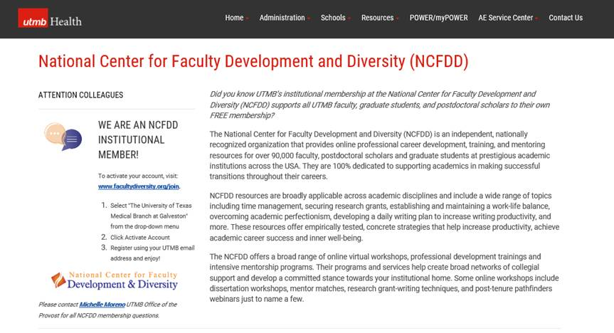  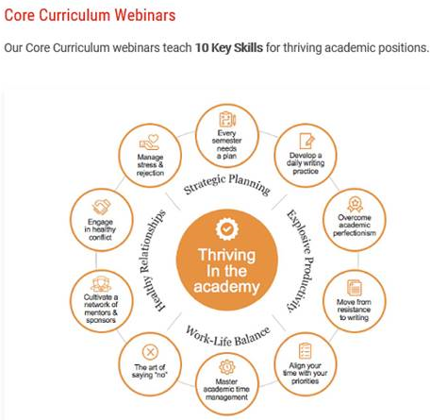  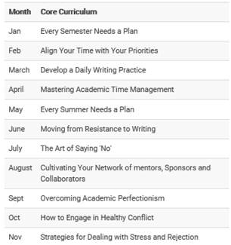 |  |  | COVID-19 UPDATES  Due to the COVID-19 Delta variant, all faculty, staff and students throughout the state must continue to remain vigilant and practice safety protocols to protect self and others. As of Sept. 21, Incident Command will be meeting every two weeks, so the next update will be on Oct. 5. In the meantime, read the latest Incident Command Update at https://utmb.us/61d.  Quick Links and Reminders:  - UTMB Experts in the age of COVID-19: Facing the Delta Variant Video clips featuring Dr. Raimer and UTMB experts Dr. Gulshan Sharma, Dr. Philip Keiser, Dr. Scott Weaver, Dr. Pei-Yong Shi and Dr. Alan Barrett.)  - Travel requirements and guidelines  - View previous Q&A sessions featuring Dr. Gulshan Sharma and other UTMB experts (UTMB login required)  - Safety Requirements, including masking, social distancing/meeting room capacity, travel, visitation  - Requirements if you are Sick or Exposed  - Emergency Leave summary and FAQs  - Schedule a vaccine online or get the vaccine through Employee Health clinics in Galveston and League City [remove underlining  - Information on authorized booster shots  - Information on monoclonal antibody treatment  Monthly Financial Update – Results as of Aug. 31, 2021: For the month of August, UTMB’s adjusted loss was $11.8 million, which was $14.0 million unfavorable to planned results. For FY21 year-end, UTMB’s adjusted margin was $37.8 million, which was $51.3 million favorable to planned results. This performance represents tremendous work on the part of faculty and staff to manage expenses and improve the efficiency of our work to ensure the long-term success of UTMB’s mission. It also will allow us to reinvest in our mission. Thank you. *The fiscal year-end results are considered preliminary, unaudited pending final annual financial audit.  Dr. Shi named director of UTMB’s new Institute for Drug Discovery: Pei-Yong Shi, PhD, has been appointed director of the UTMB Institute for Drug Discovery (IDD), vice president for Research Innovation and associate chief research officer. Dr. Shi joined UTMB in 2015 and serves as professor in the Department of Biochemistry and Molecular Biology; he also holds the John Sealy Distinguished Chair in Innovations in Molecular Biology. He is internationally recognized for his research accomplishments in virology, drug discovery, vaccine development, pathogen diagnosis and cancer therapy, and he has made critical contributions to COVID-19 vaccine research. With the establishment of the IDD, Dr. Shi will lead the way for even more groundbreaking discoveries to help improve human health.
OPICS  LEGEND |         PATIENT CARE EDUCATION & RESEARCH INSTITUTIONAL SUPPORT CMC
AROUND UTMB (Use the legend above to quickly find items of interest to your team)
UT System 2021 Fall Wellness Challenge: Getting active has never been easier with the UT System 2021 Fall Wellness Challenge. The 28-day Walktober challenge will help boost your energy and mood while taking you on a virtual color tour of the world’s most vibrant autumn landscapes and festivals. The challenge begins Oct. 4, and the goal is to earn at least 20 leaves by logging your steps or minutes of physical activity through the Living Well online platform or mobile app. All UT SELECT medical plan members and dependents age 18 and above are encouraged to participate and help UTMB compete for the UT System traveling trophy. Sign up today at www.utlivingwell.com or see iUTMB for more details. Registration for the challenge ends Oct. 8.  Texas Governor Greg Abbott names UTMB’s Dr. William Pate chair of Texas Radiation Advisory Board: Radiation Safety Officer and program director for Radiation & Occupational Safety within UTMB’s Environmental Health and Safety Department, Dr. William Pate was recently named chair of the Texas Radiation Advisory Board. The board advises the state on radiation issues and reviews the rules, policies and programs of state agencies that regulate radiation. For more information, visit https://utmb.us/61i.  Veterans and Veteran Allies – UTMB Veterans Resource Group looking for volunteers: The Veterans Resource Group is seeking three new co-chairs who can play an active role in planning events for the group. Ideally, volunteers would commit for at least one year and be available for meetings, events and managing membership and other administrative duties. If interested, please email Juan Guerrero at juguerre@utmb.edu. For more information about the UTMB Veterans Resource Group, visit https://www.utmb.edu/hr/diversity/veterans-resource-group.  UTMB experts discuss adolescent gynecology during recent Houston Moms Blog interview: Assistant professor in UTMB’s Department of Obstetrics & Gynecology, Dr. Parin Patel joined Dr. Joyce Muruthi, women’s health care provider at UTMB Health’s Women’s HealthCare clinic in Friendswood, for a recent interview with Meagan Clanahan, co-owner of the Houston Moms Blog. During the chat, the clinicians covered the ins and outs of adolescent gynecology, and how sometimes patients as young as 8 years old need their services. To watch the full discussion, visit https://utmb.us/61j. Part of the recurring monthly video series with the Houston Moms Blog, this interview and all previous videos can be found at https://utmb.us/61k.  Weekly Wellness Recap:  This month's theme is all about self-care.  - Take your time. Make space to just breathe and be still.  - Let go of other people’s expectations of you.  - Accept yourself and remember that you are worthy of love.  - Find a new way to use one of your strengths or talents.  - Avoid saying 'I should’ and make time to do nothing.  - Free up time by cancelling any unnecessary plans.  - Choose to see your mistakes as steps to help you learn.  Kudos to AE staff members ahead of National Research Administrator Day: UTMB’s robust Research Enterprise could not operate without the work of more than 240 staff members who perform research administration functions at the department and central levels. They support our research activities by performing administrative management, compliance, review and oversight, helping ensure the good stewardship of sponsored research dollars. In FY21, this included reviewing and submitting more than 650 proposals for future funding and managing more than $200 million that supported more than 550 sponsored activities for UTMB. In 2015, the National Council of University Research Administrators (NCURA) designated Sept. 25 as National Research Administrator Day to recognize the valuable work of these individuals. Please be sure to thank them for their role in supporting research that advances health care for people around the world. |  |  | SAVE THE DATE  Town Hall on Oct. 6: UTMB President ad interim Dr. Ben Raimer will host a virtual Town Hall at noon on October 6. An opportunity to provide mission area updates, the meeting will be recorded and available online at a later date. To submit questions and inquiries ahead of the meeting, visit https://www.utmb.edu/eac/contact-us.  GALVESTON CAMPUS  New retail dining option: The HEC Grill at the Health Education Center has reopened to students, employees, and the public. The restaurant currently serves sushi, salads, and rice bowls from 10:30 a.m. to 1:30 p.m., Monday – Friday. Traditional sandwich and burger options will be added to the menu later this fall.  REMINDERS  Annual benefits enrollment follow up: Employees are encouraged to review their benefits summary and their first earnings statement of the 2021–2022 benefits plan year through Employee Self Service to confirm their benefits deductions are correct. Benefits deductions first appeared in paychecks dated Sept. 10, 2021, for employees who are paid biweekly and will appear in paychecks dated Oct. 1, 2021, for employees who are paid monthly. If you have any concerns with your benefits deductions, please contact HR Benefits Services at benefits.services@utmb.edu or (409) 772-2630. Evidence of an administrative or a clerical error must be presented within 31 days of receipt of the first earnings statement of the new plan year.  Annual employee evaluations: The institutional deadline to complete employee evaluations for FY21 is Oct. 29, 2021. An annual evaluation is required by the University of Texas System for all full-time, part-time and casual employees hired on or before Feb. 28, 2021. To help ensure compliance with this system-wide directive, employees are advised to speak with their leadership regarding any entity or department specific requirements and deadlines. Employees may also visit https://hr.utmb.edu/relations/performance/ for more information about the annual evaluation process.
DID YOU KNOW?
UTMB will soon celebrate the 130th anniversary of its first class. On Oct. 5, 1891, the University of Texas Medical Department opened its doors in Galveston to 23 medical students and 13 faculty. Classes were held in the Ashbel Smith Building (Old Red), while clinical rotations were done in the original John Sealy Hospital. Since then, UTMB has grown to include four schools with 3,460 students; a world-renowned research enterprise; and a comprehensive Health System with four hospital campuses, three trauma centers (Levels 1, 3 and 4), and an extensive network of 90 clinics. Watch iUTMB and Relays for information on related celebrations of our history and our mission in October.

The Joint Commission Questions of the Week: Administering Medication & Reducing Medication Errors
What are the steps in the medication administration process?
- Verify medication selected matches the medication order
- Visually inspect medication for particulates, discoloration or other loss of integrity
- Verify medication has not expired
- Verify no contraindications exist
- Verify medication is being administered at the correct time, in the prescribed dose, and by the correct route
- Identify patient using two patient identifiers
- Infusion must start within one hour of spiking the IV bag
- Before administering a new medication, inform the patient/family about any potential clinically significant adverse drug reactions or other concerns
- See IHOP Policy: 07.10 Medication Administration for additional information
What has been done to reduce the risk of medication incidents in my area?
- Limiting the number of medication concentrations available on each unit (e.g., Heparin concentrations)
- Dual verification of High-Alert Medications (e.g., Hydromorphone)
- Double checking requirements for High-Alert Medications before administration (e.g., Chemotherapy)
- Dispensing medications with a special High-Alert sticker, seal or in a High-Alert bag (e.g., Paralytic seal for Succinylcholine)
- Identifying patients using two unique identifiers prior to medication administration
- Identifying and addressing use of “Do Not Use” abbreviation
- Processes for managing “Look-a-Like, Sound-a-Like” medications
- Verifying written orders that are unclear prior to entering them in the EMR
- Upgrades to the Pyxis automated dispensing system for medication management
- Bar-code scanning of medication before administration
- Using infusion pumps to administer IV medications
- Optimizing Pyxis to ensure that 90-95% of medications are available as floor stock in the Pyxis

