Ben
Weekly Relays User Guide
TOPICS LEGEND
 |  | WEEKLY RELAYS |  | February 3, 2022
YOUR DEPARTMENT NEWS |  |  | UTMB NEWS
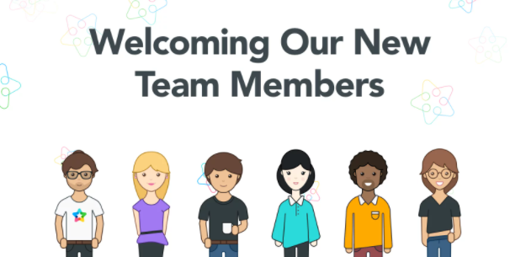  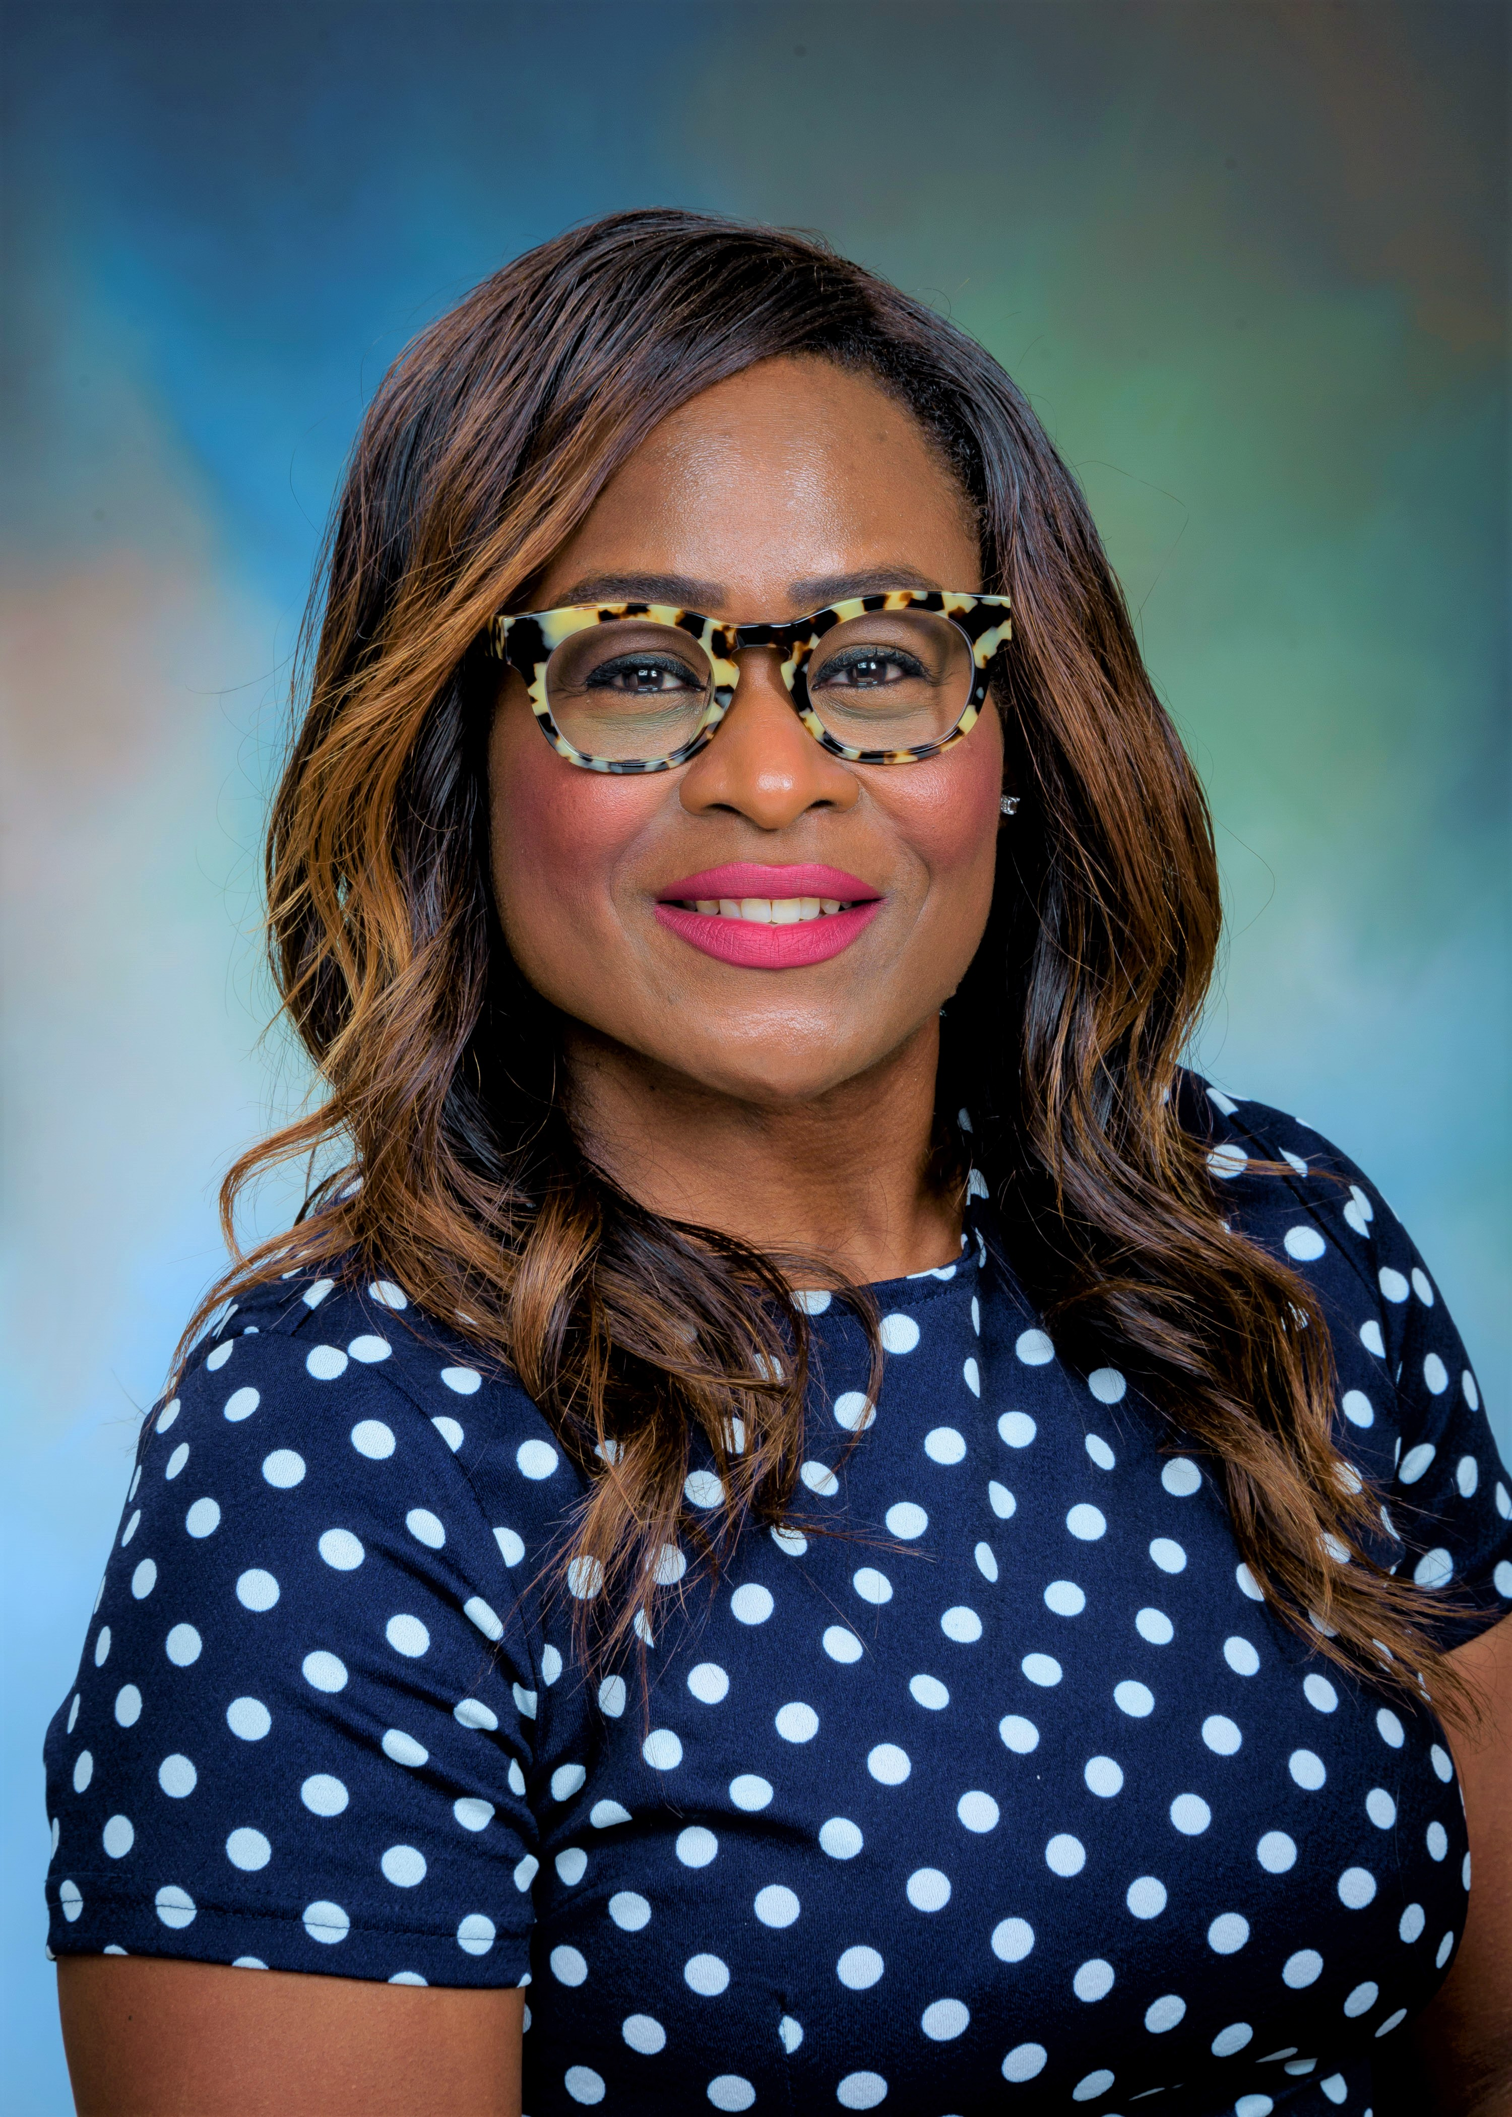  Najla Claar – Medical Education Specialist, Office of Educational Development  I am a native Houstonian, where I continue to reside with my awesome husband. I graduated from The University of Texas at Austin with a bachelor’s degree in government and from Mercy College with a graduate degree in literature. My background is in social work, law enforcement and education. When not working, I love attending Broadway shows and listening to spoken word poetry. I also enjoy finding new places to hike or kayak. I truly believe that every day is a gift from God and an opportunity to express love and kindness.  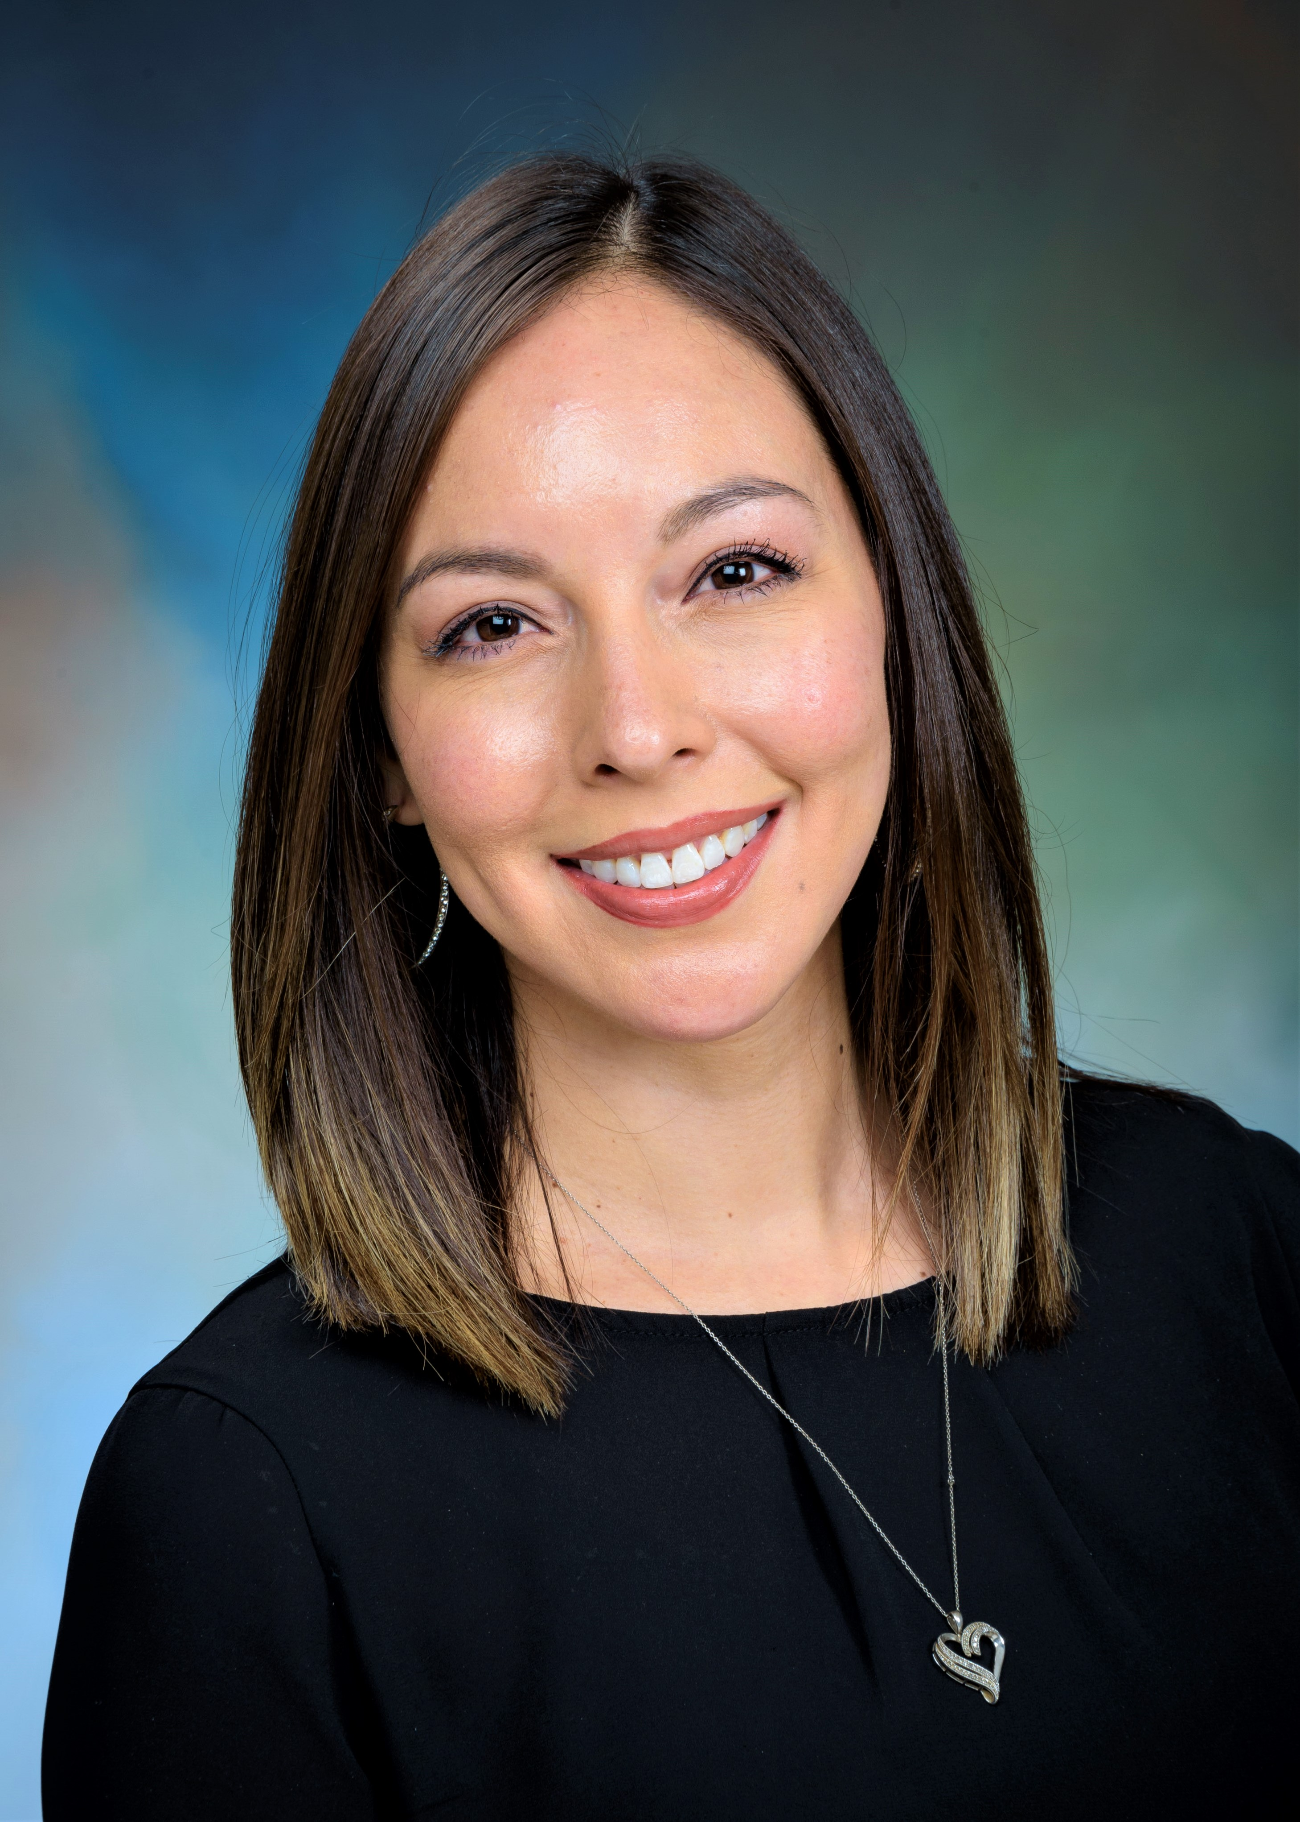  Lisa Pearce – Program Manager, Office of Admissions & Recruitment  Lisa has been with UTMB for 5+ years since receiving her bachelor’s degree from UTPB. She has worked with the Instruction Management Office, Enrollment Services, and Community Engagement prior to joining the Office of Admissions and Recruitment. She is currently pursuing a master’s degree in Higher Education from the University of Houston.  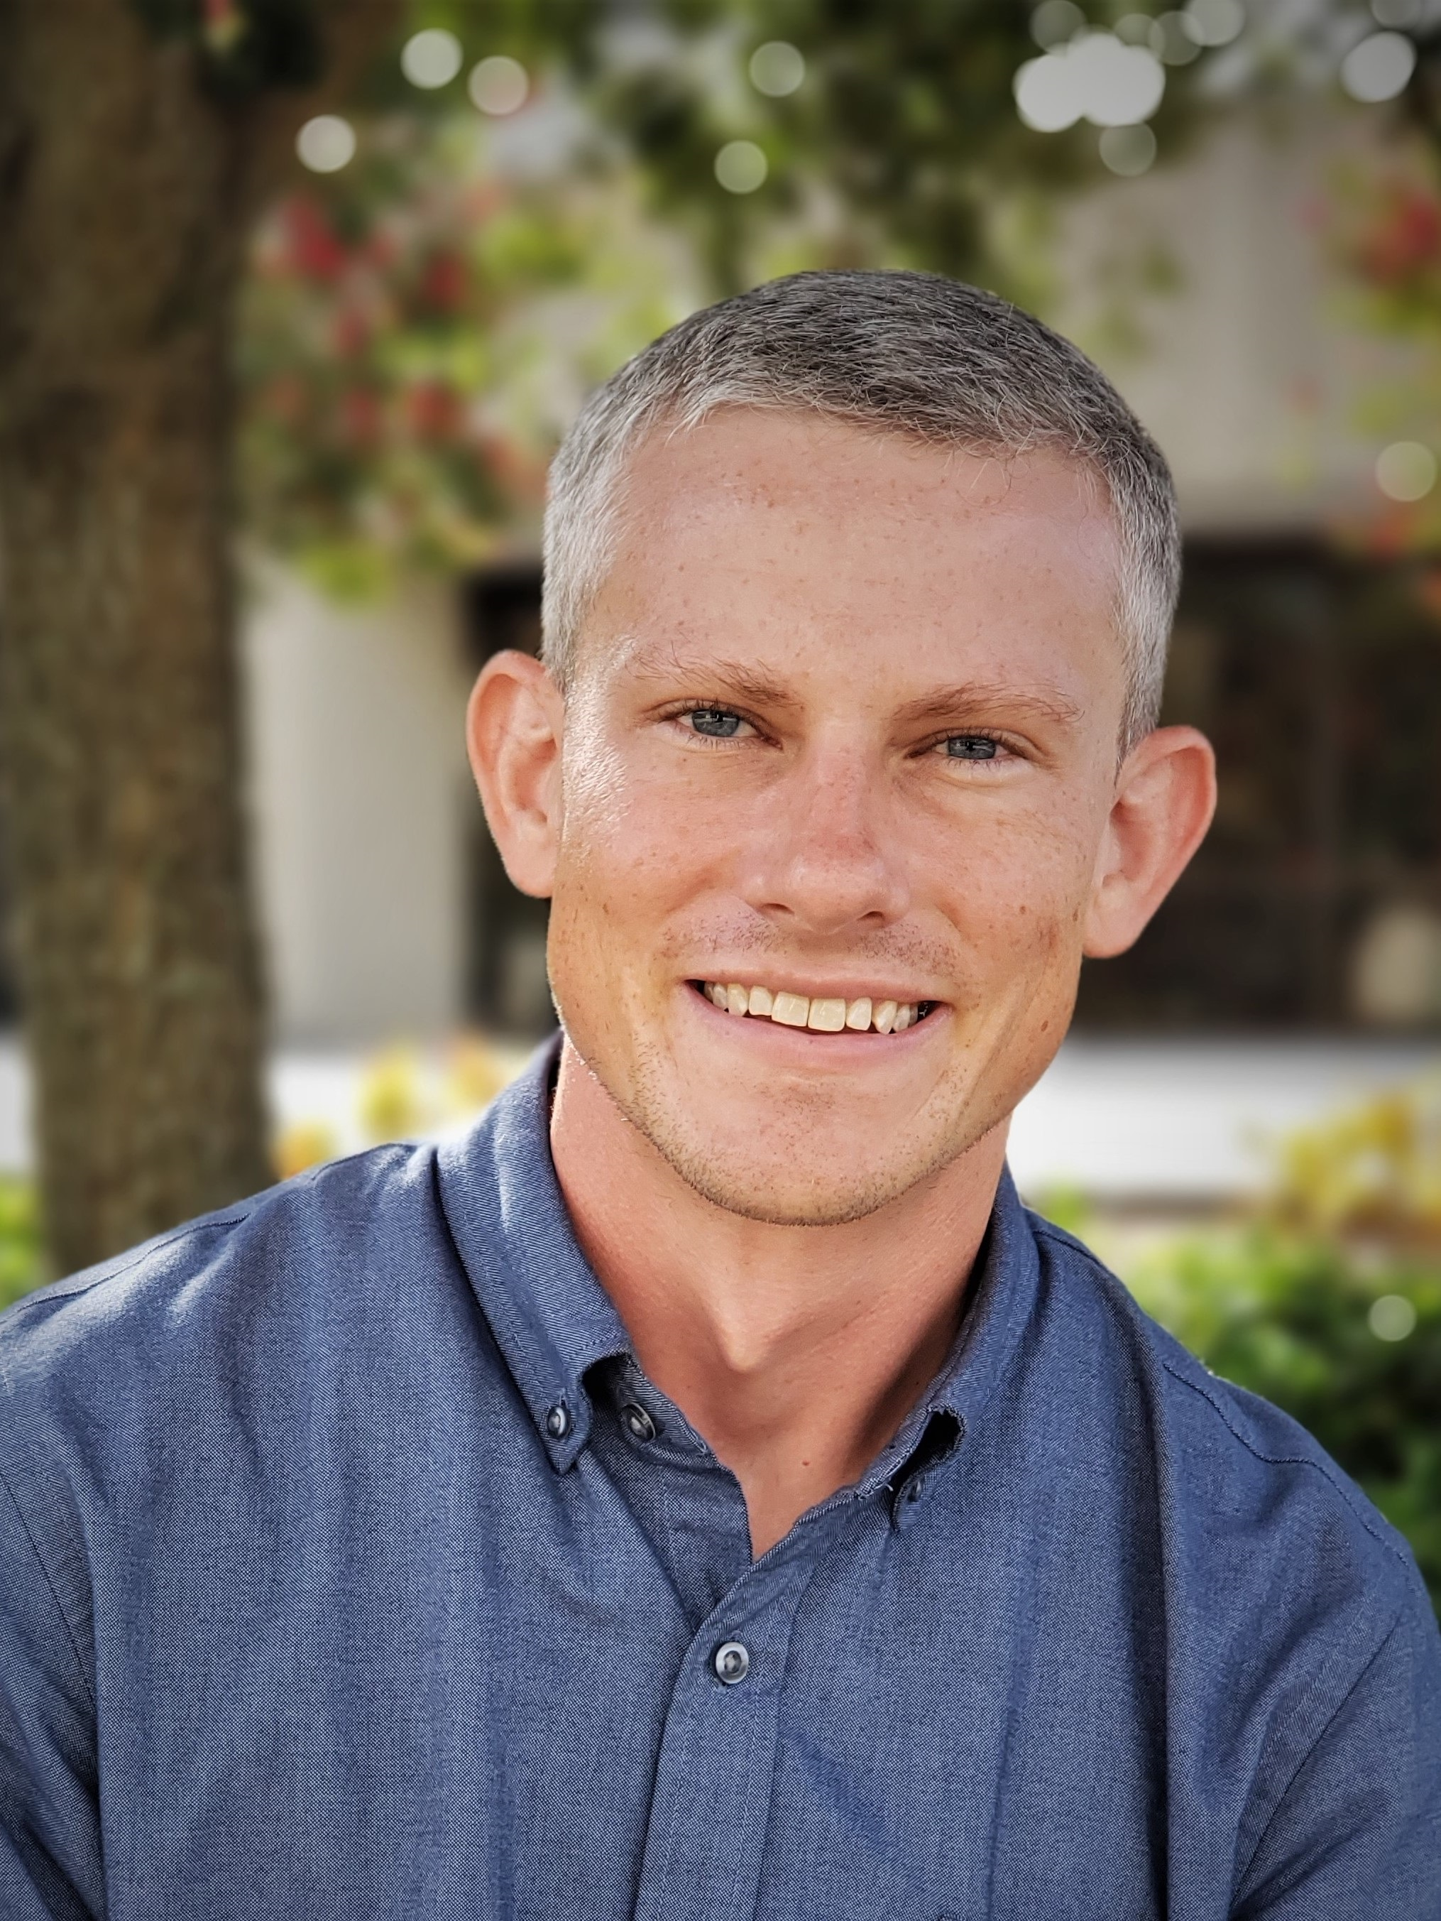  Greg Spillers, PhD – Sr. Learning Specialist, Academic Support & Career Counseling  Hi everyone! I am one of the new Learning Specialists in ASCC. Though new to UTMB, I have lived in Galveston for ~5-years while my wife completes her residency. Previously, I was at the University of Georgia (Go Dawgs!) and am originally from central North Carolina. Working with medical students has long been a professional goal of mine and so I am elated to finally join UTMB SOM. My free time is spent at the beach with my dog, Traveller, and attempting to recapture my salad days skateboarding at the Texas City skatepark.  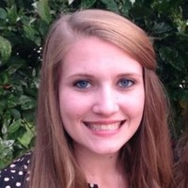  Dr. Shields welcomed twins in late summer. In January, she made the decision to leave her role as the Director for Academic Support and Career Counseling at UTMB to  spend more time with her boys for  now and has plans on private  therapy practice soon.  Drop a thank you, congrats or goodbye note for Dr. Shields here!  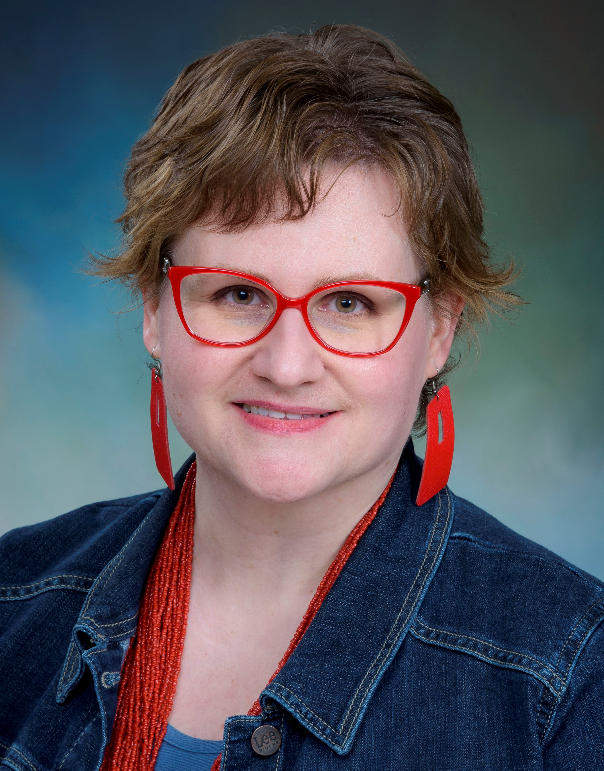  Congratulations to Dr. Güler  on her new role as  Director for Academic Support  & Career Counseling!  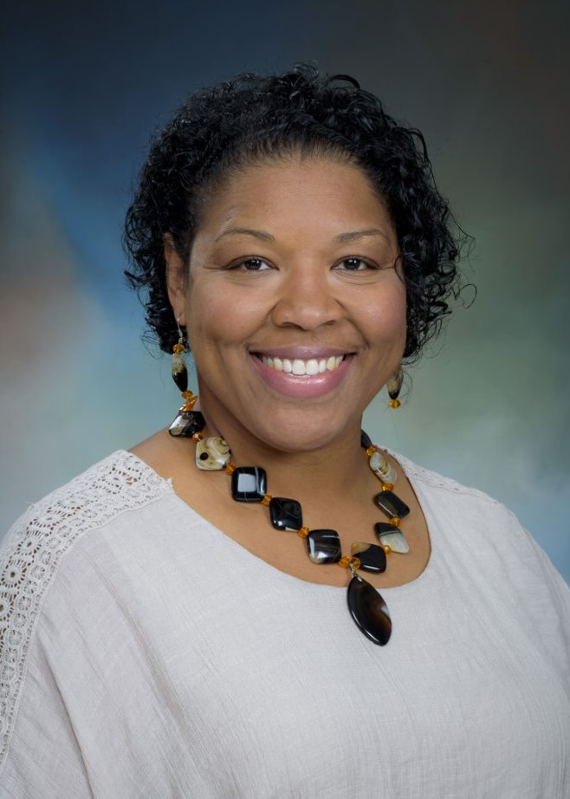  Congratulations to LeTanya Neely  on her new role as  Administrative Manager  for Outreach & Pipeline Programs!  Happy Birthday to all of our  Dr. Majka Woods 3rd  Blaine Ganter 3rd  Valerie Carmichael 10th  Dr. Norma Pérez Raifaisen 14th  Dr. Becca Güler 16th  LaDonna Haney 24th  Colin Lamb 26th  Shirley Pullen 28th |  |  | COVID-19 UPDATE  IMPORTANT REMINDERS  - Read the Jan. 26 institutional message regarding the Federal CMS Vaccine Mandate requirements.  - Due to the high transmissibility of the omicron variant, cloth masks are no longer appropriate for any UTMB facility (including non-clinical facilities). Appropriate-level medical masks are available at UTMB building entrances for non-clinical employees, students, patients and visitors. Health care providers should follow the guidance regarding use of KN95/N95 masks and other PPE. Read the Jan. 19 Clinical Task Force message regarding updated masking recommendations and requirements, based on the latest information from the CDC.  ACTION ITEM  Federal vaccination reporting requirements  - UTMB must comply with a requirement to report vaccination rates among employees. If you have had the COVID vaccine and have not taken the following steps yet, please do so as soon as possible:  - To help UTMB comply with the federal reporting requirement, send proof of vaccination to Employee Health at emphlthc@utmb.edu if you received your vaccine anywhere OTHER THAN Employee Health. (This includes UTMB provider offices, retail pharmacies, etc.)  - To ensure your medical record is current, check your MyChart account to make sure your information is up to date. If your COVID vaccination is not listed, you can request an update by sending your provider a message and a scan of your vaccine card or by bringing your vaccine card to your next provider visit.  Take 5 to find out how the myPTO program coordinates with Family and Medical Leave  Family and Medical Leave (FML) offers eligible employees up to 12 weeks of unpaid, job-protected leave in a rolling 12-month period for a personal health condition; the serious health condition of a spouse, child or parent; and/or the birth, adoption or foster care placement of a child. The myPTO program will coordinate with all FML provisions and will not affect the criteria for taking this type of leave. FML will continue to run concurrently with employees’ paid leave accruals, which means employees must use their PTO, EIB and other available accruals to cover some or all of the leave period. It is important to note that employees granted FML will be able to directly access their EIB without first using 16 hours (prorated for FTE status) of PTO, other available accruals or leave without pay. You are encouraged to apply for FML if you or your spouse, child or parent has a serious and/or chronic health condition resulting in intermittent absences from work. Please see utmb.us/5 to read more!
OPICS  LEGEND | 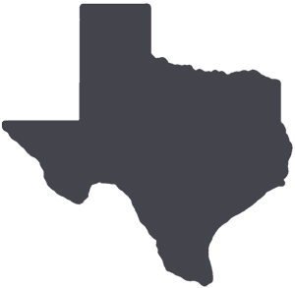  PATIENT CARE EDUCATION & RESEARCH INSTITUTIONAL SUPPORT CMC
AROUND UTMB (Use the legend above to quickly find items of interest to your team)
Volunteers sought for 2022 Health System & Nurses Week planning committee  Here’s your chance to help plan the 2022 Health System & Nurses Week festivities. Volunteers are invited to discuss ideas and planning in relation to the activities created to celebrate our staff from May 9-13. All UTMB employees are welcome to join the planning committee by completing the form at https://forms.office.com/r/bYUbNL1YuS.  Celebrating Black History Month, Feb. 1-28  Black History Month is held every February to celebrate the achievements of Black and African Americans throughout history. Each week this month, UTMB and the Black Alliance Employee Resource Group will recognize people of color who have made notable contributions to society and to our university. This week we would like to highlight Dr. Herman A. Barnett III, the first African American to be admitted into medical school in Texas when he enrolled in 1949. Dr. Barnett graduated cum laude from UTMB in 1953 and went on to practice at several hospitals in the Houston area. He was the first African American to be appointed to the Texas State Board of Medical Examiners and elected president of the Houston Independent School District Board of Education. Dr. Barnett was honored with the Ashbel Smith Distinguished Alumnus Award in 1978. To learn more about the Black Alliance Employee Resource Group and how you can get involved in upcoming Black History Month events, please visit https://www.utmb.edu/hr/diversity/black-alliance-resource-group.  Congratulations to seven UTMB physicians named United Heroes  The United Hero award, issued by United Healthcare, is presented to health care providers who achieve a patient experience survey score of at least 80 percent. Only about 3,000 health care providers nationally have met the qualifications for this achievement. Great work by our UTMB honorees!  - Dr. Peter Beshara – Pediatric and Adult Primary Care Clinic, Texas City  - Dr. Wondiful Colbert – Family Medicine Clinic, Angleton  - Dr. Karl Crudo – Adult Primary Care Clinic, League City  - Dr. Alberto Gutierrez – Department of Internal Medicine (General Medicine)  - Dr. Erin Hommel – Department of Internal Medicine (Geriatrics)  - Dr. Elizabeth Jaramillo – Adult and Geriatric Primary Care Clinic, Angleton  - Dr. Barbara Thompson – Department of Family Medicine  Jan. 27 Thought Leader Series showcased Galactic Herald: How NASA communicates space news  Presented by UTMB Health and introduced by Dr. Gary Kobinger, director of UTMB’s Galveston National Lab, the Jan. 27 Thought Leader Series explored how NASA communicates space news with the public with panelists NASA Goddard Space Flight Center producer Michael Starobin, NASA Johnson Space Center Public Affairs Officer Gary Jordan, NASA Jet Propulsion Lab Public Outreach Lead Kaitlyn Soares, and NASA Exoplanet Exploration Program Office Public Outreach Lead Thalia Khan. To view the full video, visit https://utmb.us/6fe.  REMINDERS  2021 Tax Forms  W-2 Tax Form: Employees who consented to receive an electronic copy of their W-2 tax form for 2021 may now view and print the form through Employee Self Service. The form is located under the Payroll and Compensation section, and you must be directly connected to a UTMB network to access the document. Any employee who did not sign up for digital delivery of the form were sent a paper copy through the U.S. mail by Jan. 31. For questions or more information about the W-2 tax form, email payroll.services@utmb.edu.  1095-C Tax Form: Employees’ 1095-C tax form for 2021 will not be available until further notice. This form contains information about your health care coverage for your tax records, and its unforeseen delay should not hinder you from filing your 2021 tax return. Employees who signed up to receive an electronic copy of the form will be notified when the form becomes available for downloading and printing at www.MyTaxForm.com. Any employee who did not consent to electronic delivery of the form will receive a paper copy through the U.S. mail once they’re available. For questions or more information, please email hrservic@utmb.edu. |  |  | Weekly Wellness Recap:  During February, focus on the importance of being friendly and fostering relationships and connections for resilience.  - Let someone know you’re thinking of them.  - Ask a colleague how they are doing.  - Do an act of kindness to make life easier for someone.  - Organize a virtual tea or coffee break with a colleague or friend.  - Make time to have a friendly chat with a colleague; even brief moments lead to connection.  - Get back in touch with someone you’ve not seen for a while.  - Show an active interest by asking questions when talking to others.  MONTHLY CYBERSECURITY UPDATE  How We’re Doing: During the month of January, 3.4% of recipients opened an attachment or revealed credentials in simulated phishing attacks that were initiated by the Office of Information Security. Our goal is less than 3%. A breakdown of department success/failure rate can be found at https://utmb.us/66g. Learn more about cybersecurity at https://www.utmb.edu/infosec. Report potential phishing to cirt@utmb.edu.  QR Codes are being used by Phishers: Did you know that attackers, including phishers, are taking advantage of the increased use of QR codes to steal sensitive information or conduct phishing campaigns? QR codes (an acronym for “Quick Response” code) are machine-readable labels that can be used to redirect to webpages, add contact information, load/open applications and even process payments. Although some scanning software will present URL information, QR codes are not easily human readable. Therefore, special attention needs to be paid when using them:  - Never log into an app using a QR code  - Carefully review any URL the QR code redirects to  - Ensure any payment processing is completed through a secure (https:\\) site  - Do not scan altered or pasted QR codes on printed materials (this is called QR spoofing)  IN CASE YOU MISSED IT  UTMB experts discuss the importance of selecting the right OBGYN care team during recent Houston Moms Blog interview  Taylor Thurstonson, a UTMB patient, joined Drs. Joyce Muruthi and Kimberlyn Robinson, OBGYN physicians with the UTMB Women's Healthcare Group, along with Meagan Clanahan, co-owner of the Houston Moms Blog, to share her story and recommendations for selecting an OBGYN care team for expectant mothers. To hear her story and the full conversation, visit https://utmb.us/6fd.  GALVESTON CAMPUS  John Sealy Hospital front entrance and circle drive to close Feb. 22  The front entrance and circle drive of John Sealy Hospital will close on Feb. 22 for approximately two years as part of the John Sealy Hospital Modernization project. The closure will allow for replacement of the porte cochère structure and the older brick façade on the hospital. The R. Waverley Smith Pavilion (WSP) entrance and patient drop-off will be used for John Sealy destinations. The WSP street-level entrance front desk will be staffed 24/7 (as the John Sealy entrance is now), and a limited number of 30-minute parking spots will be made available near the WSP for expectant mothers. The WSP entrance will also become the Safe Baby Site. A few other details of the closure:  - The John Sealy east entrance and the WSP first-floor tunnel entrance will remain badge-access only and exterior signage will be updated, directing vehicles for John Sealy to the WSP entrance.  - Starting Feb. 21, the Connect Transit Park and Ride bus stop currently at the WSP will move near the crosswalk between the parking garage and the Administration building (along Darrell Royal Avenue).  For more information, visit https://www.utmb.edu/construction.
 |  |  | DID YOU KNOW? February is American Heart Month, and UTMB Health is kicking off its commemoration by turning our campuses and clinics red! Friday, Feb. 4 is National Wear Red Day, the iconic day when the nation joins together in wearing red to raise awareness of the No. 1 killer of women—cardiovascular disease (CVD). UTMB Health employees, students and staff are encouraged to wear red, snap a photo, and email it to social@utmb.edu to promote UTMB's support of heart health and the elimination of CVD.

