Ben
Weekly Relays User Guide
TOPICS LEGEND
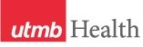 |  | WEEKLY RELAYS |  | February 24, 2022
YOUR DEPARTMENT NEWS |  |  | UTMB NEWS
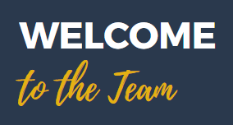  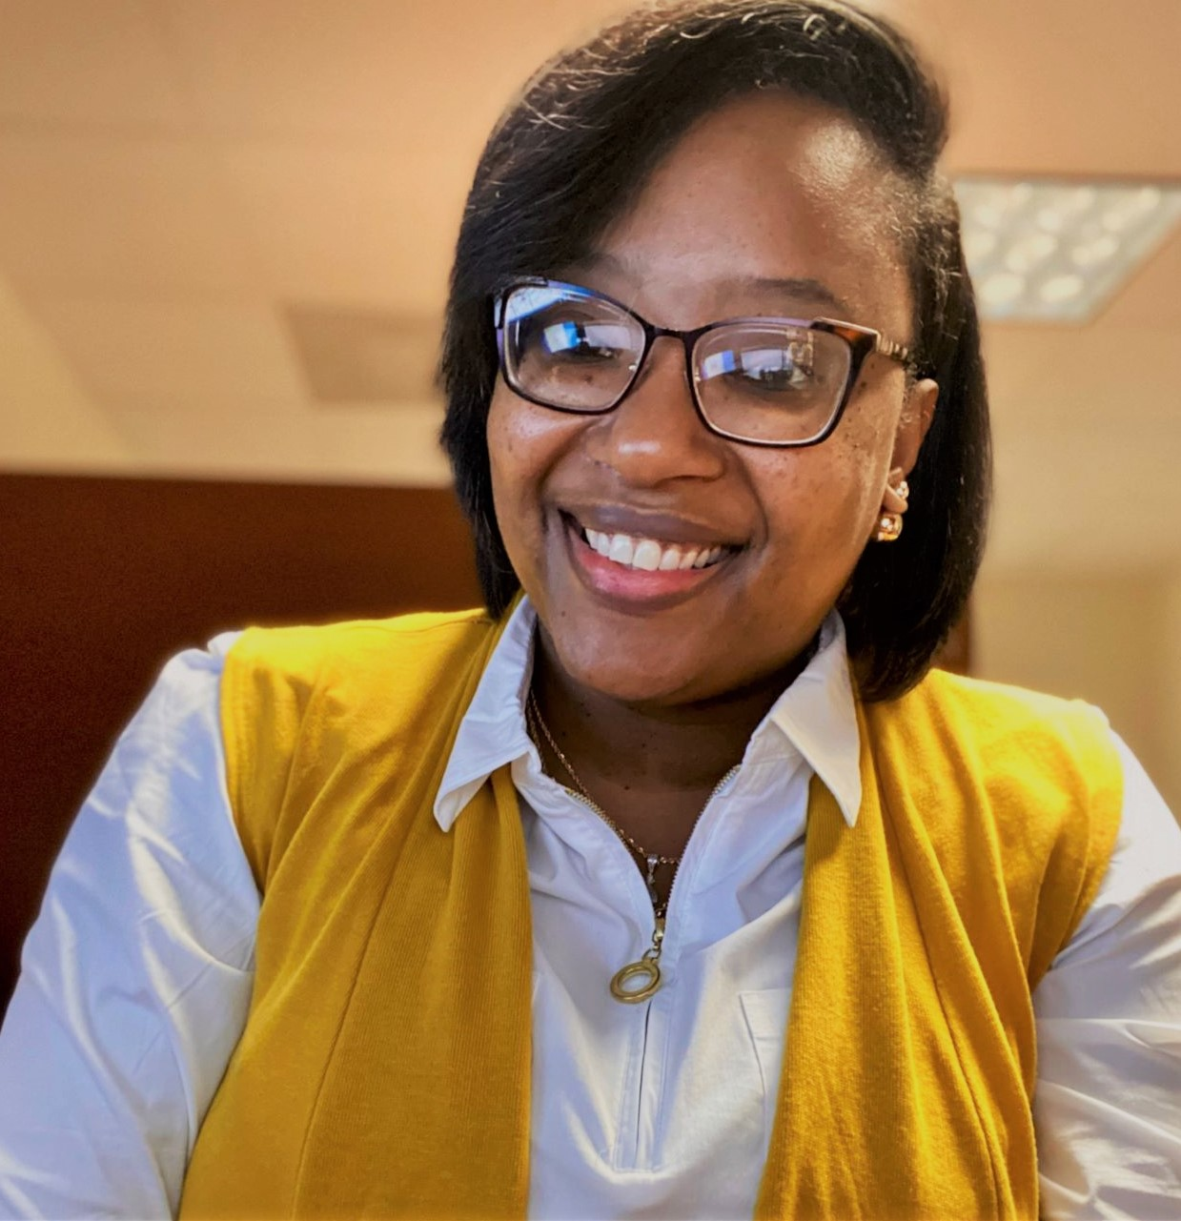  Join us in welcoming KiKi Baldwin who joined IMO on Monday, February 21, 2022, as a Coordinator II. KiKi comes to us from her most recent role as a Patient Service Specialist with TDCJ and has been working at a UTMB for 9.5 years. We are very excited to have her as part of our team!  Galveston Healing Arts Orchestra  The Galveston Healing Arts Orchestra is a new collaboration between UTMB and the Galveston Symphony Orchestra that aims to provide a home for classical music on campus. The organization consists of students, faculty, and staff members all united by a passion for making music.  With Maestro Trond Saeverud, conductor of the Galveston Symphony, at the helm, the ensemble will play famous classical works featuring musicians from across UTMB and its affiliated hospitals, programs, and departments. For more information about the organization as well as information about upcoming concerts and rehearsals, please join our email list at this link: bit.ly/utmborch  Please use this link to fill out the interest form!  GHAO Interest Form  ~ ~ ~ ~ ~ ~ ~ ~ ~ ~ ~ ~ ~ ~ ~ ~ ~ ~  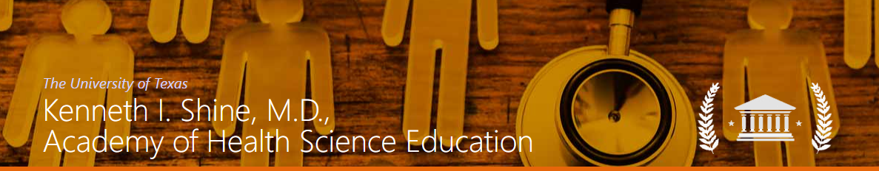Multiple Presentations at the  Kenneth I. Shine, MD,  Academy of Health Science Educators:  Innovations in Health  Sciences Education meeting  Friday Feb 25 and Saturday Feb 26  Small-group Discussion:  Short but Sweet: How Micro-Lectures Can Break Us from the Traditional Lecture Habit  Holly West, Kathleen Everling  Workshops:  It’s Never Too Early to Plan: A toolkit for Educators Late Career Transitions  Virginia Niebuhr, Pam Wood, Janet Williams, Karen Szauter, Judith Livingston.  When the Learner is the Target of Bias or Discrimination by a Patient  Karen Szauter, Alejandro Moreno, Alberto Maldonado (MS3), Joo Lee  Posters:  Adaptable, low-cost model for Virtual Patient simulation targeting pre-clerkship medical students  Ashley Adams  Assessing Change in Knowledge and Attitudes Among 4th Year Medical Students After Exposure to Anti-Racism and Health Equity Medical Literature  Farah Kudrath, MD, MPH1; Khushali Roy, BS2; Sarah Siddiqui, MD, MPH2,3  Camp PossAbilties – A Community-Academic Partnership to Address Health Disparities for People with Disability  Norman Farr, MD, MPH; J Sullivan; C Sullivan; G Segal; C McCrossan; C Koch; M Mele; J Nelson; M Gonzalez; J Walrath; A Cowan; and L Pryor; L Farroni  Common pitfalls in case-based reasoning exercise and approach to their corrections  Elena Shanina, MD; and Laura Wu, MD, PhD  Correlation of Student Participation in a Question-Writing Activity to Exam Performance in a Graduate Physician Assistant Pharmacology Course  Ashley N. Guillory, PhD; and Carla Hirsch, MMS, MPH, PA-C  Developing a Novel Telehealth Program in an Undergraduate Nursing Curriculum  Jacquelyn Svoboda, DNP, RN, WHNP-C; Morgan Cangelosi, MSN, FNP-C CCRN-K; and Kristen Starnes-OTT, PhD, CRNA, FANP  Development of an Interprofessionally-Trained Student-Led Model to Enhance Access of the Uninsured and Underserved to Lifestyle Change Programs  Hanna Sallam, Monique Ferguson, Wei-Chen Lee, Kevin McKinney. Hani Serag, MD  Disabilities and Healthcare: Awareness to Action in Health Education  Laurie Farroni, MD; and Chao T; Smith S.  Expanding the Volunteer Workforce: Training Students to Administer Vaccines  Karen Szauter, MD, FACP; Dawnelle Schatte, MD; and Julie McKee, MD  How are the Medical/Health Humanities and Bioethics Taught in American Physician Assistant Curricula?: A Narrative Review  Julie E. Kutac, MA, PhD  Integration of Narrative Literature in the Virtual Space  Brandy Wright, MD; Premal Patel, MD  Leveraging Health Processions Students in Value-Added Educational Experiences  Jacob Moran, Abhijt Rao. Julian Quiceno, Martha Diaz, John Davis, Miles Farr  Literature Review of the Internal Medicine Acting Internship Curriculum Interventions to better achieve the Core Entrustable Professional Activities (EPAs)  Ajit Koduri. Karen Szauter  Occupational Therapy's Role on the Interprofessional Primary Care Team: An Educational Model for Practice  Loree Pryor, OTD, OTR; Karen Ratcliff, PhD, OTR; Claire Leighton, OTS; Isabella Foussell, OTS; Weston Decker, OTS; Karthik Mani, OTD, OTR  Pediatric Health & Development Curriculum Evaluation  Maria J. San Andrés, MD; Hannah O’Donohoe, MD; Patricia Beach, MD; and Virginia Niebuhr, PhD  Problem Based Learning and Team Based Learning in Medical Schools During the COVID-19 Pandemic: A systematic review  William Mahony, BBA; Karen Szauter, MD  Recipes for Residency: A Podcast on Medical Student Mentorship  Austin Mefford, BS  Recognizing Patient Care Challenges through Reflection  Karen Szauter, MD; Elizabeth Freeman, MA; Maria Belalcazar, MD; and Bernard Karnath, MD  Transitions of care during hospital discharge: Incorporating analysis and reflection to the student clinical experience  L. Maria Belalcazar, MD  Undergraduate Nursing Students Engaged in Health Policy: An Innovative Education Initiative for Pre-licensure BSN Students  Meredith Ford |  |  | COVID-19 UPDATE  IMPORTANT REMINDER  - Risk reduction plan implemented: On Feb. 21, UTMB implemented a risk reduction plan for employees who are not fully vaccinated or who have approved exemptions from the federal CMS COVID vaccine mandate that applies to employees, contractors, volunteers and students. Read the COVID-19 Clinical Task Force message about the risk reduction plan.  - New Vaccine Guidance: On Feb. 11, the Centers for Disease Control and Prevention (CDC) updated their COVID-19 vaccination guidance for moderately or severely immunocompromised individuals, as well as their recommendations on COVID-19 vaccination after receiving COVID-19 monoclonal antibodies. Read UTMB’s Feb. 16 Vaccination Task Force message for more details.  - Updates to Visitation, Social Distancing, Masking and Travel Requirements: Due to declining rates of COVID-19 infections in our community, modifications have been made to the UTMB visitation policy, social distancing and masking requirements, and travel restrictions, effective Feb. 14. Read the Feb. 14 Clinical Task Force message.  myPTO Program: Take five minutes today to register for Kronos system training  All employees are encouraged to take five minutes today to register for Kronos system training on recording and managing time under the myPTO program. The training will be available March 7–31, and those who attend will learn more about:  - Viewing available accrual balances  - Submitting time-off requests  - Directly accessing EIB accruals  - Requesting holiday compensatory time instead of holiday pay  - Best practices when using the Kronos system  See utmb.us/5 for registration instructions.  Celebrating Black History Month  This week, we would like to highlight UTMB in Galveston, which opened the first state-subsidized hospital for Black patients in Texas in 1902. Prior to the opening, Black patients were treated in a segregated department at Galveston’s old City Hospital Building. Many Black citizens and Black organizations helped furnish the new hospital raising $574.85 in donations. Some of the Black organizations included St. Monica Society of Holy Rosary Church, Calton Screwmen Longshoremen Association No. 2 and ACME Lodge No. 64. Due to the denial of service in Houston to Black patients prior to 1919, this hospital served as a refuge for many Black Houstonians. While other hospitals denied people of color, UTMB served as a place for Black people to acquire the health services they needed. Later, UTMB became a leader in desegregation within its medical school. To learn more about the Black Alliance Employee Resource Group and how you can get involved in Black History Month events, please see https://www.utmb.edu/hr/diversity/black-alliance-resource-group.
OPICS  LEGEND | 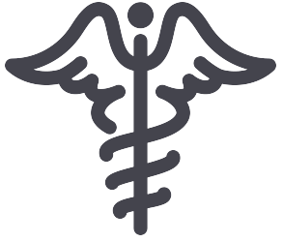  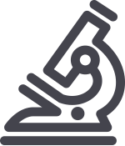  PATIENT CARE EDUCATION & RESEARCH INSTITUTIONAL SUPPORT CMC
AROUND UTMB (Use the legend above to quickly find items of interest to your team)
Weekly Wellness Tips:  Throughout the month of February, focus on the importance of being friendly and fostering relationships and connections for resilience.  - Give sincere compliments to people you talk to today.  - Be gentle with someone you are inclined to criticize.  - Tell someone about the strengths you see in them.  - Thank three people you feel grateful to, and tell them why.  - Make uninterrupted time for someone today.  - Call a friend to catch up and really listen to them.  - Give positive comments to as many people as possible today.  IN CASE YOU MISSED IT  UTMB Health's Dr. Thao Vu sat down with Meagan Clanahan, co-owner of the Houston Moms Blog, to discuss high-risk pregnancies.  This month’s video covers:  - What is considered a high-risk pregnancy?  - Are certain women more likely to have a high-risk pregnancy?  - How is a high-risk pregnancy determined or diagnosed?  - Once a high-risk pregnancy is diagnosed, how do appointments differ?  - Can all OBGYNs care for high-risk pregnancies?  - What should you consider BEFORE getting pregnant to achieve the best possible outcome for mom and baby?  Dr. Vu is a board-certified OBGYN at UTMB Health Clear Lake Hospital Campus. To hear the full conversation, visit https://utmb.us/6hg.  REMINDERS  UTMB Health Earth Day Celebration  Calling all creative faculty, staff, students and volunteers. Join us Friday, April 15, for the Recycle in Style Fashion Show during UTMB's Earth Day event. Start stockpiling recycled supplies today to create your very own red carpet ensemble. Design one or more outfits made from materials that would otherwise be thrown away (examples include packing materials or food packaging) or model a recycled outfit at the Earth Day Celebration at the Moody Medical Library Plaza, Galveston Campus. If designers do not have a model, one can be provided. This year’s theme is “Be a Force of Nature.” For additional information, contact Tilly Clark at taclark@utmb.edu.  EDUCATION & RESEARCH  Carlos Clark, DO, has been appointed Associate Chief Physician Executive for the Faculty Group Practice. Dr. Clark has been a faculty member in the Department of Internal Medicine, Division of General Medicine, since 2008. In 2012, Dr. Clark was appointed Chief Medical Information Officer for Hospital Administration, a role he will maintain as he accepts his new responsibilities. As Associate Chief Physician Executive, Dr. Clark will focus on clinical informatics, patient safety and quality of care, COVID care, Value Based Care Programs, and Revenue Cycle Operations and Compliance.  The Department of Internal Medicine has recently announced two division chief appointments.  - Hani Jneid, MD, FACC, FAHA, FSCAI, will join UTMB this spring as Division Chief of Cardiology. Dr. Jneid was most recently director of the Interventional Cardiology Fellowship Program and director of Interventional Cardiology Research at Baylor College of Medicine. He was also director of Interventional Cardiology at DeBakey Veterans Affairs Medical Center, and the Structural Heart Disease Program at Ben Taub Hospital, both affiliates of Baylor College of Medicine.  - Kevin McKinney, MD, FACE, has accepted the role of Division Chief of Endocrinology. Prior to this appointment, Dr. McKinney provided leadership as interim Division Chief. He is a UTMB alumnus, having completed medical school, his Internal Medicine residency, and his Endocrinology fellowship at UTMB. He has been a faculty member in the Division of Endocrinology since 1997. |  |  | UTMB web access to be interrupted Feb. 27  At approximately 10 p.m. on Feb. 27, UTMB will be updating its web content management system, Sitefinity. During the update, UTMB’s public and intranet web traffic will be routed to a backup/recovery webpage until the work is complete; the interruption in service will affect many UTMB websites and is expected to last approximately one hour. The software upgrade will enhance system stability and security. We ask that UTMB webpage developers not work on their sites during the update (to avoid losing work), and we apologize to our webpage visitors for this necessary disruption. For questions, please email sitefinity@utmb.edu. If you experience any issues with the website after the update, contact ishelp@utmb.edu.  PATIENT CARE  Spotlight on Joint Commission: Question of the Week  Speaking with Surveyors Part 2  - What is the best way to respond to a surveyor’s questions? If caring for a patient, politely indicate you will be right with the surveyor and arrange for someone to cover your patients. Keep your answers focused, specific to the question and don’t elaborate or give opinions (KISS = Keep It Short and Simple). There is a tendency to “over-answer” a question when you are nervous, which can have a domino effect, leading the surveyor down a path he or she didn’t intend to go.  - My co-worker clams up when they’re nervous. Can I help? Definitely. If you are present when someone else is being interviewed by a surveyor, gather around the surveyor, support each other and feel free to add relevant information without being intrusive. Respond to questions with confidence—you know the answers better than anyone.  - What are other tips to help with the interaction with the surveyor?  - Know your patients even if you have been off for a few days.  - Avoid words such as “usually” and “sometimes.” Be confident that the system works consistently.  - Be careful not to say, “This is the way I do it” when asked about a hospital or department policy/process. The correct answer is, “This is the process/policy.”  - One of the surveyor’s goals is to educate us about other or better ways to do things. Take advantage of suggestions or information that they are willing to provide.  - It is important to be prepared, be professional and use good manners during a hospital survey and in your daily interactions.
DID YOU KNOW?
Becker’s Hospital Review recognized Dr. Ben G. Raimer, UTMB President, in a recent Leadership & Management article commending his exemplary servant leadership before and throughout the COVID-19 pandemic. The article highlights effective leaders who constantly stay connected with their people and the work they are doing. To read the article, visit https://utmb.us/6ht.

