Ben
Weekly Relays User Guide
TOPICS LEGEND
 |  | WEEKLY RELAYS |  | July 14, 2022
  YOUR DEPARTMENT NEWS |  |  |   UTMB NEWS
Cookies for MS2’s!  Last week some of our JSSOM leadership passed out cookies to our MS2’s in the HEC building before their SIM Lab sessions. The cookies were a HUGE hit and the students were very appreciative! It was so nice to see of their smiling faces. We are looking for a convenient time to do the same for the MS1’s.  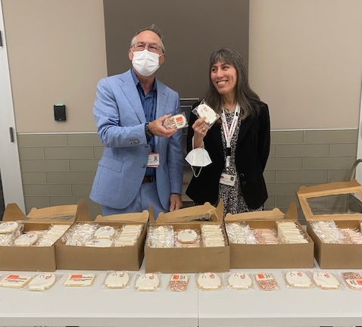  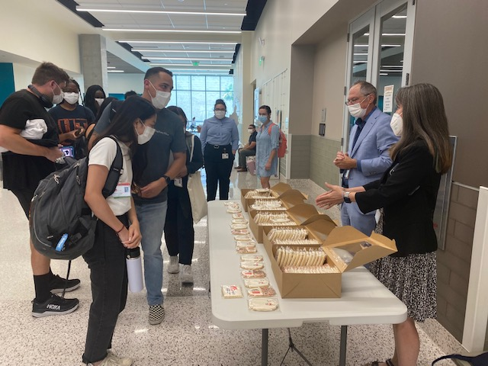  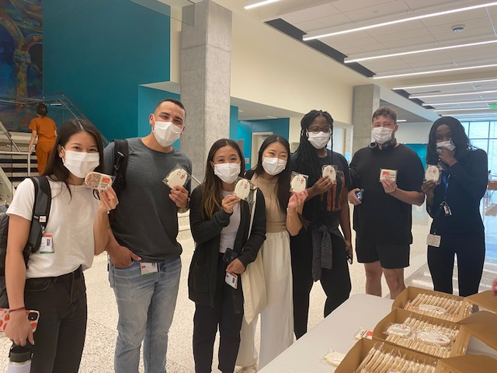  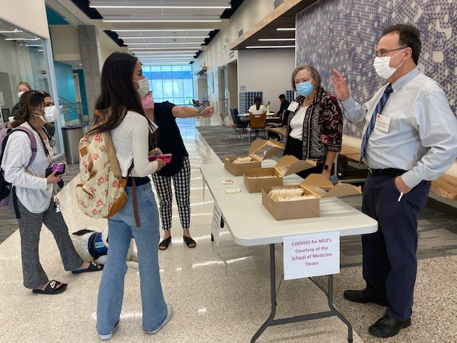  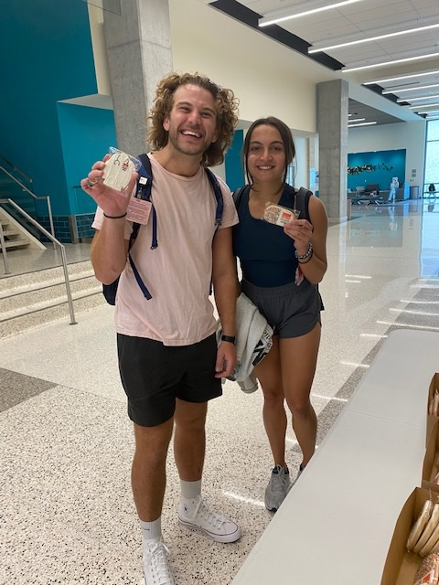  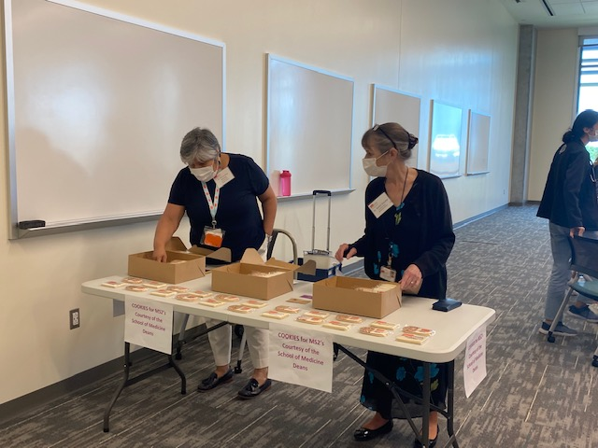  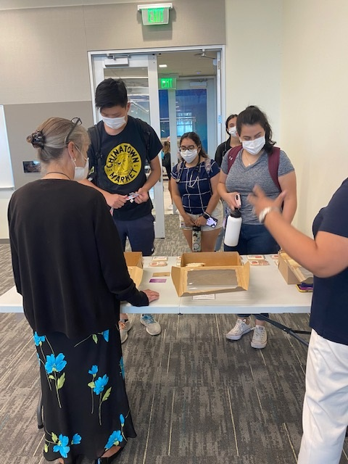  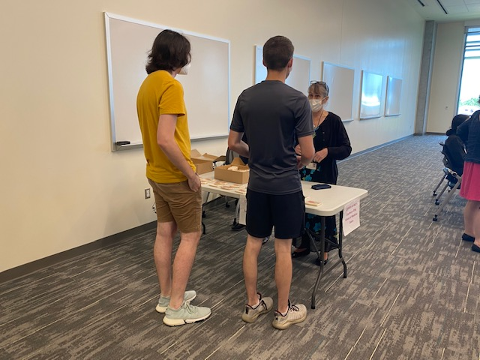  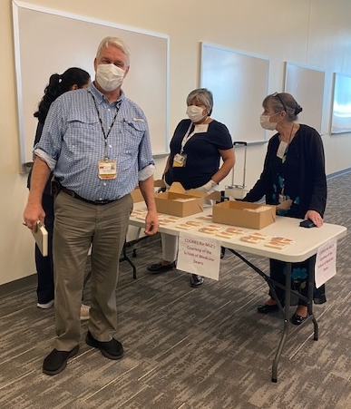  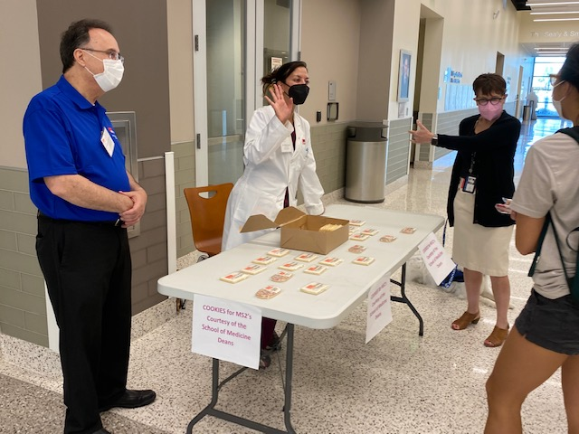  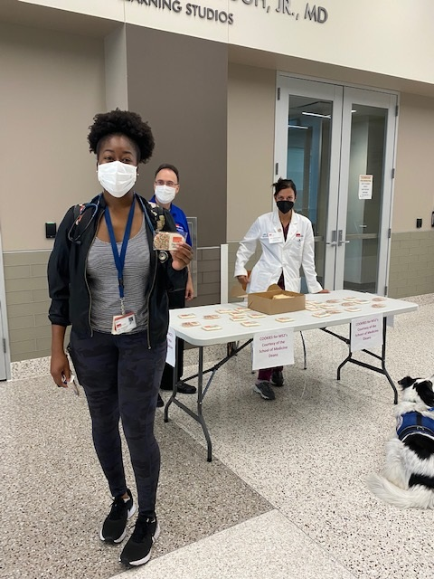  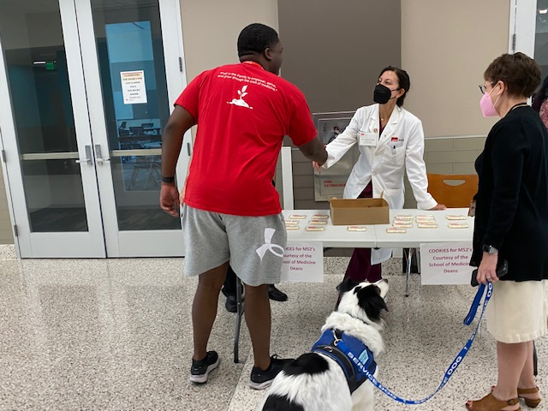  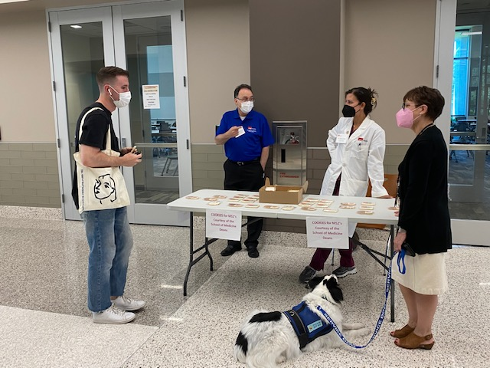  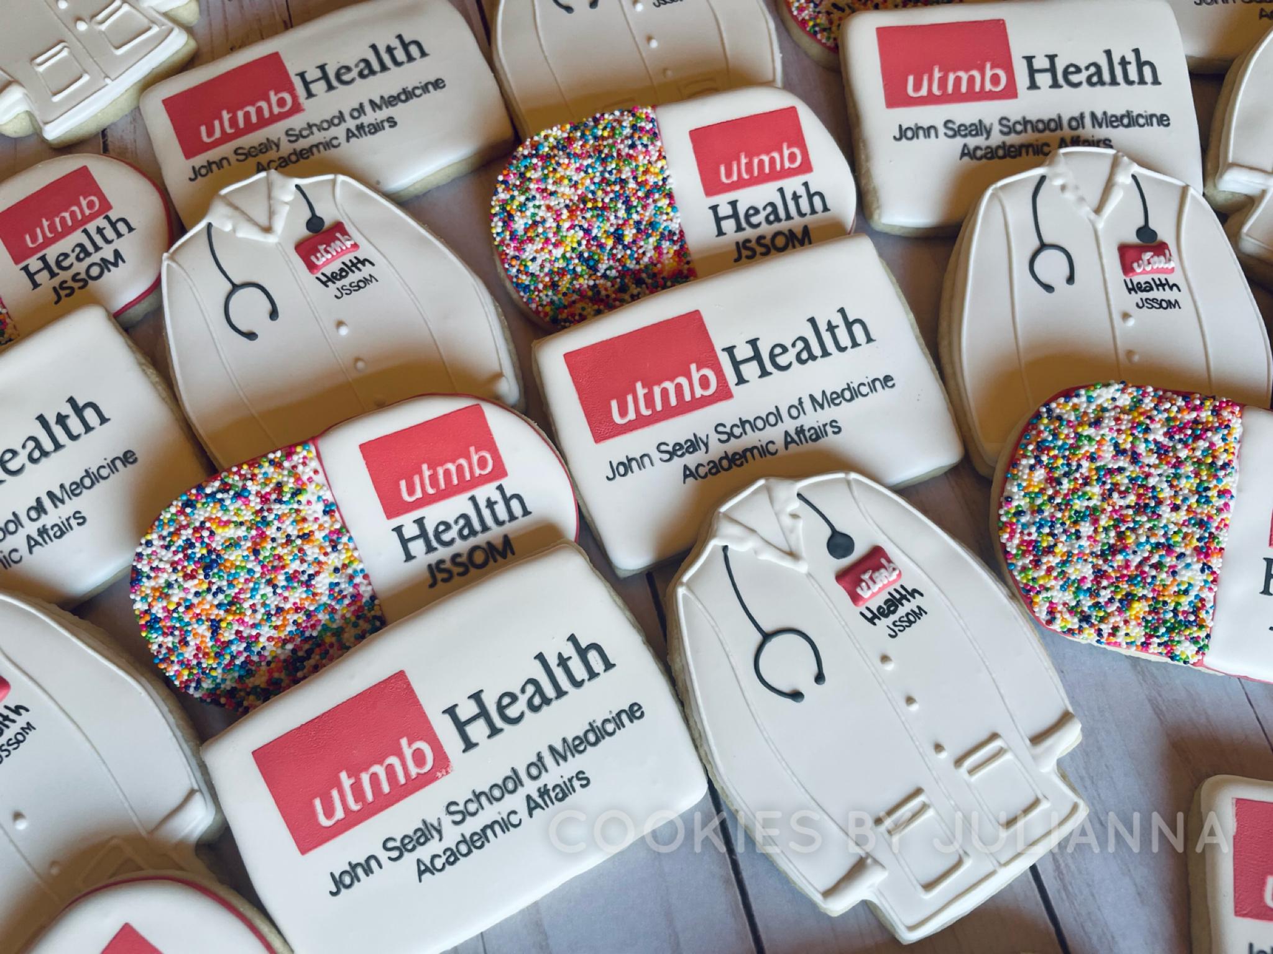 |  |  | COVID-19 UPDATES  Quick Links  - Read June 24 Vaccination Task Force message  - Read June 23 Clinical Task Force message  - Travel requirements and guidelines  - Safety Requirements  - Visitation Policy  - Sick or Exposed  - Schedule a vaccine or booster online  ACTION ITEM  Annual Benefits Enrollment  The annual enrollment period for the 2022–2023 benefits plan year is July 15 to July 31. During this period, you may make changes to your benefits elections, add or remove dependents, and enroll in a flexible spending account.  - You may access the My UT Benefits online system by identifying UTMB as your institution and entering your UTMB username and password.  - No action is necessary if you do not want to make any changes to your coverage for the upcoming plan year; however, employees interested in a flexible spending account must actively enroll each year.  - Your annual enrollment elections and new rates are effective Sept. 1.  For more annual enrollment information, including employee guidebooks and benefits cost worksheets, please see https://www.utmb.edu/hr/employees/compensation-and-benefits/annual-enrollment.  Annual required training due  The institutional deadline for all employees to complete their annual required training for FY22 is Aug. 31. Please log in to the UTMB Learn system at https://learn.utmb.edu and complete any remaining courses and activities. All faculty, staff and students are subject to legal, regulatory and accreditation standards that require certain trainings on a regular basis. All courses are assigned based on federal, state, accreditation, audit or institutional requirements and completion allows us to continue meeting those standards. For questions or concerns about your assigned training, please contact your manager or the course owner listed in UTMB Learn. Google Chrome is the recommended web browser for UTMB Learn courses. For technical issues, please contact the UTMB IS Service Desk at ishelp@utmb.edu.
OPICS  LEGEND |         PATIENT CARE EDUCATION & RESEARCH INSTITUTIONAL SUPPORT CMC
AROUND UTMB (Use the legend above to quickly find items of interest to your team)
GALVESTON CAMPUS  Parking Office relocating to John Sealy Hospital  On July 18, the UTMB Parking Office on the Galveston Campus will relocate from the Moody Medical Library to John Sealy Hospital. The Parking Office will share a space with the UTMB Store—just inside the Market Street entrance of the John Sealy Hospital. The office will be open Monday through Friday from 8 a.m. to 5 p.m. For questions, please contact the Parking Office at (409) 266-PARK (7275) or parking@utmb.edu.  IH-45 lane closure may impact access to Galveston Island July 18 - 22  The IH-45 Southbound outside lane is scheduled to close from 9 a.m. to 3 p.m., July 18 through July 22. Please review the following sources for updates and road conditions and allow additional time if needed to reach your destination:  - Houston Transtar Traffic Map*  - TxDOT Construction Schedule and Closures (filter on "IH-45 in Galveston County")  - Google Maps Live Traffic  - Waze Live Map  * If you are reviewing Transtar freeway cams, check the date stamp to ensure the image is live. Many cameras have been offline during construction.  SAVE THE DATE  July 20 episode of Health Care Unmasked will cover various topics related to children and vaccines  The next Health Care Unmasked is planned for noon, July 20 and will feature UTMB’s Dr. Janak Patel, director of infection control and healthcare epidemiology and professor in the Department of Pediatrics, and Dr. Manuela Murray, medical director for pediatric urgent care centers and ambulatory operations. They will discuss various topics related to children, vaccines and back-to-school preparedness. You can view the July 20 episode on i45Now’s Facebook page at https://www.facebook.com/i45NOW.  IN CASE YOU MISSED IT  UTMB Health Emergency & Urgent Care provide life-saving services for the Houston community—a recent Community Impact Article  When Langdon Cassidy began showing signs of a heart attack, his son and wife leapt into action performing CPR and calling 9-1-1. Read how our team at the UTMB Health Clear Lake Hospital Campus wasted no time treating him once he arrived, ultimately saving his life. To see the full story, visit https://utmb.us/6w2. |  |  | REMINDER  Importance of emergency preparedness  Emergencies affecting our work, families or homes can happen at any time and at any of our locations throughout the state. Information on UTMB’s Emergency Preparedness plans, including actions you should take to prepare at home and work, are available online at https://utmb.us/6rk.  EDUCATION & RESEARCH  UTMB’s Sealy Center on Aging (SCOA) redesignation  UTMB’s Sealy Center on Aging (SCOA) was recently redesignated as a Pan American Health Organization (PAHO) and World Health Organization (WHO) Collaborating Center on Aging and Health. This redesignation, granted June 30, is effective for four years. Collaborating centers carry out activities in support of the WHO's programs. There are nine centers that focus on research and training in aging and geriatrics. Under the directorship of Dr. Rebeca Wong, UTMB’s collaborating center plays an essential role in population-based research on aging and health in the Latin America and Caribbean region. Learn more about thePAHO/WHO Collaborating Center at https://www.utmb.edu/whopaho.
DID YOU KNOW?
The Galveston County Daily News recognized six UTMB faculty, staff and students as 40 Under 40 honorees for 2022. Considered movers and shakers in the community, the UTMB honorees are:
- Shayna Bell, senior administrative manager in the Academic Service Group VI (ASG VI)
- Andrea Francis, student in the John Sealy School of Medicine and the creator of the Hats for the Homeless program
- Dr. Amy Gonzalez, pediatric hospitalist and assistant professor in the Department of Pediatrics
- Sarah Lindsay, nurse practitioner in the Division of Pulmonary, Critical Care and Sleep Medicine
- Dr. Stacia Pfost, resident in the Department of Surgery
- Alberto Maldonado, student in the John Sealy School of Medicine
To view the full list of honorees, visit https://utmb.us/6vx.

