Ben
Weekly Relays User Guide
TOPICS LEGEND
 |  | WEEKLY RELAYS |  | August 11, 2022
YOUR DEPARTMENT NEWS |  |  | UTMB NEWS
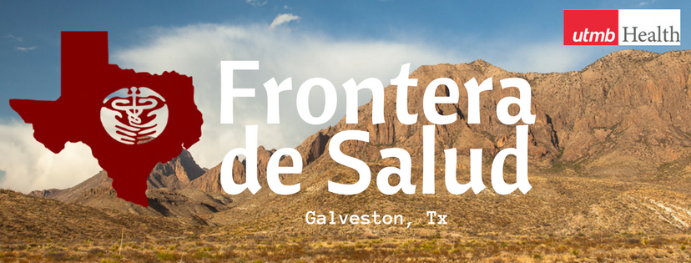  Congratulations to Frontera de Salud who is the proud recipient of a President’s Cabinet award. Co-Presidents, Tuan Pham, and Melissa Leal, under the guidance of Dr. Norma Pérez Raifaisen and Dr. Amber Armstead, submitted for $6500 to build 5 garden beds at Holland House, an affordable housing complex for low socioeconomic families, senior citizens, and persons with disabilities. Construction of the beds will be overseen by Frontera de Salud and Seeding Galveston, a non-profit organization focused on community farming. |  |  | Enhanced Emergency Paid Leave for Qualifying COVID-19 Reasons set to expire on Aug. 31:  Our state and nation have made tremendous progress against COVID-19, with effective vaccines, treatments and infection control practices. While UTMB is currently experiencing a wave of COVID-19 infections (due to the BA.4 and BA.5 variants as noted in the July 26 Clinical Task Force message) we are not seeing the surge in severe illness and hospitalizations characteristic of previous waves. For these reasons, UTMB leadership has decided to sunset the enhanced emergency paid leave benefit effective Aug. 31, 2022. After that date, any leave related to COVID-19 or other medical condition will come from employees’ accruals. Learn more at https://utmb.us/6zf.  REMINDER  Annual required training due:  The institutional deadline for all employees to complete their annual required training for FY22 is Aug. 31. Please log in to the UTMB Learn system today at https://learn.utmb.edu and complete any remaining courses and activities. Employees who do not finish their Compliance Department required training by the institutional deadline will be suspended without pay until all requirements are met. For questions or concerns about your assigned training, please contact your manager or the course owner listed in UTMB Learn. For technical issues, please contact the UTMB IS Service Desk at ishelp@utmb.edu.  SAVE THE DATE  August 17 Health Care Unmasked will explore Aerospace Medicine:  Dr. Ronak Shah, director for UTMB’s Aerospace Medicine division, and Dr. Serena Auñon-Chancellor, UTMB assistant professor of aerospace medicine and American physician, engineer and NASA astronaut, will join host TJ Aulds at noon on Wednesday, Aug. 17 to discuss the UTMB Aerospace Medicine program. To watch the discussion, visit https://www.facebook.com/i45now.  COVID-19 UPDATES  QUICK LINKS  - Travel requirements and guidelines  - Safety Requirements  - Visitation Policy  - Sick or Exposed  - Schedule a vaccine or booster online
OPICS  LEGEND | PATIENT CARE EDUCATION & RESEARCH INSTITUTIONAL SUPPORT CMC
AROUND UTMB (Use the legend above to quickly find items of interest to your team)
PATIENT CARE
Annual tuberculosis screen requirement:
UTMB’s Employee Health, as the partner of Infection Control/Healthcare Epidemiology, distributed a message to all health care workers to complete their annual tuberculosis screen by July 1, 2022, as a requirement of The Joint Commission. Due to the summer COVID surge, and technical difficulties, the timeframe was extended. The web-based survey only takes a few minutes to complete and is located at https://utmb.us/4yz. The FINAL date for compliance is Friday, August 26. In addition, managers can verify their employee’s compliance at the following link: 2022 TB Compliance for Health Care Workers.

DID YOU KNOW?
On Thursday, Aug. 4, UTMB Health and the Angleton-Danbury Hospital District Board of Directors invited the community to celebrate the one-year anniversary of the Bleakney Building. The Bleakney Building was named in memory of Dave Bleakney—the former CEO and Hospital Administrator of the Angleton Campus for 26 years—in recognition of his years of service, insight and commitment to the health care of the Angleton Danbury communities and southern Brazoria County. Community and county leaders from across the region expressed their appreciation of the never-ending support and investment into health care needs of the region by the hospital district and UTMB Health. The clinics at the UTMB Health Bleakney Building, which include Urgent Care, Family Medicine, Orthopedics and Specialty Care, have cared for more than 55,000 patients in the past year. To learn more about the Bleakney facility and team, visit https://vimeo.com/666068735.

