Ben
Weekly Relays User Guide
TOPICS LEGEND
 |  | WEEKLY RELAYS |  | October 13, 2022
YOUR DEPARTMENT NEWS |  |  | UTMB NEWS
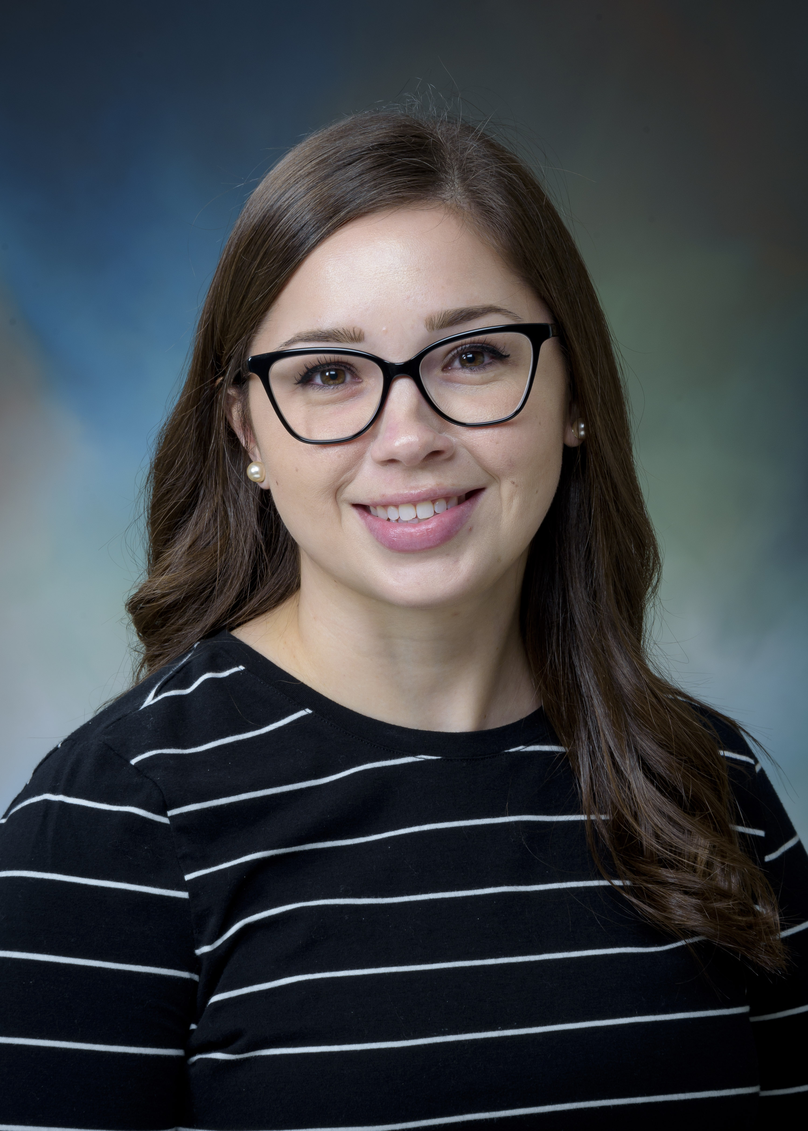  Our very own Kimberly Turner is featured on the TTR Educators Symposium website for her award as 2022 Coordinator of the Year!  https://www.ttreducators.com/coordinator-of-the-year-2022  The First Annual WE Summit was held on Saturday, October 8, 2022, with Dr. Norma Pérez Raifaisen hosting and Dr. Charles Mouton closing the event, which was attended by 80 medical students and a dozen faculty members. The event was very successful with students leaving with names and emails of potential research mentors and several projects looking to work with students. A few of our students reached an agreement for research mentorship before the end of the day.  The summit awarded 11 medical students for their research efforts: Kendall Wermine, Andrea Francis, Brittany Miles, Alexandra Flaherty, Sheina Duncan, Sean O’Leary, Seth Buscho, Emma Rowlinson, Helen Onuorah, Jason Yeung, and Mohamed Jimale. Drs. Mukaila Raji, Maria Belalcazar, and Lisa Campo-Engelstein were recognized for their significant research mentorship with Dr. Soham Al Snih receiving the award for Top Faculty Researcher for her extensive contributions to student success. For further information, please visit the website: We Summit, We Learn, We Empower, We Grow (utmb.edu)  Willie the Champ!!!  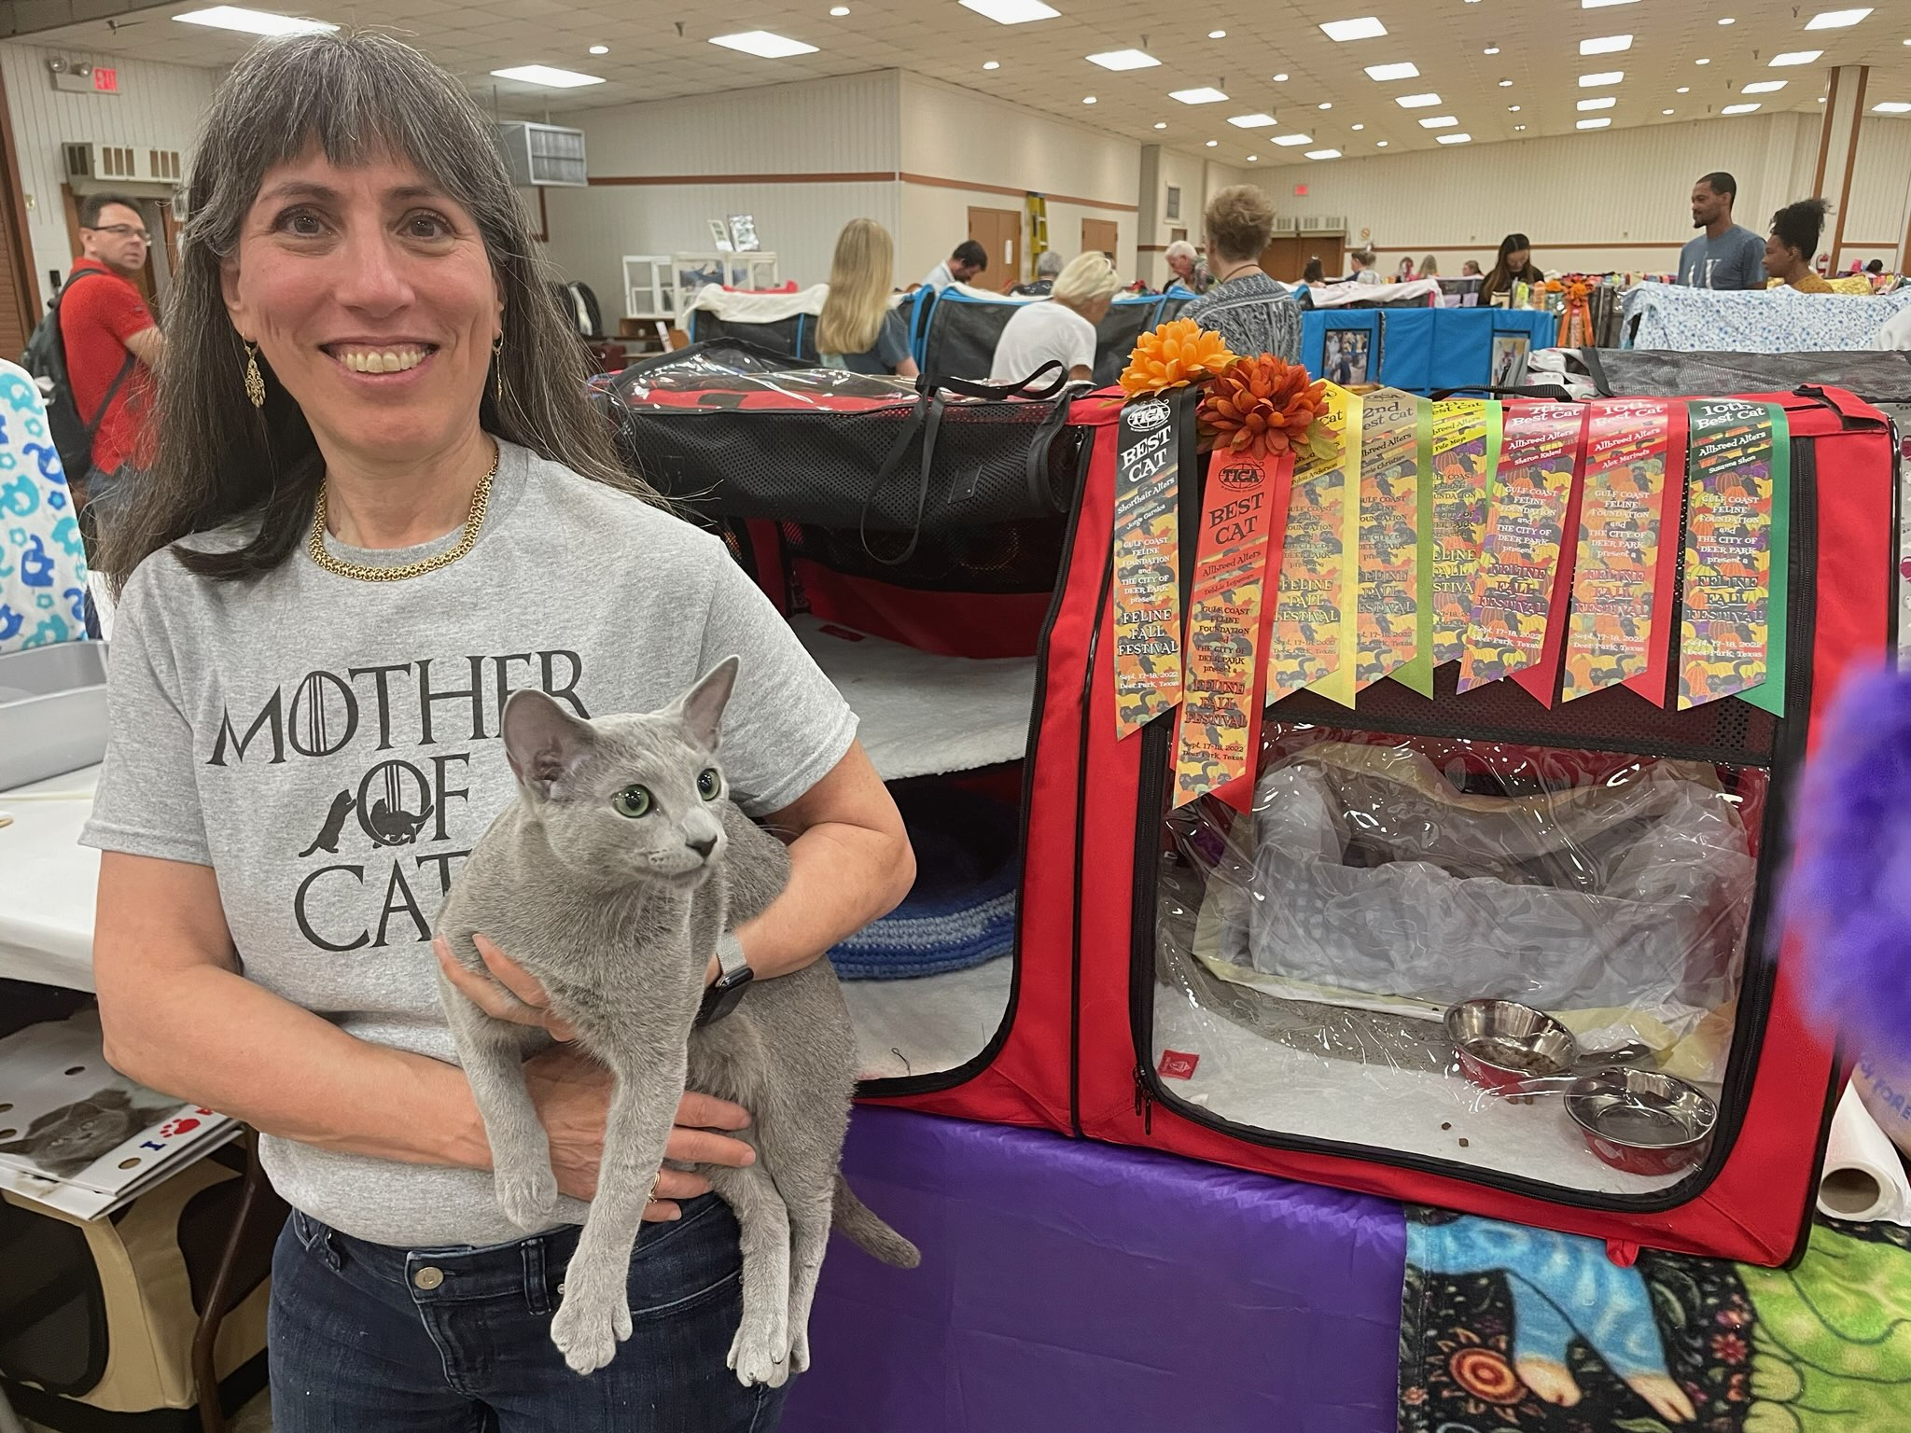  Meet Dr. Levine’s cat, Valnika's Will Robinson, (Willy for short) who competed in the Gulf Coast Feline Foundation show in Deer Park, Texas on 9/16/22-9/17/22. This is part of The International Cat Association (TICA). In the alter category (pedigree cats that have been spayed or neutered) he earned "Best Cat" in three finals, and "Second Best" in two more. He earned enough points to qualify for the "Quadruple Grand Champion Alter"  and is only one title away from the top title of "Supreme” Grand Champion Alter. He is scheduled to compete again this weekend at the Texas Feline Fanatics show in Temple, Texas.  Way to go Willie! Bring home the win!  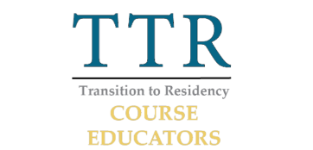  UTMB has 3 poster presentations at the TTR symposium this year from different projects within the course. They can be viewed here: https://www.ttreducators.com/2022-virtual-posters  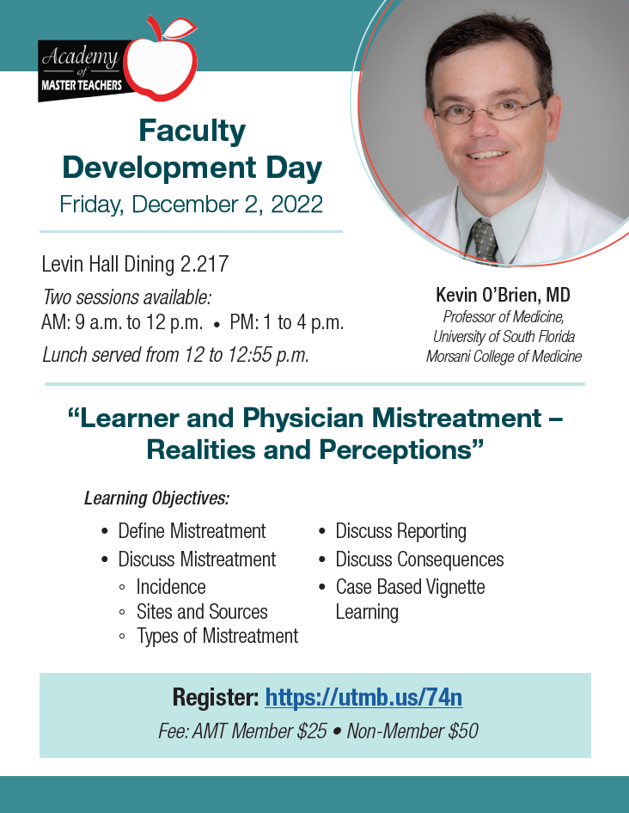 |  |  | Employee evaluations due Oct. 31  The institutional deadline to complete employee evaluations for the FY22 performance review cycle is Oct. 31. As of Oct. 12, the percent of completed evaluations for each operating area is:  - Academic Enterprise – 22%  - Health System – 51%  - Institutional Support – 42%  - Office of the President – 15%  - Overall UTMB – 43%  For questions about your evaluation, please reach out to your leader. You may also visit https://utmb.us/737 for more information and resources.  FY23 Holiday Schedule  UTMB’s holiday schedule for fiscal year 2023 has been updated to include the dates clinics will be opened and closed and the addition of two new alternate holidays – Eid-al-Fitr and Eid-al-Adha. To read more and to download a copy of the updated schedule, see https://utmb.us/771.  Moving and relocation vendor update  UTMB recently contracted with an additional moving and relocation vendor to service departmental moves from office-to-office, building-to-building and campus-to-campus (excluding most CMC sites). Both vendors provide:  - Hard quotes and time and materials services  - Relocation of medical and laboratory equipment (hoods, microscopes, biosafety cabinets, beds, etc.)  - Relocation of free-standing furniture, including storage shelving  - Relocation to surplus of all items  - Climate controlled storage  - Relocation of items from one UTMB facility to another  The moving and relocation vendors are:  East End Transfer  - For general questions or time and materials quotes, contact Geneva Williams at moverequest.UTMB@eastendtransfer.com or (409) 877-3391  - For hard quotes and hot shot services, contact David Painchault at david@eastendtransfer.com or (832) 776-2334  - For other concerns, contact April Surratt at april@eastendtransfer.com  A-Rocket  - For information, contact Marvin Davis at mwdavis@utmb.edu, mdavis@arocket.com or (281) 808-8098 (text is preferred)  As a reminder, departments must complete a Surplus Equipment Warehouse (SEW) form for all surplus equipment items to be moved to the Surplus Warehouse. For additional information on surplus property transfers, visit https://utmb.us/6xv. For questions about surplus property, contact Dave Ng at djng@UTMB.EDU or Sam Blackwell at ssblackw@UTMB.EDU.
OPICS  LEGEND | PATIENT CARE EDUCATION & RESEARCH INSTITUTIONAL SUPPORT CMC
AROUND UTMB (Use the legend above to quickly find items of interest to your team)
Active shooter exercise planned for Oct. 15  The UTMB Police Department will conduct an active shooter training exercise on Oct. 15 from 8 a.m. to noon at the UTMB Health Education Center (HEC) on the Galveston Campus. During the training exercise, the HEC will not be accessible. An Everbridge Alert will be distributed at the beginning of the exercise and again when it concludes. For more information about the exercise, contact Lieutenant Joel Rivera at jirivera@utmb.edu or (409) 772-2691. To check or update your contact information in Everbridge/UTMB Alerts, visit https://www.utmb.edu/alert/.  IN CASE YOU MISSED IT  Oct. 12 Health Care Unmasked covered breast cancer signs, symptoms and treatments and the importance of mammograms  The Oct. 12 Health Care Unmasked featured a candid conversation with Drs. Colleen Silva and Angelica Robinson about breast cancer signs, symptoms and treatments and the importance of mammograms. Constable Jimmy Fullen joined the discussion to talk about the annual BRA Dazzle event benefiting UTMB Health’s mobile mammography program. To watch the episode on the i45Now Facebook page, visit https://fb.watch/g6PgdmUX_q/.  REMINDERS  Town Hall at Levin Hall Auditorium on Galveston Campus set for Oct. 20  UTMB President ad interim Dr. Charles P. Mouton will host a Town Hall at noon on Oct. 20. Dr. Mouton will provide an end-of-the-fiscal-year update, discuss UTMB’s future strategic plans and share information about UTMB’s priorities for the 88th session of the Texas Legislature. The meeting will be livestreamed and recorded for later viewing for those unable to attend in person. Check http://www.utmb.edu/townhall for links to the livestream closer to the meeting time. Have a question? Submit it to the Employee Advisory Council.  Protect yourself and others with a seasonal flu shot  Free flu shots are now available at all UTMB campuses and clinics for employees and volunteers. For details on how to receive your vaccination and UTMB’s health care worker requirements for the 2022-2023 flu season, please see https://utmb.us/731.  COVID-19 QUICK LINKS  - Travel requirements and guidelines  - Safety Requirements  - Visitation Policy  - Sick or Exposed  - Schedule a vaccine or booster online  PATIENT CARE (cont.)  Language Services new telephonic and video interpreter process  For video interpreter services, users should:  - Continue using the current application “TeleLanguage” to make video and audio call to an interpreter until the device has temporary or permanent instruction cards for the new “Propio ONE” app installed.  - View the new application instructional video at https://www.youtube.com/watch?v=Mwmx3XwiqjURollout  - Review the video roll-out timeline:  - Oct. 10 – 14: UTMB IS will remotely push out the new application/desktop icon to the hundreds of VRI devices throughout the Health System. Both the current and the new apps will remain on the device until all carts are rebranded with the new laminated instruction cards.  - Oct. 12 – 14: The new vendor, Propio, will contact the department-designated Language Access Champions to ensure the devices are plugged in, turned on, connected to the “UTMB WIFI” network, and temporary instructions have been printed. Please provide requested information to them if you are contacted.  - Oct. 17 – 21: Buffer week for all teams to ensure tasks have been completed.  - Oct. 25 – 28: On-site rollout teams from Language Access, IS, and Propio will be on-site to rebrand carts, perform test calls and routine cart maintenance, and provide in-service.  For questions, contact Language Access Services at (409) 772-4772. |  |  | Purchasing Department offers monthly training courses  The Purchasing Department offers monthly training classes ranging from basic purchasing courses to purchase order change requests through UTMB’s Training Gateway calendar. The following sessions are available:  - What is Purchasing 101? – This course covers a variety of topics, including Rules and Regulations, Asset Management Information, PPE Ordering, Historically Underutilized Businesses (HUB) and All About the Manage Requisition Screen.  - Receiving – This class explains how to make receipts within the PeopleSoft system.  - All About PO Change Orders – This course covers the process for change orders, including what to change; how to approve it; what you cannot change and how to delete lines from a requisition.  - Gas Ordering – This course reviews the process of creating an account, ordering gases and placing equipment orders with the Praxair company.  - Signature Authorization Process – This course covers the process and importance of filling out a Signature Authorization Form. It also explains the steps once the form reaches the Purchasing Help Desk, as well as approval levels and where to look to see if the Requisition needs a Signature Authorization Form.  Employees may register for these courses at https://innovation.utmb.edu/TrainingGateway/#/.  PATIENT CARE  Language Services new telephonic and video interpreter process  When UTMB staff interpreters are busy helping other callers, users are transferred to a third-party vendor to assist with all patient interpreting needs. To improve the overflow process, UTMB has transitioned to a new vendor, Propio Language Services.  For telephonic interpreter services, users should:  - Continue to dial extension 7-2121 or (409) 747-2121 for a telephonic interpreter.  - Follow the prompts to select desired language.  - When the Propio phone menu begins, users may be prompted to select the desired language a second time.  - In the Propio phone menu, users can select the #1 for Spanish and #8 for all other languages.  - If #8 is selected, users will be prompted to speak the name of the desired language.  - Helpful hint: Chinese is not considered a language. Most requests for Chinese will require a Mandarin interpreter.  The new service allows users to be connected to an interpreter sooner and the person asking the intake questions will be the interpreter—instead of an operator—so the data and the spelling of names will be collected quicker and more accurately.
2022 Agency for Healthcare Research and Quality (AHRQ) Culture of Safety Survey: Oct. 17 through Dec. 2
All clinicians and employees across the organization are being asked to participate in the 2022 Agency for Healthcare Research and Quality (AHRQ) Culture of Safety Survey. The survey is a tool for understanding, promoting and maintaining a culture of patient safety. It helps UTMB identify strengths and areas for improvement while also allowing us to make external comparisons against other organizations. Look for an email in the next few days that gives you more information about the survey and a link to the survey tool. The survey tool will become available Monday, Oct. 17, and will remain open until Dec. 2. The survey should take no more than 10 minutes to complete, and your responses will help shape the patient experience at UTMB.
EDUCATION & RESEARCH

2023 John P. McGovern Student Awards in Oslerian Medicine
The John P. McGovern Student Awards in Oslerian Medicine provide monetary support to medical students who exemplify the medical practice ideals that Sir William Osler taught. Students with this honor are “Osler Student Scholars.” Faculty who worked with medical students as small group facilitators or preceptors in clinical settings, or mentors in the Osler Student Societies or other organizations, can recommend this opportunity to worthy students. For more information or to download an application, visit https://www.utmb.edu/osler/awards/student-award-in-oslerian-medicine. The deadline for application packets is 5 p.m. Jan. 6, 2023.

DID YOU KNOW?
Thanks to the Women’s Health and Cancer Rights Act of 1998, whenever a mastectomy is covered by insurance, so are breast reconstruction and prostheses. Dr. Julie Park, a plastic surgeon and the director of breast reconstruction at UTMB, is passionate about ensuring patients know their options when it comes to reconstruction after breast cancer. She works closely with other members of the UTMB Breast Health team to provide patients like Kimberly Branum the highest level of care throughout their cancer journey. Branum, who was first diagnosed with cancer in 2016, trusted Dr. Park with her most recent reconstruction needs. Her story was recently highlighted in “Think Pink,” a special section released by the Galveston County Daily News. Her full story is available online at https://utmb.us/773.

