Ben
Weekly Relays User Guide
TOPICS LEGEND
 |  | WEEKLY RELAYS |  | November 3, 2022
YOUR DEPARTMENT NEWS |  |  | UTMB NEWS
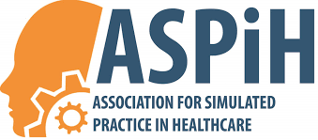  Dr. Karen Szauter delivered a keynote address this week for the conference of the Association for Simulated Practice in Healthcare (ASPiH) entitled Simulated Patients – Are we Optimizing their Roles in Education?  ASPiH is an organization for simulation specialists in Great Britain  JSSOM Halloween Fun!!!!  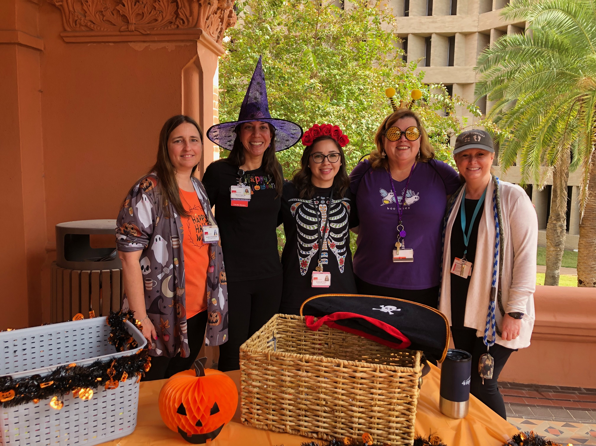  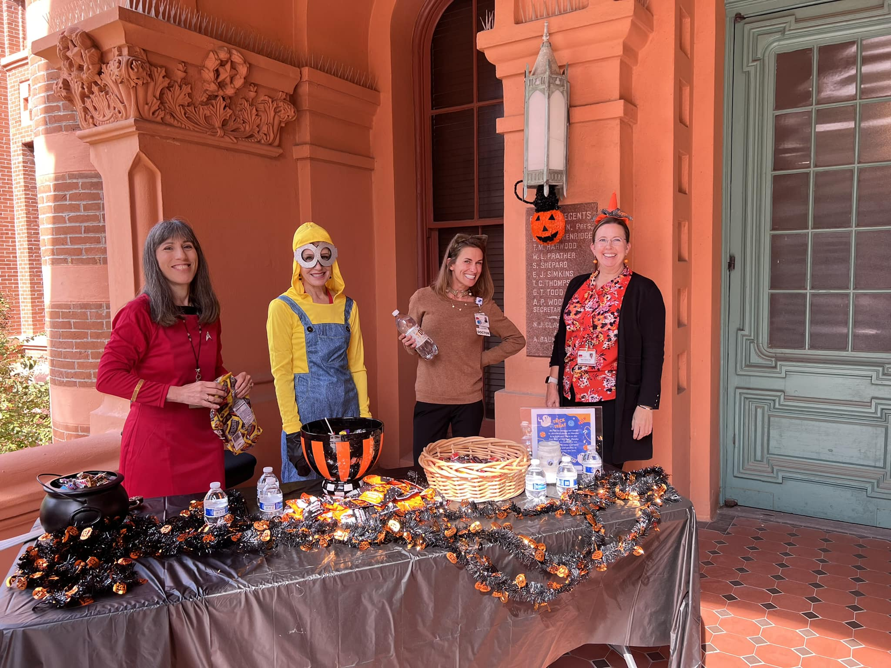  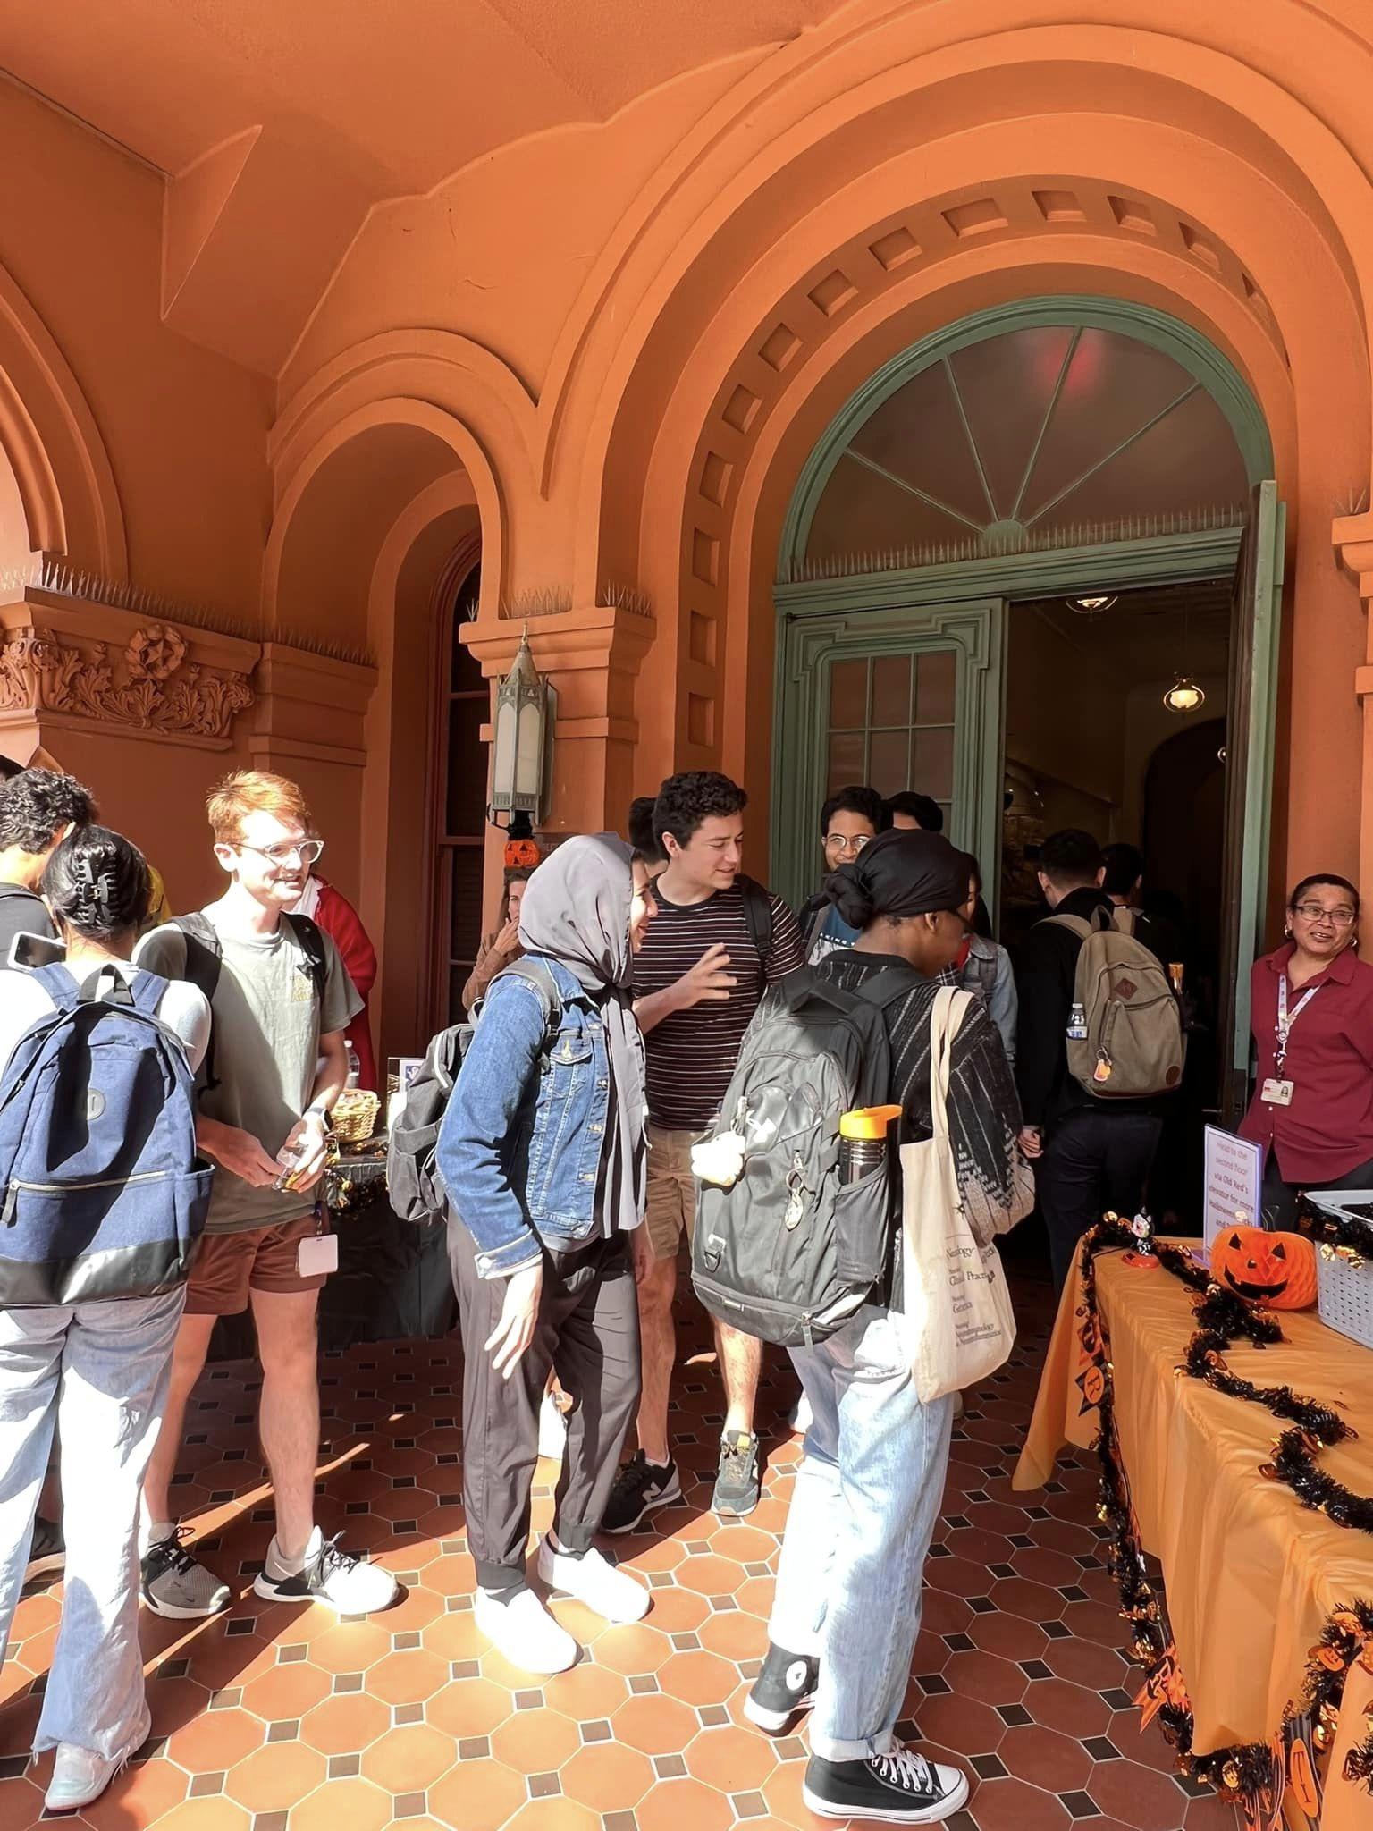  Thanks to everyone who came to pass out candy to the students!!!  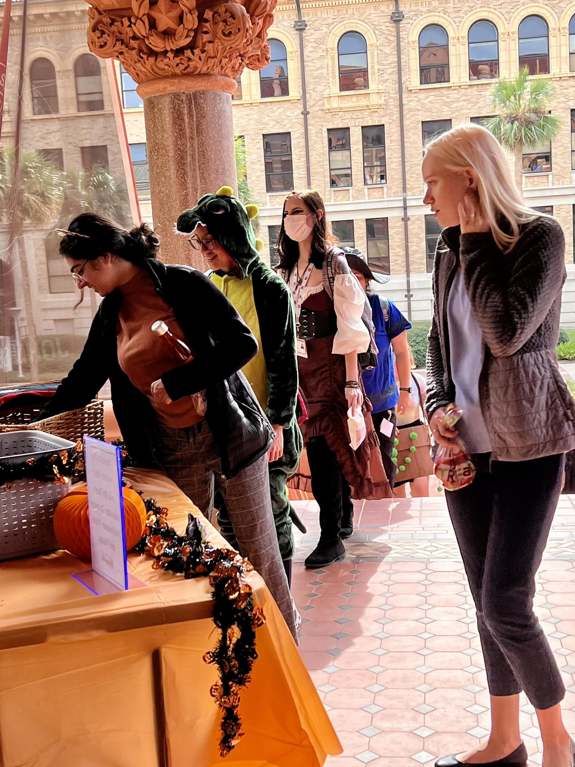  Celebrating Dia de los Muertos  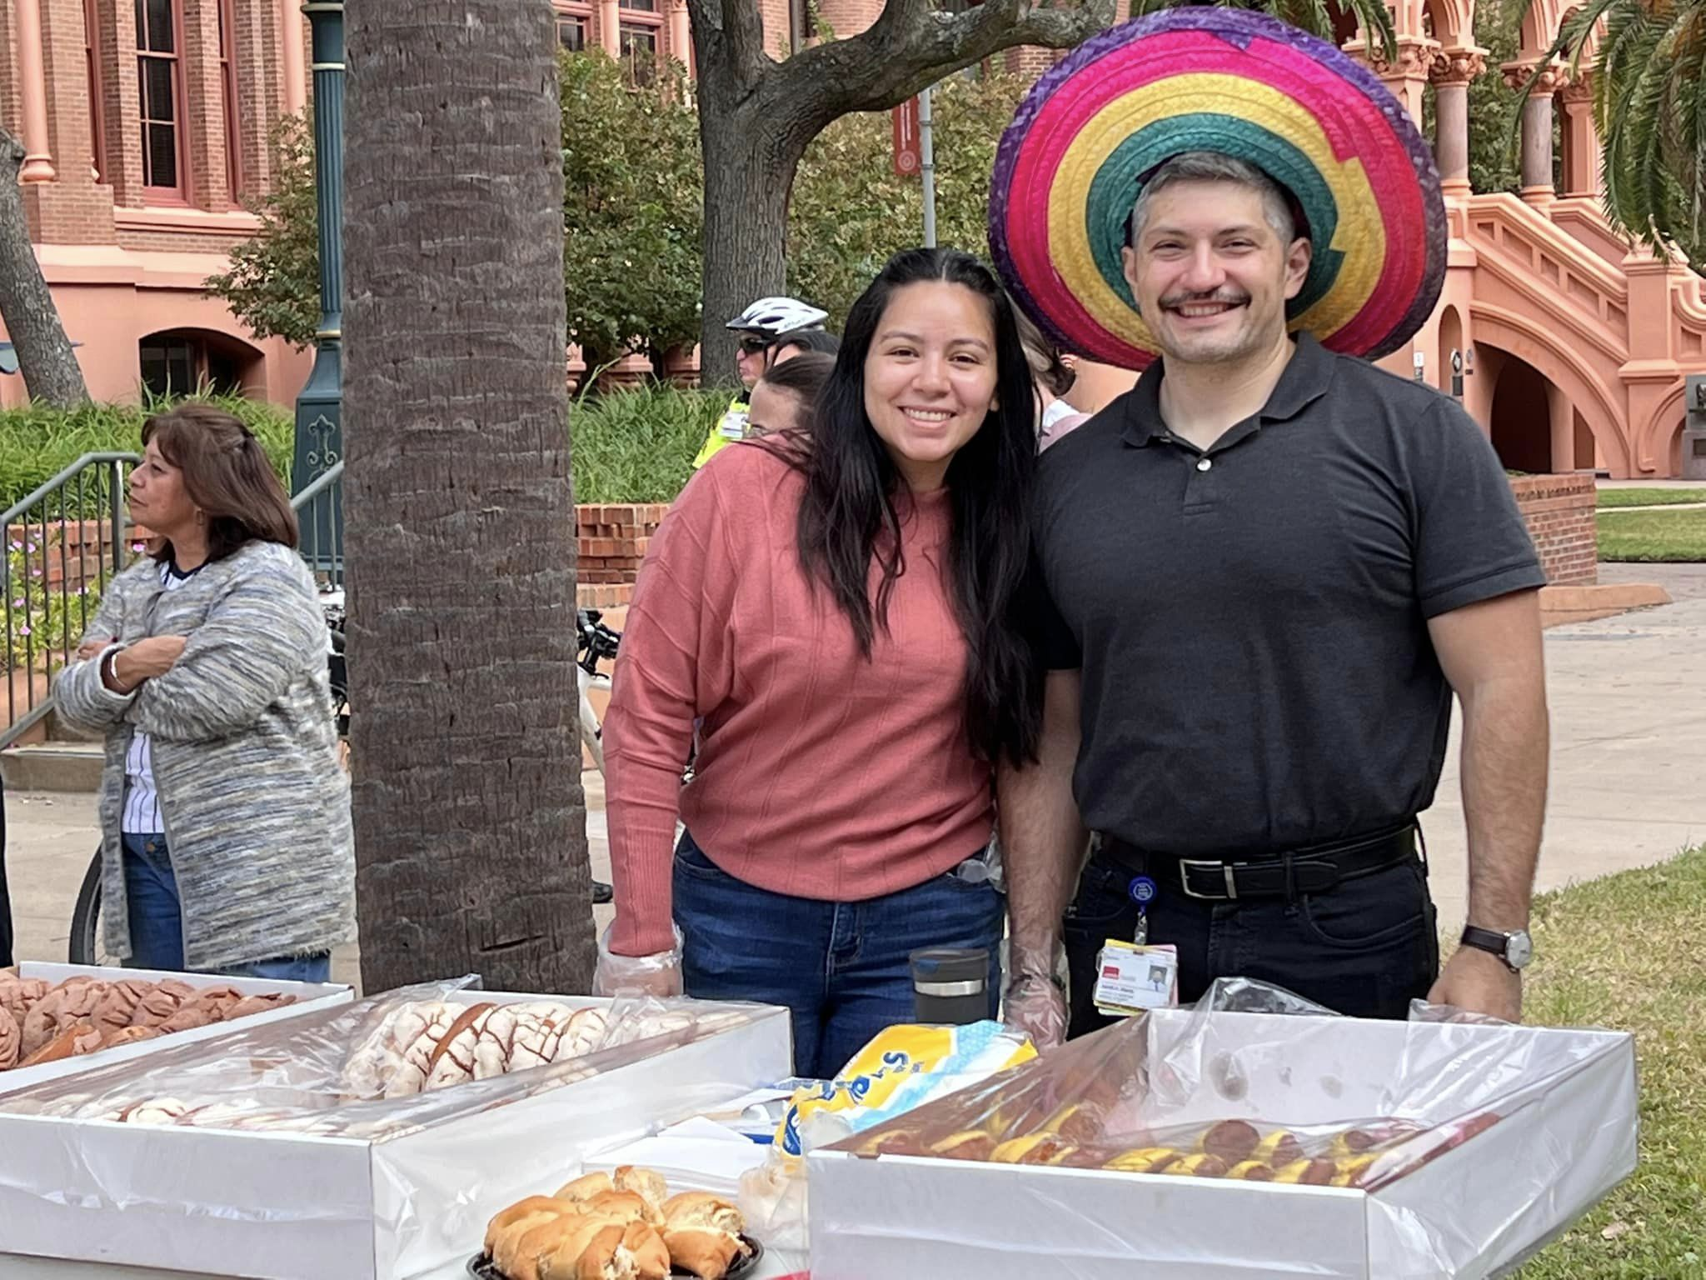  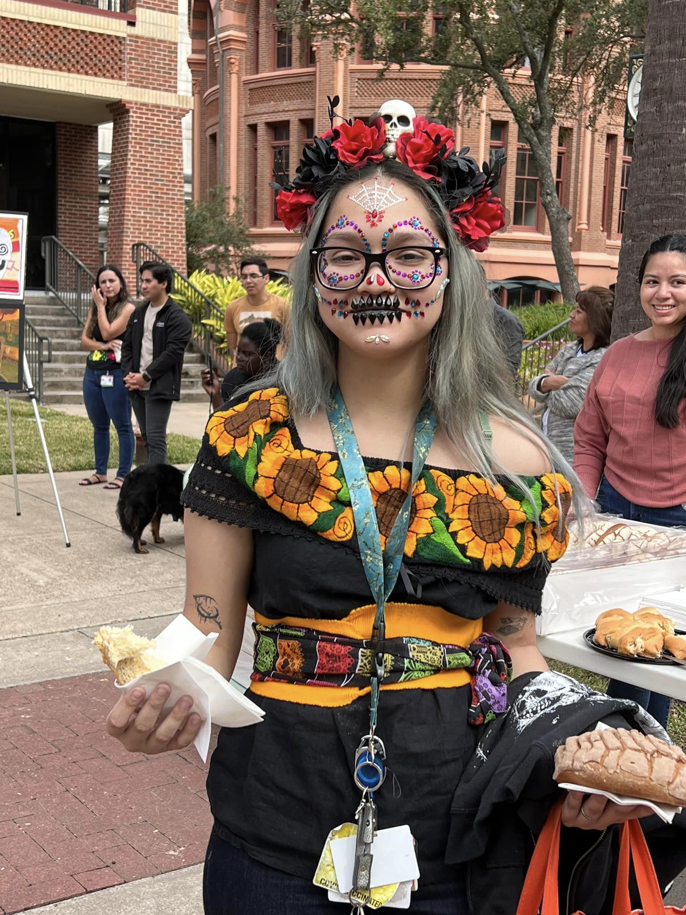  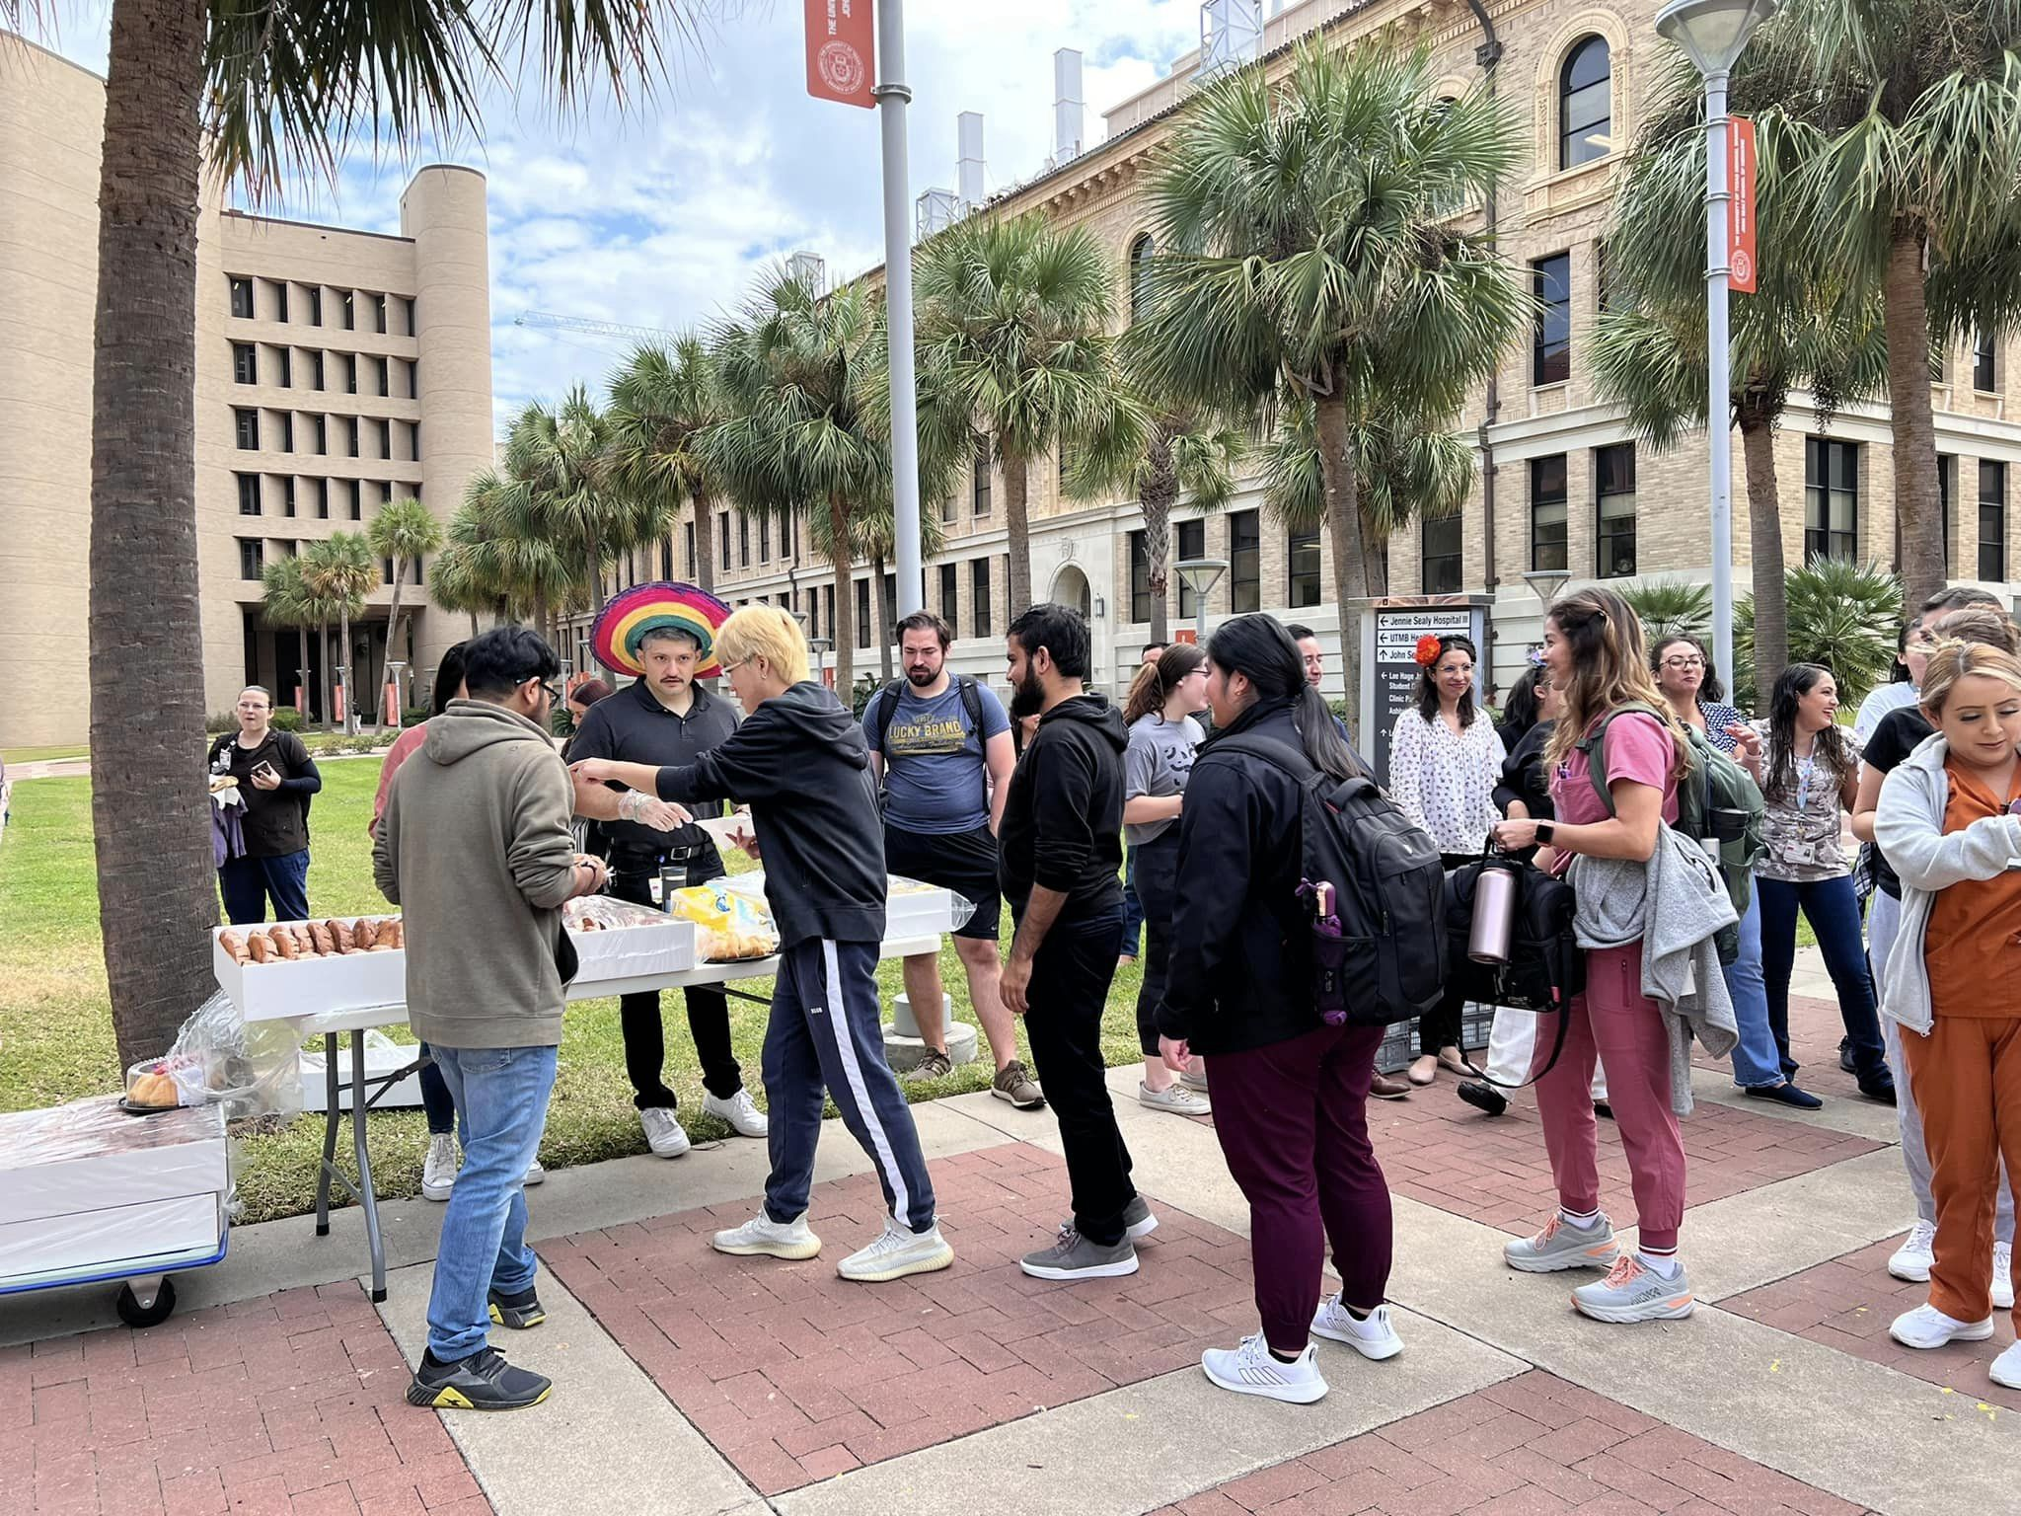 |  |  | MONTHLY CYBERSECURITY UPDATE  How Are We Doing: During the month of October, 6.07% of recipients opened an attachment or revealed credentials in simulated phishing attacks initiated by the Office of Information Security. Our goal is less than 3%. A breakdown of department success/failure rates can be found at https://utmb.us/66g. Learn more about cybersecurity at https://www.utmb.edu/infosec. Report potential phishing to cirt@utmb.edu.  Scammers trying to beat the Holiday rush!  ’Tis the Season—almost. Phishers, scammers and other less-than-jolly threat actors are already starting their holiday-themed attacks in an effort to steal your holiday joy—and your money and account credentials. Please be aware of the following scams, already being seen by UTMB users:  - Gift Card scams — These start out as an email request for a private phone number to receive a text message. If provided, the threat actor will text a request for “a favor” of purchasing generic gift cards for a family member. If the victim provides the card number and security codes, the scammer has the money.  - Invoice scam — Victims will receive a phony invoice for a product or services. If the victim makes contact to contest the charges, the threat actor will attempt to extort money for products being delivered. Even if no money/credit is exchanged, the scammer will know the original email account is actively monitored.  - Online shopping redirection — Victims will be redirected from a real shopping site to faked product websites in an attempt to steal money for items, which will never be sent. In 2018, the fake website amazone.com (not to be confused with amazon.com) scammed over $3 million from victims.  - Illegitimate charities — Faked “adopt-a-child” angel-tree scams and food bank collections. Consider contacting the Better Business Bureau (www.bbb.org) website to confirm the legitimacy of charities asking for your support.  If you receive any emails from outside the university email system that you are uncertain about, forward them to cirt@utmb.edu for investigation. Have a happy holiday season and thank you for being security aware.  2022 State Employee Charitable Campaign (SECC)  The annual State Employee Charitable Campaign is here, and this year we’ll be taking a trip to Funkytown. We’ll be celebrating music, embracing disco and hoping it brings a smile to your face and a strut to your step. The SECC is an important and easy way for members of our UTMB community to give back, and we've done it generously year after year. The campaign allows participants to support the causes and charities of their choosing, at the level they are comfortable with, and use a super simple online process to pay via payroll deduction. Gifts can be made once, stretched out via monthly contributions, or made via a paper pledge form. The campaign runs until Nov. 14 and has already raised more than $142,000. You can review your options, learn more and make your pledge today on the SECC website at www.utmb.edu/SECC.
OPICS  LEGEND | PATIENT CARE EDUCATION & RESEARCH INSTITUTIONAL SUPPORT CMC
AROUND UTMB (Use the legend above to quickly find items of interest to your team)
Information on FY2023 Merit Pay Program  UTMB’s merit pay program is an important part of the total compensation strategy for Classified, Non-Teaching and Administrative & Professional (A&P) employees. Merit pay increases are designed to reward staff for meeting or exceeding performance expectations. At the Oct. 20 Town Hall, Dr. Charles Mouton, President ad interim, shared that merit pay increases will be made to eligible employees in Fiscal Year 2023. Merit increases will be effective Nov. 26, for Classified employees and Jan. 1, for Non-Teaching and Administrative & Professional employees. To learn more about the FY2023 merit program, visit the related iUTMB News article at https://utmb.us/7aa.  Veterans Day Celebration Luncheon set for Nov. 9  The UTMB Diversity Council and Veterans Resource Group cordially invite you to the Veterans Day Celebration luncheon scheduled for 11:30 a.m. to 1 p.m. in the Levin Hall Dining Room on the Galveston Campus. Please submit reservations to events@utmb.edu. Limited seating is available, and priority will be given to veterans.  Vaccine Smarts—Don’t wait, vaccinate!  Flu season started early this year. This winter, we may have a "twin-demic” of both COVID-19 and flu filling hospital beds, Drs. Megan Berman and Richard Rupp warn in their Vaccine Smarts newspaper column. UTMB News is now posting the Vaccine Smarts column on the UTMB Health Blog to spread the word that it’s not too late to get your flu shot this year. To read the latest columns, visit UTMB’s Health Blog webpage at https://www.utmbhealth.com/health-blog.  That’s a wrap: UTMB patients and events raised awareness about breast cancer throughout October  Observed each October, Breast Cancer Awareness Month is always a priority at UTMB and this year was no different. To help inform the communities we serve about the breast health services available at UTMB, numerous community and campus events were held throughout the month where information was shared and connections were made. In addition to these activities, UTMB Breast Health patients recounted their breast cancer journeys and experiences across a variety of platforms to reach and inspire others who may be on similar paths. To see some of the latest pieces supporting this cause, visit the UTMB Health Blog cancer section.  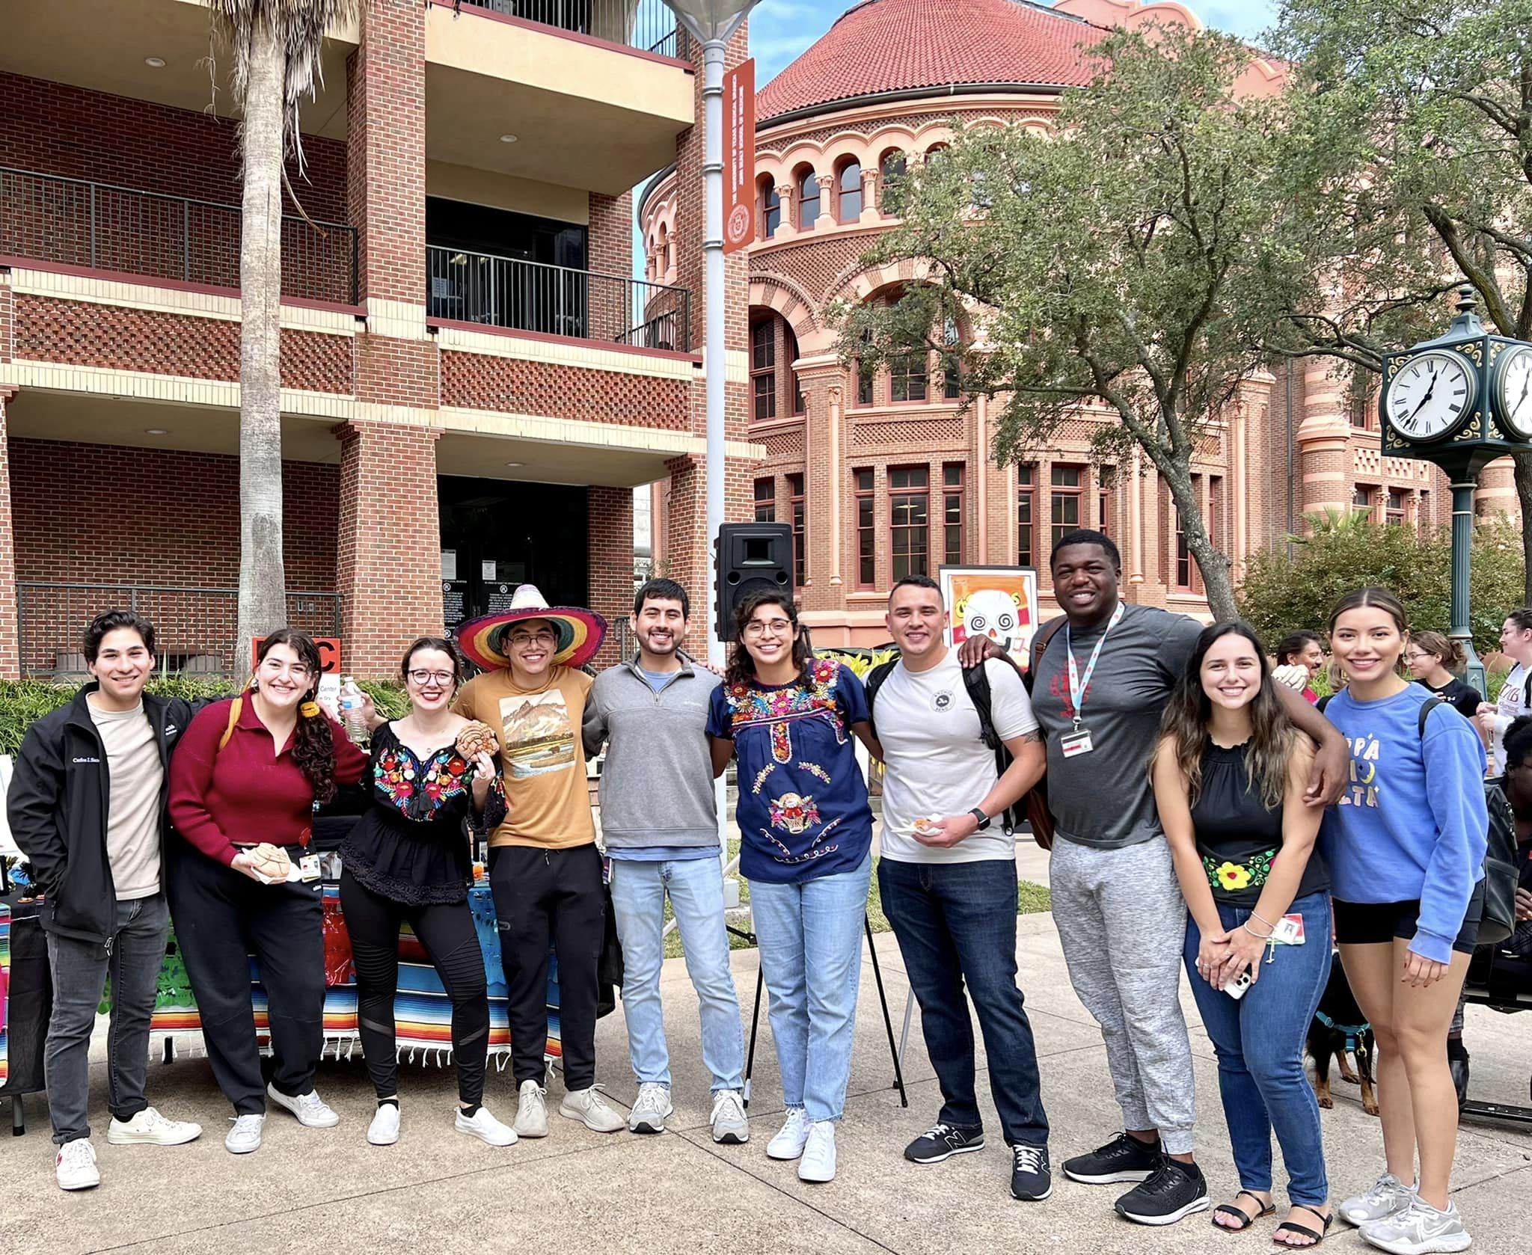 |  |  | IN CASE YOU MISSED IT  UTMB pediatrician joined i45NOW to discuss the importance of COVID-19 and flu vaccinations as winter approaches  UTMB Health pediatrician Dr. Manuela Murray joined i45NOW to discuss the importance of COVID-19 and flu vaccinations. As winter approaches, she and other physicians fear the emergence of another wave of COVID-19, coupled with influenza and respiratory syncytial virus, making more people ill, keeping them out of school and work, and overwhelming medical facilities. To watch the interview, visit the i45NOW Facebook page at https://utmb.us/79w.  COVID-19 QUICK LINKS  - Travel requirements and guidelines  - Safety Requirements  - Visitation Policy  - Sick or Exposed  - Schedule a vaccine or booster online  EDUCATION & RESEARCH  UTMB community invited to Dec. 1 inaugural One Health Symposium  The UTMB community is invited to UTMB’s inaugural One Health Symposium from 9 a.m. to 1:30 p.m. on Dec. 1. Attendees may join in person at the Health Education Center in Room 3.200 on the Galveston Campus or virtually. The World Health Organization defines One Health as “an approach to designing and implementing programs, policies, legislation and research in which multiple sectors communicate and work together to achieve better public health outcomes.” The symposium will feature UTMB scientists and clinicians sharing rapid-fire presentations to demonstrate how One Health is a foundation in their work, as well as a breakout session where participants will brainstorm how UTMB might effectively compete for large multidisciplinary research and training grants. Registration is required by Nov. 18. See the full agenda and register at https://www.utmb.edu/one-health/from-bench-to-bedside.  B. Montgomery “Monte” Pettitt, PhD, to serve as Chair ad interim for the Department of Biochemistry and Molecular Biology (BMB)  B. Montgomery “Monte” Pettitt, PhD, will serve as Chair ad interim for the Department of Biochemistry and Molecular Biology (BMB), effective Jan. 1. Dr. Pettitt is a professor in the department and Director of the Sealy Center for Structural Biology and Molecular Biophysics. He holds the Robert A. Welch Distinguished University Chair of Chemistry. He also holds an appointment in the Department of Pharmacology and Toxicology. Dr. Pettitt joined UTMB in 2012 from the University of Houston, where he spent 27 years. In his 10 years at UTMB he has strengthened our research enterprise through his contributions as a researcher and educator. Please join us in thanking him for taking on this important responsibility.
DID YOU KNOW?

The UTMB Galveston Campus is a new member of “The Schwartz Center for Compassionate Healthcare,” an organization dedicated to providing education, training and support to unite caregivers from a range of disciplines. As part of this organization, “Schwartz Rounds” will launch on the Galveston Campus in December. These rounds provide a space where individuals from all facets of the UTMB Health organization are invited to share experiences, learn from each other and focus on the human dimension of medicine and patient care. The sessions are in-person “grand rounds” style events and focus on panel discussions of themes related to the emotional impact of patient care and working in the health care system. Panelists from diverse disciplines participate in the sessions, including physicians, nurses, students and trainees, social workers, psychologists, facilities management employees, security and police officers, allied health professionals and chaplains. After listening to a brief panel presentation, attendees are invited to share their own perspectives on the case and broader related issues.

UTMB’s first official Schwartz Rounds will be hosted Dec. 2, from noon to 1 p.m. in the Clinical Sciences Auditorium, Floor 3, Room 3.362, on the Galveston Campus. All UTMB students, staff, faculty and executives are encouraged to attend. For more information on the upcoming session, visit https://bit.ly/3NxxvqN.

