Ben
Weekly Relays User Guide
TOPICS LEGEND
 |  | WEEKLY RELAYS |  | June 8, 2023
YOUR DEPARTMENT NEWS |  |  | UTMB NEWS
John Sealy School of Medicine  Class of 2023 Commencement  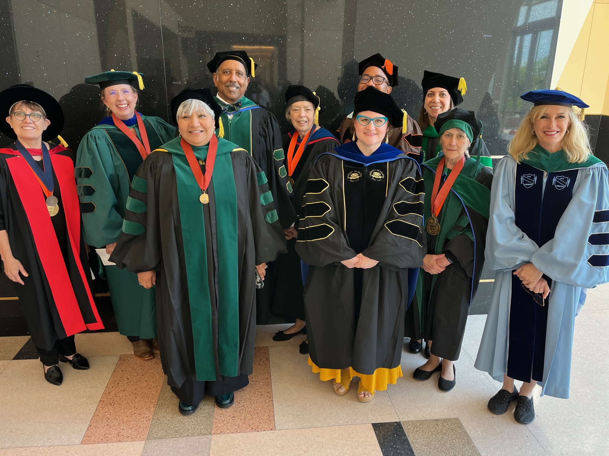  JSSOM Leadership  Congratulations to the UTMB John Sealy School of Medicine Class of 2023. Our commencement ceremony was Saturday, June 3rd, at Moody Gardens, with 225 students receiving their MD degrees. Bernard Harris, MD, a UTMB SOM alumna and former astronaut, served as keynote speaker. Bernard Karnath, MD, professor in the Department of Internal Medicine, was selected as senior faculty marshal and macebearer. Thank you to all faculty and staff who helped make this year’s commencement a tremendous success!  The ceremony was recorded and can be viewed at the following link: https://www.youtube.com/watch?v=lajjVKKCcW4 |  |  | MONTHLY CYBERSECURITY UPDATE  How are we doing:  During the month of May, 3.1% of recipients opened an attachment or revealed credentials in simulated phishing attacks initiated by the Office of Information Security. Our goal is less than 3%. A breakdown of department success and failure rates can be found at https://utmb.us/66g. Learn more about cybersecurity at https://www.utmb.edu/infosec. Report potential phishing to cirt@utmb.edu.  Are you security ready for Hurricane Season:  Even as the days are getting longer, hotter and potentially stormier, it is not too late to get ready for hurricane season. All UTMB employees, faculty and students are encouraged to make or update personal action plans to protect themselves, their families and their property in the event of a hurricane landing. While you are at it, please take the time to ensure your and UTMB’s ability to continue providing critical services (or quickly recover the ability to do so) by completing the following security related activities:  All UTMB information system users:  - Change your password now. Resources to assist users in changing their passwords may not be available during a storm.  - Move or copy any work-related data from desktop or mobile computers to OneDrive, SharePoint or other institutional storage.  - Plan to protect, move or secure any in-place information resources prior to leaving for the storm.  - If you need to work remotely during or after a hurricane, ensure the “Remote Access” role is enabled for your account. Ensure you have enrolled a device (mobile phone) for Duo two-factor authentication and be sure to test your remote access (access to storefront.utmb.edu, VPN and Office 365) before you need it.  System, Application or Database owners:  - Check with Information Technology Services (ITS) to confirm tiering level for all servers, systems and applications. This will ensure appropriate service restoration priority after the storm.  - Confirm reliable backups of servers and systems are being performed and test restore and recovery processes.  - Prepare or update contact information for any critical staff, service providers and vendors.  Hurricanes can form quickly, so don’t wait to begin these activities. You can contact ITS or the Office of Information Security by calling the Helpdesk at (888) 898-2401. Thank you for being Security Aware (and be safe out there).
OPICS  LEGEND | PATIENT CARE EDUCATION & RESEARCH INSTITUTIONAL SUPPORT CMC
AROUND UTMB (Use the legend above to quickly find items of interest to your team)
Welcome to the new UTMB Health System Chief Financial Officer Jennifer “Jenny” Sarpalius:  On June 5, Jennifer “Jenny” Sarpalius, CPA, officially assumed her position as a vice president and chief financial officer with the UTMB Health System. A seasoned health care finance executive, she has held CFO positions with LCMC Health, Louisiana; Cancer Treatment Centers of America, Florida; and CHI St. Luke’s, Houston. Thank you to David Gruener for graciously filling in as interim CFO during the search process for this position, as he has been a tremendous asset and has provided excellent leadership. Sarpalius’s appointment was first announced in a March 20 message from Tim Harlin, executive vice president & CEO of the UTMB Health System.  UTMB Police: Timely warning and motor vehicle theft notice: UTMB campuses are being targeted by the regional trend of late-model General Motor pickup truck thefts (specifically GMC trucks) in the League City, Webster and Friendswood areas. If you own one of these vehicles, take extra precautions if you can. For additional information on these thefts and safety tips visit https://utmb.us/8un. And remember, if you see something or someone that looks out of place, immediately call UTMB Police at (409) 772-2691 or 911 if you feel unsafe or are at an off-campus UTMB facility.  Mini-URL: Tool to shorten UTMB web links for sharing: “Mini-URL” is a UTMB web-based service that takes long web links (URLs) and compresses them into fewer characters to make a link that is easier to share on social media and in text messaging, email, presentations and publications. UTMB’s Mini-URL tool is for university business. To help prevent abuse or misuse, the tool is on UTMB’s intranet and users are required to log in with their UTMB credentials. Any URL can be shortened, including SharePoint links, video streams, intranet pages and external web pages. To learn more, visit https://utmb.us/8v8 Or, use the app at https://intranet.utmb.edu/mini-url.  REMINDER  Recognizing professionalism in the workplace:  Have you witnessed a positive act of professionalism? UTMB’s Professionalism Committee is looking for members of the UTMB Community who demonstrate the ideals of professionalism. To share your story, visit https://utmb.us/8s9. For information, visit www.utmb.edu/Professionalism/. |  |  | PATIENT CARE  Attention all Epic Schedulers and Referral Coordinators—Registration & Referral Activity Updates coming July 9  Whether you are scheduling a new patient, revising registration information during check-in, or updating referrals and authorizations in Epic, these activities will look different on July 9. Please register for a webinar to gain and understand the similarities and differences to tasks you currently complete. ‘Using the Updated Registration and Referral Activity’ webinar will be offered from June 15 to July 7. To register for a session today, visit UTMB Class Schedule Manager. Filter the training calendar through the By Application filter and select New Activity: Registration & Referral Activity.  Medical Staff Services: new E-Privileges tool:  UTMB has a new software, E-Privileges, used to display provider demographic information, appointment data, privileges and more. The tool allows users to search providers by last name, specialty, department, privilege form and privilege item. To search providers by privilege form, select the 'Privileges' button on the left menu bar and then view individual providers by selecting specific names. To access the tool, click https://epriv.asm-cloud.com/app-3/utmb, or visit the Medical Staff Services webpage at www.utmb.edu/mss/home. For questions, contact Sonia Morales Soto at (409) 722-5287.  Health Information Management: Physician Orientation Handbook now online: The Medical Record and Health Information Management Services Handbook—designed to orient faculty, house staff physicians and ancillary heath care professionals—is now available on the Health Information Management webpage at www.utmb.edu/HIM. For questions, contact Le Ochia Bonilla at (409) 772-9275.  Latest issue of the Health System Heartbeat newsletter is here: Check it out at utmb.edu/heartbeat. The Health System Heartbeat newsletter features stories and photos about the people, programs and departments that make up the UTMB Health System. There's still time to contribute your news, kudos, favorite recipes, fun photos and story ideas for June. Email mmbattis@utmb.edu.  REMINDER: June 13 Memorial Tribute for Dr. Josette Armendariz-Batiste: You’re invited to join a Memorial Tribute celebrating the life of Dr. Josette Armendariz-Batiste at 4 p.m., June 13 in Levin Hall Main Auditorium with a reception to follow in Levin Hall Foyer. For an online streaming option, please visit https://vimeo.com/event/3414640.  Transitioning to new Productivity and Staffing Solution: Effective June 12, the UTMB Decision Support team will discontinue its use of the Berkley Research Group’s (BRG) DRIVE analytic platform and will transition to a homegrown Productivity and Staffing solution. The new tool has a comparable user experience but provides more customization and responsiveness to UTMB needs. New applications to expand the analytics capabilities beyond what DRIVE offered will continue to be developed and deployed.  EDUCATION & RESEARCH  SAVE THE DATE: Research Quarterly Update set for Aug. 22:  The next Research Quarterly Update will take place on Aug. 22 beginning at 11 a.m. via MS Teams. The meeting is open to all faculty, staff and trainees who are interested or involved in research at UTMB. The agenda will include Dr. Carole Tucker with updates on the Center for Health Promotion, Performance, and Rehabilitation Research (CHPPRR) and Dr. Peter Cram with an overview on the Center for Health-system Improvement (CHI). Add the Research Quarterly Update to your Outlook calendar here: https://utmb.us/8vl.
DID YOU KNOW?
The John Sealy School of Medicine held its MD commencement ceremony on Saturday, June 3, at Moody Gardens Convention Center, with 225 students receiving their medical degrees. Former NASA astronaut and current CEO of Vesalius Ventures, Dr. Bernard A. Harris, Jr., served as keynote speaker. Dr. Bernard Karnath, professor in the Department of Internal Medicine, Division of General Medicine, was selected by the graduating class to serve as Senior Faculty Marshal and mace-bearer. Congratulations to the Class of 2023!

