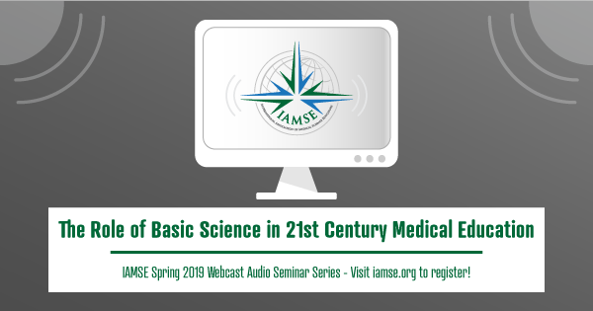

Listed below are the details needed to participate in the upcoming IAMSE Web Seminar:
"Role of Foundational Sciences in Clinical Years," presented by Dr. Kimberly Dahlman.
We will broadcast the webinar through Go To Webinar. As soon as possible, please click the following link to register with Go to Webinar for the March 21, 2019 12:00 PM ET session.
A WAS Institutional subscription may be shared with the faculty within your organization only. The connection information may not be shared with other universities/locations.
To view the webinar, visit: https://attendee.gotowebinar.com/register/5471321988817778690
After registering at the link above, you will receive a confirmation email containing information about joining the webinar.
AUDIO INSTRUCTIONS: You will listen to this presentation through your computer speakers. There is no phone number required, or available, to access the audio. Go to Webinar gives you the option to test your computer/audio compatibility, please do this prior to the webinar.
​
The questions for the Q&A portion of the webinar will be submitted through GoToWebinar during the session.
Session Extras:
Handouts - http://www.iamse.org/wp-content/uploads/2019/03/Role-of-Foundational-Sciences-in-Clinical-Years-Handouts.pdf
This session will become an archived presentation for registered participants, so it will be recorded for future use by IAMSE. Registration for this event will indicate your permission to be recorded if you choose to speak. If you wish not to be recorded, you choose not speak, or please do not register for the live presentation of this event. Please note: recording of any kind by participants is strictly prohibited.
Additional information regarding IAMSE Webcast Audio Seminar programs, including access to past events and the schedule of upcoming events, is available here.
Please feel free to contact the IAMSE office by e-mail at support@iamse.org if you need any assistance.
Thank you,
IAMSE WAS Committee

