Ben
Weekly Relays User Guide
TOPICS LEGEND
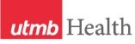 |  | WEEKLY RELAYS |  | Feb. 15, 2018
YOUR DEPARTMENT NEWS |  |  | UTMB NEWS
OCE  The rising MS3 Clerkship Site Selection meeting, which will be hosted by the Office of Clinical Education, is scheduled for Monday, February 26, 2018 from 5:00 – 7:00 pm in Levin Hall South.  OSAA  NRMP rank lists close 2/21 at 8 pm our time. Wishing the best for all of our students!  OEA  Faculty and educators from across UTMB went to the 2018 Innovations in Healthcare Education Annual Meeting on February 15 – 16 in Austin, TX. Our research and scholarship were highlighted with numerous posters, presentations, and workshops, several winning awards. Below is a list of all the UTMB presenters. Please congratulate them on their efforts!  Michael Ainsworth, Karen Szauter, Era Buck. Standardized Patient-based Clinical Skills Assessment for Undergraduate Pre-medical Students: Building EPA 1 Competencies Prior to Medical School  2017 GRANT Awardee: project presentation  Suzanne Alton, Sheba Luke, Maureen Wilder. Using Technology to Conduct Clinical Site Visits  Maria Ansar, A Dimet, CB Levine, A Miller, J Moon, C Rice, A Schaeffer, J Andersson, S Ekpo-Out, E McGrath, H Sarraj. Attitudes of Medical and Graduate Students in the Biomedical Sciences Before and After Interprofessional Experiences (abstract of distinction, invited for oral presentation)  Daniel Antiporta, H Serag, A Pezo, CM Reátegui-Rivera, MM Dacso. Training in Leadership for Global Health: A proposed framework for the Global Health Leadership Academy at the University of Texas Medical Branch  3rd place poster award  Ashraf Aly, Huda Sarraj, Ola A Aly. Does Pre-testing Improve Medical Students’ Performance in the Classroom? POSTER AWARD FINALIST  Lisa Elferink, Majka Woods, Era Buck. National Board of Medical Examiners Customized Assessment Services for Undergraduate Medical Education – Lessons Learned. POSTER AWARD FINALIST  Sharon Forest, Sandra Priest. Interactive Tools for Teaching Quality Improvement (abstract of distinction, invited for oral presentation)  Philip F. Lavere, Harold S. Pine, Karen Szauter. Fostering Medical Student Interest in Otolaryngology through Early Interactive Workshop Exposure: A Model for Medical Education.  Michael Miller. Diagnostic Appreciation: Understanding the Origins and Meaning of Diagnosis for the Patient  Premal Patel, Caley Satterfield, Matthew Dacso. Moving Beyond Cultural Competence to Cultural Humility in Global Health Training: The Bafa Bafa Experience at the University of Texas Medical Branch POSTER AWARD FINALIST  Judith Rowen, Christine Ford, Premal Patel. Treatment Adherence: An Experiential Workshop for Students  Caley Satterfield, Mary T. White, Jason T. Blackard. Building Research Skills in Global Health Trainees: A Multi-Institutional Collaboration POSTER AWARD FINALIST  P. Darlene Self, Era Buck, Karen Szauter. Acknowledging disability: Are students prepared to bridge the gap? 2nd Place POSTER AWARD  Amy Shanks, Karen Szauter, P. Darlene Self, Bill Boudreaux. Creating Self-Paced Videos to Streamline Standardized Patient Feedback Training  Karen Szauter, Dawnelle Schatte. Medical Student Documentation of Patient’s Substance Use  Karen Szauter, Lisa Elferink, Michael Ainsworth, Majka Woods, Ruth Levine, Judith Rowen Identification of At Risk Students  Mark Wolffarth, Bruce Niebuhr, Virginia Niebuhr. Building an App for a Pediatric Residency Program: The Process and Utility POSTER AWARD FINALIST  CONFERENCE PRESENTATIONS:  Preconference Workshop: Erin Hommel, Lindsay Sonstein How to Teach Quality Improvement: A Train the Trainer Workshop  Workshop: Karen Szauter, Era Buck, Mark Holden, Majka Woods Assessing Humanism: Perspectives of Simulated Patients  Innovation Award Finalist (3rd place winner): Celia Chao Integration of Leadership Training for Graduate and Medical Students Engaged in Translational Biomedical Research |  |  | Monthly financial update—January:  - For the month of January, our bottom line (adjusted margin) was a negative $6.8 million, which is $6.8 million behind where we had planned to be.  - For FY2018 to-date, through the end of January, our bottom line was a negative $18.3 million. This is off target by $27 million.  - The primary reasons for this budget shortfall are Hurricane Harvey losses and lower-than-expected revenue, due in large part to the complexity of the patient cases we have actually seen this fiscal year versus what we had planned to see (referred to as “acuity” and “case-mix index”).  - To return to budgeted levels, we are:  - Pursuing more complex (or higher acuity) cases  - Reducing non-personnel expenses  - Reviewing our clinical documentation and coding efforts  - Reviewing physician and clinic volumes to increase access to care  - Reviewing inpatient cases for cost and utilization improvements  - At the Jan. 24 Town Hall, UTMB President David Callender gave a comprehensive update on the university’s finances, including where we stand relative to budget this fiscal year-to-date. You can view this presentation at https://www.utmb.edu/townhall/. The topic will also be discussed at Mondays in March presentations. For the schedule and information on Mondays in March, visit https://www.utmb.edu/mondays-in-march.  Best Care update:  On Feb. 9, UTMB received its first-quarter performance report for the 2018 Vizient Quality and Accountability Study. Our current overall ranking is No. 2 among the study’s 96 participating academic medical centers. As shown in the table below, we have made significant improvements across most of the domains covered in the study. We continue to maintain our gains in mortality and safety. The results show that UTMB has opportunities for improvement in patient centeredness (measured by our patient satisfaction survey scores). For information, please visit http://intranet.utmb.edu/best-care.  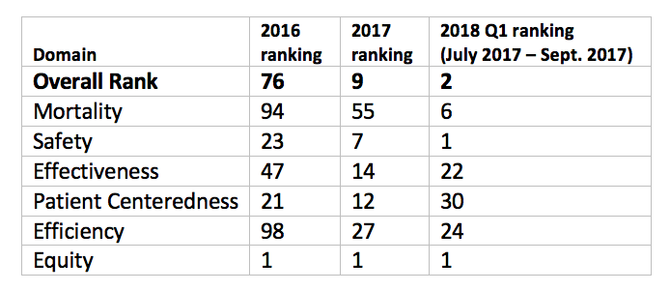
TOPICS  LEGEND | PATIENT CARE EDUCATION & RESEARCH INSTITUTIONAL SUPPORT CMC
AROUND UTMB (Use the legend above to quickly find items of interest to your team)
SAVE THE DATE  Health Care Innovation lecture series begins April 23:  If you could imagine the future of health care – a future without boundaries – what would it look like? If you could change any rule to create a better care experience for patients or staff, what would it be? How would you cure a disease or improve patient access to the system? Join us on April 23 to kick off this new lecture series sponsored by the UTMB Health System and Academic Enterprise as Futurist Garry Golden explores the “Health Care Delivery System of the Future.” Hosted by the Chief Medical and Clinical Innovation Officer, Dr. Gulshan Sharma, the event will be held from 11:30 a.m. to 1 p.m. in Levin Hall Main Auditorium on the Galveston Campus and is open to all.  2018 Leone Awards call for nominations:  Nominations are now being accepted for the 2018 Nicholas and Katherine Leone Award for Administrative Excellence. This award recognizes managers/supervisors who display the highest degree of professionalism and comes with a $7,500 monetary prize – $2,500 for the winning manager/supervisor and $5,000 for the development and training of his or her department/unit. The deadline for nominations is Feb. 28. See http://hr.utmb.edu/tod/leone/ to learn more about the award or to submit a nomination.  REMINDER  Osler Academy call for nominations:  This year, two new William Osler Scholars in the John P. McGovern Academy of Oslerian Medicine will be selected for an endowment to support each scholar’s activities related to patient care and teaching. The endowments are funded by the John P. McGovern Foundation of Houston, which is named for the prominent Houston physician and philanthropist. The successful candidates exemplify the principles of highly competent, humane, compassionate, patient-centered care and teaching embodied by Sir William Osler. The deadline for nominations is noon, March 9. For more information, visit www.utmb.edu/osler/Scholars/FacultyScholars. |  |  | The Joint Commission Question of the Week:  Contact precautions provide barriers that help reduce the chance of spreading infections to other patients, staff and visitors. Personal protective equipment used during contact precautions typically consists of gloves and gowns, and in some instances, facial protection. What is the difference between Droplet and Airborne Precautions?  Answer: Droplet Precautions are used for a variety of infections (such as the flu and meningitis) and require the use of a surgical or procedure mask to enter a patient’s room. Airborne precautions are required for infections such as pulmonary tuberculosis and chickenpox and require the use of an N95 respirator or PAPR (powered air purifying respirators). Health care workers who use a respirator must first receive medical clearance and must either be fit-tested for an N95 respirator or trained to use a PAPR. For questions, contact Healthcare Epidemiology at (409) 772-3192 or page (409) 643-3133.  CMC—Hospital Galveston metrics:  Metrics at Hospital Galveston for the month of January 2018 and Fiscal Year-To-Date (FYTD) 2018:  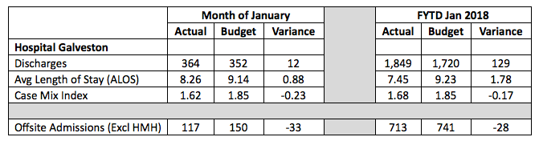  HMH: Huntsville Memorial Hospital
DID YOU KNOW?
Health sciences education continues to be a primary focus and an enormous source of pride for us at UTMB as we work to do our part to resolve the shortage of physicians, nurses and health care professionals in Texas and train tomorrow’s biomedical scientists. According to the latest Data Reference Card published last month, enrollment at UTMB’s four schools for the Fall 2017 semester was 3,302, a more than 40 percent increase from enrollment in the Fall 2008 semester. Other notable facts about student enrollment: 3,083 indicate they are a resident of Texas; 69 percent of students are female while 31 percent are male. For more information about enrollment and other UTMB statistics, check out the Data Reference Card online at www.utmb.edu/business.

