Ben
Weekly Relays User Guide
TOPICS LEGEND
 |  | WEEKLY RELAYS |  | March 29, 2018
YOUR DEPARTMENT NEWS |  |  | UTMB NEWS
Note from Dr. Mouton  Over the past year, I have observed the outstanding work of many of our Office of Academic Affairs team members. Many members have, and continue to go, above and beyond the “call of duty.” I plan publically recognizing the work of individuals that go the extra mile or provide a “little lagniappe” in support of the great work of the Office of Academic Affairs. And to personally show my appreciation, I am calling the new column “VDAA Accolades.” Thank you to all the members of the Office of Academic Affairs team for your continued great work.  Best Regards  Charles Mouton  OCE  Save the Date: The 19th Annual Teachers of Distinction Awards Banquet (Top Doc) will be held on Saturday, October 20, 2018 at Moody Gardens Hotel Spa and Convention Center.  The Award Ceremony is a recognition of excellence in community-based education.  IMO  Megan Bates, Coordinator II, will start on April 21, 2018.  OSAA  Save the Date: Match Workshop April 25, 5 pm Levin Hall |  |  | UTMB Breast Health and Imaging Center re-accredited by NAPBC:  UTMB’s Breast Health and Imaging Center has been re-accredited by the National Accreditation Program for Breast Centers (NAPBC), a program administered by the American College of Surgeons. The three-year full accreditation is presented to centers that provide the highest level of quality breast care and demonstrate compliance with standards established by the NAPBC for treating women who are diagnosed with the full spectrum of breast disease. For more information about the National Accreditation Program for Breast Centers, visit www.accreditedbreastcenters.org.  Dr. Sharma named one of Becker’s CMOs to know in 2018:  Dr. Gulshan Sharma, vice president and chief medical and clinical innovation officer, has been named among Becker’s Healthcare “100 hospital and health system CMOs to know | 2018.” The list features national physician leaders dedicated to strengthening their organizations through physician leadership development, patient safety and quality improvement.  ACTION ITEM  Annual TB screening:  The deadline for all health care workers to complete their annual tuberculosis screening for FY18 is May 31. Annual TB screenings are a condition of continued employment for anyone who provides direct patient care, enters patient rooms and/or comes within six feet of patients in the course of his or her duties. To assist with this requirement, TB testing will be offered:  - Jennie Sealy Hospital: April 3, 5, 10, 12, 24 and 26 and May 1, 3, 8, 10, 22 and 24  - League City Campus Hospital: April 17 and 19 and May 15 and 17  - Employee Health Clinic on the Galveston Campus: Monday through Friday  For details about these TB testing opportunities, see https://hr.utmb.edu/ehc/tb/. Health care workers at UTMB’s Angleton Danbury Campus, clinics and inpatient units should contact their supervisors or Employee Health at (409) 747-9172 for TB testing assistance.  UTMB’s newsletter Impact wants to know—What’s your hidden talent?:  Do you crochet hats for cats, run ultra marathons or know how to juggle while riding a unicycle? Let the Impact team know! Based on feedback from a recent reader survey, the Impact team is looking to add a section highlighting UTMB employee talents—from the quirky and random to the athletic and academic. Email impact.newsletter@utmb.edu with your hidden talent for a chance to be featured in an upcoming edition.
TOPICS  LEGEND | PATIENT CARE EDUCATION & RESEARCH INSTITUTIONAL SUPPORT CMC
AROUND UTMB (Use the legend above to quickly find items of interest to your team)
REMINDERS  UT System Spring 2018 Wellness Challenge:  The last day to register for the Keep UT System Active wellness challenge is April 9. The four-week challenge is open to all UT SELECT medical plan members and dependents age 18 and above, and those who log 100 or more points will be eligible for rewards. Sign up at www.utlivingwell.com or see iUTMB for more details.  ANGLETON DANBURY CAMPUS  Rape Aggression Defense (RAD) class planned for April 13-14:  The UTMB Police Department will host its Rape Aggression Defense (RAD) class April 13 from 5 to 9 p.m. and April 14 from 9 a.m. to 5 p.m. in the POB II, Auditorium on the Angleton Danbury Campus. RAD, which is a 12-hour basic self-defense class for women, embodies a practical blend of threat avoidance strategies and real-world assault resistance tactics. UTMB Police offer the class for free to any female 13 and older. New students are required to attend both classes for completion. Contact Sgt. Shawn Carr at sdcarr@utmb.edu. Register online at https://goo.gl/forms/fnSZgg9Y3aGOUjYD3.  IN CASE YOU MISSED IT  Mondays in March:  All four Mondays in March sessions—including updates from the Health System, Academic Enterprise, Business and Finance and the executive leadership panel—are now available at https://www.utmb.edu/mondays-in-march.  SAVE THE DATE  Employee Service Day:  UTMB will honor the ongoing commitment of our faculty and staff at the 2018 Employee Service Day ceremony on May 16. Stay tuned for more details.  Epic 2017 upgrade open house:  Clinical Information Services will host an Epic Open House to provide a hands-on preview of Epic’s new version enhancements that will go live on June 2. Don’t miss your chance to provide feedback that will help the build team ensure these new tools are user friendly and streamline your workflow. Open house hours will be:  - April 16-17: 1.146 Rebecca Sealy training room from 8 a.m. to 4 p.m.  - April 18-19: 1.179 Primary Care Pavilion training room from 7 a.m. to 4 p.m.  - April 20: 1.148 Rebecca Sealy training room from 8 a.m. to 4 p.m.  Open house dates for the League City and Angleton Danbury campuses will be announced in the next Weekly Relays. Stay tuned.  Epic Radiant for ordering providers:  On April 10, providers will notice an increase in the number of available imaging orders from approximately 300 to 1,200 orders. This is the first phase of the implementation of Radiant, a new module in Epic that will replace UTMB’s current Radiology Information System. This will give physicians a chance to get acquainted with the new ordering system before it officially goes live June 2. Radiant will help make finding specific exams easier and more intuitive. Please note that current preference lists, including imaging orders, will need to be updated. During the month of May, radiology staff will begin training in the new system. Additional information and pertinent workflow bulletins are available at http://intranet.utmb.edu/emr/Radiology.asp.  Decision support for medication refill protocols—healthfinch rollout begins:  Did you know that UTMB receives approximately 1,000 refill requests per day? Many steps are taken by physicians and staff daily to ensure refills are completed in a safe and efficient manner. To help make this process even easier, UTMB recently successfully piloted a new tool in Epic called “healthfinch” in select adult primary care clinics: family medicine, internal medicine, and Pediatric and Adult Primary Care, Texas City. Beginning April 3, the tool will be implemented in all adult primary care and geriatrics clinics. In June, the tool will be implemented in pediatrics clinics and all clinics offering OB/GYN services. The tool will be available in all specialty clinics in July. Online training (webinars) and informational materials will be supplied to each clinic prior to go-live; the materials may also be accessed at http://intranet.utmb.edu/emr.  Nurses on Board Development and Leadership Training Program:  UTMB will host a Nurses on Board Development and Leadership Training Program during the 2018 Health System & Nurses Week. The session will be held on May 9 from 8 a.m. to 5 p.m. on the Galveston Campus. The training, offered through Texas Healthcare Trustees (THT) and Texas Team Advancing Health through Nursing, is intended to increase nurse participation on health care and community boards of directors. The program was developed in response to a charge by the Institute of Medicine to “prepare and enable nurses to lead change to advance health,” as published in the report, The Future of Nursing: Leading Change, Advancing Health (2010). An application for the training is required. Information on the event and a link to the application can be found on the Nurses on Board website at http://tht.org/Education/Conferences-and-Seminars/Nurses-on-Board/Upcoming-Events. |  |  | The Joint Commission Readiness Questions of the Week:  What is allowed to be stored in the corridors?  Answer: Nothing can be stored in corridors. TJC and other regulatory standards require that means of egress be free of clutter. The three components of the means of egress are: EXIT access (the corridor), the EXIT itself (the door), and the EXIT discharge (the sidewalk/walkway path to safety). If an item is in a corridor for longer than 30 minutes, TJC considers it “stored.” Exceptions include crash carts, isolation carts, patient lift and transport equipment as well as chemo carts that are in use, and wheeled items “in use” (attended within the last 30 minutes) – this is timed.  Can I store oxygen cylinders in the Nurse Station? What do I do with loose oxygen cylinders?  Answer: Improper handling and storage of oxygen cylinders can potentially turn a cylinder into a lethal projectile. Improperly segregated cylinders can put patients at risk if a cylinder is accidentally used that does not contain an adequate supply of medical gas. Cylinders must be segregated and separated by FULL and EMPTY/PARTIAL so that staff select the proper cylinder during emergency situations. Cylinders must be physically secured in a rack, a cart or in an enclosure designed for such cylinders. For details on storage and safe use of oxygen tanks, please view the Spotlight on Oxygen Safety available on UTMB’s Joint Commission website at https://utmb.us/1sn. If you find a loose oxygen cylinder, place it in a rack or cart until it can be picked up. If you do not know the location of a rack or a cart, notify your nurse manager immediately.
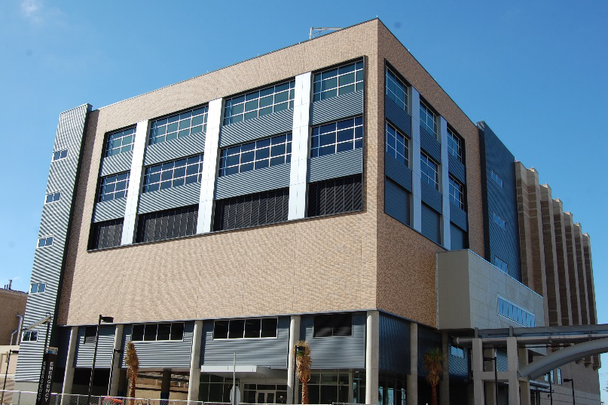
DID YOU KNOW?
The new Research Building 17E on the Galveston Campus enhances UTMB’s research space and will include state-of-the-art equipment as well as safeguards against future destructive forces such as hurricanes. The building features a behavioral core that supports research into addiction, traumatic brain injuries, learning and memory. It also provides easy access to the Mary Moody Northen Pavilion and the Truman Graves Blocker, Jr. Medical Research Building. The first four levels of Research Building 17E are scheduled to open next month, with the sixth level, featuring a sky bridge, scheduled to be operational in December.

REMINDERS
CMC—Annual training deadline:
All CMC annual training is to be completed by March 31. If you have not completed this training, please do so by the end of this week.

CMC—Hospital Galveston metrics for February 2018:
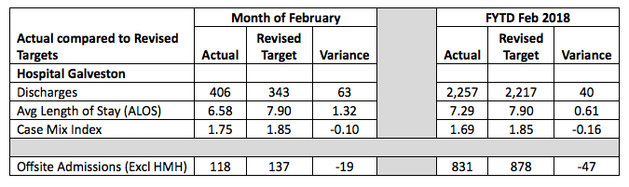
HMH: Huntsville Memorial Hospital

