Ben
Weekly Relays User Guide
TOPICS LEGEND
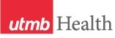 |  | WEEKLY RELAYS |  | April 5, 2018
YOUR DEPARTMENT NEWS |  |  | UTMB NEWS
No news to report. |  |  | BEST CARE  Second period results:  The period two results for the 2018 Vizient Quality and Accountability Study are in and UTMB remains in the Top 10 among the study’s 95 participating comprehensive academic medical centers with a current overall ranking of No. 5. As indicated in the chart below, UTMB continues to do well across most domains, with the exception of safety, where we slipped to No. 27. Ongoing efforts to reduce healthcare-associated infections and perioperative and post-operative complications are in progress to help us regain our standing in the safety domain in the next period’s results.  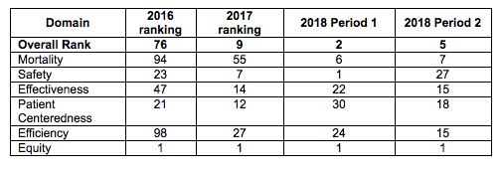  National Emergency Preparedness Drill, April 10-13:  UTMB will take part in a federal national preparedness drill over several days next week, including an activity that will simulate a patient with Ebola being transported to the Galveston Campus on April 12. The exercise, coordinated by the Department of Health and Human Services, involves more than 50 organizations across the nation and is the largest patient-movement exercise in HHS history. The exercise is designed to test and validate domestic procedures and capabilities to move patients with highly infectious diseases from local hospitals to designated Regional Ebola Treatment Centers. There is no actual Ebola virus involved in the drill. Participating in trainings and exercises is one of several requirements for the nine designated regional centers and helps the nation be better prepared to safely move patients who are seriously ill or injured to specialized treatment centers such as UTMB.  Safety Tip—See Something, Say Something:  In light of recent criminal events involving explosions of packages, University Police at UTMB want to remind our community that the likelihood of UTMB students, staff or faculty receiving a package, briefcase, suitcase, backpack or letter containing an explosive or other harmful contents is remote. However, it is important that everyone remains vigilant in taking precautions against any potential threats related to suspicious packages. To learn more about how you can help, please visit https://utmb.us/2nw.
TOPICS  LEGEND | 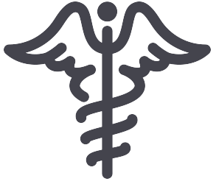  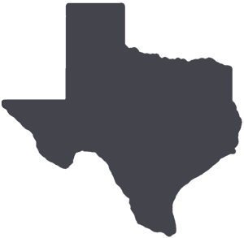  PATIENT CARE EDUCATION & RESEARCH INSTITUTIONAL SUPPORT CMC
AROUND UTMB (Use the legend above to quickly find items of interest to your team)
UTMB Safe app: The UTMB Safe app, which allows students and employees to access various law enforcement contacts and support resources, is available for download on the Google Play and iTunes app stores. Mobile Blue Light (available on the Galveston Campus only) allows the user to send his or her current location and initiate a phone call to the UTMB emergency number, similar to one of the stationary “blue light” emergency call boxes on the Galveston Campus. Having the technology available on a mobile device means subscribers have access to the call-box service anywhere on campus. Virtual Walk Home, which is only available on the Galveston Campus and immediate surrounding areas, allows users to request a police telecommunicator to monitor their real-time progress as they walk from one location to another. Learn more about the app at https://itunes.apple.com/us/app/utmb-safe/id1270366512?mt=8.  BEST CARE  Antimicrobial Stewardship Program update:  UTMB’s Antimicrobial Susceptibility Profile (Jan. through Dec. 2017) is now available https://utmb.us/2nv. This profile provides local susceptibility rates and serves as an aid in selecting empiric antibiotic therapy, and in monitoring resistance trends over time. The profile and more information on UTMB’s Antimicrobial Stewardship Program can also be found at http://intranet.utmb.edu/best-care/HPVO/antiobiotics/default.asp.  REMINDERS  Epic Radiant for ordering providers:  On April 10, providers will notice an increase in the number of available imaging orders from approximately 300 to 1,200 orders. This is the first phase of the implementation of Radiant, a new module in Epic that will replace UTMB’s current Radiology Information System. This will give physicians a chance to get acquainted with the new ordering system before it officially goes live June 2. Radiant will help make finding specific exams easier and more intuitive. Please note that current preference lists, including imaging orders, will need to be updated. During the month of May, radiology staff will begin training in the new system. Additional information and pertinent workflow bulletins are available at http://intranet.utmb.edu/emr/Radiology.asp.  The Joint Commission Readiness Questions of the Week: Life Safety  During a fire or fire alarm, hospitals allow occupants to “defend in place.” What does this mean?  Answer: Defend in place means in a fire situation, only the occupants on the fire floor or those in the immediate area of the fire need to evacuate.  Why doesn’t everyone need to evacuate?  Answer: In health care organizations, designated fire doors separate hospital floors into “smoke compartments.” Fire doors are usually kept closed or are set to automatically close when a fire alarm sounds to prevent the spread of fire and smoke. It is important to ensure that these doors always remain clear of equipment and furniture and have not been rigged to prevent them from closing or latching. Fire doors are only able to prevent the spread of smoke or flames if they are able to close and latch!  When is it appropriate to evacuate?  Answer: Occupants within the immediate area of a fire should evacuate to an adjacent smoke compartment, unless the fire expands or the fire department dictates otherwise. If occupants outside of the immediate fire area see smoke or other conditions that dictate the need to evacuate, they should do so without waiting for instruction from the fire department.  How do we move patients during a fire evacuation?  Answer: Patients should be evacuated horizontally first, meaning they are moved to the adjacent smoke compartment on the same floor. If patients need to be evacuated to another floor, fully ambulatory patients should be moved first, utilizing the stairwell. Patients who need assistance moving down stairwells should be moved with a specially-designed Sked stretcher, found in most units of the hospital. Not every unit is required to have a Sked; however, areas where it is likely that a patient would need to be moved by stretcher should have Skeds available. Environmental Life Safety keeps several extra available, should an area need one. Training on the use of Skeds is also available. Please contact Brent Sparks, occupational safety and fire prevention specialist, for more information at brespark@utmb.edu. |  |  | Nurses on Board Development and Leadership Training Program:  UTMB will host a Nurses on Board Development and Leadership Training Program during the 2018 Health System & Nurses Week. The session will be held on May 9 from 8 a.m. to 5 p.m. on the Galveston Campus. The training, offered through Texas Healthcare Trustees (THT) and Texas Team Advancing Health through Nursing, is intended to increase nurse participation on health care and community boards of directors. The program was developed in response to a charge by the Institute of Medicine to “prepare and enable nurses to lead change to advance health,” as published in the report, The Future of Nursing: Leading Change, Advancing Health (2010). An application for the training is required. Information on the event and a link to the application can be found on the Nurses on Board website at http://tht.org/Education/Conferences-and-Seminars/Nurses-on-Board/Upcoming-Events.
DID YOU KNOW?
Based on recommendations outlined in February’s site visit by the Southern Association of Colleges and Schools Commission on Colleges, UTMB’s mission statement was recently updated. The expanded mission statement now reads:

“UTMB’s mission is to improve health for the people of Texas and around the world by offering innovative education and training, pursuing cutting-edge research and providing the highest quality patient care.”

The statement was expanded on the recommendation of an off-site review committee to more fully depict and distinguish our work as an academic health center.

Academy of Master Teachers accepting membership letters:
The Academy of Master Teachers (AMT) is accepting letters of intent to apply for membership. The application forms and information are available at https://www.utmb.edu/amt/how-to-apply. The deadline to apply is noon, May 21. AMT is an honorary organization recognizing academic leaders and scholarship within the UTMB community of educators. Members are expected to provide service and actively participate in AMT-sponsored events to advance the mission of the organization and to promote the scholarly efforts of advancing educators through mentorship, faculty development and funding. The rewards of membership include reduced registration to annual AMT conferences and eligibility to hold the honorary title of UT Distinguished Teaching Professor in addition to eligibility for endowed professorships. For additional information, contact D’Anne DeWitt, academy coordinator, at vddewitt@utmb.edu or (409) 747-0203.

