Ben
Weekly Relays User Guide
TOPICS LEGEND
 |  | WEEKLY RELAYS |  | February 28, 2019
YOUR DEPARTMENT NEWS |  |  | UTMB NEWS
OCE  The Office of Clinical Education will be hosting the Rising 3rd Year Class Meeting on Wednesday, March 6th at 5:00 pm in Levin Hall North. Y3 scheduling, clerkship tracks, year-round and individual clerkship site selection and other relevant issues will be reviewed.  OEA  Congratulations to Educational Affairs for winning the Houston Livestock Show & Rodeo “Go Texan Day” contest with their Chili Cook-Off event. Educational Affairs was awarded the HLSR bowlegged “H” trophy, as well as ground passes for the cook-off winners.  Chili Cook-Off Winners:  1st Place  Wild West Rodeo Chili – Isaac Ohalete  2nd Place  Dr. Pepper Chili – Crystal Carpenter  3rd Place  Home Spice Chili – Fran Dawe  OED  The OED would like to thank everyone who helped in the interview process for our Senior Medical Educator – Program Evaluation candidate, Dr. Stefanie Carter.  Medical Science Educator, the journal of the International Association of Medical Science Educators (IAMSE), is soliciting articles for a special issue on Team-Based Learning. The deadline for submission is May 1, 2019. OED would love to help you write up your experience with TBL for submission. Please, contact us if we can be of assistance.  OAA  Academic Affairs All-Star Award  The School of Medicine Academic Affairs All-Star Award (AAA Award) has been created to recognize employees within Academic Affairs for going above and beyond. Employees can be recognized by peers, subordinates and supervisors for their outstanding work and the AA All-Star Award can be utilized by any employee in any of the School of Medicine Academic Affairs departments (Office of Continuing Education, Educational Affairs, Educational Development, Instructional Management Office, Office of Clinical Simulation, Office of Clinical Education, Student Affairs and Physician Assistant Studies). The program was implemented February 7, 2019, and we already have several AAA Award recipients.  NAME TITLE DEPARTMENT  Alma Block Administrative Secretary Educational Affairs  Valerie Carmichael Administrative Associate Student Affairs  Erma Ceasar Business Coordinator Student Affairs  Lori DeWillis Assistant Administrator Academic Affairs  Miles Farr Assistant Dean Educational Affairs  Shaine LeGrand Program Manager Clinical Education  Kenisha Moore Clinical Skills Training Coordinator Instruction Management Office  Norma Perez Director, SOM Special Programs Student Affairs  Catalina Salinas Coordinator I Physician Assistant Studies  Trea Smith Business Coordinator Student Affairs  Employee Spotlight  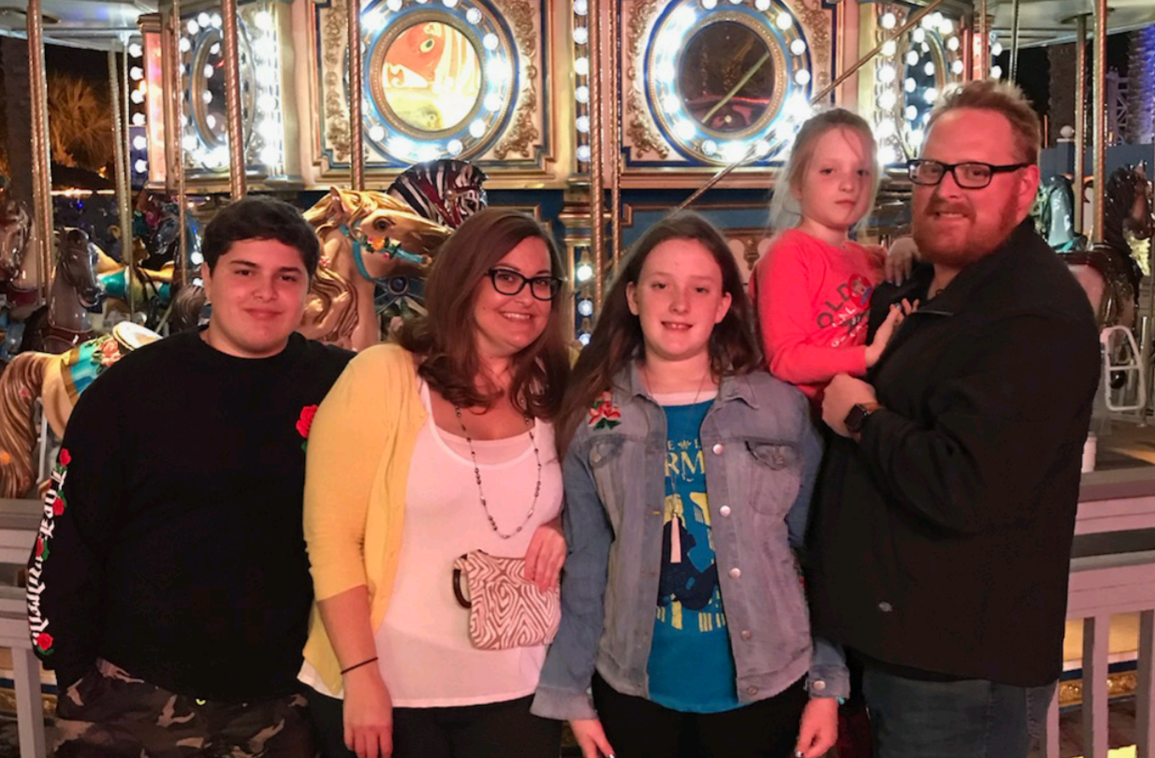  Richard Briley, M.Ed.  Software System Specialist II  Office of Clinical Simulation  What are some of your work responsibilities?  I provide education technology support for the Office of Clinical Simulation (OCS) by managing all components of OCS’s monitoring equipment and software.  Tell us something personal about yourself.  I have been employed at UTMB for 5 years. I was born and raised in Northwest Houston. My wife and I have three kids that keep us busy on most weekends. My hobbies include playing jazz on trumpet or drums, fishing, painting with oil paints and volunteering with my family at a ranch for rescued horses.  Fun Fact  I was a band director for 9 years teaching grades 6th-8th. |  |  | Dr. Barbara Bryant named to Blood Products Advisory Committee of the FDA: Dr. Barbara Bryant, professor and vice chair of Pathology and medical director of UTMB’s Transfusion Medicine program, has been named to the17-member Blood Products Advisory Committee of the Food and Drug Administration. The advisory committee reviews and evaluates available data concerning the safety, effectiveness and appropriate use of blood, products derived from blood and serum biotechnology which are intended for use in diagnosis, prevention or treatment of human diseases. She will serve on this committee until Sept. 20, 2023.  Vote for UTMB in STAT Madness 2019: One of UTMB’s discoveries has been selected to compete in this year’s STAT Madness competition. STAT is a national publication that covers health, medicine and science discoveries. The STAT Madness event is set up like the NCAA’s college basketball March Madness. It is an elimination tournament that pairs different teams against each other in brackets. UTMB’s work growing lungs in the laboratory is in the running in this year’s competition, which begins at 11 p.m. on March 3. Once it begins, you can cast your vote at https://www.statnews.com/feature/stat-madness/bracket/.  Naturally Slim-Apply now for 2019 Spring session: Naturally Slim—the online program that teaches you how to lose weight while eating the foods you love—is back. The 2019 spring session kicks off April 1 and is available at no cost to all UT SELECT medical plan members age 18 and above, including employees, retirees, spouses and dependents. Applications for the upcoming session will be accepted March 4–15 at www.naturallyslim.com/livingwell, and those selected for the program will be notified on March 22. For more information, email info@naturallyslim.com.  REDUCE YOUR USE SUSTAINABILITY INFO SERIES  Sustainability Presentations: In an effort to promote a culture of sustainability at UTMB, Angela McDowell, sustainability coordinator, is available to lead presentations and trainings for groups on campus looking for tips and tricks on how they can reduce their use and impact on the environment. If you or your team is interested, please contact Angela at ammcdowe@UTMB.EDU to arrange a time for her to visit with your group. Presentations vary in length and can be customized to focus on specific topics/concerns for each area.
TOPICS  LEGEND | PATIENT CARE EDUCATION & RESEARCH INSTITUTIONAL SUPPORT CMC
AROUND UTMB (Use the legend above to quickly find items of interest to your team)
REMINDERS
Mondays in March—submit your questions: The 2019 Mondays in March series kicks off March 4 with “The Case for Growth,” a panel discussion featuring Becky Korenek, senior vice president for strategic and business planning; Cheryl Sadro, chief financial officer; and Dr. Vicente Resto, physician executive for growth and associate chief physician executive for the Faculty Group Practice. UTMB President Dr. David L. Callender will moderate the session. To submit questions for consideration during the month-long series, visit https://www.utmb.edu/mondays-in-march/questions. For more information and a full schedule, visit https://www.utmb.edu/mondays-in-march.

Feedback requested: League City Hospital South Tower Patient Rooms: Your feedback is requested on the new inpatient rooms at the League City Campus! Design teams are soliciting your feedback on the functionality of the inpatient rooms as we work to finalize the design for ICU patient rooms (view fully finished room) and medical/surgical patient rooms (headwall only). New areas of the hospital are expected to be operational by mid-2020. You can see mock-ups March 7 from 9 a.m. to noon in Jennie Sealy Hospital, Floor 12 (please take the elevators to Floor 11 where you will be escorted by a member of the Design and Construction team to Floor 12).

DID YOU KNOW?
From Nov. 1, 2018, to Jan. 31, 2019, researchers throughout the university have published – or had accepted for press – 179 publications in 127 unique journals. Findings from 26 of these publications have been reported in news media, and 15 publications have been cited in industry blogs. Additionally, over that same period of time, UTMB researchers were awarded 68 grants totaling more than $13.5 million. More than $11 million of these funds originated from the National Institutes of Health (NIH), with the rest coming from private funds, non-NIH governmental entities and industry/corporate sponsors. The full list of publications and awards was shared in the Feb. 26 Research Quarterly Update and are available online at:
https://research.utmb.edu/home/research-quarterly-updates.

