Ben
Weekly Relays User Guide
TOPICS LEGEND
 |  | WEEKLY RELAYS |  | April 11, 2019
YOUR DEPARTMENT NEWS |  |  | UTMB NEWS
Office of Educational Development  - Please join us on Monday, April 15th for our next Teaching Skills session with Dr. Premal Patel titled “Debunking Learning Myths: Evidence-based Studying Strategies.” It is being offered at both noon and 4 pm; both sessions will be held in room 1.102 in the Mary Moody Northen Pavilion. Please follow this link to register: https://utmb.us/395  - The Office of Educational Development would like to congratulate our graduating Scholars in Education, 2017-2019 Cohort:  Maria Belalcazar, MD  Mohammad Bilal, MD  Marie Dawlett, MD, FAAP  Julianna M. Dean, PhD Candidate, MS, CSCS  Monique R. Ferguson, PhD  Amjad Hossain, PhD, HCLD  Chris Messenger, MS, RD, LD, CNSC  Charles P. Mouton, MD, MS, MBA  Ranjana Nawgiri, MD  Bi-Hung Peng, PhD  Cristiana Rastellini, MD  Patricia Rodriguez, MD  Dawnelle Schatte, MD  Gwenn Scott, RN DNP, FNP-BC  Amy Shanks, MA  Barbara A. Slusher, MSW, PA-C, DFAAPA  Shannon Stevenson, MSN, RNC-OB, CNE  Emma Tumilty, PhD  Natalie Williams-Bouyer, PhD  Physician Assistant Studies  Marci Contreras, MPAS, PA-C. attended the Texas Gulf Coast Physician Assistant Association conference in Houston on April 5, 2019, and made a presentation on “Modern Day Slavery: How Healthcare Providers can Make an Impact in this Growing Epidemic”. She also was the recipient of the 2019 Educator of the Year Award from the Texas Academy of Physician Assistants.  Employee Advisory Council  The UTMB Employee Advisory Council (EAC) exists to foster bi-directional communication and dialog for all Classified, Administrative & Professional (A&P), and Non-Teaching staff, excluding residents. The EAC, which is sponsored and endorsed by the Office of the President, works to promote a positive and collaborative work environment that is committed to assessing, prioritizing and communicating employee needs. It also serves as a focus group/advisory panel by providing a feedback loop on broad issues and potential new programs that can impact Classified, A&P, and Non-Teaching staff, excluding residents. For the purposes of representation on the council, the university is grouped in four large segments: Academic Enterprise, Correctional Managed Care, Hospitals and Clinics and Institutional Support. For more information, please visit the website: https://www.utmb.edu/eac  Employee Spotlight  Paul Shreve, MPAS, PA-C  Assistant Professor of Instruction  Physician Assistant Studies  What are some of your work responsibilities?  Curriculum development, instruction and clinical coordinator.  Tell us something personal about yourself.  Joined UTMB on January 14th of this year. I grew up in Colorado, have 4 children and 2 grandchildren. I love to read, listen to music, am fascinated by medieval history, a “hardcore foodie” and a retired Army veteran.  Fun Fact  I've visited approximately 25 different countries. |  |  | Best Care second-period results:  UTMB recently received its results for the second period of the 2019 Vizient Quality and Accountability Study. Our overall results among the study’s 94 participating comprehensive academic medical centers is No. 9. As shown in the table below, we continue to do well across most domains. We need to focus on continued improvement in length of stay and 30-day readmission rates over the next three months. For more information, please visit http://intranet.utmb.edu/best-care/home.  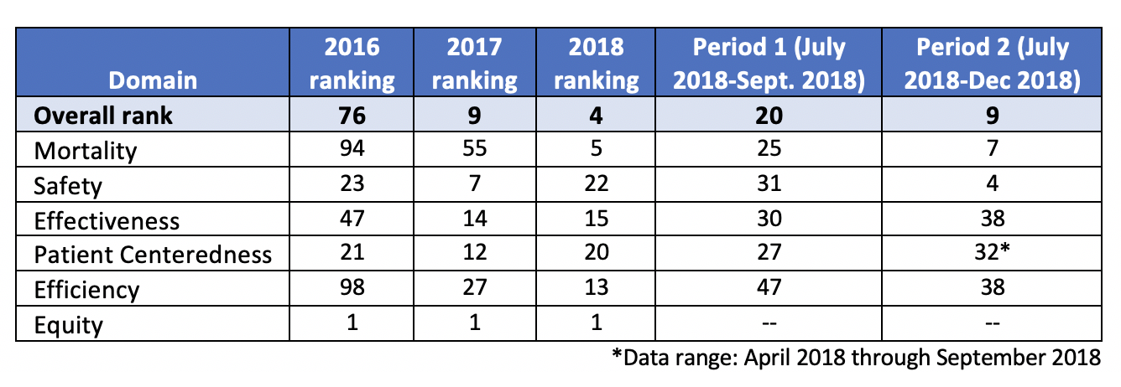  Holiday schedules for fiscal years 2020 and 2021:  UTMB provides benefits-eligible employees with paid time off to observe authorized state holidays. To ensure patient access and continuity of care, holidays can vary in some departments. If the work schedule or duties of your department make it necessary for you to work on a holiday, you may accrue holiday time off for use on another day that is mutually agreeable to you and your supervisor or you may receive holiday pay in lieu of a day off (if available in your area). Accrued holidays must be taken within 12 months of the date accrued. The FY20 and FY21 schedules are now available online at https://utmb.us/398 or https://hr.utmb.edu/employees/. It is important to check with your supervisor prior to each holiday regarding the work status of your area.  UTMB Campus Carry website updated:  UTMB’s Campus Carry policy website, which relates to the 2016 state law permitting concealed handguns on Texas public university campuses, has been updated. Changes include (a) updates to the campus map to reflect new construction; and (b) updates to the status of UTMB buildings to include language regarding the UTMB Health Clear Lake Campus. Signage to more clearly identify open carry restrictions will also be added to selected buildings off the UTMB Galveston Campus. To review the updated website, visit https://www.utmb.edu/campus-carry.
TOPICS  LEGEND | PATIENT CARE EDUCATION & RESEARCH INSTITUTIONAL SUPPORT CMC
AROUND UTMB (Use the legend above to quickly find items of interest to your team)
Health System leadership changes:  On April 9, Donna Sollenberger, executive vice president and CEO of the Health System, announced the following changes to the Health System Executive Leadership structure due to the departure of Dr. David Marshall. He will become the senior vice president, chief nurse executive at Cedars-Sinai Health System at Cedars-Sinai Health System in Los Angeles, California, effective May 3.  - Josette Armendariz-Batiste will serve as the interim system chief nursing and patient care services executive, responsible for the practice of nursing throughout UTMB Health. She will also expand her current operational responsibilities, in the interim, to include inpatient operations and nursing at the Galveston Campus, including Hospital Galveston. She will oversee the Clinical Operations administrators at Galveston and all areas that advance the practice of nursing, including nursing quality, nursing practice innovations and nursing excellence.  - Annette Macias-Hoag will permanently expand her current set of responsibilities as vice president, Health System and Service Line Operations, to include perioperative services and endoscopy for all campuses. She will also add transplant services to her portfolio.  - Finally, Jim Amato, vice president, Health System Operations, will add patient services at all campuses to his responsibilities, including language services, volunteer services and pastoral care.  An organizational chart reflecting these changes is available at https://utmb.us/39b. A national search for Marshall’s permanent replacement will begin soon.  Cavazos receives national advocate of the year award:  Nora Cavazos, a senior legal assistant in UTMB’s International Affairs Office, was recently presented with the 2019 Advocate of the Year Award from the National Association for Foreign Student Affairs (NAFSA): Association of International Educators. The award recognizes a member of the NAFSA community who embodies the spirit of advocacy and serves as an inspiration to others to make a difference by engaging elected officials in advocacy discussions. For more information about the honor, visit https://utmb.us/399.  UPCOMING EVENTS (CONTINUED)  UTMB Research Day:  UTMB Research Day will be May 7 from 8 a.m. to 2 p.m. All members of the UTMB community are invited to learn about research on our campus through presentations, panel discussions, table displays and tours of various research areas. Dr. Sachin Kheterpal, associate dean for Research Information Technology at the University of Michigan, will be the keynote speaker. Activities will take place in Levin Hall on the Galveston Campus. To see the schedule of events and register to attend, visit https://research.utmb.edu/researchday.  SAVE THE DATE  Annual emergency prep meeting May 14:  Storms and other emergencies can happen at any time and can affect every part of the state where UTMB has operations. As part of our annual preparations, UTMB will hold the 2019 Emergency Preparedness meeting on May 14 from noon to 1 p.m. in the Levin Hall Dining Room on the Galveston Campus. The meeting will include general information for any emergency and feature an overview of UTMB’s emergency response plan. Box lunches will be available, but on-site seating is limited to 200 and RSVPs are required. RSVP by May 10 to Amanda Simpson at events@utmb.edu or (409) 747-6735. The meeting will be live-streamed; more details to come. It will also be recorded for viewing later.  Dr. Phillips receives Mentor of the Year Award:  Linda Phillips, MD, chief of the Division of Plastic Surgery, has received the American Council of Academic Plastic Surgeons’ 2019 Robert Goldwyn Mentor of the Year Award. Phillips was honored at the ACAPS annual conference in Baltimore, Maryland, on April 7. This award is presented to an ACAPS member who has contributed significantly to the development of ethical, compassionate and academically productive surgeons for the next generation.  Dr. Levine honored with Career Educator Award:  Ruth Levine, MD, was awarded the 2019 Career Educator Award by the AAMC Southern Group on Educational Affairs (SGEA). Levine is associate dean for Student Affairs and Admissions in the School of Medicine, and professor of Psychiatry and Behavioral Sciences. The SGEA is one of four regional groups that provide forums for discussing the concerns of the medical education profession, serve as resources and act in an advisory capacity to the national GEA and AAMC. |  |  | UPCOMING EVENTS  Plan to attend UTMB Earth Day celebration on April 26:  UTMB students, faculty and staff and members of the community are invited to attend UTMB’s annual Earth Day Celebration from 10 a.m. until 2 p.m. on April 26 at the Moody Medical Library Plaza on the Galveston Campus. Participants attending the event, which has a “Reduce Your Use” theme, can enjoy the following activities and much more.  - Recycle in Style fashion show  - Swap shop: individuals who want to donate excess, non-inventoried office supplies and items to be upcycled and repurposed by others for business purposes only can do so by bringing their materials to the booth on the east side of the library plaza between 9:30 a.m. and 1 p.m. For more information, contact (409) 747-2959  - Exhibitor fair  The event will also include giveaways and live music, and the winner of the art contest will be announced. For more information, visit https://www.utmb.edu/bof/Utilities/Sustainability/EarthDay2019/default.asp
DID YOU KNOW?
UTMB’s Environmental Health and Safety Biosafety Program plays an integral role in training for the research community. An award granted to the group in 2006 led to the development of UTMB’s International Biosafety Training Center (IBTC), which houses a team of consultants and professionals who specialize in sharing hands-on training courses and exercises for best practices and industry standards in a variety of areas including BSL2-BSL4 in vitro/in-vivo research and personal protective equipment use for clinicians. The team also works to educate a variety of students, including individuals in UTMB’s Biosafety Graduate Program, participants in summer sponsored-research programs and local Ball High School students. In addition to the work the IBTC does within the UTMB community, the group also serves external clients including universities, private companies, and state and federal laboratories. Since its startup, the IBTC has garnered national and international recognition, serving over 44 countries and 30 states in the U.S., including Texas. During FY18, the group provided more than 800 internal trainings and 190 external trainings. For more information on the center, visit https://www.utmb.edu/biosafetytraining or https://www.facebook.com/UTMBBiosafety/.

NOTES:

