Ben
Weekly Relays User Guide
TOPICS LEGEND
 |  | WEEKLY RELAYS |  |  | May 16, 2019
YOUR DEPARTMENT NEWS |  |  | UTMB NEWS
Office of Clinical Simulation  Dr. Karen Szauter served as faculty for a multi-day course at the University of Maastricht, in the Netherlands May 6th – 8th. The course, titled Simulated and Standardized Patients, had an international audience including participants from Brazil, Ecuador, Mexico, Norway, Switzerland, Poland, Turkey and Portugal.  Office of Educational Development  - OED candidate teaching session: Monday May 20 @ 9:00am, MMN 1.102 Dr. Everling will present on the NowComment platform  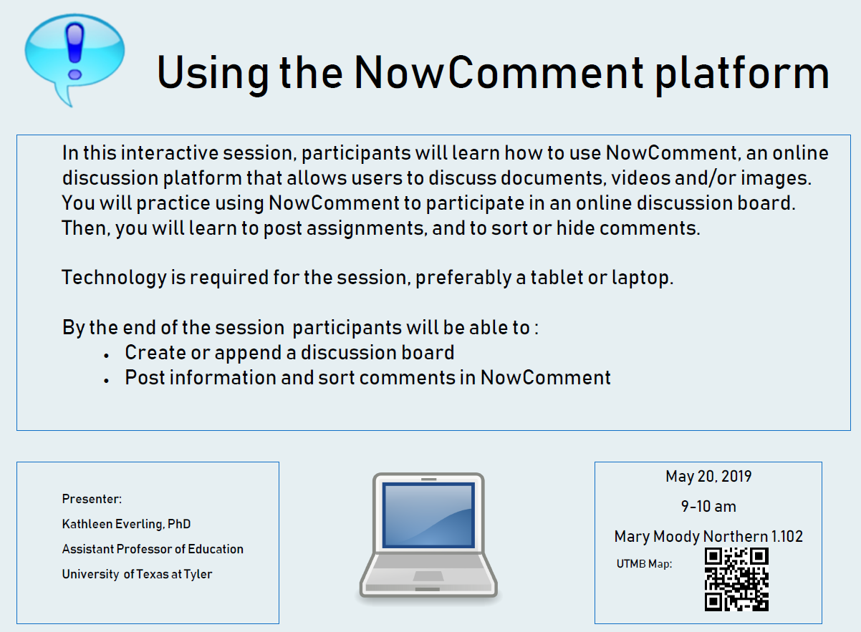  - Teaching Skills Workshop Series: Monday May 20 @ 4pm, Levin Hall 3.320 & Tuesday May 21, 12pm, Levin Hall 3.320 “Finding Images for Teaching.” Register today! https://utmb.us/3a0  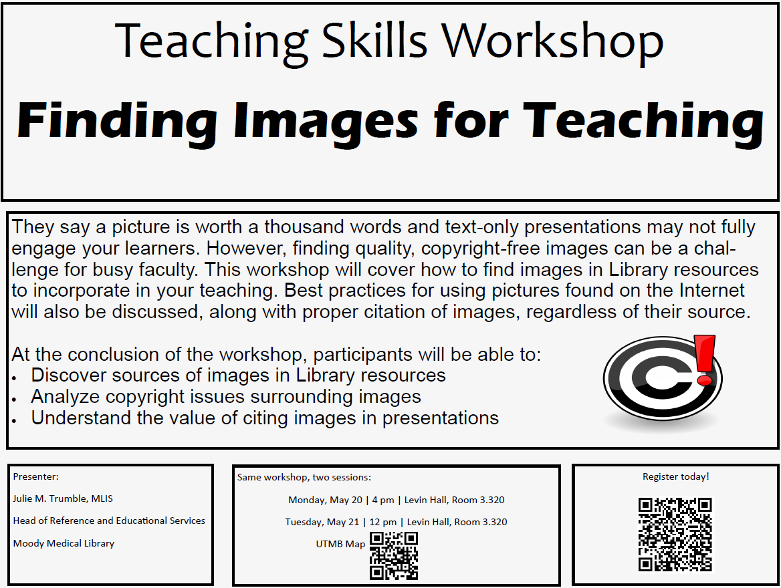 |  |  | Monthly financial update—results as of April 30, 2019: UTMB Results  - For the month of April 2019, UTMB (including the Clear Lake Campus) had an adjusted margin of $8.6 million, which was $2.8 million better than planned. (See additional note on Clear Lake Campus below).  - Fiscal year-to-date, we had a loss of $17.6 million, which was $11.6 million better than planned.  Clear Lake Campus Results  As a reminder, we will monitor financial performance for the Clear Lake Campus both on its own and as a part of overall UTMB results through the remainder of FY19. The following information relates only to the Clear Lake Campus:  - For the month of April 2019, Clear Lake Campus had an adjusted margin loss of $3.7 million, which was $.3 million better than planned.  - Fiscal year-to-date, Clear Lake Campus had an adjusted margin loss of $27.2 million, which was $2.6 million better than planned.  Thank you for your ongoing efforts to manage expenses and improve the efficiency of our work to ensure the long-term success of UTMB’s mission.  2019 Emergency Preparedness Meeting materials now online: If you weren’t able to attend or view the 2019 Emergency Preparedness Meeting, a video of the meeting and the presentation are now available online. The presentations include a hurricane season update from the National Weather Service, priority risks for UTMB for the coming year, expectations of employees and students during an emergency, and information on safety, security and communications in an emergency. View the video and the presentation at https://utmb.us/3a5.  UTMB recertified with Advanced Certification in COPD by The Joint Commission: UTMB has once again earned The Joint Commission’s Gold Seal of Approval for Advanced Certification in Chronic Obstructive Pulmonary Disease (COPD). The certification recognizes organizations in the outpatient care setting that focus their efforts for COPD care on staff education requirements, use of spirometry (a breathing test to measure how well lungs are working), smoking cessation, risk-factor reduction, patient education on self-management of COPD and coordination of care. UTMB was the first organization in Texas to receive this recognition in 2015 and is currently one of only two organizations in the state to have earned this designation.
Employee Spotlight

Stacy Shields, PhD
- Sr. Specialist for Learning & Career Counseling
Student Affairs

What are some of your work responsibilities?
I provide individual and group support to School of Medicine students for concerns related to adjustment to medical school, learning strategies and study planning, exam preparation, time and stress management. etc. I also help to manage the course tutoring and Step 1 mentoring programs.

Tell us something personal about yourself.
I've been at UTMB for about 5 months. Before starting here, I was a career counselor and therapist at the University of Houston-Clear Lake. I still maintain my license as a Psychologist in Texas. I moved around a lot as a child because my dad was in the Navy, but I claim being from Texas. :-) My husband is currently a PA student with Yale University's online program.

TOPICS  LEGEND | PATIENT CARE EDUCATION & RESEARCH INSTITUTIONAL SUPPORT CMC
AROUND UTMB (Use the legend above to quickly find items of interest to your team)
Important notice regarding FY19 compliance-related training: All faculty and staff have been assigned two new compliance-related training courses in UTMB’s online learning management system for FY19.  - Intellectual Property Policy – This course pertains to the ownership of intellectual property created by employees for educational or research purposes, and it is a requirement of the University of Texas System. Intellectual property generally refers to creations of the mind (i.e., inventions) that can be protected under federal law through patents, trademarks and copyrights. For questions about this course, please email research.education@utmb.edu.  - Hazard Communication – This course provides employees with specific information regarding hazardous chemicals used or stored in the workplace and is required by Environmental Health and Safety. Any questions about this course may be emailed to wjpate@utmb.edu.  These courses, as well as all other FY19 training assignments, are available at https://learn.utmb.edu/  and must be completed by Aug. 31.  Research Quarterly Update set for May 21: The spring Research Quarterly Update will take place May 21, from noon to 1 p.m. in Levin Hall South Auditorium on the Galveston Campus. Dr. Randy Urban, chief research officer, and other leaders will share important updates and recognize recent achievements in the Research Enterprise. All members of the UTMB community are welcome to attend. To submit a question for discussion at the event, go to https://utmb.us/3bg.  Explore the Epic 2018 Upgrade website now: The Epic 2018 Upgrade web site—your home base for all information related to the upgrade—is now available. New content will be added daily, so check the website early and often! Learn about the key enhancements within Epic 2018 and take full advantage of training tools and webinars offered. Explore Epic’s new look and feel in the Epic Training Playground; follow the login instructions listed on the Epic 2018 Upgrade website. Don’t get caught by surprise on the first day of roll-out—get to know Epic 2018 today  (http://intranet.utmb.edu/emr/epic-2018-upgrade/overview).  Change in Language Access Services Vendor: To maintain the highest quality service for our Limited English Proficient patients, UTMB has selected a new vendor for Language Access. Providers and staff requesting a phone interpreter will notice the information requested by the operator has changed to the following:  - The location from which you are calling, which is limited to the following eight options: Ambulatory Clinics, Jennie Sealy Hospital, John Sealy Hospital, Access Center, Angleton Danbury Hospital, League City Campus Hospital, Clear Lake Campus Hospital or TDCJ Hospital Galveston.  - Patient encounter information, to include the following: patient’s full name; patient’s medical record number; your department name; and the name and/or employee ID number of the employee speaking to the patient.  The new iPad interpretation application will roll out following the implementation of the telephonic interpreting platform. If you have any questions, or if your work area does not fall into one of the eight categories listed above, please contact Patient Services at (409) 772-4772. More information is available at http://intranet.utmb.edu/patientservices. |  |  | REMINDER  President’s Cabinet Award applications due May 31: The President’s Cabinet Awards committee is seeking proposals for the 2019 President’s Cabinet Awards. The theme of this year’s awards, “UTMB Health—The Community and Beyond: Working Together for our Future,” recognizes the shared interests of the university, the surrounding community and beyond by promoting a vibrant and supportive environment. Projects that mobilize the creativity, ingenuity and dedication of UTMB students, staff and faculty to benefit the community are especially encouraged. Applications are available online at https://development.utmb.edu/file/pcapp.pdf and should be turned in no later than 4:30 p.m., May 31. For information on where to submit proposals, visit www.utmb.edu/cabinet.  User desktop in PEARL: On May 15, users defaulted to the User Desktop. For a review of Best Practices, please see a recorded training demo, which is available for all users in the Training Videos folder on each computer desktop called User Desktop Demo. Users will need to use a computer with speakers in order to hear the audio during the presentation. There is also an excellent SOP available on iSpace in the SOPs folder.  Discontinue masking for health care workers not vaccinated for influenza: The CDC has determined that the distribution of influenza in Texas is now sporadic. In addition, both testing volumes and positive tests have dropped significantly at all UTMB locations. As of May 13, the requirement for non-vaccinated health care workers to wear a surgical mask when working in patient care locations has been discontinued.
DID YOU KNOW?
Figures from the 2019 RecycleMania competition have been finalized and thanks to the efforts of everyone across the institution, UTMB earned the No.1 spot for cardboard recycling, coming in first place in that category during the friendly eight-week challenge. Pitting colleges and universities against each other to see which can recycle the most, RecycleMania tracks recycling volumes for a variety of materials, including paper, cans and bottles. For the paper recycling category, UTMB secured third place. Out of 300 competing institutions from across 43 states, UTMB finished 48th in total recycling efforts. To learn more about recycling and sustainability here at UTMB, visit https://www.utmb.edu/bof/Utilities/Sustainability/.

