Ben
Weekly Relays User Guide
TOPICS LEGEND
 |  | WEEKLY RELAYS |  | June 6, 2019
YOUR DEPARTMENT NEWS |  |  | UTMB NEWS
Office of Student Affairs  Congratulations Dr. Levine on being one of the finalists for the Fifth Annual Editor’s Choice Award in Teaching and Learning and Medicine for her article:  Ruth E. Levine, Nicole J. Borges, Brenda J. B. Roman, Lisa R. Carchedi, Mark H. Townsend, Jeffrey S. Cluver, Julia Frank, Oma Morey, Paul Haidet, & Britta M. Thompson. High-Stakes Collaborative Testing: Why Not? https://bit.ly/2VPTbGb  Office of Educational Development  OED will be hosting a Teaching Skills workshop June 17 at 4pm and June 18 at 12pm. MMN 1.102 To register go to the following link: https://docs.google.com/forms/d/e/1FAIpQLSc5t36nVrcmRvJj5DxgPjwILueB63WdWByfPICeh6Pu_BxkLg/viewform  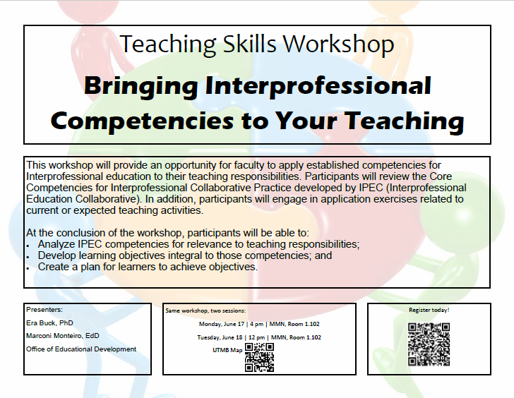  OED is now accepting applications for the Scholars in Education 2019-202 cohort through July 1. Apply at the following link: https://utmb.us/3bw  OED will host an introduction to PBL session on Wednesday June 26 from 1-3pm in Graves 2.308 https://utmb.us/3cr  Academic Affairs – School of Medicine  We would like to send out a special thank you to everyone who was involved in making the 2019 School of Medicine MD Commencement a huge success!  Joshua Archibald, Student Affairs  Kim Barfield, Alumni Relations  Tammy Bird, Student Affairs  Julie Cantini, Alumni Relations  Lois Carter, Continuing Education  Kathleen Collins, Student Affairs  Rita Copado, Student Affairs  Valerie Carmichael, Student Affairs  Lorraine Terrell Davis, Continuing Education  Lori DeWillis, Academic Affairs  Lori Ellis, Educational Affairs  Pattie Finch, Academic Affairs  Erin McEldowney, University Events  Hope McNatt, Ophthalmology  Berengaria Navarre, Student Affairs  LeTanya Neely, Student Affairs  Laura Nevarez, Student Affairs  Isaac Ohalete, Educational Affairs  Shirley Pullen, Student Affairs  Theresa Silva, Student Affairs  Amanda Simpson, University Events  Brian Sullivan, Educational Affairs  We appreciate you and all  of your hard work very much!  Employee Spotlight  If you have not done so already Please send along your information (and don’t forget to upload a photo) via the form found here:  https://webforms.utmb.edu/frevvo/web/tn/forms/user/giflynn/app/_M2ECYBTmEempUclRFxPosw/formtype/_dn1HoASZEempsq_jYOb_6Q/popupform.  Thank you! |  |  | Congratulations to our 2019 School of Medicine graduates:  UTMB’s School of Medicine celebrated commencement on June 1 at the Moody Gardens Convention Center. This year, 222 students received their medical degrees, with two graduates completing the dual MD/PhD track. Congratulations to our newest alumni and to the faculty and staff who trained them well!  Annual Space Survey—deadline July 1: To support effective planning and management of UTMB’s space and to meet state and federal requirements, the Facilities Portfolio Management department is conducting UTMB’s Annual Space Survey. The survey of UTMB’s more than 29,000 rooms is used for internal and external reporting, as well as to determine space allocations. The survey remains a vital part of our overall strategic planning and operational effectiveness. Your departmental representative is responsible for updating all space usage in the Archibus software system by July 1. A listing of departments and respective representatives may be found at:  https://ispace.utmb.edu/xythoswfs/webview/_xy-24753865_1. For questions, please contact Sarah Gardescu, Facilities information manager, at sagardes@utmb.edu.  Parking during inclement weather: As a reminder, individuals at all UTMB facilities should park in their designated locations, even during inclement weather to ensure that garages and other visitor-only parking spaces remain available for patients and visitors who need close access to our clinics and hospitals. If you do not currently have a parking location or have questions, the Parking office (409-266-PARK, parking@utmb.edu) can assist you.  Latest Pulse video congratulates those recognized at Employee Service Day: President Callender uses this Pulse video segment to offer congratulations to employees honored as part of the annual Employee Service Day festivities and also recognizes the winner of this year’s Nicholas and Katherine Leone Award for Administrative Excellence. To view this video, visit https://utmb.us/3cu. For previous Pulse installments, visit https://www.utmb.edu/president/pulse.  ANGLETON DANBURY CAMPUS  UTMB Community and Angleton Danbury Auxiliary invited to CT Suite guided tour: Enjoy a guided tour of the new state-of-the-art CT suite on June 21 from 2 until 4 p.m. and learn more about the exciting new technology on the Angleton Danbury Campus. For more information, contact Tonya Visor at tfvisor@UTMB.EDU.
TOPICS  LEGEND | PATIENT CARE EDUCATION & RESEARCH INSTITUTIONAL SUPPORT CMC
AROUND UTMB (Use the legend above to quickly find items of interest to your team)
CLEAR LAKE CAMPUS  The Science and Communities Interact (SCI) Café expands to the Clear Lake Campus: Beginning in June, UTMB’s popular SCI Café will be offered at the new Clear Lake Campus. Join UTMB experts for a discussion of various topics, kicking off with the June 27 “Fact or Fad? Making Sense of Nutrition Trends” event  https://utmb.us/3cv. SCI Café is free and open to the public and additional sessions for the 200 Blossom St. location have been scheduled for July 25 and August 22. All Clear Lake sessions will be held from 5:30 until 6:30 p.m. in room 2.211. Parking is available in the hospital garage. Contact Rebecca Trout Unbehagen for more information at 409-747-2734 or rltrout@utmb.edu.  Dr. Anish Bhardwaj appointed vice provost: Dr. Anish Bhardwaj has been appointed vice provost, effective June 1. In this role, he will oversee the creation of a strategic plan for faculty development and mentoring. He will coordinate and cultivate faculty development opportunities through UTMB’s three academies, establish approaches to support long-term faculty retention and direct efforts to enhance wellness and resilience. Prior to this appointment, Dr. Bhardwaj had been associate provost for faculty affairs and professional development since March 2018. He also served as provost ad interim from August 2018 to April 2019. He joined UTMB in 2013 and is chairman of the Department of Neurology; John Sealy Chair in Neurology; and professor of Neurology, Neurosurgery, and Neuroscience, Cell Biology and Anatomy.  MyStar/Campus Solutions upgrade necessitates extended outage June 6-7: Information Services is upgrading MyStar/Campus Solutions, which will be unavailable to students and UTMB employees for an extended period of time beginning at 5 p.m. on June 6. The outage is expected to last until 10 p.m. on June 7. Information Services regrets any inconvenience this upgrade may cause. Please contact ais.incidentmanagement@utmb.edu or the IS Service Desk at extension 25200 with any questions. |  |  | New Universal Protocol for preventing wrong-site, wrong-procedure and wrong-person invasive: UTMB has implemented an updated Universal Protocol Process to prevent wrong-site, wrong-procedure and wrong-person invasive procedures. The process supports The Joint Commission’s recommendations for patient safety by having the procedural team take the following action:  - Conduct a pre-procedure verification process.  - Mark the procedure site.  - Perform a “Time Out” immediately before starting the invasive procedure or making the incision.  - Perform a post-procedure debrief.  To help procedural teams fully understand the steps required, the OR staff demonstrated the process in a short video. All staff who are involved in an invasive and/or surgical procedure are urged to view the video and understand the requirement. The video may be accessed at https://utmb.ensemblevideo.com/Watch/x7W3Bjp8.  Wrong-blood-in-tube events – monthly update: As with all medical procedures, drawing blood samples from patients, whether in the hospital or ambulatory setting, is not without risk. Correctly identifying the patient using two patient identifiers and labeling the blood sample with the correct patient’s information in the presence of the patient are fundamental and imperative actions in health care. If the sample in the tube does not match the patient whose name is on the label—known as a “wrong blood in tube” (WBIT) error—and the error is not detected, there is potential for serious harm to a patient. For example, if a patient were to receive a blood transfusion based on an incorrect blood sample, the adverse outcome could be catastrophic. Since last month’s WBIT report, which includes all campuses, UTMB has gone 13 days without detecting a WBIT error. Detection of the error that was made prevented a potentially serious outcome.
DID YOU KNOW?
People from a variety of UTMB departments and groups, as well as the local community, worked hard for months to open the doors of the new UTMB Clear Lake Campus Hospital. Part of that work included installing 59,800 feet—or more than 11 miles—of cable to help support the technical infrastructure of the building. Read more about the opening of the facility in the latest edition of Impact at https://utmb.us/3ct.

