Ben
Weekly Relays User Guide
TOPICS LEGEND
 |  | WEEKLY RELAYS |  | June 27, 2019
  YOUR DEPARTMENT NEWS |  |  |   UTMB NEWS
Office of Educational Development    OED is thrilled to announce 2 Senior Medical Educators joining the team:  Dr. Holly West  Dr. Kathleen Everling  There will be treats in the OED workroom Wednesday morning – please come by to welcome our new team members as your schedule allows.  Teaching Skills  Preparing a Poster Presentation - Monday, July 1st at 4pm and Tuesday, July 2nd at noon in MMN 1.102  Employee Spotlight  Shirley Pullen, BS  Senior Administrative Manager  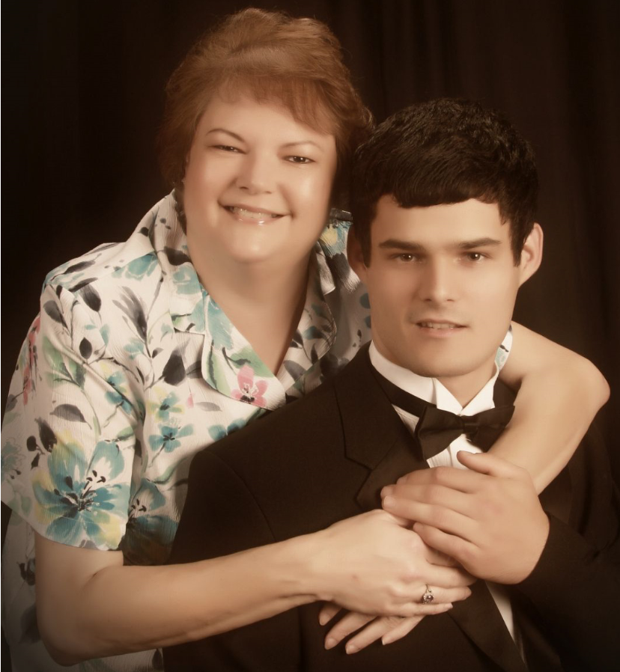  Office of Student Affairs & Admissions  What are some of your work responsibilities?  In my position there are various responsibilities that I undertake. Many say they do not want my position, I wonder why. I assist the deans and directors in planning, development, and operation of business including office policy and procedures. On the financial side I prepare, reconcile department budgets and fiscal activities included endowments, cost transfers, reports on a monthly basis plus complete purchasing overview and approvals almost daily. Regarding HR duties I oversee the department hiring, separation, position changes and updates plus currently oversee the tutoring program for MS1 and MS2 students. I am responsible for Kronos, department payroll oversight and supervise various staff in the department, plus live on email responding to issues daily.  Tell us something personal about yourself.  I have been at UTMB over 8 years going on my 5th year with Student Affairs. I was actually born in Pasadena, TX yet raised in a small rural town in Mississippi where my father and his ancestors settled. My mother was also born in same Mississippi County with her ancestors dating back to the late 1700's. Visiting there definitely feels like home. I love to write and hope to one day complete "My Alaskan Tales" focusing on events while living, working and traveling in Alaska for 20 years. I have one son, Will, who came to my family when he was almost 13 years old. He is my joy, my heart and greatest accomplishment.  Fun Fact  For 18 years my positions were in the Travel and Tourism industry which allowed me to work and visit the State of Alaska from the southern tip of Metlakatla Indian Reservation to “Top of the World” Barrow. Ask me about my bear story when my brown eyes met his brown eyes and my 2 miles deep in the earth of a Gold Mine. Ahhh, the tales to be told. |  |  | Latest Pulse video focuses on positive outcomes for UTMB from the latest session of the Texas Legislature:  In his latest Pulse video message, President Callender discusses the many positive outcomes for UTMB as a result of the 86th Session of the Texas Legislature. To view this video, visit https://utmb.us/3dy. For previous Pulse installments, visit https://www.utmb.edu/president/pulse.  SAVE THE DATE—President’s Town Hall set for July 18:  Please plan to attend Dr. Callender’s next Town Hall July 18 at noon in the Levin Hall Main Auditorium on the Galveston Campus. Online viewing options will be available. Stay tuned for more details in Weekly Relays, iUTMB and the I Am UTMB Facebook page.  Conducting meaningful performance evaluations: To assist with the FY19 performance review cycle, Human Resources is offering training on UTMB’s performance management program. All employees and managers are invited to attend one of these training sessions to learn more about each phase of the annual evaluation process and how to effectively document, track and measure performance.  · Angleton Danbury Campus – July 24 and 30  · Galveston Campus – July 16, 23 and 24  · League City Campus – July 17 and 23  · Clear Lake Campus – July 25 and 31  · Correctional Managed Care – Contact local HR office for assistance  The FY19 review period ends Aug. 31, 2019, and the institutional deadline for completing an evaluation for eligible employees is Oct. 31, 2019. Details about the training sessions are available at https://hr.utmb.edu/relations/performance/.  Annual benefits enrollment begins July 15:  UTMB invites all employees to attend one of its Benefits Fairs to learn more about annual enrollment and the insurance, retirement and wellness programs available for the 2019–2020 plan year. Fairs will be held:  · July 9 – Angleton Danbury Campus  · July 10 – Galveston Campus  · July 11 – League City Campus  · July 12 – Clear Lake Campus  Visit https://hr.utmb.edu/hrbbc/benefits/annual_enrollment/ for details about the fairs and be on the lookout for more annual enrollment information from UTMB and the UT System Office of Employee Benefits.
TOPICS  LEGEND |         PATIENT CARE EDUCATION & RESEARCH INSTITUTIONAL SUPPORT CMC
AROUND UTMB (Use the legend above to quickly find items of interest to your team)
Retail food service July 4th holiday hours:  The holiday hours for retail food service vendors are as follows:  Galveston*  John Sealy Hospital  - Subway will be open from 8 a.m. to 11:30 p.m.  - Café on the Court, Chick-fil-A, and Starbucks will be closed  Jennie Sealy Hospital  - Einstein Bros. Bagels will be open from 6:30 a.m. to 2 p.m.  - Hospital Lobby vending machines will remain open 24/7 with healthy options  Clinical Services Wing (CSW):  - Sixth Floor Staff Lounge SmartMarket will remain open 24/7 with healthy options  Moody Medical Library:  - Starbucks will be closed  Lee Hage Jamail Student Center  - Joe’s Café will be closed  League City Campus*  - Einstein Bros. Bagels will be closed  - Vending machines will remain open 24/7  Angleton Danbury Campus*  - Bayou Café will be closed  *Retail dining at the Angleton Danbury Campus, the League City Campus and the Galveston Campus will resume with regular business hours on July 5.  Clear Lake Campus  - The Grill will be open July 4-7 8a.m. to 1:00 p.m.  - Starbucks will be closed July 4– 7  - Vending machines will remain open 24/7  Retail Dining at Clear Lake Campus will resume with regular business hours on July 8.  The Joint Commission—Revised National Patient Safety Goal (NPSG) 15.01.01 on reducing the risk for suicide: To assist health care organizations in improving and saving patients’ lives, The Joint Commission has revised the NPSG 15.01.01 on reducing the risk for suicide. Effective July 1, 2019, all clinical staff and health care providers who do intake screenings on patients aged 12 years or older must document whether a patient is being evaluated or treated for a behavioral health condition as their primary reason for care. To align with the new standard, UTMB has revised policy 09.13.38 (Suicide Risk Screening and Suicide Precautions for Patients). Providers, nurses and clinical staff should familiarize themselves with the new policy. A training and competency assessment of staff who care for patients at risk for suicide is required. For more information and to complete the training, please visit https://intranet.utmb.edu/QHS/SuicideRisk.asp.  AHRQ Patient Safety Culture Survey Results: Informational Sessions for frontline clinicians and staff in inpatient settings: Chief Medical and Clinical Innovation Officer Dr. Gulshan Sharma invites frontline clinicians and staff who work in or support an inpatient environment to join him for informational sessions to learn about the results of the 2019 Agency for Healthcare Research and Quality (AHRQ) Patient Safety Culture Survey. During the sessions, Dr. Sharma will host an interactive discussion with attendees about ways to promote improvements in patient care processes and to explore a vision for the future of a culture of patient safety at UTMB.  Galveston Campus:  - Wednesday, July 3, 2019 from 3:00 to 4:00 p.m. in Jennie Sealy Hospital, Conference Room (Lobby) 2.506B  - Wednesday, July 24, 2019 from 3:00 to 4:00 p.m. in Jennie Sealy Hospital, Conference Room (Lobby) 2.506B  - Friday, July 26, 2019 from 7:30 to 8:30 a.m. in Jennie Sealy Hospital, Conference Room 4.200A  Angleton Danbury Campus: Tuesday, July 9, 2019 from 7:30 to 8:30 a.m. in the ADC Boardroom  League City Campus: Wednesday, July 24, 2019 from 7:30 to 8:30 a.m. in LCC Conference Room 2.700  CMC ePerformance Deadlines: Important deadlines are outlined below:  - All managers must create performance documents in ePerformance by no later than June 28, 2019. HR created the base performance review document this year that may have included preloading Section 2 Competencies; however, managers need to review Section 2 to ensure competencies were loaded correctly and make any necessary adjustments to the criteria. In addition, managers will need to add criteria for Section 1 KPIs. The KPIs can be selected from the drop down menu and include 2 system wide KPIs (Hemoglobin A1c control and diabetic nephropathy screening) and the discipline specific KPIs that have been discussed since September 2018. The results are posted each month on the CMC web. The My Road Ahead goals should be loaded as well.  - All employees must complete a self‐evaluation by no later than September 13, 2019. Managers will notify employees when performance documents are available and ready for input.  - To ensure the institutional deadline is met, managers must meet with staff to review FY19 performance documents and complete the evaluation process in ePerformance by no later than October 11, 2019.  FIT ordering capability in Pearl: The FIT ordering capability in Pearl for units that have Quest as a lab vendor has been updated to be able to send the FIT samples only to the Estelle lab. Please ensure that your units start using this test. |  |  | REMINDER  In-person annual training classes: Each year, live annual required training classes are scheduled for those who prefer interaction with trainers rather than online learning. Reservations are not required. Interactive presentations from five facilitators will cover general compliance, Equal Employment Opportunity and Title IX regulations, Information Security, fire safety and threatening situations. All who attend the full session will be credited for the annual required training learning plan in the UTMB Learn system. All classes will be held on the Galveston Campus in Research Building 6, Room 1.206. The remaining class schedule is listed below:  - July 1 – 1 to 3:30 p.m.  - July 25 – 8 to 10:30 a.m.  - August 6 – 2 -to 4:30 p.m.  - August 23 – 9 to 11:30 a.m.
DID YOU KNOW?
The Sealy Institute for Vaccine Sciences (SIVS) has had a Clinical Trials Program in place since 2002. With a team of investigators, research nurses and coordinators, the group conducts research focused on the development and use of vaccines in premature and full-term infants, toddlers, children, adolescents, adults and the elderly. The final step in the vaccine development process, clinical trials provide an opportunity for researchers to gather data related to the safety and effectiveness of potential treatments for various conditions, including meningitis, pneumococcal disease and more. To date, the SIVS Clinical Trials Program team has completed more than 45 studies and is currently overseeing several active studies. To see a list of the four studies that are currently recruiting participants, visit https://utmb.us/3dz. You may also call 409-772-5278 to be added to the group’s registry to receive notifications of future studies for which they might be eligible. For more information on the group and its operations, like their Facebook page at https://www.facebook.com/SIVSClinicalTrialsProgram/.

