Ben
Weekly Relays User Guide
TOPICS LEGEND
 |  | WEEKLY RELAYS |  | July 25, 2019
YOUR DEPARTMENT NEWS |  |  | UTMB NEWS
Employee Spotlight  Brenda Johnson, Med, CHCP  Director  Office of Continuing Education  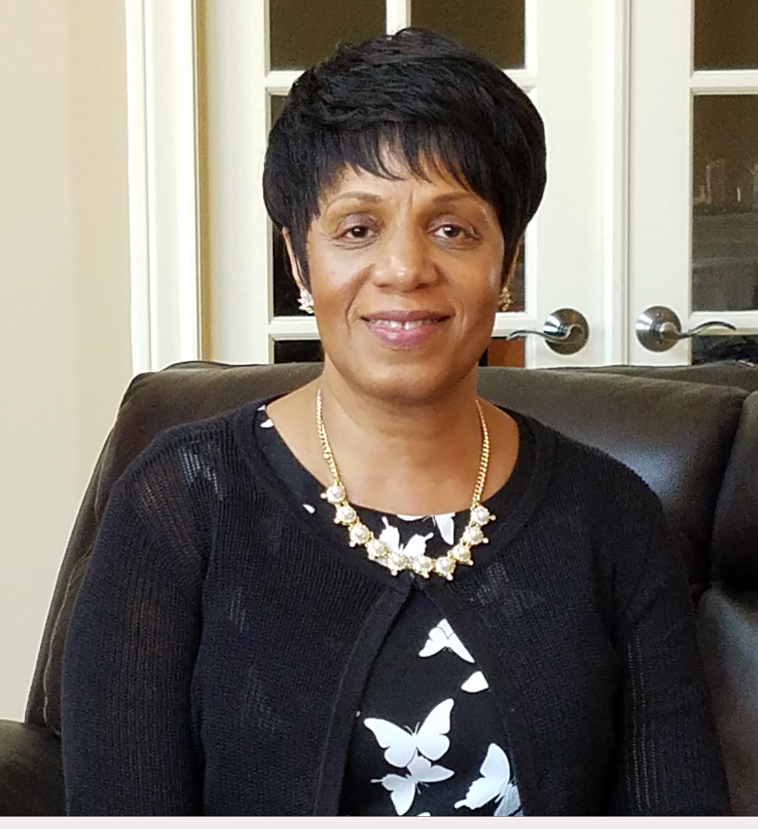  Tell us something personal about yourself.  Has 3 adult children - 2 sons and a daughter. Has worked for UTMB for 8 years. Was born in Vicksburg, MS; raised in Chicago, IL; and as a military spouse, has lived in several states in the US, and spent two years in Turkey working in the Education Office.  Fun Facts  - Former middle school teacher (Math, Science and History)  - I am a business owner - Independent Mary Kay Consultant  - I am a preacher and the Sr. Pastor of Evangelist Chapel AME Church, Houston, TX  What are some of your work responsibilities?  Brenda Johnson, MEd, CHCP, serves as the Director, Office of Continuing Education for the University of Texas Medical Branch at Galveston where she oversees over 100 CME activities annually for physicians in Galveston, Houston and surrounding areas in Texas. In 2012, Ms. Johnson was instrumental in obtaining a 6-year reaccreditation with commendation status from the Accreditation Council for Continuing Medical Education (ACCME) for UTMB's CME Program. And was successful in obtaining a 4-year reaccreditation in 2018. Ms. Johnson completed her undergraduate training at Concordia University in River Forest, Illinois where she received a Bachelor of Science degree, in Elementary Education, with a major in Life Science and a minor in Psychology. Ms. Johnson has over twenty-five years experience in education, association management and organizational development. Her most recent prior work experience is with The UT Health Science Center San Antonio where she served as Director, Continuing Medical Education. Prior to her work in Texas, Brenda served as the Director of Education at SNM (formerly, the Society of Nuclear Medicine). There she launched a successful PET Learning Center where physicians and nuclear medicine  technologists have received training in the utility and clinical application of PET. Prior to working for SNM, Brenda served at the American Medical Women’s Association (AMWA), as Deputy Executive Director, and the Uniform Services University of the Health Sciences (USU), as Educational Program Manager. UTHSCSA, SNM and USUHS were awarded 6-year reaccreditations  Health Sciences (USU), as Educational Program Manager. UTHSCSA, SNM and USUHS were awarded 6-year reaccreditations with commendation status from the Accreditation Council for Continuing Medical Education (ACCME) for which Ms. Johnson was integrally involved. In addition to implementing CME activities, Brenda has effectively designed and implemented several continuing education programs and their accreditations including, Accreditation Council for Pharmacy Education, American Nurses Credentialing Center, American College of Healthcare Executives, and Council for Accreditation of Medical Physics Education Program. Her focus is directing Performance Improvement continuing medical education (PI CME) activities that focus on demonstrated changes in physician competence, performance, and patient health outcomes.  Ms. Johnson is a Certified Continuing Healthcare Education Professional (CHCP), and a distinguished member of the Alliance for Continuing Education in the Health Professions, and a member of the Society for Academic Continuing Medical Education, where she served as on the membership committee, and as Editor of the Society newsletter. |  |  | President Callender announces his departure from UTMB:  Last week, Dr. David L. Callender, who has served as UTMB president since 2007, announced that his last day as the organization’s leader will be Aug. 31. Effective September 1, Callender will join the Memorial Hermann Health System in Houston as its president and CEO. At its Aug. 14-15 meeting, The University of Texas System Board of Regents is expected to name an interim president to lead UTMB while the national search for a new president progresses. A farewell reception for Dr. Callender will be held on Thursday, Aug. 29 from 4 to 6 p.m. at Levin Hall Dining Room on the Galveston Campus. To read more about this development, visit https://www.utmb.edu/president/communications.  In case you missed it—Town Hall:  If you missed the July 18 President’s Town Hall, all materials, including the full video, are now available online at www.utmb.edu/townhall.  Physician Assistant program receives Accreditation-Continued status:  The Physician Assistant Studies (PAS) program has received Accreditation-Continued status by the Accreditation Review Commission on Education for the Physician Assistant, Inc. (ARC-PA). This status is granted when a currently accredited program is in compliance with the ARC-PA Standards. Accreditation remains in effect until the program closes or withdraws from the accreditation process, or until accreditation is withdrawn for failure to comply with the standards. The approximate date for the next validation review of the program by the ARC-PA will be June 2027, contingent upon continued compliance with accreditation standards and ARC-PA policy. The PAS program, which graduates about 90 students a year, trains new healthcare professionals to be a critical part of the care team. We are proud of the work its graduates do to serve patients in Texas and beyond.
TOPICS  LEGEND | PATIENT CARE EDUCATION & RESEARCH INSTITUTIONAL SUPPORT CMC
AROUND UTMB (Use the legend above to quickly find items of interest to your team)
What would you do with an extra $3,000?  All paid UTMB employees who refer an applicant to a nurse clinician (II–V) position or an identified hard-to-fill position for the Health System will be eligible for a special $3,000 bonus. If your referral is hired into a benefits-eligible position by Aug. 31, you will receive $1,500 when he or she completes six months of service and another $1,500 when he or she completes one year of service. UTMB is holding an invitation-only hiring event on Aug. 14, so please encourage your referrals to visit https://hr.utmb.edu/recruit/hiring/ to learn more about this event and to submit their resume for consideration. Interviews will be extended only to those who meet the qualifications needed. For more information about the employee referral bonus and how you can benefit from this limited-time offer, see https://hr.utmb.edu/recruit/referral/.  PeopleSoft Update:  UTMB Health is upgrading its PeopleSoft Human Capital Management (HCM) system with PeopleTools 8.56.15. A related outage will begin on Friday, Aug. 2 at 5 p.m. until Monday, Aug. 5 at 8 a.m. Users will not be able to access Recruitment (Job Applications), Employee Self Service, Manager Self Service or Payroll.  ACTION ITEM:  Annual Compliance Training:  The institutional deadline for all employees to complete their annual training for FY19 is Aug. 31. Please take a few minutes today to log in to the online UTMB Learn system at https://learn.utmb.edu/ and complete any remaining courses and activities. Employees who do not finish their Compliance Department required training by the institutional deadline will be suspended without pay until all requirements are met. For questions or concerns about your assigned training, please contact your manager or the course contact listed in UTMB Learn. For technical issues, please contact the UTMB Service Desk at (409) 772-5200 or (888) 898-2401.  Goree Prosthodontic Clinic:  There is a new Dental Prosthodontic Specialty clinic located at the Goree unit. The identifier in FORVUS is PRDEN. Offenders are selected for this clinic as part a of a quality of care program and are not referred from the unit. The dental director's office enters the referral into FORVUS, approves, and schedules the appointment. When your unit scheduler receives the printout on the FORVUS printer, they will need to create the specialty reminder. Please be sure to add Goree to your transportation list. Also, offender sick calls and mail regarding this initiative are not to be sent to the Goree unit via truck mail.  Disaster plan:  The CMC Disaster plan has been updated and posted on the CMC website. It is highly encouraged that all management teams review this plan with unit based staff. Even if units are not in impact zones where adverse weather events have occurred before, there is a good chance that they will be designated as receiving units in case of an emergency.  Weekend CDO expansion:  The weekend Constant Direct Observation (CDO) program utilizing master-level QMHPs for mental health was recently expanded to the Beto, Ellis, Stiles, and Byrd units. This will allow for better coverage at those units on the weekends. |  |  | REMINDER  Annual Benefits Enrollment:  The deadline for making changes to your benefits elections, adding or removing dependents, and/or enrolling in a flexible spending account for the 2019–2020 plan year is 11:59 p.m. on July 31. To view or update your current coverage, log in to the My UT Benefits online system using the personal identification number provided to you by the UT System Office of Employee Benefits. See https://hr.utmb.edu/hrbbc/benefits/annual_enrollment/ for more annual enrollment information.  Wrong Blood in Tube events:  Wrong Blood in Tube errors occur when the blood in the tube does not match that of the patient identified on the label. These events may lead to catastrophic outcomes, such as death from an incompatible red cell transfusion. Transfusion is a multistep, multidisciplinary process in which the human error rate has remained unchanged despite interventions such as education, training, competency testing and guidelines. UTMB has gone 24 days without a Wrong Blood in Tube being detected across all campuses.
DID YOU KNOW?
UTMB School of Nursing’s highly rated online Master of Science in Nursing program includes seven tracks to meet the unique needs of nursing professionals. These include specialized tracks for nurse practitioners, nursing educators and leaders to help them develop in their fields. The online program was recently rated number one by Best Master’s Program, an online guide to the best master’s degrees and careers. Ratings were determined by average alumni salary, niche student reviews, tuition rate and U.S. News & World Report rankings. UTMB School of Nursing was the first in Texas to offer online graduate education, and since its inception in 1998 has graduated more than 1,700 students from the online master’s program. Kudos to the School of Nursing for preparing its graduates to enter the field providing the highest quality of care!

