Ben
Weekly Relays User Guide
TOPICS LEGEND
 |  | WEEKLY RELAYS |  | August 15, 2019
YOUR DEPARTMENT NEWS |  |  | UTMB NEWS
Academic Affairs  Open Photo Shoot  A photographer for will be available to take headshots and departmental photos as needed with two four hour blocks. There is no need to RSVP, simply show up and get them taken. The dates and times are:  August 20th - 12pm – 4pm (Tuesday)  August 21st – 7:30am – 11:30am (Wednesday)  The location is Levin Hall 4th floor, 4.444  This is a great opportunity to have a professional picture made at no cost to you or your department.  ALL ACADEMIC AFFAIRS MEETING  MARK YOUR CALENDARS!!!  MONDAY, AUGUST 19, 2019  3:00 – 4:00 PM  Old Red Amphitheatre  Come and see who will win  the drawing to have lunch  with Dr. Mouton!  Employee Spotlight  Elizabeth Freeman, MA  Medical Education Specialist  Office of Educational Development  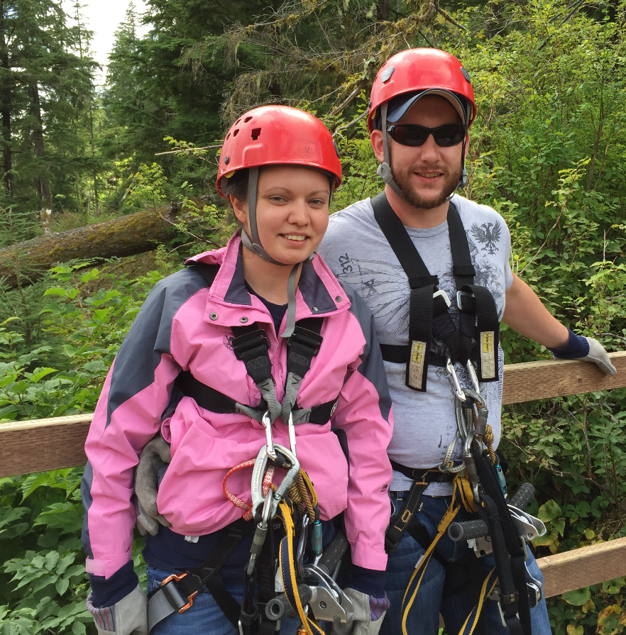  What are some of your work responsibilities?  I assist the Senior Medical Educators with creating reports, monitoring the Program Evaluations for all required clerkships, and analyzing data for special projects requested by Faculty.  Tell us something personal about yourself.  I've been at UTMB for almost 5 years and was born in New Hampshire but moved to Galveston when I was 3. I enjoy bike riding and spending time with my family and my 3 dogs.  Fun Facts  I took a fencing class in college. |  |  | BREAKING NEWS  Dr. Ben Raimer named interim president of UTMB:  UT System Chancellor James B. Milliken announced Aug. 15 that Ben Raimer, MD, a physician-leader whose service to the Galveston community and the state of Texas has spanned five decades, has been appointed interim president of UTMB. Raimer will take the reins from Dr. David Callender, who announced last month that he would be stepping down as UTMB president to become president and CEO of the Memorial Hermann Health System. Raimer will serve as interim president while the Board of Regents launches a national search for a permanent president for UTMB, Milliken said. To read the full news release about Raimer’s appointment, visit https://utmb.us/3gn.  Monthly financial update—Results as of July 31, 2019:  UTMB Results:  NOTE: As discussed last month, UT System implemented a change in the way Tuition Revenue Bond (TRB) proceeds will be reported going forward, causing UTMB’s financials to appear less favorable than our actual performance. The overall impact of this reporting change to the adjusted margin is $13 million through July 31, 2019.  For the month of July, UTMB’s adjusted margin (including the Clear Lake Campus) was a loss of $8.8 million, which was $3.9 million worse than planned. Excluding the impact of the new TRB reporting requirements, UTMB’s adjusted margin for the month of July was a loss of $7.6 million, which was $2.7 million worse than planned.  UTMB’s fiscal-year-to-date adjusted margin for July (including the Clear Lake Campus) was a loss of $48.8 million, which was $7.1 million worse than the planned loss of $41.7 million. Excluding the TRB impact, however, UTMB’s year-to-date adjusted margin was a loss of $35.8 million, $5.9 million better than planned.  Clear Lake Campus Results:  As a reminder, we are continuing to monitor the financial performance of the Clear Lake Campus, both independently and also as part of overall UTMB results through the remainder of FY19. The following information relates only to the Clear Lake Campus:  - For the month of July 2019, Clear Lake Campus had an adjusted margin loss of $2.8 million, which was $.7 million better than planned.  - Fiscal year-to-date, Clear Lake Campus had an adjusted margin loss of $35.7 million, which was $5.4 million better than planned.  Thank you for your ongoing efforts to manage expenses and improve the efficiency of our work to ensure the long-term success of UTMB’s mission.
TOPICS  LEGEND | PATIENT CARE EDUCATION & RESEARCH INSTITUTIONAL SUPPORT CMC
AROUND UTMB (Use the legend above to quickly find items of interest to your team)
Monitoring and containing year-end expenditures:
As we approach the end of fiscal year, UTMB’s executive leaders are asking that you carefully monitor your respective department’s expenses for the remainder of FY19. While UTMB is continuing to progress financially, a critical part of being successful is forgoing unnecessary expenses before the new fiscal year starts. To that end, we ask that you restrict purchases only to the items you consider essential for your department’s operation. Together, by making a concerted effort to limit spending during these final weeks, we could make a positive difference and end the year with a positive margin. As always, we are most grateful for your cooperation and for all that you do to ensure UTMB’s success.

Employee Access 2-Care program offered as a benefit to UTMB employees:
Feeling under the weather? UTMB offers Access 2-Care appointments as a benefit to all active employees and their dependents for immediate care needs. With Access 2-Care, employees can schedule an appointment with a primary care physician within 24 hours or a specialist within 7 days.* (If you are seriously ill or injured, please go directly to your nearest emergency room). For more information, visit intranet.utmb.edu/2-care. To schedule an appointment, call (409) 772-CARE (2273). *Your wait may be longer than seven days to see a specialist. Your wait may be longer than 24 hours if you want to see your preferred PCP and/or if the 7-day/24-hour timeframe falls on a Sunday.

Dr. Norma A. Pérez named an assistant dean in UTMB’s School of Medicine:
Norma A. Pérez, MD, DrPH, will serve as assistant dean for Student Affairs in the Office of Academic Affairs in the School of Medicine. Her appointment will be effective Sept. 1. Pérez currently serves as director of Career Counseling and Special Projects in the Office of Student Affairs and Admissions. She is also associate professor in the Department of Internal Medicine, Division of Geriatrics, and serves as president of Hispanic-Serving Health Professions Schools, an organization that supplies academic and career development resources to help improve the quality of health care available to Hispanics in the United States. Please welcome her to her new role.

DID YOU KNOW?
August 16 marks the fifth anniversary of the inception of our UTMB Angleton Danbury Campus partnership. The campus, an acute care hospital that serves Angleton, Danbury, Rosharon and the surrounding communities, is the first trauma-designated facility in Brazoria County and serves more than 60,000 people in the region. Established in 1969 as the Angleton Danbury General Hospital by the Angleton Danbury Hospital District, the campus provides a variety of quality services including 24-hour emergency care, an American College of Radiology-accredited mammography program, cardiopulmonary clinical laboratory, diagnostic imaging services, outpatient surgery, rehabilitation, physical therapy, wellness and more. To learn more about the history of the campus, visit https://utmb.us/3gj.

