Ben
Weekly Relays User Guide
TOPICS LEGEND
 |  | WEEKLY RELAYS |  | Oct. 10, 2019
Academic Affairs Department News |  |  | UTMB NEWS
Office of Educational Development  The Office of Educational Development would like to remind you that there is still time to register for the upcoming Teaching Skills Workshop:  Incorporating Debriefing into Learning Activities  Choose a Session!  Monday, October 14, 2019 12:00pm to 1:00 pm  Tuesday, October 15, 2019 4:00 pm to 5:00 pm  Location: Mary Moody Northen Building  MMN Room 1.102  Register today by clicking this link: https://forms.gle/AvLXaKKCFgznScB88  Workshop objectives  At the conclusion of the workshop, participants will be able to:  - Identify when to use debriefing, including what works, what does not work, and any other attendee concern  - Differentiate feedback and debriefing  - Explore best practices for debriefing  - Devise a take-away idea to implement in the participant’s setting  Presenters:  Suzanne Alton, DNP, APRN, FNP-BC  Cliff Snyder, MPAS, PA-C  Academic Affairs  Would you like to recognize and honor a colleague for a job well done? This is a perfect opportunity to utilize the AAA Award! It can be found on our wonderful School of Medicine Academic Affairs - Employee Resources Portal:  https://www.utmb.edu/meded/EmpResPort/  (which also has a ton of  wonderful relevant information!)  Employee Spotlight  Becca Guler  - Learning Specialist  Academic Support & Career Counseling, Office of Student Affairs & Admissions  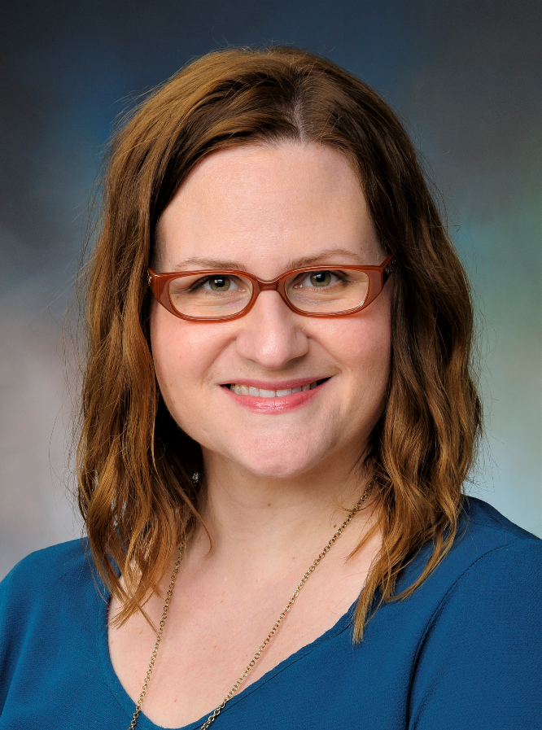  What are some of your work responsibilities?  Analyze how students are learning, test taking and managing time and determine with the student what adjustments will provide success.  Tell us something personal about yourself.  At UTMB since Sept 3, previously with UH-Clear Lake 4 years as Learning Specialist. Taught English for Academic Purposes (ESL with university prep) to international undergraduates and graduates for first 14 years of career, including 3 years in Turkey and 2 semesters in India. My son is 13 and my mother lives with us at our home in Seabrook.  Fun Fact  I make a line of natural bath and body products. |  |  | Celebration to mark 50th anniversary of UTMB’s Graduate School of Biomedical Sciences:  The Graduate School of Biomedical Sciences (GSBS) will celebrate 50 years of granting doctoral degrees on Oct. 18-19. The GSBS 50th Anniversary Celebration and Alumni Symposium will begin with a keynote address by 1969 graduate Dr. Mary Guinan, founding dean emerita, School of Public Health at the University of Nevada, Las Vegas, on Oct. 18 at 4 p.m. in the Levin Hall Main Auditorium on the Galveston Campus. The Dean’s Reception and Alumni Showcase will follow the keynote address from 5:30 to 7 p.m. in the Levin Hall Foyer. On Oct. 19, the GSBS will host the Alumni Symposium, featuring more than 30 GSBS alumni from each of the five decades of the graduate school and representing diverse career fields, including biotech, government and education. The festivities will conclude with the 50th Anniversary Dinner at the Tremont Hotel in Galveston on Saturday evening. The weekend’s celebration will recognize and honor the GSBS faculty, alumni, trainees, staff and supporters who strive to advance research and medicine and develop the biomedical leaders of tomorrow. For inquiries or to RSVP for the celebrations, call (409) 772-2665.  Volunteers sought for bioterrorism attack exercise:  On Oct. 25, UTMB and the Galveston County Health District will conduct an exercise that simulates responding to a bioterrorism attack in which anthrax has been released in the air. During the exercise, UTMB will simulate dispensing medications to protect the UTMB community, especially health care workers. This exercise, to be held at the Health Education Center on UTMB’s Galveston Campus, will simulate operations at a Point of Dispensing (POD), a location that could be used to distribute medications to the UTMB community in the event of a health emergency. A Point of Dispensing can be activated during public health emergencies such as disease outbreaks (pandemic flu, for example) or bioterrorism disasters. UTMB is seeking up to 200 staff and student volunteers for the exercise to learn how a POD operates, what needs may arise and how students, staff and administrator could help respond to a real‐world public health emergency where PODs are activated. For more information or to volunteer, contact Charles “Fritz” Kuebler, assistant director of Institutional Preparedness, at chkueble@utmb.edu.
OPICS  LEGEND | PATIENT CARE EDUCATION & RESEARCH INSTITUTIONAL SUPPORT CMC
AROUND UTMB (Use the legend above to quickly find items of interest to your team)
REMINDERS
Health Education Center formal dedication:
The formal dedication of the newly opened Health Education Center on UTMB’s Galveston Campus will take place Oct. 18 at 1:30 p.m. on the third floor of the new facility, located at 301 11th St. A reception and opportunity to tour the facility will follow immediately after the ceremony. For more information about the dedication, visit https://development.utmb.edu/events.

UT FLEX Program:
The deadlines for incurring expenses and filing reimbursement claims for your FY19 flexible spending accounts are approaching.

UT FLEX Health Care Reimbursement Account (HCRA)
- Last day to incur expenses – Nov. 15, 2019
- Claim filing deadline – Nov. 30, 2019

UT FLEX Dependent Day Care Reimbursement Account (DCRA)
- Last day to incur expenses – Aug. 31, 2019 (last day of plan year)
- Claim filing deadline – Nov. 30, 2019

See www.myutflex.com for list of eligible expenses or to file a claim.
Communicating with Limited English Proficient patients:
The strength of our organization lies in the diversity of our medical staff, including those who are bilingual or multilingual. However, as a reminder, The Joint Commission requires that all clinical providers and staff who speak to patients and families in any language other than English during clinical interactions be validated for proficiency in that language. When communicating with a Limited English Proficiency patient or their family about medical information, you must work with a UTMB-approved interpreter, available in person, by video or by telephone. Patients should be discouraged from having family and friends interpret for them, and minors are never permitted to serve in such a role. UTMB-approved Medical Language Interpreters are required: (1) for invasive procedures which require written consent, (2) if the patient has been diagnosed with a life-threatening condition or (3) when discussing end-of-life issues. For more information on UTMB Language Access Services, please visit http://intranet.utmb.edu/patientservices.

DID YOU KNOW?
In another example of the strength of UTMB’s research enterprise, total research grant award funding increased by $14.8 million to $139.5 million in FY19. Research funding increases from FY19 include:

- National Institutes of Health: $11.5 million
- Department of Defense: $6.5 million
- NASA: $624,000
- National Science Foundation: $244,000
- Other federal: $370,000
- State: $206,000
- Clinical trials revenue: $1.9 million
- UT System STARs Awards provided $3 million
- Recruitment awards from CPRIT and TIRR provided $6.7 million

UTMB’s focus on recruiting and retaining the highest-caliber research faculty, investing in state-of-the-art equipment and facilities and building fruitful collaborations across many disciplines will continue to advance health care for patients in Texas and beyond.

