Ben
Weekly Relays User Guide
TOPICS LEGEND
 |  | WEEKLY RELAYS |  | Oct. 24, 2019
  YOUR DEPARTMENT NEWS |  |  |   UTMB NEWS
Attention Academic  Affairs Employees!!!  Did you know that you have AA News at your fingertips??? Just visit the Academic Affairs Employee Resource Portal. It’s got current and past announcements and Weekly Relays as well as various campus resources!!  https://www.utmb.edu/meded/EmpResPort/  Don’t forget to submit Academic Affairs All-Star Awards for your colleagues. This is an opportunity for you to recognize your peers, subordinates and supervisors for their outstanding work!!  Office of Educational Development  This is a reminder that Thursday, October 31st is the deadline (no pun intended since it is Halloween), to submit proposals for the 2020 Southern Group on Educational Affairs (SGEA) Annual Meeting which will be held March 11-14, 2020 in Atlanta, Georgia. All abstracts must be submitted online no later than 11:59pm EST October 31, 2019.    Employee Spotlight  Marci Contreras, MPAS, PA-C  Director of Didactic Education & Assistant Professor  Physician Assistant Studies  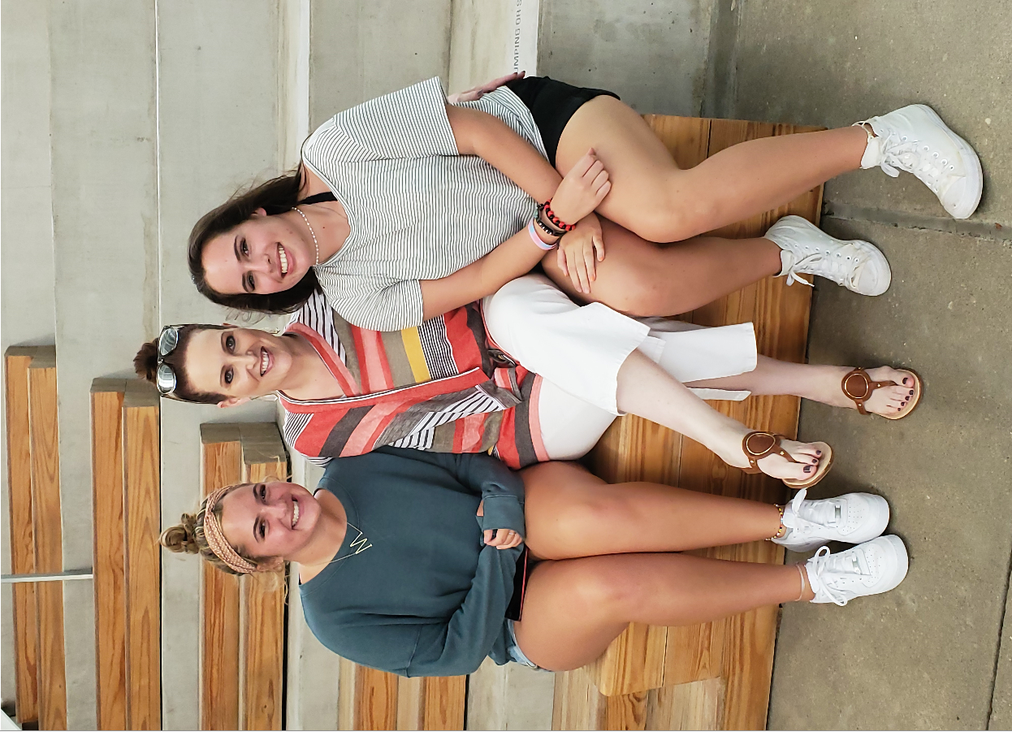  What are some of your work responsibilities?  In between drinking a ton of coffee and responding to limitless emails, I get to work with an amazing team in the PA department. We've been through several transitions (including moving to SOM) and have many new faculty, so it has been exciting to build anew and view things with a different lens. I'm inspired by curricula development, the students (of course) and collaborating with colleagues across campus.  Tell us something personal about yourself.  I've been at UTMB for 5 years and have been a practicing PA in the field of neurology since 2008. I'm a Houston native with twin daughters who are seniors in high school. If I could, I would collect many more animals than city ordinance allows, but for now I have 3 dogs. I'm a book nerd-- I read 3-5 books weekly (that includes my Audible during the commute.) I wish I was more outdoorsy, but I don't like to get dirty.  Fun Fact  Before being a PA, I was a business/marketing executive for an international fashion designer. |  |  | UT System Board of Regents launches national search, names search advisory committee for UTMB President:  The University of Texas Board of Regents has announced members of a committee who will advise the board in its search for the next president of UTMB. The committee includes members of the Board of Regents; UTMB dean, faculty and staff; a UTMB student and alumnus; and external and community members who are familiar with UTMB’s mission and with academic medicine. To learn more, view the UT System press release at https://utmb.us/3lj.  2019 SECC—Doing Good Things: The 2019 State Employee Charitable Campaign (SECC) has officially kicked off, and Associate Chief Physician Executive Vicente Resto, MD, PhD, FACS, is leading the charge as this year’s chair. With $52,000 already raised toward UTMB’s $500,000 goal, the campaign is off to a solid start. To lend your support to these efforts and do good things for others, contribute today. For updates and to share your campaign stories, follow the new SECC Facebook page. Make your pledge at www.utmb.edu/secc.  Getting approval to sponsor community events: The UTMB Sponsorship Committee, on behalf of the Office of the President, works to ensure UTMB financially supports community events, activities and organizations that align with the institution’s values, mission, vision and strategic plan. To support that effort and guarantee that UTMB is deliberate, intentional and prudent in its spending, UTMB’s Community Relations staff work with the UTMB Sponsorship Committee to manage all institutional sponsorship and outreach opportunities. All recommendations from the Sponsorship Committee are submitted to the President for final approval. Individual departments or units within the institution are not permitted to sponsor community activities or events with UTMB-related funds without prior review or approval by the committee and President. Please note that the committee meets monthly, so requests should be made six to eight weeks in advance of the earliest deadline associated with the proposed sponsorship. For more information, please see IHOP policy 04.04.01 (https://utmb.us/3kq) or contact Lori Blackwell at loblackw@utmb.edu or Becky Trout Unbehagen at rltrout@utmb.edu.
OPICS  LEGEND |         PATIENT CARE EDUCATION & RESEARCH INSTITUTIONAL SUPPORT CMC
AROUND UTMB (Use the legend above to quickly find items of interest to your team)
My Total Rewards: Total rewards statements for FY19 are now available through Employee Self Service for all full- and part-time employees. This personalized statement reflects the institution’s commitment and investment in our employees and is designed to help you better understand the true value of the total compensation package you receive from UTMB. For details on accessing and reading your statement, see https://hr.utmb.edu/hrbbc/benefits/total_rewards/.  Health Education Center dedication ceremony video now online: Watch as UTMB President ad interim Dr. Ben Raimer, Student Government Association President Faith Mason and members of UT System leadership address the crowd during the recent event: https://www.youtube.com/embed/MrxRo0vmTpM.  REMINDERS  Merit pay increases and Team Awards: As announced in the Town Hall on Sept. 25, merit pay increases and Team Award payments have been approved for eligible employees.  - UTMB’s merit pay program rewards employees for meeting or exceeding performance expectations and is an important part of our total compensation strategy for eligible Classified, Non-Teaching and Administrative & Professional (A&P) staff. Merit pay increases for Classified employees will be effective Nov. 16, 2019, and will first appear in paychecks dated Dec. 6, 2019. Merit pay increases for Non-Teaching and A&P employees will be effective Dec. 1, 2019, and will first appear in paychecks dated Jan. 2, 2020.  - UTMB will recognize the collective efforts and contributions of our workforce in FY19 with a one-time Team Award payment on Nov. 15. The $500 award amount will be paid to employees in a benefits-eligible Classified, CMC, Non-Teaching, Resident or A&P position who meet all eligibility criteria and did not participate in the Faculty Compensation and Incentive Plan, Executive and A&P At-Risk Compensation Plan or any other incentive plan.  For more details about the merit pay program or Team Awards, click here. |  |  | Annual Employee Evaluations: The institutional deadline to complete employee evaluations for FY19 is Oct. 31, 2019. As a reminder:  - An annual evaluation is required by the University of Texas System for all full-time, part-time and PBL employees hired on or before Feb. 28, 2019.  - For an evaluation to be considered final in the ePerformance system, managers must mark the performance document as complete after the employee electronically acknowledges the evaluation.  - Managers may track the progress of evaluations for all employees in their reporting structure through the ePerformance Manager Dashboard.  For further assistance with the annual evaluation process, please see https://hr.utmb.edu/relations/performance/ or contact your assigned Employee Relations Advisor.
DID YOU KNOW?
The Clear Lake Campus laboratory has earned its College of American Pathologists accreditation following a recent, initial inspection in which 860 regulatory standards were met and zero deficiencies were found—a rare accomplishment, especially for new labs. This recent success speaks to the lab team’s day-to-day attention to detail and commitment to ensuring all UTMB patients receive the best quality of care. Managed by members of UTMB’s Laboratory Services Department, the lab consists of one manager, one technical supervisor, three senior medical laboratory scientists and 10 medical laboratory scientists, along with lab assistants who work the bench to process approximately 600 tests every day. With laboratories across all four UTMB campuses, consistency is key, so Laboratory Services personnel and leadership have worked hard to standardize processes for instrumentation, testing, document control, competency assessments and more. For more information about this accreditation, visit
https://www.utmb.edu/ls-ltd/links/lab-accreditation.

