Ben
Weekly Relays User Guide
TOPICS LEGEND
 |  | WEEKLY RELAYS |  | Feb. 20, 2020
YOUR DEPARTMENT NEWS |  |  | UTMB NEWS
Office of Educational Development  to Dr. Dawnelle Schatte for successfully cohosting the national MedEd Twitter Chat  on Thursday night: 'Unsiloing' the Psychiatry Clerkship: What Psychiatry Content do Doctors Need to Know?  ~~~~~~~~~~~~~~~~~~~~~~~~~~~~~~~~~~~~~~  Most of the Office of Educational Development will be at the SHINE Academy 2020 Meeting next week in Austin, Texas.  We look forward to returning with fresh ideas!  Academic Affairs  Don’t forget to sign up to compete  in our chili cook-off next week on  Tuesday, February 25th in the Jamail Student Center! If not competing sign up here to bring some fixin’s at this link: https://docs.google.com/document/d/1tbfgrwl6Ifd6E8VVAb-8Zb_RMKhhPsI4zUS70LP-yz0/edit?usp=sharing  UTMB Shirts  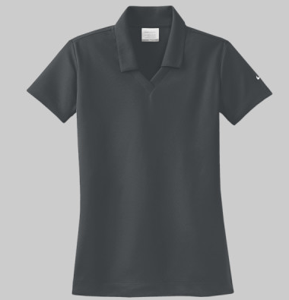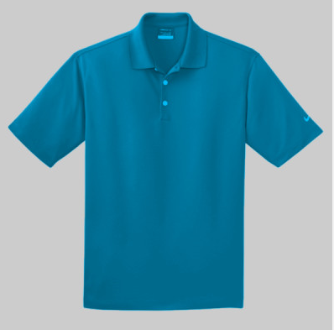  Come by Old Red 1.208 and see samples of the shirts that we will be ordering. Feel free to try them on and choose your style and color.  Please come by end of day on  Monday, February 24th.  All Academic Affairs  Bi-Annual Meeting  Friday, March 6th from 2:30-3:30  Research Building 6, Room 1.206  There will be door raffles & snacks  as well as informational presentations! |  |  | Monthly financial update—results as of Jan. 31, 2020:  For the month of January, UTMB’s adjusted margin was a loss of $13.9 million, which was $3.8 million worse than planned. Year-to-date was worse than planned by $2.7 million with an adjusted margin loss of $42.0 million. Please ensure you continue to manage expenses to allow us to meet our overall budget target for the fiscal year. Although the next few months will be challenging, your efforts are essential to the continued long-term success of UTMB’s mission.  IN CASE YOU MISSED IT  Feb. 14 Town Hall meeting now online:  To learn more about UTMB’s finances, you can now watch the Feb. 14 President’s Town Hall online. In addition to finances, UTMB President ad interim Dr. Ben Raimer discussed a variety of topics, including an update on facilities at our four campuses. He also recognized UTMB’s exemplary research community. Watch the Town Hall at https://utmb.us/3t5.  New UTMB Clear Lake Campus Pediatric Inpatient Unit and Emergency Department now open:  The new Pediatric Inpatient Unit and Emergency Department in the UTMB Clear Lake Campus Hospital welcomed its first patients on Feb. 19. The new unit on the 8th floor and the emergency department on the 1st floor are a collaboration between UTMB Health and Children’s Memorial Hermann at the hospital, 200 Blossom St. in Webster. The opening continues UTMB’s expansion of our geographic footprint while adding patient care services vital to the region’s growing population. For more information on the Clear Lake Campus, visit https://www.utmbhealth.com/locations/hospitals-campuses/clear-lake-campus/hospital.  Nominations for the 2020 Leone Award now being accepted:  Nominations are now being accepted for the 2020 Nicholas and Katherine Leone Award for Administrative Excellence. This award recognizes managers/supervisors who display the highest degree of professionalism and comes with a $7,500 monetary prize—$2,500 for the winning manager/supervisor and $5,000 for the development and training of his or her department/unit. The deadline for nominations is March 13. Visit https://utmb.us/3t9 to learn more about the award or to submit a nomination.
TOPICS  LEGEND | PATIENT CARE EDUCATION & RESEARCH INSTITUTIONAL SUPPORT CMC
AROUND UTMB (Use the legend above to quickly find items of interest to your team)
You’re Invited—Research Day 2020:  UTMB’s annual Research Day is scheduled for May 5, from 8 a.m. to 2 p.m. in Levin Hall on the Galveston Campus. Open to all faculty, staff, students, residents and fellows, Research Day allows the UTMB community to learn about many of the diverse research endeavors taking place, resources for researchers, opportunities for collaborations and more. Dr. Gerard Cote, director of the Center for Remote Health Technologies and Systems at Texas A&M University, will be the keynote speaker. Panel discussions will focus on team science and UTMB research cores. Any department, laboratory, core or organization that would like to reserve a display table at the event may do so at https://research.utmb.edu/RDexhibitor. Individuals who want to attend should register at https://research.utmb.edu/researchdayregistration.  Epic Slicer Dicer presentation now available for streaming:  The IS Business Intelligence and Data Analysis team would like to thank everyone who attended the Epic Slicer Dicer presentation on Feb. 13. If you were unable to attend, you can now view the session online through the Clinical IS website. Visit http://intranet.utmb.edu/emr/clinical-information-systems and click the “Slicer Dicer” hyperlink.  Prevent patient harm through patient event reporting:  In response to feedback from clinicians and staff for an improved patient event reporting system, UTMB implemented a new system, RLDatix, earlier this year. Reporting events, concerns and patient experience information is essential to identifying root causes and trends so we can effectively improve care processes, reduce risk and prevent patient harm. Access the Patient Event Reporting tool via iUTMB. Reporting is easy. Login using your regular UTMB credentials, select a report type using the icons, complete the form and click submit. More information can be accessed at http://intranet.utmb.edu/qhs/report-patient-risk-and-experience. |  |  | PATIENT CENTEREDNESS TIP OF THE WEEK  Promote patient-centered care by showing we respect our patients:  Set a goal this week of demonstrating respect for our patients by showing we value the feelings, wishes and rights of each patient. Coordinate communications using consistent messages across the care team, listen to the patient’s perspective and include them in their plan of care. This week, ask a colleague to critique how well you did.
DID YOU KNOW?
Every year, students from health science centers around the state work together to host Out for Health—an interprofessional health conference that provides outreach, education and information to lesbian, gay, bisexual and transgender people, their health care providers and the community at large about the importance of inclusive, welcoming and respectful care for this population. UTMB is hosting the event for the first time with the help and support of the John P. McGovern Academy of Oslerian Medicine and the UTMB Allies in Medicine student group. Striving to create a more inclusive environment at UTMB, Allies in Medicine provides training programs about topics such as gender, gender expression, sex, sexual orientation, and other topics on the LGBTQ+ spectrum. The 7th annual Out for Health conference is on March 14, and will feature workshops that cover these topics and more. With a history of providing comprehensive transgender care dating back to 1965, UTMB is a natural setting for these discussions. For more information on the work done by the Allies in Medicine group, visit https://utmb.us/3tc. For information on the event, visit http://tiny.cc/RegisterOUTforHealth2020.

