Ben
Weekly Relays User Guide
TOPICS LEGEND
 |  | WEEKLY RELAYS |  | March 5, 2020
  YOUR DEPARTMENT NEWS |  |  |   UTMB NEWS
Office of Educational Development    UTMB TED Masterclass sign-up starts March 6th and ends March 16th or after 25 faculty register. Please contact Holly West or Kathleen Everling for questions.  Register by clicking this link:  https://www.surveymonkey.com/r/TEDUTMB    All Academic Affairs  Bi-Annual Meeting  Today  2:30-3:30  Research Building 6, Room 1.206  There will be door raffles & snacks  as well as informational presentations!    Thanks to ALL our Chili Cook-Off Chefs for making this a tremendous event.  Congratulations to our winners!  1st Place -Mile High Chili (Paul Shreve and Dora Hawkinson)  2nd Place – The Unstoppables (Brenda Johnson, Lorraine Terrell Davis and Lois Carter)  3rd Place – Campfire Chili (Mary Mallini)  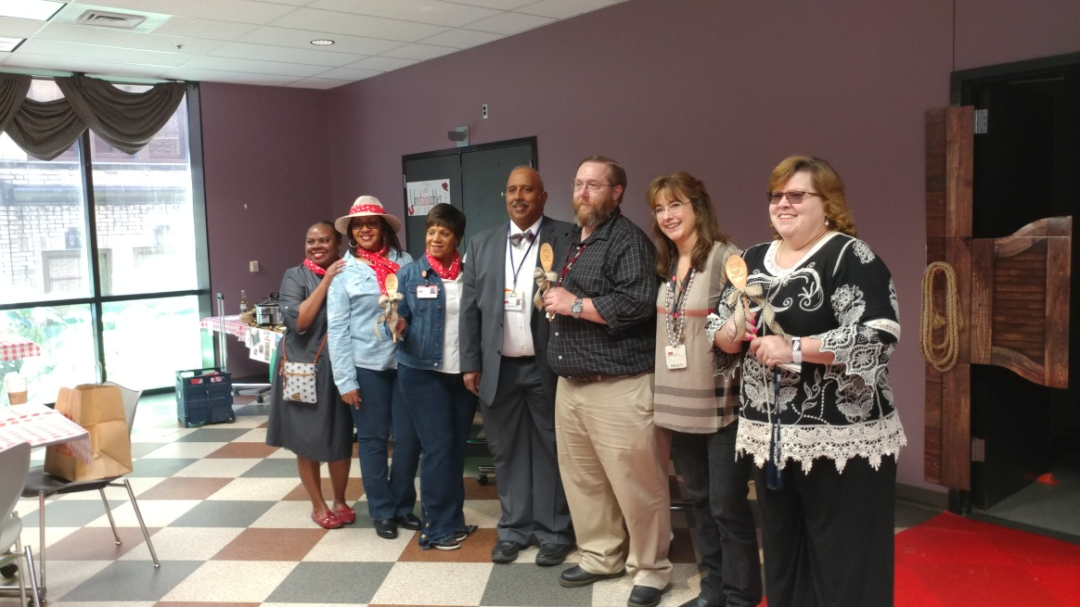  Best Dressed Cowgirls:  Brenda Johnson  Josanne Smathers  Marci Contreras  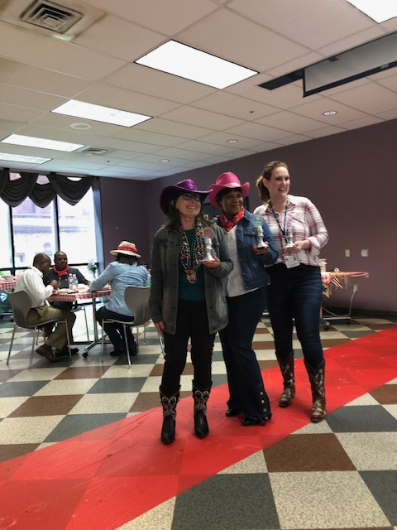 |  |  | COVID-19: Novel coronavirus updates  UTMB Health leadership is planning more frequent communication regarding plans and procedures related to the novel coronavirus and the disease it causes, COVID-19. Updates will be included in this special section of Relay Notes as needed.  Dr. Raimer’s March 2 message to employees:  UTMB President ad interim Dr. Ben Raimer’s email message to employees on March 2 outlined the latest information as it pertains to COVID-19 and UTMB’s preparedness for the disease, including new travel guidance. To read the message, visit https://utmb.us/3ut.  UTMB launches new COVID-19 informational website:  UTMB recently launched a new website at https://www.utmb.edu/covid-19 to serve as an internal resource for UTMB Health staff and employees that outlines processes and procedures for COVID-19 should a patient present with symptoms in a UTMB patient care setting. In addition to providing a wealth of information about the disease, the site also includes up-to-date information from the Centers for Disease Control and Prevention on current U.S. cases. Work is underway to expand the scope of the web site to include information for patients and the community. Check it frequently for updates.  Special Town Hall March 6 regarding COVID-19:  UTMB plans to hold a special Town Hall meeting on Friday, March 6 from noon to 1 p.m. at Levin Hall on the Galveston Campus. The meeting will focus on steps UTMB has taken in preparation for COVID-19 and will feature information from our world-renowned team of infectious disease and public health experts. There will be time for audience Q&A. For more information and remote viewing options, visit https://utmb.us/3uw or refer to the March 5 global message about the meeting. A video recording will be available a few days after the meeting.  Introducing ‘In Focus,’ a new video series from UTMB President ad interim Dr. Ben Raimer:  The debut episode of 'In Focus,' a new video series with UTMB President ad interim Dr. Ben Raimer, is now online. In this video message, Dr. Raimer discusses the new Pediatric Inpatient Unit and Emergency Department Services now open at the Clear Lake Campus Hospital thanks to a collaboration with Children's Memorial Hermann. View the first episode at https://utmb.us/3ui.
OPICS  LEGEND |       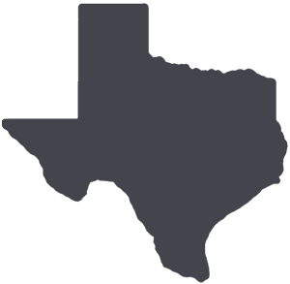  PATIENT CARE EDUCATION & RESEARCH INSTITUTIONAL SUPPORT CMC
AROUND UTMB (Use the legend above to quickly find items of interest to your team)
REMINDER
Nominations for the 2020 Leone Award now being accepted:
Nominations are now being accepted for the 2020 Nicholas and Katherine Leone Award for Administrative Excellence. This award recognizes managers/supervisors who display the highest degree of professionalism and comes with a $7,500 monetary prize—$2,500 for the winning manager/supervisor and $5,000 for the development and training of his or her department/unit. The deadline for nominations is March 13. Visit https://utmb.us/3t9 to learn more about the award or to submit a nomination.

CMC—Take time to recognize our dental assistants:
Dental Assistants Recognition Week (DARW), March 1-7, is a great time to remember that dental assistants take on important responsibilities in the operation of a dental clinic. This is especially true for our CMC dental assistants given the added duties of working in a correctional environment. Many people don’t realize the amount of training, attention to detail and sheer dedication it takes to be a successful dental assistant in our system. We are thankful for all of the dedicated and hardworking dental assistants we have in CMC. You are all much appreciated.

CMC—National Colorectal Cancer Awareness Month:
In March, all CMC units will be focusing on screening for colorectal cancer using the new FIT testing available to patients. Please encourage screening for all eligible patients and save lives by providing the information people need.

CMC—Annual online training:
CMC’s deadline for completing annual compliance training is March 31. The training is available online at https://learn.utmb.edu. Please ensure that all employees complete this training by the deadline.
DID YOU KNOW?
UTMB’s School of Nursing celebrates its 130th anniversary on March 9. UTMB’s SON was the first school of nursing in the nation to be affiliated with a university, the first school of nursing west of the Mississippi, the first in Texas to establish a Master of Science in Nursing program and the first in Texas to offer online graduate education in nursing. With an alumni network of nearly 14,000 and enrollment growing 103 percent over the past 10 years, the school is now graduating more nursing professionals than ever. SON will celebrate this milestone anniversary throughout 2020, which the World Health Organization has declared the Year of the Nurse and Midwife, with a speaker series, podcasts and other special events. Visit the School of Nursing website, as upcoming events will be posted on the home page as they are scheduled.

