Ben
Weekly Relays User Guide
TOPICS LEGEND
 |  | WEEKLY RELAYS |  | July 2, 2020
YOUR DEPARTMENT NEWS |  |  | UTMB NEWS
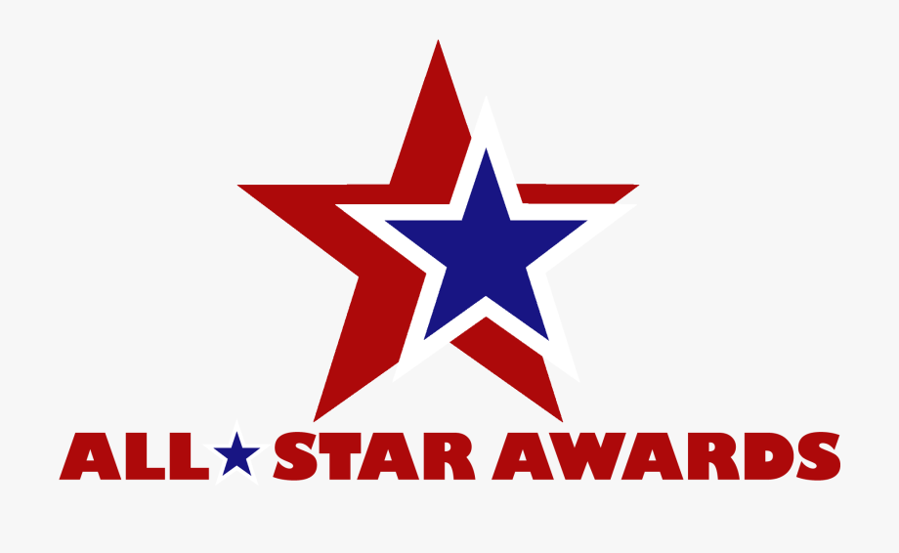  Each of you is encouraged to participate to honor a colleague for a job well done!  Employees who receive at least one AA All-Star Award will be recognized at the year-end Academic Affairs meeting.  You can access the AA All-Star Award form here: Academic Affairs All-Star Award  *************************************************  Please note that every employee needs to go through the IS training for v8 Kronos Upgrade  There are two separate trainings:  1. Employee  2. Timekeeper & Manager  Those who are Timekeeper & Managers  will have to take both trainings  Please register here:  https://innovation.utmb.edu/TrainingGateway/#/  Search for Kronos |  |  | Weekly Wellness Recap: Shared by the UTMB RISE (Resilience in Stressful Events) Task Force, these tips are just one way we can all work to stay emotionally healthy during the COVID-19 pandemic.  This week, we focus on getting WIRED for resilience to experience growth, taking it day by day. (This content is adapted from Nurses Master Resilience-Building Habits at http://digital.olivesoftware.com/olive/ODN/HoustonChronicle/Default.aspx)  W = Wellness. Take care of yourself! Do not neglect self-care of the mind, body and spirit. Visit the UTMB RISE website and do one thing for yourself each day.  I = Input. Learn about yourself, particularly your stressors. Seek input from others on this and be open to hearing it. We all experience stress. The more you learn about your stressors, the more you can work on increasing both actual and perceived control.  R = Recognize what is working and what you are proud of—about your team, your organization, your family, your friends and yourself. Write it down. Say it out loud.  E = Efficacy. Boost your efficacy (task-specific self-confidence). We all enjoy doing what we are good at. Right now, we will need to learn new skills. The more we learn and do, the better our efficacy. We can come out of this with more skills and confidence. Take on learning a new task with the knowledge that you are becoming more resilient.  D = Dialogue. Now is the time to heighten dialogue with each other—our teams, leaders, friends and loved ones. Broadening and deepening relationships is one of the most crucial resilience factors.  Related to Efficacy and Dialogue—Learn the basics of conflict management. Tensions may overflow during stressful times. Consider improving skills in communication and early de-escalation—for you and others. Don’t take everything personally and recognize that anxiety is the root of conflict. Contact Dr. Tammy Cupit at tcupit@utmb.edu for more training related to this.  Related to Recognizing and Wellness—Store up the positive experiences and proud moments so you can recall them and counter the constant or emergent stress we face. These become part of our coping skills. Don’t be afraid to share them.  Links and resources on the John Sealy Modernization Project: As completion of the John Sealy AB wing nears, a list of links and resources relating to the project has been compiled and made available to the UTMB community. To view the full list, which includes anticipated closures, detours and impacts, visit https://utmb.us/45o. For information on the project, reach out to Amber Clayton at adclayto@utmb.edu or (409) 750-1544.  REMINDER  Mandatory Kronos training for timekeepers and managers: Webinars remain available until July 14 for timekeepers, managers and employees. Please be advised that training is required for timekeepers and managers. Save your spot now at https://innovation.utmb.edu/TrainingGateway/#/ and review FAQs and tip sheets at https://utmb.us/45n.  COVID-19: Novel coronavirus updates  Important recent messages regarding our COVID-19 response: Over the last two weeks, a number of important messages have been released relating to the pandemic. Check the links below and the COVID-19 website frequently to stay up to date on our response.  - June 26 message from the COVID-19 Task Force regarding evaluating and managing COVID-19 in the workplace  - June 25 message from President ad interim Dr. Raimer regarding the importance of masking, social distancing and hand hygiene as COVID-19 rapidly increases in our region  - June 18 message from the COVID-19 Task Force regarding restrictions on non-essential gatherings  COVID-19 Q&A session for clinicians: In a recent Q&A session for clinicians, Dr. Gulshan Sharma, vice president and chief medical and clinical innovation officer, addressed the rising numbers of community spread cases in our region, testing capabilities and milestones and much more relating to the COVID-19 pandemic. To watch the full session, visit https://utmb.us/45p.  COVID-19 site: You can find the latest information regarding UTMB’s institution-wide response online at www.utmb.edu/covid-19.
OPICS  LEGEND | PATIENT CARE EDUCATION & RESEARCH INSTITUTIONAL SUPPORT CMC
AROUND UTMB (Use the legend above to quickly find items of interest to your team)
Patient centeredness tip of the week: The patient-centered focus this week is compassionate care. One of our recently discharged patients shared their experience and how we provided compassionate care during her stay: “[The doctor], went to extremes to explain EVERYTHING to my daughter and sister about my care and condition. He made sure to call my daughter or sister or both to give them updates about my condition and care plans with the other doctors. In fact, he arranged a meeting with my daughter and sister to meet with the other doctors treating my conditions and taking care of me. Thanks to EVERYONE for ALL of my care and compassion.” A powerful example of how we optimized the patient experience through small gestures that had a big impact.

Thayer Awards for Excellence in Teaching: Selected by Osler Student Scholars in the John P. McGovern Academy of Oslerian Medicine, the following residents exemplify sound scientific knowledge, compassion towards patients, and dedication to learning and teaching.

- Dr. Charlena J. Melnyk – Department of Psychiatry & Behavioral Sciences
- Dr. Adam V. Nguyen – Department of Dermatology
- Dr. Arsalan Saleem – Department of Radiology
- Dr. Paul J. Weatherby – Department of Orthopedic Surgery
For more information, see: https://www.utmb.edu/osler/awards/thayer-award-for-excellence.
DID YOU KNOW?
If you’ve ever tried to copy and paste a long website address—also known as a Uniform Resource Locator or URL—into a document or a PowerPoint presentation, you understand just how unwieldy they can become. It's much simpler to share a short and memorable URL than a lengthy one, especially when those website addresses contain random numbers. UTMB has its own branded URL shortener that employees can use to reduce the size of website addresses. You can give it a try at https://intranet.utmb.edu/mini-url the next time you’re including website addresses into your documents or presentations.

