Ben
Weekly Relays User Guide
TOPICS LEGEND
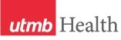 |  | WEEKLY RELAYS |  | August 27, 2020
YOUR DEPARTMENT NEWS |  |  | UTMB NEWS
HURRICANE LAURA UPDATES
For the latest details about UTMB’s response to Hurricane Laura, visit https://www.utmb.edu/public-alert.

Congratulations to the 2020 Leone Award winner:
Bethany Hoover, nurse manager for CLC Nursing Administration at our UTMB Clear Lake Hospital, has been selected as the 2020 recipient of the Nicholas and Katherine Leone Award for Administrative Excellence. The award recognizes managers and supervisors who display the highest level of professionalism and includes a combined $7,500 monetary gift for the winning manager and department. For more information about the Leone Award and a complete list of the 2020 nominees, see https://utmb.us/4bm. In addition, you can watch a video of Bethany receiving the award.

REMINDER
Annual required training: The institutional deadline for all employees to complete their annual required training for FY20 is Aug. 31. Please log in to the UTMB Learn system today at https://learn.utmb.edu/ and complete any remaining courses and activities. Employees who do not finish their Compliance Department required training by the institutional deadline will be suspended without pay until all requirements are met. For questions or concerns about your assigned training, please contact your manager or the course owner listed in UTMB Learn. For technical issues, please contact the UTMB IS Service Desk at ishelp@utmb.edu.
2020 COMMENCEMENTS
School of Health Professions: The School of Health Professions held its virtual commencement ceremony on Friday, Aug. 21 with 251 graduates in six different disciplines receiving their degrees. The Distinguished Alumnus Speaker was James Hury, 2004 Clinical Laboratory Sciences graduate, and the Faculty Grand Marshal was Dr. Jose Rojas, Chair of the Department of Respiratory Care. The school conferred the following degrees:
- Bachelor of Science in Clinical Laboratory Sciences: 47
- Master of Science in Clinical Laboratory Sciences: 14
- Master of Science in Transfusion Medicine: 4
- Doctorate in Clinical Laboratory Sciences: 11
- Bachelor of Science in Respiratory Care: 25
- Master of Science in Health Professions: 3
- Master of Science in Nutrition and Metabolism: 19
- Master of Occupational Therapy: 60
- Doctorate of Occupational Therapy: 5
- Doctorate of Physical Therapy: 63
View the virtual commencement ceremony online at https://shp.utmb.edu/ASA/commencement/default.asp.
OPICS  LEGEND | 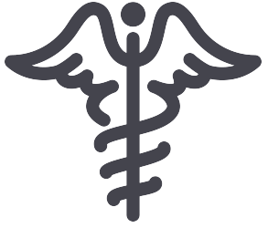  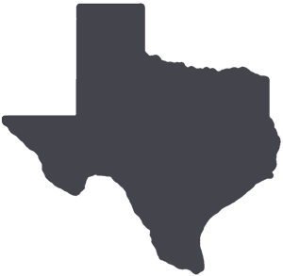  PATIENT CARE EDUCATION & RESEARCH INSTITUTIONAL SUPPORT CMC
AROUND UTMB (Use the legend above to quickly find items of interest to your team)
School of Medicine’s Physician Assistant Studies Program: The School of Medicine’s Department of Physician Assistant Studies held its virtual commencement ceremony on Saturday, Aug. 22. The ceremony featured a keynote speech by Timi Agar Barwick, former CEO of the Physician Assistant Education Association, and conferred Master of Physician Assistant Studies degrees upon 88 graduates. Following the ceremony, graduates formed a vehicle processional in front of the Health Education Center, where PAS faculty congratulated them and Dr. Charles Mouton, executive vice president, provost and dean, handed them their diplomas. View the virtual ceremony and livestreamed vehicle processional online at https://utmb.us/4bl.

COVID-19: Novel coronavirus updates
COVID-19 website: You can find the latest information regarding UTMB’s institution-wide response online at www.utmb.edu/covid-19.

DID YOU KNOW?
The UTMB Police Department deployed a new drone to inspect building rooftops on our Galveston Campus and to “see” road conditions in and around the campus before and after Hurricane Laura made landfall in Louisiana on Aug. 27. The drone is a welcome addition to UTMB Police’s public safety toolkit because it can fly in inclement weather, including heavy rains and winds of up to 60 mph, making it ideal for viewing the region before and after a tropical weather event.

