Ben
Weekly Relays User Guide
TOPICS LEGEND
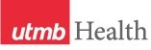 |  | WEEKLY RELAYS |  | March 18, 2021
YOUR DEPARTMENT NEWS |  |  | UTMB NEWS
Happy Senior Match Day 2021!  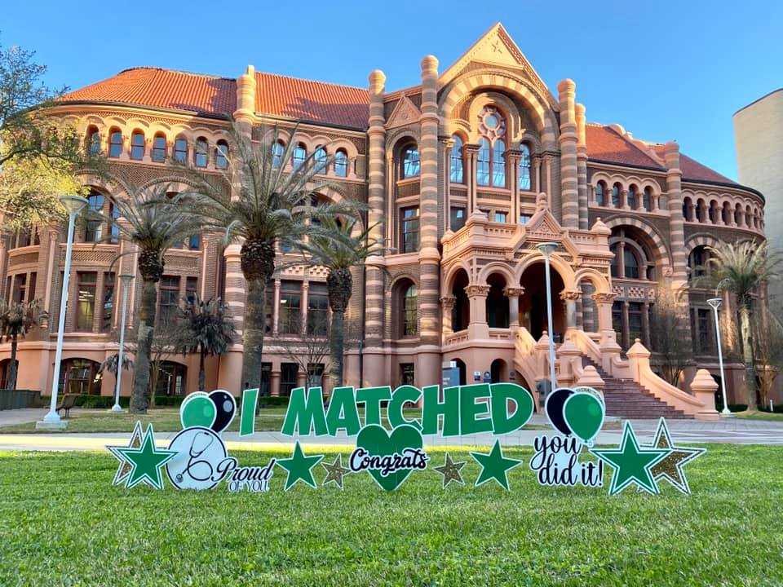 |  |  | Monthly Financial Update—Results as of Feb. 28: For the month of February, UTMB’s adjusted margin was a loss of $12.5 million, which was $9.1 million unfavorable to planned results. Year-to-date, UTMB’s adjusted margin was a loss of $24.5 million, which was $21.6 million favorable to planned results. Thank you for your ongoing efforts to manage expenses and improve the efficiency of our work to ensure the long-term success of UTMB’s mission.  Vaccination of individuals in Phase 1C began March 15: On March 15, the state expanded COVID-19 vaccine eligibility to individuals in Phase 1C, which includes people who are 50 years of age or older. Vaccination of individuals who meet the criteria for 1A (health care workers) and 1B (people who are 65 years of age or older with high-risk health conditions) continues. Eligible UTMB employees looking to schedule an appointment may visit https://www.utmb.edu/covid-19/vaccine/employees. All others are encouraged to register for the Galveston County Vaccine Waitlist at www.utmbhealth.com/waitlist.  Volunteers Needed! Help us Vaccinate Texas against COVID-19: Are you interested in serving our community? Our COVID-19 vaccination program is a long-term project that will continue to expand as larger groups of people become eligible and we get additional vaccines. Support is needed in many areas and for many roles. Medical experience, access or experience with the Epic EMR, or being bilingual are among the skills in greatest need. Shift lengths vary by location, and volunteer opportunities exist across the region among partners that include UTMB, the Galveston County Office of Emergency Management and the Galveston County Health Department, and Brazoria County. Learn more and sign up at https://utmb-health.volunteerlocal.com/volunteer/.  Leadership changes in the Academic Enterprise: Rex McCallum, MD, FACP, FACR, will step down from his role as Vice President and Chief Physician Executive effective April 1. He will remain at UTMB as a Professor in the Department of Internal Medicine. With his departure, Vicente Resto, MD, PhD, FACS, will serve as ad interim Chief Physician Executive, providing leadership and representation of the Faculty Group Practice’s efforts for institutional issues, such as strategic planning, marketing, operations and managed care contracting. We thank Dr. McCallum for his 10-plus years of service to UTMB, and Dr. Resto for taking on this important responsibility.
OPICS  LEGEND | 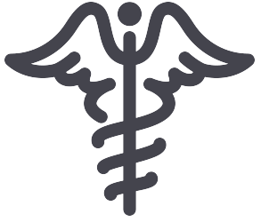  PATIENT CARE EDUCATION & RESEARCH INSTITUTIONAL SUPPORT CMC
AROUND UTMB (Use the legend above to quickly find items of interest to your team)
IN CASE YOU MISSED IT  March 9 Town Hall now online: The video of the March 9 Town Hall is now available online at https://utmb.us/4qj. During the livestream-only event, Dr. Ben G. Raimer, UTMB president ad interim, and other UTMB leaders provided updates on UTMB's COVID-19 response as well as news on our financial performance and mission-specific updates for patient care, education and research.  REMINDER  Next episode of Health Care Unmasked set for March 24: In recognition of Colorectal Cancer Awareness Month, the next Health Care Unmasked will feature UTMB Drs. Pamela Daher Tobia and Stacey Gibbons as they join host TJ Aulds to discuss colorectal cancer. The conversation is set for noon, March 24, on the i45NOW Facebook page at https://www.facebook.com/i45NOW/.  Nicholas and Katherine Leone Award for Administrative Excellence: Nominations for the 2021 Nicholas and Katherine Leone Award for Administrative Excellence will be accepted beginning Monday, March 22, 2021. This award recognizes managers/supervisors who display the highest degree of professionalism and come with a $7,500 monetary prize - $2,500 for the winning manager/supervisor and $5,000 for the development and training of his or her department/unit. The deadline for nominations is Friday, April 9, 2021. See UTMB Employee Advisory Council website to learn more about the award or to submit a nomination.  Weekly Wellness Recap: Shared by the UTMB RISE (Resilience in Stressful Events) Task Force, these tips are just one way we can all work to stay emotionally healthy during the COVID-19 pandemic. Here are this week’s tips:  - Do a random act of kindness today.  - Get some exercise today—it activates the feel good chemistry in your body.  - Allow yourself to do something you enjoy today.  - Be mindful of suffering—yours and others. Process and learn from it.  - Learn one new thing today. It makes new connections in your brain, and we need all the connections we can get (smile).  - Plan for something that’s worrying you. Being prepared can reduce our anxiety.  - Show affection or gratitude for someone you care about today. |  |  | The Joint Commission Spotlight – National Patient Safety Goals: The purpose of the National Patient Safety Goals is to improve patient safety. These goals focus on problems in health care safety and how to solve them. All health care workers should be familiar with these goals, which describe protocols for proper patient identification, effectiveness of communication between caregivers, medication safety, harm associated with clinical alarm systems, suicide risk reduction, hand hygiene and universal protocol. Download the goals at https://utmb.us/4s4 or visit http://intranet.utmb.edu/qhs/the-joint-commission for more information on general preparedness information for UTMB’s upcoming survey by The Joint Commission.  REMINDER: AHRQ Patient Safety Culture Survey for Inpatient and Ambulatory still open: The Health System invites all clinicians and employees across the organization to participate in the 2021 Agency for Healthcare Research and Quality (AHRQ) Patient Safety Culture Survey, open until April 11, 2021. The survey is the industry’s best tool for understanding, promoting, and maintaining a culture of patient safety. The survey will help UTMB identify strengths and areas for improvement while also allowing us to make external comparisons against other organizations. Your feedback is important! For more information and to access the surveys, please visit http://intranet.utmb.edu/qhs/ahrq-patient-safety-culture-surveys-2021.
DID YOU KNOW?
During 2020, UTMB’s Microbiology and Immunology Department secured more than $35 million in funding from the National Institutes of Health (NIH), according to the Blue Ridge Institute for Medical Research. This total helped the department outrank the 95 other M&I departments called out on the list. The many new and supplemental COVID-19 grants secured by the UTMB M&I team, as well as the new West African Center for Emerging Infectious Diseases, are credited with helping UTMB secure the top spot for a second year in a row.

