Ben
Weekly Relays User Guide
TOPICS LEGEND
 |  | WEEKLY RELAYS |  | April 15, 2021
YOUR DEPARTMENT NEWS |  |  | UTMB NEWS
Welcome to the Team!  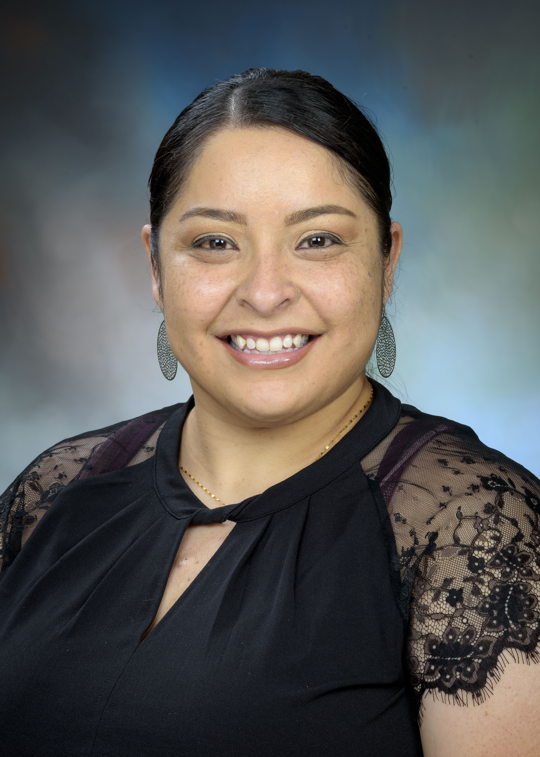  Valerie Vazquez is a Coordinator II in the UTMB Department of Physician Assistant Studies. She is from Laredo, Texas, and moved to Pasadena 13 years ago. Previous work experience has been in the medical administration field at Memorial Hermann Hospital, Methodist Hospital, and Legacy Community Health. She is currently enrolled in San Jacinto College pursuing a business administration degree with emphasis in healthcare. She enjoys working with students and helping them obtain their medical training. Her desire is to help at least one person each day and her goal is to make a positive impact in society. Valerie and her husband, José, live in Pasadena with their dog, Thor, and in her spare time, she enjoys playing billiards and gardening.  Welcome Valerie!  *ACADEMIC AFFAIRS ALL-STAR AWARD*  Here are some of our outstanding  team members who have been recognized with an AA All-Star  Award so far this fiscal year:  * Amanda Carey * Alma Block *  * Catalina Salinas * Catherine Hale *  * Colin Lamb * Dawnelle Schatte *  * Elizabeth Freeman * Fran Dawe *  * Hope McNatt * Isaac Ohalete *  * Kathleen Collins * Kausha Thomas *  * Laura Nevarez * Lori DeWillis *  * Majka Woods * Mary Mallini *  * Patti Heflin * Rodrigo Salinas *  * Stephen Wilson * Tammy Bird *  * Valerie Carmichael * Zelma Bocanegra *  If you would like to submit an AAA Award for someone, you can do so by clicking here: Academic Affairs All-Star Award The School of Medicine Academic Affairs All-Star Award (AAA Award) has been created to recognize employees within Academic Affairs for going above and beyond. Employees can be recognized by peers, subordinates and supervisors for their outstanding work and the AAA Award can be utilized by any employee in any of the School of Medicine Academic Affairs departments (Office of Continuing Education, Educational Affairs, Educational Development, Instructional Management Office, Office of Clinical Education, Student Affairs and Physician Assistant Studies). |  |  | UTMB to launch new Plastic Surgery and Aesthetics team:  Three UTMB departments, including Dermatology, Otolaryngology and Plastic Surgery, are coming together to launch the institution’s new Plastic Surgery and Aesthetics team. Set to begin seeing patients on April 19 at UTMB’s Town Center location in League City, the powerhouse of specialists are ready to help patients achieve their personal goals. From Botox injections, chemical peels, hair loss therapies and CoolSculpting to surgical procedures such as a tummy tucks, nose jobs, breast augmentations and facelifts, the team is equipped to provide a wide array of services. To learn more, visit https://www.utmbhealth.com/aesthetics/home.  SAVE THE DATE  Next episode of Health Care Unmasked set for April 21:  The next Health Care Unmasked will feature UTMB’s Mari Robinson, director of Telehealth, and Oliver Black, a senior systems analyst with the Health Innovations Department. The pair will join host TJ Aulds to discuss telemedicine and its impact on health care, while giving an overview of the UT Virtual Health Network, a program that helps University of Texas health care providers leverage available technology to bring expanded access to clinical care to people in the most remote locations. Dr. Alexander Perez, surgeon and professor with the Department of Surgery, and Dr. Taylor Williams, a post-graduate year 2 resident with the Department of Surgery, are also set to participate in the interview and will shed some light on UTMB’s tele-mentoring surgery program. The discussion is set for noon, April 21, on the i45NOW Facebook page at https://www.facebook.com/i45NOW/.  REMINDER  Skype for Business to be retired on June 4:  Information Services has announced that the Skype for Business environment at UTMB will be retired on June 4. To help with the transition to Microsoft Teams, trainings conducted by a certified Microsoft trainer will continue to be available through May. The classes below are available for registration now via the UTMB Training Gateway at https://innovation.utmb.edu/TrainingGateway/#. You can filter the calendar by selecting Microsoft Teams under the ‘By Application’ tab from the top menu.  - Microsoft Teams 100: Getting Started with Teams (Beginner)  - Microsoft Teams 200: Getting More with Teams (Intermediate)  - Microsoft Teams 300: Teams and Mobile Solutions (Intermediate)  For the latest Skype to Teams transition information, including a growing FAQ and Quick Start Guide, visit https://www.utmb.edu/o365/skype-for-business-to-teams-migration/.
TOPICS  LEGEND | 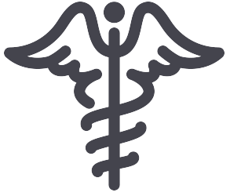  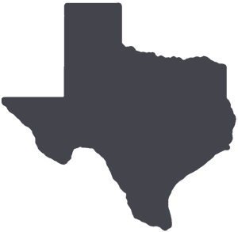  PATIENT CARE EDUCATION & RESEARCH INSTITUTIONAL SUPPORT CMC
AROUND UTMB (Use the legend above to quickly find items of interest to your team)
Weekly Wellness Recap:  Shared by the UTMB RISE (Resilience in Stressful Events) Task Force, these tips are just one way we can all work to stay emotionally healthy during the COVID-19 pandemic. Here are this week’s tips:  - Educate yourself about prejudice, and do your part to stop hate.  - Practice forgiveness today, not just for the sake of others but for you.  - Listen to music to relax.  - Advocate for someone to help their well-being and yours.  - Look for evidence that challenges your knowledge and assumptions.  - Go out of your way to connect with a colleague.  - Boost your mood through movement.  - Work to be happy; you will more easily see connection and meaning.  - Practice mindfulness to overcome bias.  The Joint Commission Spotlight—Medication management:  This month’s The Joint Commission Spotlight focuses on medication management. The spotlight addresses protocol for proper medication security and storage information, including refrigeration/freezer temperatures, multi-dose vials, high-risk medications, administration guidelines, adverse drug events and more. Download the goals at https://utmb.us/4uj or visit http://intranet.utmb.edu/qhs/the-joint-commission for more information on general preparedness information for UTMB’s upcoming survey by The Joint Commission.  Patient-Centeredness Tip of the Week—Every detail represents our approach to patient care  Best Care encompasses everything about patient care, from communication to outcomes to excellent service processes. When we get to know our patients by name and strive to understand what matters to them most, we serve them best. No matter how busy we are, we should never appear rushed and instead make time to talk to the person in front of us. Our smile is ever present! These are actions that demonstrate our values and can make a hard day for our patients far better. |  |  | Emergency Management standards preparedness:  As part of continuous readiness for the upcoming survey by The Joint Commission, it is important that we can all articulate our story of UTMB’s emergency preparedness for the Emergency Management (EM) Standards portion of the survey. Over the past two years, UTMB has successfully responded to simultaneous large-scale incidents. The following key talking points are related to our preparedness and resilience as an organization:  - In 2020, UTMB experienced the onset of the COVID-19 pandemic alongside a highly active hurricane season; the most serious storm threat to our area was Hurricane Laura.  - Our response to COVID-19 continued in 2021; during this time, we also experienced a period of arctic temperatures that caused a loss of water, steam, heat and normal electric power; this combination of elements resulted in damage to the physical infrastructure of UTMB campuses and surrounding communities.  - UTMB’s early COVID response was augmented by the integration of the Research Enterprise and Galveston National Laboratory into planning and response for the Command Team. This resulted in the ability to provide state-wide support for testing. Ultimately, UTMB researchers supported the worldwide response to the pandemic through their contributions to the development of medical countermeasures.  - UTMB led the effort to establish a multi-model COVID testing program which has served more than 350,000 community members; it also facilitated a regional vaccination center “hub” in partnership with state and local agencies and organizations, mobilizing hundreds of volunteers in the effort.  - As part of UTMB’s COVID response, the Health System developed an innovative COVID data dashboard to provide the organization with real-time data for decision-making.  - UTMB is part of the National Special Pathogens System, another example of UTMB’s readiness and ability to support regional and national emergencies.  - Despite staffing challenges, UTMB was able to adapt and continue to provide excellent care to our patients during this timeframe.
DID YOU KNOW?
Earth Day is a treasured annual tradition at UTMB, and while we have not been able to participate in group activities because of COVID-19, we can still celebrate. Taking a virtual field trip to a national park, picking up litter around your neighborhood or the beach and planting a new garden or green space are all ways that we can commemorate this year’s Earth Day. Currently, UTMB continues to be a leader in sustainable efforts across all its campuses, including expanding its recycling program to include operating room plastics, maintaining energy conservation standards and providing continued information sharing to all its students, faculty and staff on what sustainable initiatives are offered. UTMB Sustainability looks forward to reviving the Earth Day celebration in the years to come.

