Ben
Weekly Relays User Guide
TOPICS LEGEND
 |  | WEEKLY RELAYS |  | January 13, 2022
  YOUR DEPARTMENT NEWS |  |  |   UTMB NEWS
  We are delighted to announce that we have had several new employees recently join the School of Medicine Academic Affairs team. Please join us in extending a warm welcome to our newest team members!  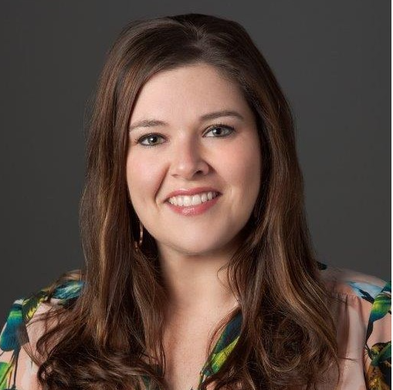  Megan M. Bates – Coordinator II – IMO  My name is Megan. I am a previous employee with UTMB. I am married with 3 very active children. Ages 9, 5, and 3. When I am not working, I enjoy spending time with my family. We love to go to the pool or beach. We love to collect shells at the beach and try to find hermit crabs. I also love cooking and baking when time allows for it. My dream is to one day own a coffee shop/bakery. As a busy mom, I thrive off of coffee and baked goods 😊  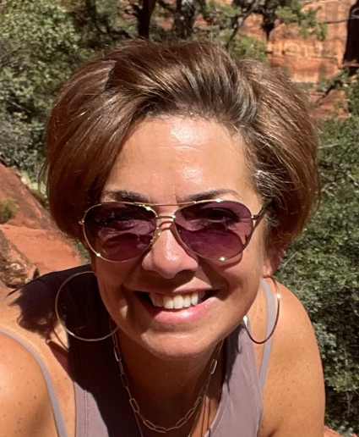  Shyla M. Hansche - Coordinator II - Student Affairs “I am a new resident to Galveston Island along with being new to the UTMB SOM community. I am excited to be a part of both! My husband Matt and I were living in Placitas, New Mexico the last year and a half, but missed Texas and our families!!! We decided to make the return to Texas via Galveston. We are both originally from the Richmond, Texas area. We are fortunate to have three children between the two of us. Two sons and one daughter. And four grandbabies! Two of those grandkids live here on the Island also. We love road trips, being outdoors and spending time with the kiddos!”  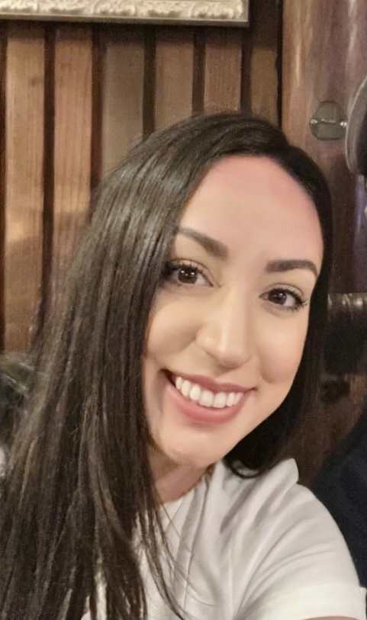  Meagan M. Hill – Coordinator II - IMO  -I am brand new to UTMB and very excited to be joining the IMO team! I was previously a manager with an E-Commerce company that caters to the needs of those experiencing medical hair loss. I was born and raised in Orange, TX. I am married and we have an 11-year-old son. We moved around the world during my husband’s time in the Army and have settled back down in League City. A few of my favorite things are, binge watching television series with my husband, being outdoors and art! ~  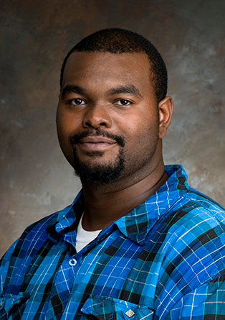  Aaron Quilla - Coordinator II - IMO  Born and raised in Galveston Texas. He is a father of one and has 15 years of service at UTMB total. He is self-described as artistic, and silly.  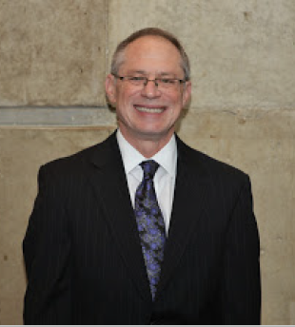  Dr. Jeffrey Susman – Senior Associate Dean – Office of Academic Affairs,  Educational Performance  Dr. Susman was here for a couple of days this week to lend his expertise to our LCME self-study meeting. He will officially join us in mid-February.  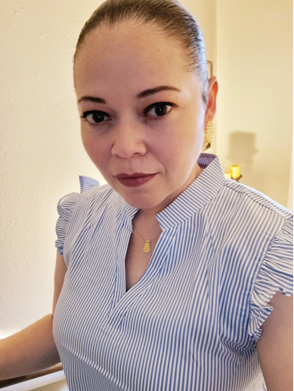  Karen J. Trevino – Coordinator II –  Office of Clinical Education  HOLA!  My name is Karen J. Treviño. I am the new Coordinator II for the Office of Clinical Education at UTMB-Galveston. Previously, I was a Senior Administrative Coordinator for the Integrative Biology and Pharmacology Department at McGovern Medical School in the Texas Medical Center. My work experience involves working in the logistics and transportation industry and the hospital & health care industry. I'm skilled in Public Speaking, Management, Leadership, HR, and Bilingual (English and Spanish). I have a Bachelor's in Science focused on Health Care Administration/Management from the University of Houston-Clear Lake and soon will start my graduate program to complete an MHA degree. I love to spend time with my family and my dog. They motivate me to keep conquering goals and be a better person every day.  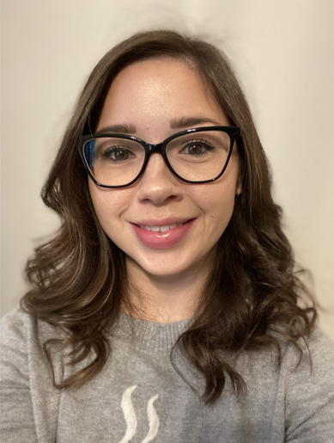  Kimberly Turner - Clinical Education Specialist -Office of Clinical Education  Kimberly is the newest Clinical Education Specialist in OCE. She has spent 12 years in the K-12 education space as a middle school teacher. After obtaining her master’s degree in Adult Learning and Leadership from Kansas State University, Kimberly decided to take the leap into adult education and is excited to be working with medical students and the OCE department. Her husband Stephen is an occupational therapist working for the Veterans Affairs Medical Center, they have a 6-year-old daughter, Olivia.    Reminder to sign up for the  PTO Information Sessions – everyone  should attend one of these sessions!  The employee information sessions will be available Jan. 3 – Feb. 18, 2022, Follow these steps to register for the session of your choice:  - Open ITS Training Gateway calendar (recommended web browser is Google Chrome)  - Click on By Application and select myPTO from dropdown  - Select your preferred session  - Click on Sign Me Up for Class  Those who attend a session will learn more about:  - UTMB’s reasons for transitioning from the state-sponsored vacation and sick leave plans to a paid time off program for all benfits eleigble faculty and staff  - New PTO accrual rates and maximum caryforward limits  - Situations in which employees will be able to directly access their EIB accruals without first having to use 16 hours of PTO,other available accruals or leave without pay  - Expanded income protection for employees who exhaust their accruals and need more time away from work for an illness/ injury or parental leave  - Distribution of personalized employee impact statements and more |  |  | COVID-19 UPDATE  The omicron variant continues to cause a sharp increase in COVID cases throughout our region. Read the Jan. 10 Incident Command message for the latest information.  IMPORTANT COVID-19 REMINDERS  - Return-to-Work/Campus requirements for employees and students were updated on Jan. 5. See this page to read the updated information.  - Please note that advice to students has been revised to require clearance from Student Health.  - Guidance on ability to care for neonates, NICU and immune-compromised patients has been clarified.  - Read the Jan. 6 Vaccination Preparedness Task Force message (https://utmb.us/6de ) regarding Pfizer-BioNTech booster shots for the 12 to 15 age group and other new CDC recommendations regarding boosters.  - Failure to comply with the most current antigen testing and return-to-work requirements will result in forfeiture of Emergency Paid Leave for Qualifying Reasons. The employee’s own leave accruals or leave without pay, if no accruals are available, will need to be applied to the absence. For additional details on emergency paid leave, visit https://utmb.us/6bu.  - Employees in the Houston/Galveston/Brazoria County region should schedule a COVID-19 test through MyChart or at  http://intranet.utmb.edu/covid-19-internal/employee-covid-19-testing  (UTMB login required) if they have COVID symptoms or believe they were exposed to the virus.  - An employee-only Microsoft Teams Question & Answer session regarding the omicron variant was conducted by Dr. Gulshan Sharma on Dec. 30. You can view a recording of that session here. (UTMB login required).  Weekly Wellness Recap: Throughout the month of January, try to focus on finding joy in the workplace.  - Take a different route today and see what you notice.  - Eat healthy food that really nourishes you today.  - Get outside and notice five things that are beautiful.  - Contribute positively to your work environment.  - Be gentle with yourself when you make mistakes.  - Get back in contact with an old friend.  - Focus on what’s good, even if today feels tough.
OPICS  LEGEND |         PATIENT CARE EDUCATION & RESEARCH INSTITUTIONAL SUPPORT CMC
AROUND UTMB (Use the legend above to quickly find items of interest to your team)
Take 5 to learn about the myPTO program’s direct access to EIB provisions: Take 5 minutes today to learn more about the situations in which you will be able to directly access the hours in your Extended Illness Bank (EIB). These situations include:  - Personal wellness activities – up to 16 hours (prorated for FTE status) per fiscal year  - Care for the illness/injury of employee and immediate family members – up to 16 hours (prorated for FTE status) per fiscal year  - Hospital admissions that require an overnight stay for employee and immediate family members  - Continuous or intermittent leave approved by HR Leave Management  - Leave requests pending approval by HR Leave Management  - School-sponsored educational activities for dependent children who are in pre-kindergarten through 12th grade – up to eight hours (prorated for FTE status) per fiscal year  Visit utmb.us/5 for complete details!  GALVESTON CAMPUS  John Sealy Hospital front entrance and circle drive to close Feb. 22: The front entrance and circle drive of John Sealy Hospital will close on Feb. 22 for approximately two years as part of the John Sealy Hospital Modernization project. The closure will allow for replacement of the porte cochère structure and the older brick façade on the hospital. The R. Waverley Smith Pavilion (WSP) entrance and patient drop-off will be used for John Sealy destinations. The WSP street-level entrance front desk will be staffed 24/7 (as the John Sealy entrance is now), and a limited number of 30-minute parking spots will be made available near the WSP for expectant mothers. The WSP entrance will also become the Safe Baby Site. A few other details of the closure:  - The John Sealy east entrance and the WSP first-floor tunnel entrance will remain badge-access only and exterior signage will be updated, directing vehicles for John Sealy to the WSP entrance.  - Starting Monday, Feb. 21, the Connect Transit Park and Ride bus stop currently at the WSP will move near the crosswalk between the parking garage and the Administration building (along Darrell Royal Avenue). |  |  | - As a reminder, the designated location for vehicles picking up or dropping off employees at John Sealy is the 9th Street turnaround, between Research Building 6 and the Moody Medical Library.  Please contact Amber Clayton at (409) 750-1544 with questions or concerns and visit https://www.utmb.edu/construction to learn more.  Retail Dining Martin Luther King Day Hours:  Galveston  Health Education Center:  - The HEC Grill will remain closed until reopening Monday, 01/24/22  John Sealy Hospital:  - Sub Connection will be open from 10:30 a.m. to 8 p.m.  - Café on the Court, Chick-fil-A, and Starbucks will be closed  Jennie Sealy Hospital:  - Bistro 712 will be open from 6:30 a.m. to 2 p.m.  - Hospital Lobby vending machines will remain open 24/7  Clinical Services Wing (CSW):  - Sixth Floor Staff Lounge Micro Market will remain open 24/7 with healthy options  League City Campus  - Bayside Bistro grill will be open from 7 a.m. to 2 p.m.  - Vending machines will remain open 24/7  Angleton Danbury Campus  - Bayou Café will be closed  Clear Lake Campus  - The Grill will be open from 8 a.m. to 1 p.m.  - Starbucks will be closed  - Vending machines will remain open 24/7  REMINDER  Next Health Care Unmasked set for Jan. 19: Dr. Philip Keiser, chair of the UTMB COVID-19 Vaccination Task Force and Galveston County Health Authority, and Dr. Janak Patel, director of UTMB Infection Control and Healthcare Epidemiology, will appear on the Jan. 19 edition of Health Care Unmasked. Drs. Patel and Keiser will address the latest information on the Omicron variant. The episode will air at noon on the i45 Now Facebook channel at https://facebook.com/i45now.
 |  |  | DID YOU KNOW? UTMB Health’s Angleton Danbury Campus has achieved Level I Neonatal Facility Designation from the Texas Department of State Health Services. The Level 1 Neonatal Facility Designation reflects the facility’s documented capabilities and history of providing a specific level of care to infants. As a Level I-designated facility, ADC provides care for mothers and infants of at least 35 weeks gestational age who have routine perinatal problems, has skilled personnel with training specific for the patient population served, and provides the same level of care that an infant of less than 35 weeks gestational age would receive at a higher-level designated neonatal facility. There are 227 Designated Neonatal Facilities across the state of Texas, with 82 designated as Level I. For more information, visit https://utmb.us/6d6.

