Ben
Weekly Relays User Guide
TOPICS LEGEND
 |  | WEEKLY RELAYS |  | February 17, 2022
YOUR DEPARTMENT NEWS |  |  | UTMB NEWS
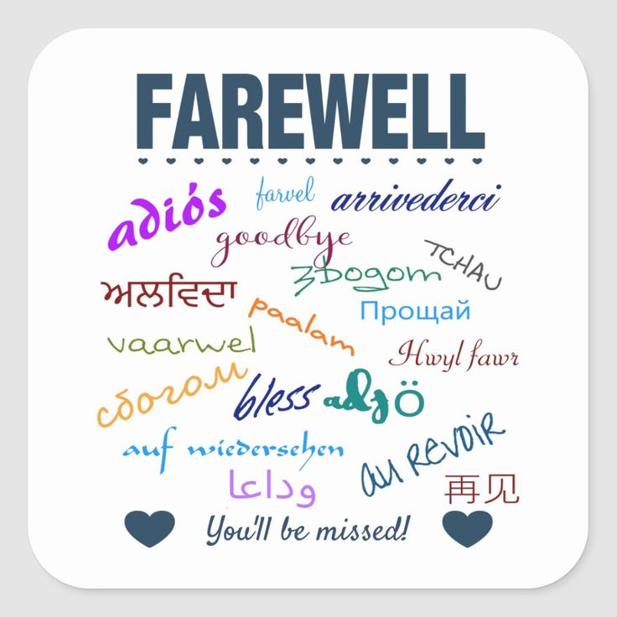  Dr. Schatte we wish you the best in Colorado! We will miss you and your comments in the teams chat!  Take care and come back to visit us!  Side Note: this is the picture Dr. Schatte submitted to be used in her farewell…  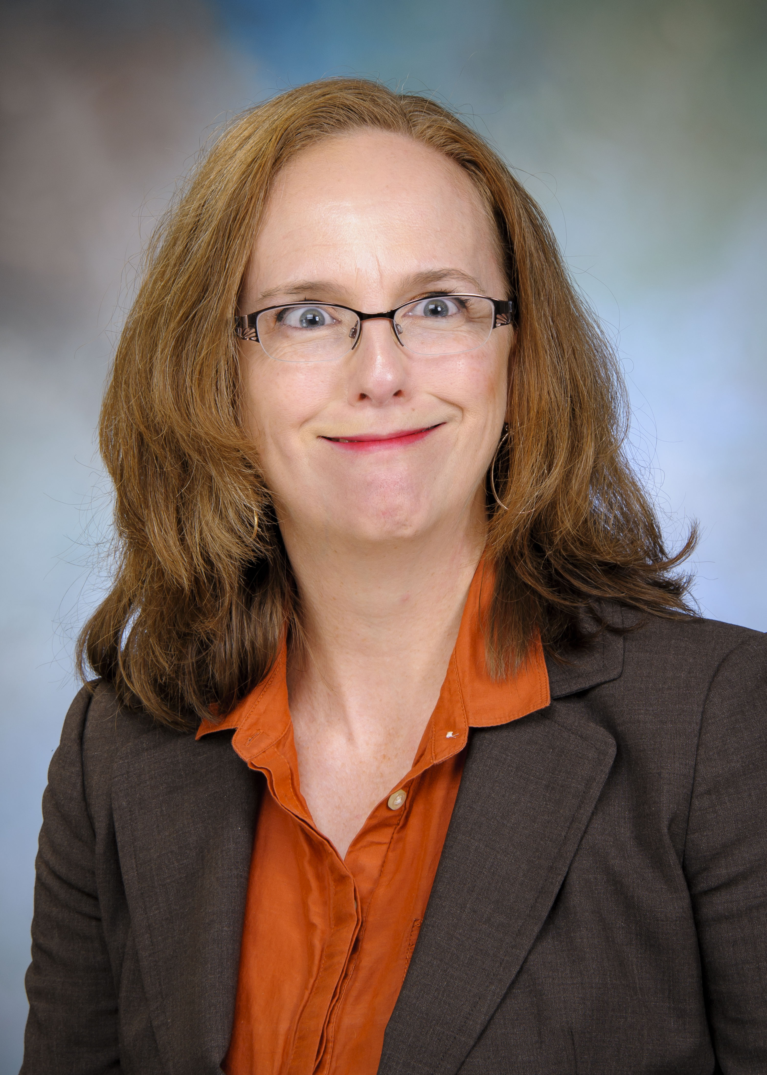  We REALLY are going to miss you!!! |  |  | Monthly Financial Update — Results as of January 31, 2022  For the month of January, UTMB’s Adjusted Margin Loss was $11.1 million, which was $4.7 million unfavorable to planned results. Year-to-date, UTMB’s Adjusted Margin Loss was $4.5 million, which was $1.2 million unfavorable to planned results. Thank you for your ongoing efforts to manage expenses and improve the efficiency of our work to ensure the long-term success of UTMB’s mission.  COVID-19 UPDATE  - New Vaccine Guidance: On Feb. 11, the Centers for Disease Control and Prevention (CDC) updated their COVID-19 vaccination guidance for moderately or severely immunocompromised individuals, as well as their recommendations on COVID-19 vaccination after receiving COVID-19 monoclonal antibodies. Read UTMB’s Feb. 16 Vaccination Task Force message for more details.  - Updates to Visitation, Social Distancing, Masking and Travel Requirements: Due to declining rates of COVID-19 infections in our community, modifications have been made to the UTMB visitation policy, social distancing and masking requirements, and travel restrictions, effective Feb. 14. Read the Feb. 14 Clinical Task Force message.  IMPORTANT REMINDERS  Read the Jan. 26 institutional message regarding the Federal CMS Vaccine Mandate requirements.  Celebrating Black History Month  This week, UTMB and the Black Alliance Employee Resource Group would like to honor Dr. Virginia Stull. In 1962, Dr. Stull became the first Black woman to begin classes at UTMB. Her clinical training was limited to a Black hospital in Galveston due to Jim Crow segregation with the exception of pediatrics training, which had both white and Black children. Dr. Stull underwent major challenges due to her race and gender and was often mistaken as a nurse's aide because administrators and physicians did not recognize a Black woman as a physician or physician in training. Despite her circumstances, she was resilient and graduated with her medical degree in 1966. For more information about UTMB’s Black History Month events and how you can get involved in the Black Alliance Employee Resource Group, please see https://www.utmb.edu/hr/diversity/black-alliance-resource-group.
OPICS  LEGEND | PATIENT CARE EDUCATION & RESEARCH INSTITUTIONAL SUPPORT CMC
AROUND UTMB (Use the legend above to quickly find items of interest to your team)
myPTO program: Take 5 to learn about UTMB’s Major Disaster Recovery Bank  Following the transition to the myPTO program, you will be able to donate a portion of your accrued PTO and/or EIB hours to a Major Disaster Recovery Bank (MDRB). The MDRB will be activated as needed on a temporary basis to support employees adversely affected by a declared major disaster. You may request to receive withdrawals from the MDRB if you have exhausted all available accruals and are unable to work due to a major disaster that has caused a severe hardship for you or an immediate family member. You may receive up to two grants of MDRB hours per activation of the bank, not to exceed 80 hours per grant. If the bank is activated multiple times in a fiscal year, then the maximum MDRB hours that may be granted for all activations is 300. Granted MDRB hours will be paid at your monthly or hourly base pay rate at the time of use. Visit utmb.us/5 for more MDRB details!  NOTICES  Encrypting Confidential Information in Email  UTMB users sending any confidential information (PHI, PII, financial, etc.) via email should use on-demand email encryption to ensure that confidential information is protected while being transferred between email services. There are two methods to initiate an on-demand encrypted email:  - Using any version of Outlook or webmail: In a New email, place the text #ENCRYPT# in the Subject line before entering the actual subject information  - Using an up-to-date version of Outlook, Outlook-Citrix or Webmail: In a New email, select the Options tab, select the Encrypt dropdown menu from the ribbon and click the Encrypt Only option.  Using either method will protect (encrypt) the email in transit and allow only the verified recipient to decrypt the message. For questions, please contact ishelp@utmb.edu.  UTMB web access to be interrupted Feb. 27  At approximately 10 p.m. on Feb. 27, UTMB will be updating its web content management system, Sitefinity. During the update, UTMB’s public and intranet web traffic will be routed to a backup/recovery webpage until the work is complete; the interruption in service will affect many UTMB websites and is expected to last approximately one hour. The software upgrade will enhance system stability and security. We ask that UTMB webpage developers not work on their sites during the update (to avoid losing work), and we apologize to our webpage visitors for this necessary disruption. For questions, please email sitefinity@utmb.edu. If you experience any issues with the website after the update, contact ishelp@utmb.edu.  REMINDERS (continued)  2021 Tax Forms: 1095-C Form Now Available  Employees who signed up to receive an electronic copy of their 1095-C tax form for 2021 may now log in to www.MyTaxForm.com to download and print the form. This form contains information about your health care coverage that will be needed to complete your income tax return. Any employee who did not consent to electronic delivery of the form will receive a paper copy through the U.S. mail. Lost or damaged forms will be reissued at no cost; however, a fee will be charged for each additional paper copy. For assistance with logging in to MyTaxForm.com, email hrservic@utmb.edu.  PATIENT CARE  Spotlight on Joint Commission: Question of the Week  Speaking to Surveyors  - Will I have to speak with The Joint Commission surveyors? While not every person will have the opportunity to speak with The Joint Commission surveyors, those involved in direct patient care, ancillary services and support services will likely encounter surveyors. If you have the opportunity to speak with them, be confident, be positive and demonstrate what you know.  - What if I don’t understand what the surveyor is asking me? Don’t allow too much of a pause between the question and your answer. If you don’t understand the question, request that the surveyor repeat or restate the question. You can ask the surveyor to phrase the question in a different way. For example, “I’m not sure what you are asking. Could you explain what you mean?” Remember, you know your job; surveyors are just asking you to explain what you do.  - What if I don’t know the answer? Should I make one up? Be truthful. If you do not know an answer, say so and tell the surveyor where or whom to go for the answer. This might include referring to a policy manual or contacting a director, supervisor or another department. Falsification or misrepresentation is absolutely not tolerated and can cause the organization to lose its accreditation. Keep in mind there are some things that all staff should know, such as where to find emergency exits and fire extinguishers. |  |  | Weekly Wellness Recap  During February, focus on the importance of being friendly and fostering relationships and connections for resilience.  - Support a colleague or other department with a positive review or friendly message.  - Check in on someone who may be struggling and offer resources.  - Appreciate the good qualities of someone in your life.  - Respond kindly to everyone you talk to today, including yourself.  - Share something you find inspiring, helpful or amusing.  - Make a plan to connect with others and do something fun.  - Really listen to what people say, without judging them.  IN CASE YOU MISSED IT  Health Care Unmasked from Feb. 16  Dr. Gal Levy, cardiovascular and thoracic surgeon and assistant professor with the Department of Surgery, appeared on the Feb. 16 edition of Health Care Unmasked. Dr. Levy addressed cardiovascular disease (CVD) and the prevalence of CVD in women. Heart disease is a leading cause of death for both men and women in the United States, but the good news is you can do a lot to protect your heart and stay healthy. You can watch the full episode on the i45 Now Facebook channel at https://facebook.com/i45now.  REMINDERS  GALVESTON CAMPUS  John Sealy Hospital front entrance and circle drive to close Feb. 22  The front entrance and circle drive of John Sealy Hospital will close on Feb. 22 for approximately two years as part of the John Sealy Hospital Modernization project. The closure will allow for replacement of the porte cochère structure and the older brick façade on the hospital. The R. Waverley Smith Pavilion (WSP) entrance and patient drop-off will be used for John Sealy destinations. The WSP street-level entrance front desk will be staffed 24/7 (as the John Sealy entrance is now), and a limited number of 30-minute parking spots will be made available near the WSP for expectant mothers. The WSP entrance will also become the Safe Baby Site. A few other details of the closure:  - The John Sealy east entrance and the WSP first-floor tunnel entrance will remain badge-access only and exterior signage will be updated, directing vehicles for John Sealy to the WSP entrance.  - Starting Feb. 21, the Connect Transit Park and Ride bus stop currently at the WSP will move near the crosswalk between the parking garage and the Administration building (along Darrell Royal Avenue).  - As a reminder, the designated location for vehicles picking up or dropping off employees at John Sealy is the 9th Street turnaround, between Research Building 6 and the Moody Medical Library.  For more information, contact Amber Clayton at (409) 750-1544 or visit https://www.utmb.edu/construction.
DID YOU KNOW?
The Moody Medical Library subscribes to a database from NewsBank, an online resource that consolidates current and archived information from thousands of newspapers (including the Houston Chronicle and The Galveston County Daily News) as well as newswires, web editions, blogs, videos, broadcast transcripts, business journals, periodicals, government documents and other publications. Anyone with UTMB credentials can access this content at no individual cost. To try it, go to the NewsBank landing page. For help or more details, contact a librarian at askus@utmb.libanswers.com.

