Ben
Weekly Relays User Guide
TOPICS LEGEND
 |  | WEEKLY RELAYS |  | February 10, 2022
  YOUR DEPARTMENT NEWS |  |  |   UTMB NEWS
  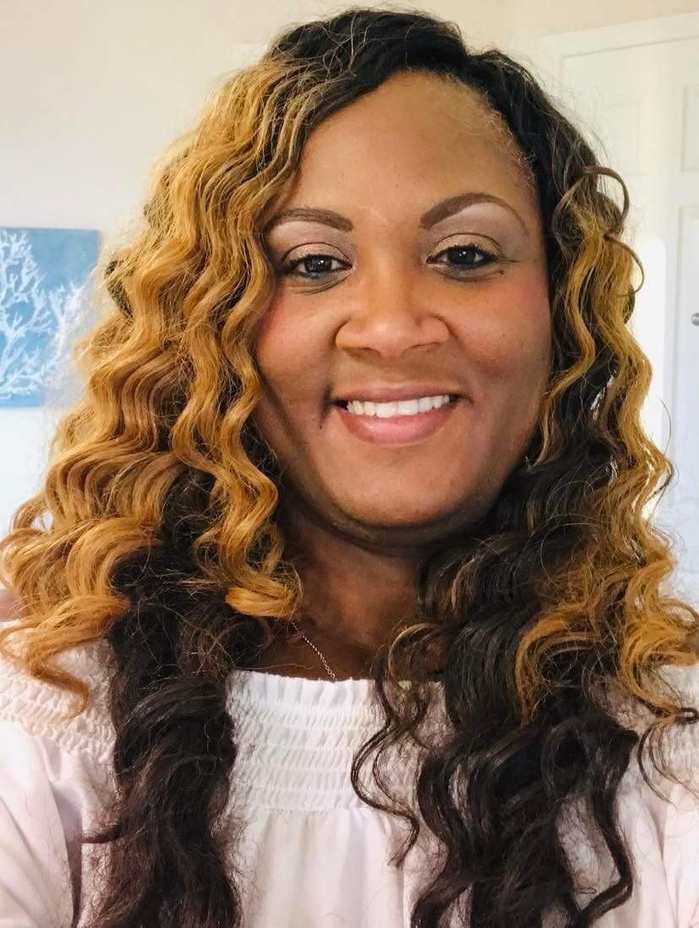  Chantea Palmer – Coordinator II – IMO  Hi! My name is Chantea Palmer. I’m happy to be a part of the IMO Family as one of the newest Coordinators. I live on the mainland with my husband, Phillip of 14 years and our 4-year-old twins; Dionne and Durelle. We love family outings; especially going to the movies and going out to eat. We are a busy family with running a newly opened restaurant to doing my event planning on the weekends, but we wouldn’t trade it for the world! I received my Bachelor of Science from the University of Houston-Clear Lake, majoring in Behavioral Science. I’ve worked for many non-profit agencies and am excited about new endeavors here at UTMB!    Congratulate our Seniors on Match Day!  On Friday, March 18, the Class of 2022 will find out the residency program they have matched into. We will celebrate their success at Levin Hall Dining Room from 11:00 AM to 3:00 PM with a festive balloon arch, and celebratory yard signs near Levin Hall and Old Red.  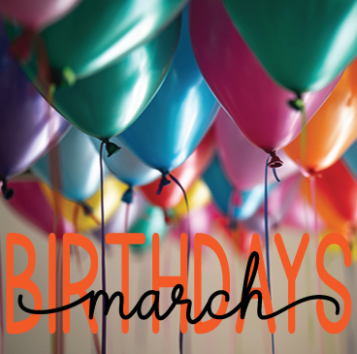  Catalina Salinas March 1st  Shirley McGraw March 13th  Kathleen Collins March 15th  Pierre Banks March 28th  Sally Harris March 31st |  |  | COVID-19 UPDATE  IMPORTANT REMINDER  All faculty, staff and students must continue to remain vigilant and practice safety protocols to protect themselves and others. To read the Jan. 26 Clinical Task Force message, visit https://utmb.us/6g4.  ACTION ITEM  UTMB must comply with the CMS vaccination mandate and reporting requirements. If you have had the COVID vaccine and have not taken the following steps yet, please do so as soon as possible:  - To help UTMB comply with the federal reporting requirement, send proof of vaccination to Employee Health at emphlthc@utmb.edu if you received your vaccine anywhere OTHER THAN Employee Health. (This includes UTMB provider offices, retail pharmacies, etc.)  - Check your MyChart account to make sure your information is up to date. If your COVID vaccination is not listed, you can request an update by sending your provider a message and a scan of your vaccine card or by bringing your vaccine card to your next provider visit.  2021 Tax Forms: 1095-C Form Now Available  Employees who signed up to receive an electronic copy of their 1095-C tax form for 2021 may now log in to www.MyTaxForm.com to download and print the form. This form contains information about your health care coverage that will be needed to complete your income tax return. Any employee who did not consent to electronic delivery of the form will receive a paper copy through the U.S. mail. Lost or damaged forms will be reissued at no cost; however, a fee will be charged for each additional paper copy. For assistance with logging in to MyTaxForm.com, email hrservic@utmb.edu.  myPTO Program: You spoke, we listened, and now it will be even easier to directly access the hours in your Extended Illness Bank!  Based on your feedback, UTMB has enhanced the myPTO program to allow you to directly access a combined total of 40 hours (prorated for FTE status) of EIB each fiscal year for:  - Personal wellness activities  - Your own illness/injury or an immediate family member’s illness/injury  - School-sponsored educational activities for dependent children who are in pre-kindergarten through 12th grade  The hours may be used as preferred, and documentation will not be required unless you are out for your own illness/injury for three or more consecutive workdays. Take 5 minutes today to read more at utmb.us/5.
OPICS  LEGEND |       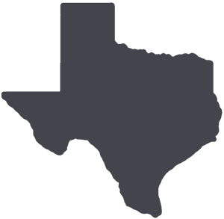  PATIENT CARE EDUCATION & RESEARCH INSTITUTIONAL SUPPORT CMC
AROUND UTMB (Use the legend above to quickly find items of interest to your team)
Celebrating Black History Month  This week, UTMB and the Black Alliance Employee Resource Group would like to honor an African American woman, Henrietta Lacks, who had the first immortalized cell line in American History. In 1951, Lacks went to John Hopkins regarding a health concern. Later she would be diagnosed with cervical cancer. Her doctor obtained a biopsy from her cervix for diagnosis and treatment. A small part of her tissue was taken to the tissue culture laboratory without Lacks’ knowledge or consent, which was a common practice at the time. Dr. George Gey, who was head of the tissue culture laboratory, found that Lacks’ cells survived and replicated. Before then, no human cells survived outside the body. Henrietta Lacks died a few months after her cancer diagnosis, but her cells (HeLa Cells) have been used in many medical research and breakthrough efforts and vaccine development. Some examples include research on the effects of zero gravity in outer space, the development of the polio vaccine, and the study of leukemia, the AIDS virus and cancer. HeLa cells are also used in COVID-19 research and were instrumental in the development of IVF, the HPV vaccine and more. It has been almost seven decades, and HeLa Cells have now lived more than twice as long outside Lacks’ body than inside. Henrietta Lacks’ cells continue to be a vital part of medical research and we give her high honors! For more information about UTMB’s Black History Month events and how you can get involved in the Black Alliance Employee Resource Group, please see https://www.utmb.edu/hr/diversity/black-alliance-resource-group.  Weekly Wellness Recap:  Throughout the month of February, focus on the importance of being friendly and fostering relationships and connections for resilience.  - Share what you’re feeling with someone you trust.  - Thank someone and tell them how they made a difference for you.  - Look for good in others, particularly when you feel frustrated with them.  - Send an encouraging note to someone who needs a boost.  - Focus on being kind rather than being right.  - Smile at the people you see and brighten their day.  - Tell someone why they are special to you.  EDUCATION & RESEARCH  The John P. McGovern Academy of Oslerian Medicine announced the recipients of its 2022 Excellence in Clinical Teaching Awards.  This award recognizes the fundamental concept, exemplified by Sir William Osler, that the development of outstanding physicians occurs primarily in clinical settings. This honor is accompanied by a monetary award to support professional development and/or teaching programs. Congratulations to this year’s honorees!  - Dr. L. Maria Belalcazar, Department of Internal Medicine, Endocrinology  - Dr. Khaled F. Chatila, Department of Internal Medicine, Cardiology  - Dr. Hania Kassem, Department of Internal Medicine, Nephrology  - Dr. Arsalan Saleem, Department of Radiology  - Dr. Lindsay K. Sonstein, Department of Internal Medicine, General Medicine  Research Quarterly Update  The next Research Quarterly Update will take place Feb. 15 at 11 a.m. via Teams Live. All UTMB faculty, staff, and students are invited to tune in and learn what’s new in the Research Enterprise. Dr. Giulio Taglialatela, professor and vice chair for research in the Department of Neurology and director of the Mitchell Center for Neurodegenerative Diseases, will provide information on the new Brain Health Institute at UTMB, and Dr. Gary Kobinger, director of the Galveston National Laboratory (GNL) will share updates from the GNL. Join online at https://utmb.us/64w. |  |  | Message from the President – Reorganization Among Finance Leadership  UTMB President Dr. Ben Raimer announced the next phase in the reorganization of the university's finance group on Feb. 4. These changes will not only position UTMB Health for even greater success in the future but will allow UTMB to make the best use of the considerable talents and skills among our finance leaders. For more information, visit https://utmb.us/2x4.  PATIENT CARE  Spotlight on Joint Commission: Question of the Week  Did you know that what Joint Commission sees is just as important as what they ask?  During the survey, Joint Commission will observe staff and the environment while they ask questions. The Joint Commission will see:  - Identification badges worn above the waist and visible.  - Use of two patient identifiers when administering medications, collecting blood or other specimens, or providing a treatment, procedure or delivering food trays.  - Labeling specimens in the presence of the patient.  - Performing hand hygiene before entering and after exiting a patient room or patient contact, contact with the patient’s environment or donning and doffing PPE.  - Compliance with Universal Protocol (e.g., Time out).  - Patient privacy maintained and security of HIPAA-protected information.  - Medication storage and security.  - Cleanliness and safety of environment.  - Clear corridors (i.e., Stretchers and equipment on one side if they are in use). Any items in corridors for more than 30 minutes are considered “storage” rather than “in use” and are considered clutter.  - Clear access to fire extinguishers, pull stations, medical gas shut-off valves and exits.  - Storage of clean equipment and how to identify clean equipment.  - Clean refrigerators and ice machines. Remember to document refrigerator temperatures daily and know what to do if the temperature is out of range.  - Crash cart checks up to date with no expired items.  - Open EKG electrode packets dated with 30-day expiration.  - Sharps containers no more than three-quarters full.  - Limited access to secure areas.  For more information on environmental preparedness, see the Environmental Preparedness Checklist.
DID YOU KNOW?
In 2021, UTMB Health introduced an additional resource to share ongoing information focused on key aspects of improving and maintaining overall health. The UTMB Health Blog offers posts on various topics from women and men’s health to pediatrics to how to choose between primary care, urgent care and emergency care services. One of the latest posts, “Self-Care for a Healthier Heart,” covers why it is important to prioritize yourself, not only for your overall well-being, but to improve your heart health. Read more at https://utmb.us/6fs.

Forward links as needed. Send questions and feedback to relay.leader@utmb.edu. Visit the Weekly Relay website at http://blogs.utmb.edu/relay.

