Ben
Weekly Relays User Guide
TOPICS LEGEND
 |  | WEEKLY RELAYS |  | April 28, 2022
YOUR DEPARTMENT NEWS |  |  | UTMB NEWS
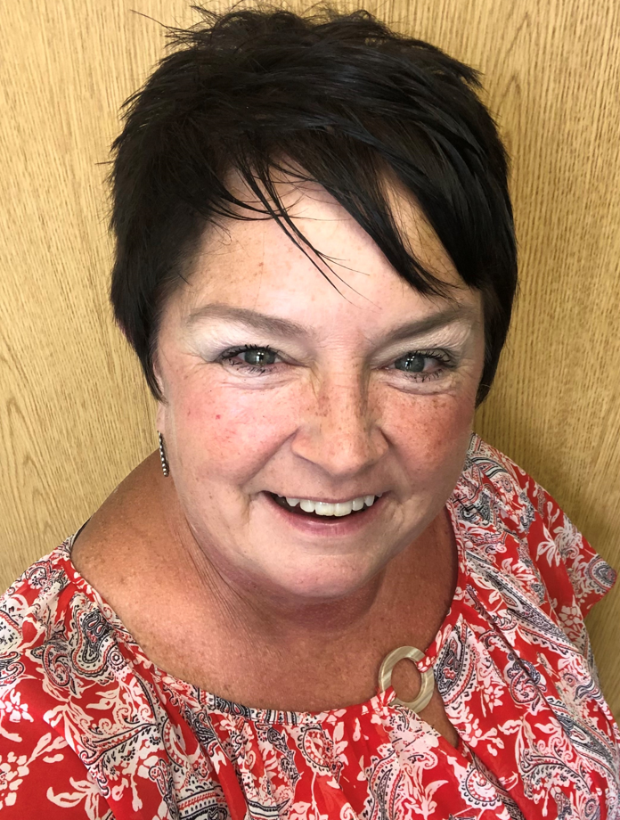  D’Anne DeWitt – Recruitment & Admissions Coordinator, Office of Student Affairs and Admissions  I am originally from Northeast but currently live in the Bacliff area. I’ve been a UT System employee for over 25 plus years. When not working, I love relaxing at the beach, gardening, playing with our fur babies and enjoying my husband’s cooking.  Welcome D’Anne! It’s great to have you on board! |  |  | Weekly Wellness Tips  Throughout the month of April, focus on being active.  - Enjoy moving to your favorite music. Really go for it.  - Go out and do an errand for a loved one or neighbor.  - Get active in nature. Feed the birds or go wildlife-spotting.  - Have a ‘no screens’ night and take time to recharge yourself.  - Take an extra break in your day and walk outside for 15 minutes.  - Find a fun exercise to do while waiting for the kettle to boil.  - Meet a friend outside for a walk and a chat.  REMINDER  myPTO program resources available online  UTMB completed its transition to a paid time off program for all benefits-eligible faculty and staff on March 28. The new myPTO program provides the flexibility and privacy needed for a healthier work-life balance and enables employees to have more control over how they use earned time off. For more about the myPTO program—including video training related to the program’s integration with Kronos and a myPTO handbook—visit https://www.utmb.edu/hr/paid-time-off-program.  COVID-19 UPDATES  Important Reminders & Quick Links  - Travel requirements and guidelines remain in place until further notice  - Safety Requirements  - Visitation Policy  - Requirements if you are Sick or Exposed, including return-to-work/campus guidelines after infection  - Schedule a vaccine or booster online
OPICS  LEGEND | PATIENT CARE EDUCATION & RESEARCH INSTITUTIONAL SUPPORT CMC
AROUND UTMB (Use the legend above to quickly find items of interest to your team)
PATIENT CARE
Spotlight on Joint Commission: Questions of the Week

Who can request an RRT?
- A patient or the patient’s family may request the RRT to evaluate changes in a patient’s condition. Information about the RRT is provided to patients/families in designated areas.
- Any healthcare provider may activate the RRT. No healthcare provider should discourage or prohibit the use of the RRT.

When do you activate the RRT?
- See IHOP Policy: 09.13.31 Activation of the Medical Surgical Rapid Response Team (RRT) for criteria. Basically, staff can activate the RRT for any concern or worry about the patient.

How do you activate the RRT?
- Each campus should dial their specific phone number or extension below to request a Rapid Response Team. The caller should provide the Operator with the following information:
  - Precise location (unit and building)
  - Caller’s name and extension

- The phone number for your campus is:
  - Galveston Campus, dial 409-772-4000 or x2-4000
  - Angleton Danbury Campus dial, x3333
  - League City Campus, dial 409-772-4000 or x2-4000
  - Clear Lake Campus dial, x15200 or 832-632-6367

- In the event medical attention is needed for an individual who is not an inpatient, employees of those areas should either:
  - Call a code, or
  - Arrange for transportation to the Emergency Department (when applicable)

Note: The RRT is committed to providing critical care resources to patients who may be in crisis. A physician order is not required for a Rapid Response Activation, but all treatments and interventions require a physician’s order. See IHOP Policy: 09.13.31 Activation of the Medical Surgical Rapid Response Team (RRT) for additional information
DID YOU KNOW?
UTMB School of Nursing held its commencement ceremony on April 22 at Moody Gardens Convention Center, with graduates’ families and friends invited to celebrate in person. Dr. Erin Perez, three-time UTMB School of Nursing graduate and Hall of Fame member, delivered the commencement address. Dr. Sharron Forest, associate professor and DNP Program director, served as mace bearer. Congratulations to all the graduates! This school awarded the following degrees and certificates to its class of 2022:

· Adult Gerontologic Acute Care Nurse Practitioner – 47
· Adult Gerontologic Primary Care Nurse Practitioner – 10
· Clinical Nurse Leader – 5
· Doctor of Nursing Practice – 27
· Executive Nurse Leader – 17
· Family Nurse Practitioner – 56
· Neonatal Nurse Practitioner – 19
· Nurse Educator – 7
· RN-BSN – 44
· Traditional BSN – 327
· Certificates – 5

