Ben
Weekly Relays User Guide
TOPICS LEGEND
 |  | WEEKLY RELAYS |  | May 26, 2022
YOUR DEPARTMENT NEWS |  |  | UTMB NEWS
Medical Education Conference  UTMB educators came together for a lively and informative conference on May 25th  The morning began with remarks by Dr. Charles Mouton, followed by welcomes, farewells, and introduction of people who have recently joined Educational Affairs.  Course directors, clerkship directors, coordinators and others joined together in the morning to discuss the assessment of students  The plenary, Equity in Clinical Grading: Mitigating Bias in Performance Assessment, delivered by Dr. LuAnn Wilkerson and Dr. Gareth Gingell (UT at Austin, Dell Medical School) set the stage for an interactive discussion of narrative comments used in assessments. This was followed by an update on the Coaching and Professionalism Program Coaching (CAPP, formally the ECN system)  The afternoon breakouts provided coordinators a chance to learn about new computer software being used in the curriculum.  Course Directors worked on mapping their course content to the USMLE Licensing Exam content and Clerkship and Clinical Course Directors worked on mapping clinical curriculum to the Entrustable Professional Activities and Physician Competency Reference Set.  Special thanks to Alma Block, Sally Harris, and Chloe Nguyen for the behind-the-scenes work to make this conference possible.  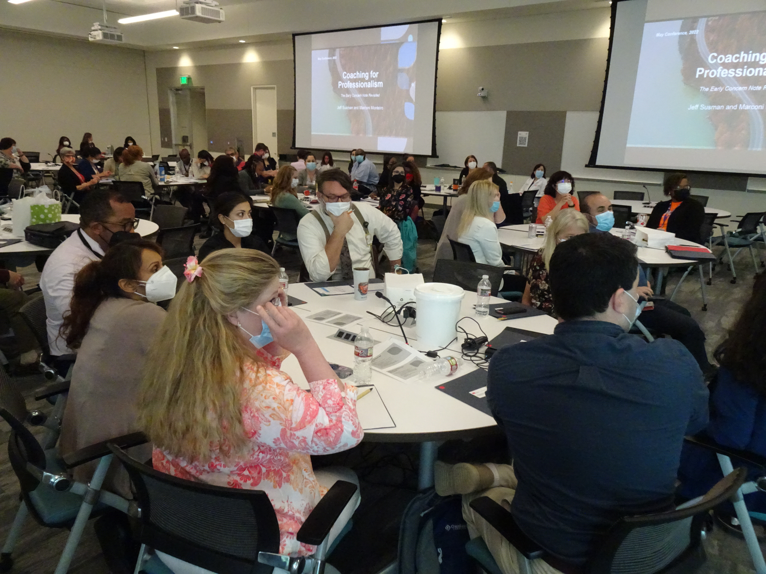  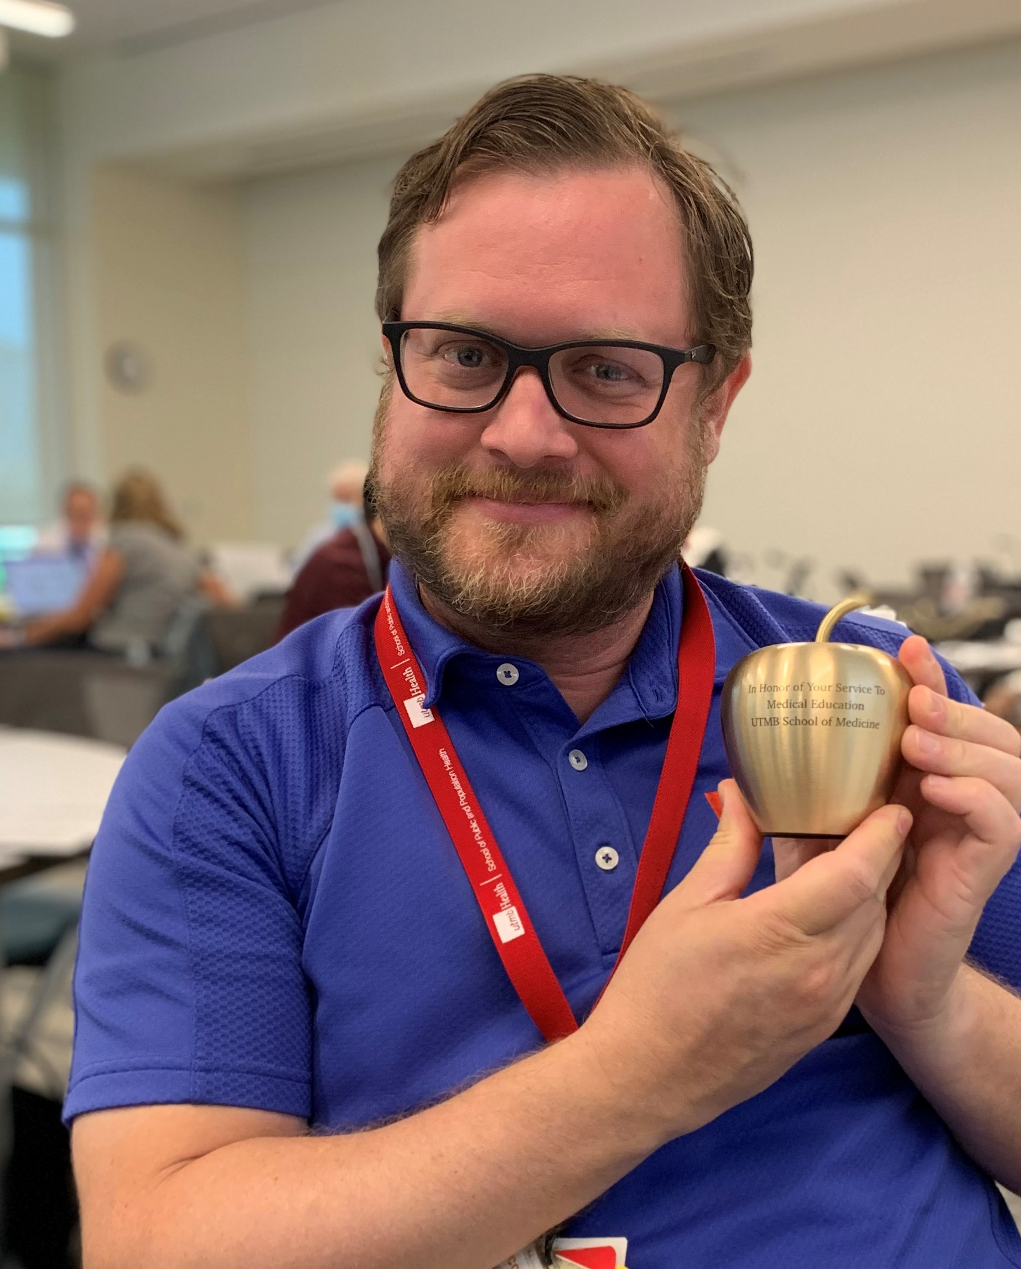  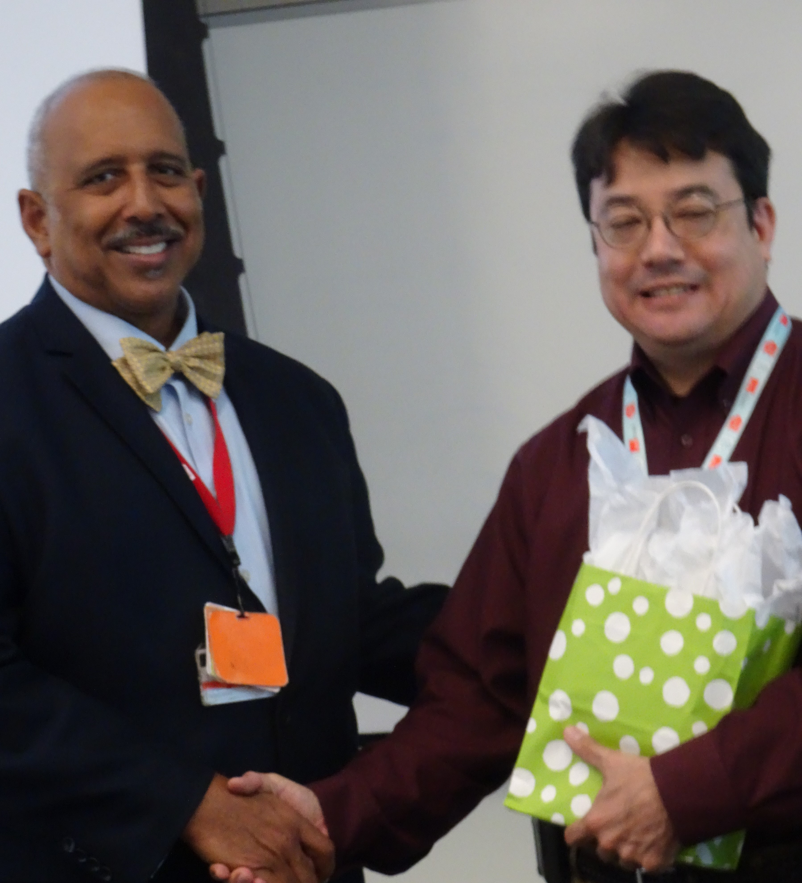  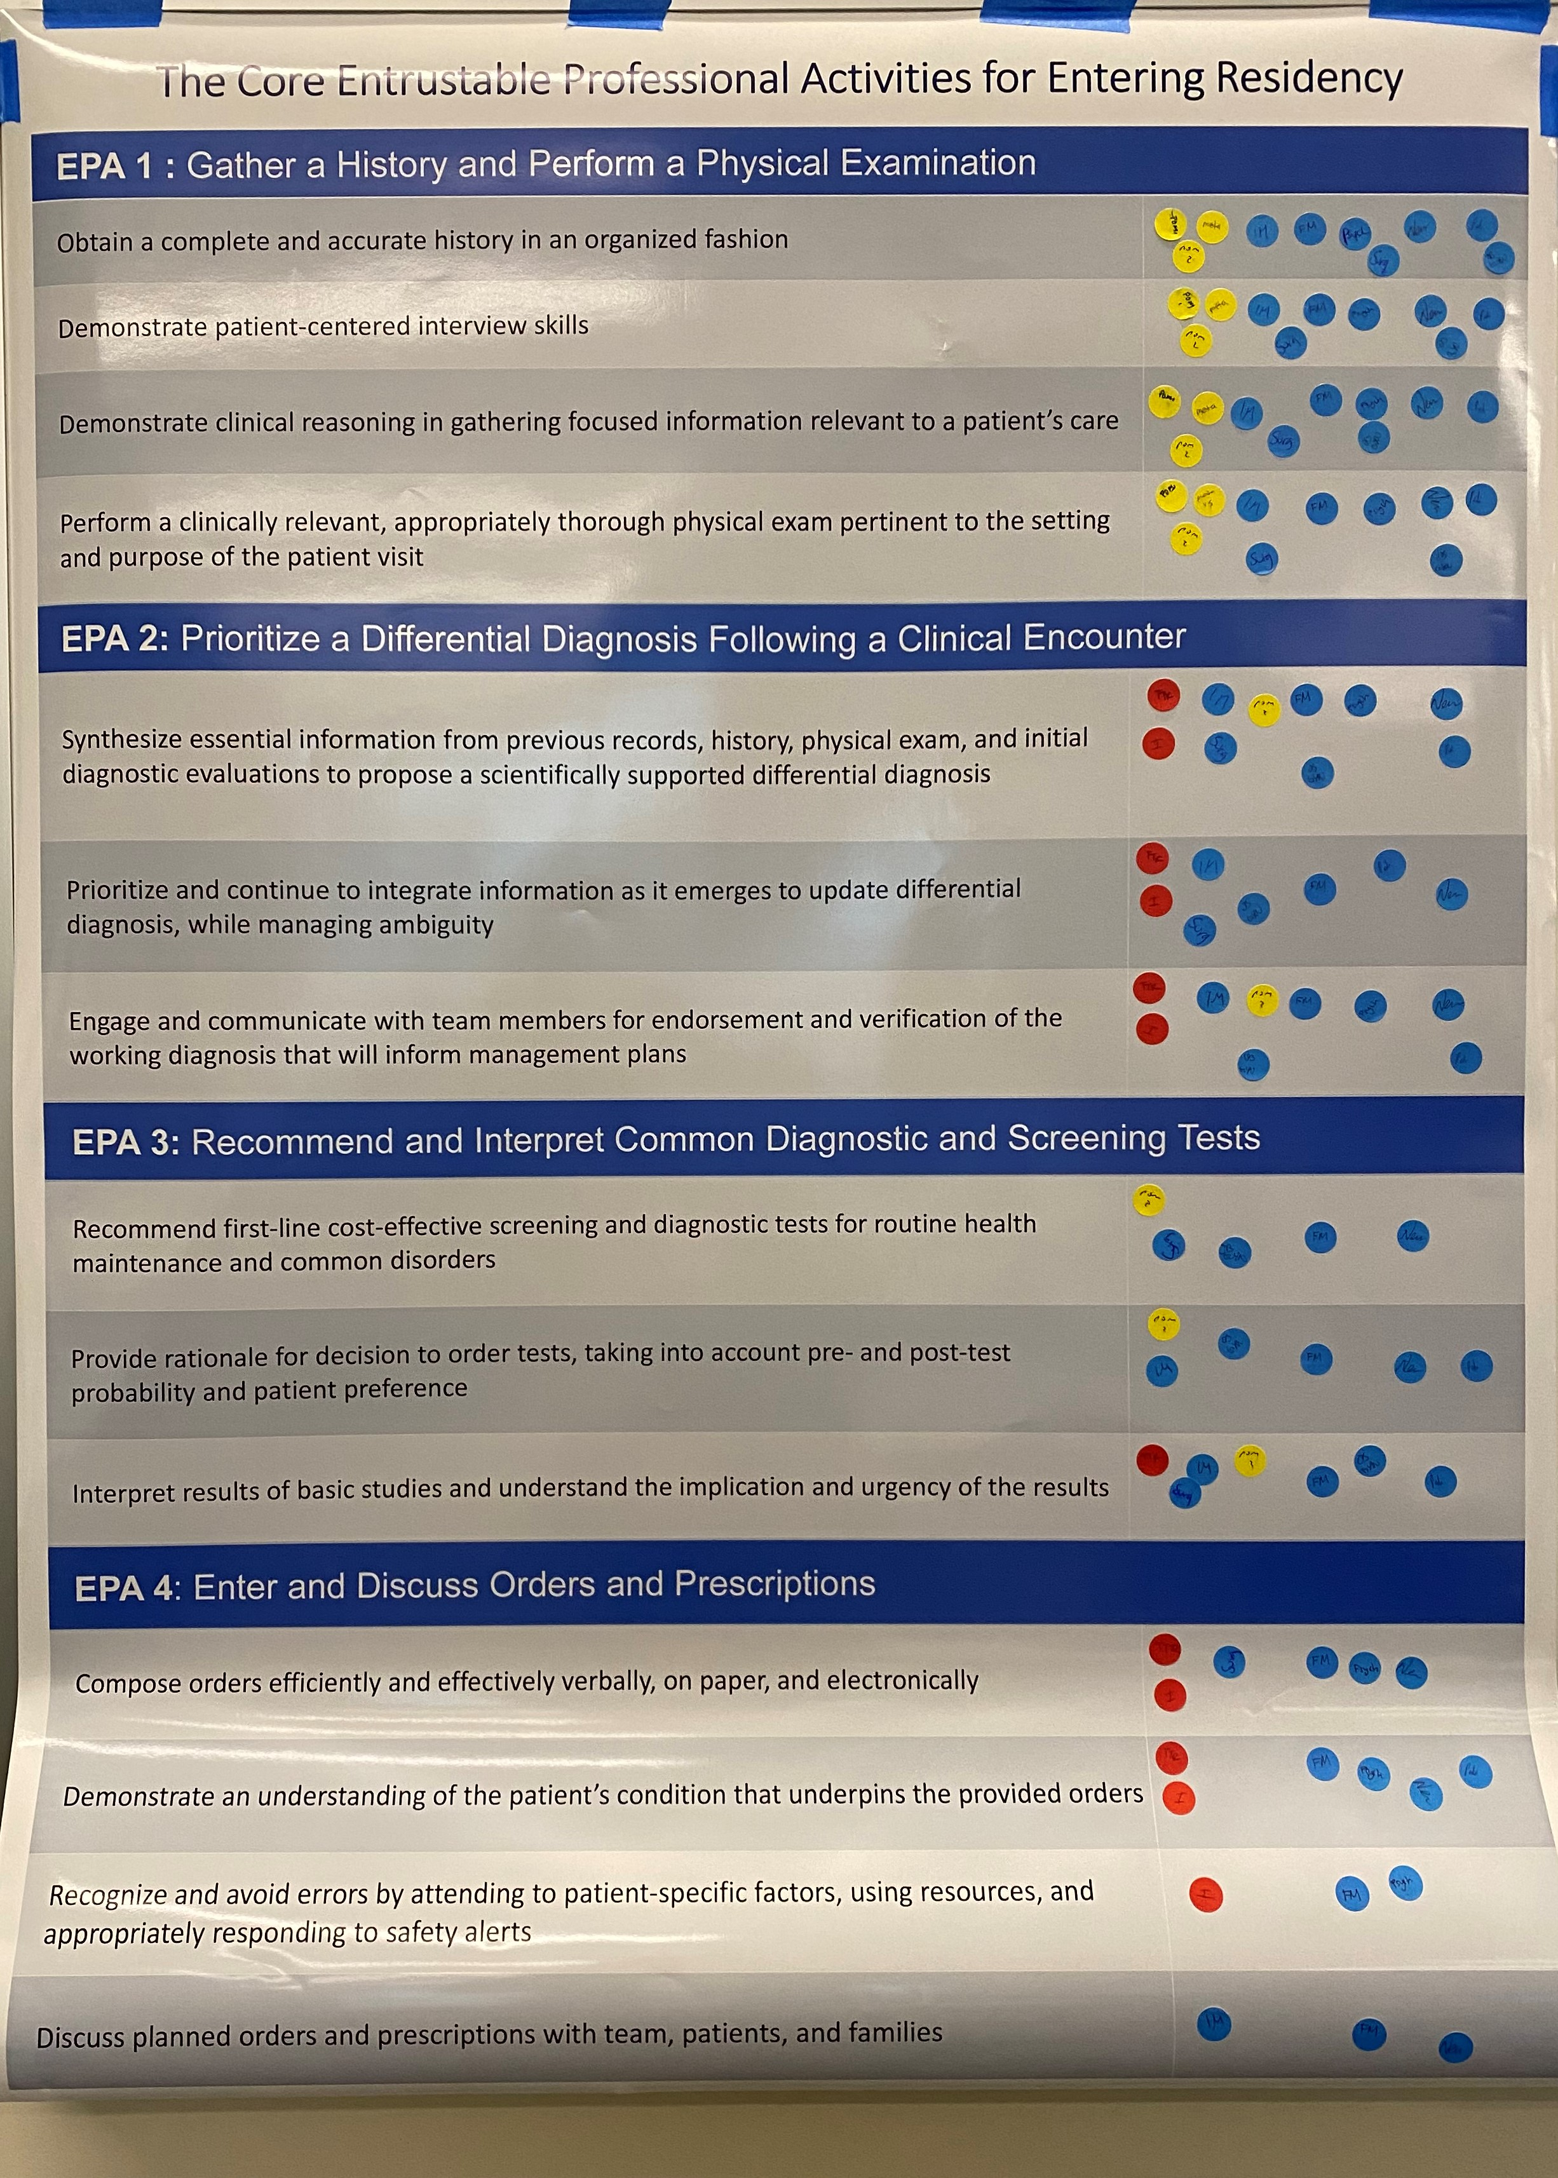 |  |  | Team Award to be paid to eligible employees May 27  UTMB will provide Team Awards this year to recognize the efforts and contributions of employees toward the achievement of specific institutional goals as well as the impact of overall inflation and higher gas prices. The university will issue a one-time, discretionary payment of $500 on May 27, 2022, to employees who meet the eligibility criteria. For more information about this year’s Team Award, read President Raimer’s message at https://utmb.us/6re.  Important 2022 Emergency Preparedness information  Every year during hurricane season, the Gulf Coast region goes into preparation mode. Information on UTMB’s Emergency Preparedness plans, including actions you should take now to prepare at home and at work are available online at https://utmb.us/6rk.  2022 Employee Demographic and Emergency Classification Form  All UTMB faculty and staff are required to complete the 2022 Employee Demographic and Emergency Classification Form. The institutional deadline for completing the form is June 1, and it may be accessed at https://utmb.us/84. Employees are also encouraged to the take the following actions to help ensure they are prepared for any emergency:  - Speak with your supervisor or faculty advisor about the role they assign to you and your responsibilities during an emergency  - Be sure that you understand to whom you would report to in an emergency  - Review UTMB’s Institutional Emergency Operations Plan and the business continuity plans for your department  - Update your contact and location information in Employee Self Service  - Sign up for the UTMB Alerts emergency notification system with a mobile number if you have not already done so  For more information on UTMB’s emergency operations, please see https://www.utmb.edu/emergency_plan/.  COVID-19 UPDATES  Update on masking policy  The rate of COVID-19 infection has continued to increase in our region as well as among our patients and UTMB work force. Although rates of severe infection and hospitalization due to COVID remain stable and low, caution is advised to keep our employees and patients safe from COVID-19 infection during this current wave. Read UTMB’s May 24 Clinical Task Force message for the latest information.  Quick Links  - Travel requirements and guidelines  - Safety Requirements  - Visitation Policy  - Sick or Exposed  - Schedule a vaccine or booster online
OPICS  LEGEND | PATIENT CARE EDUCATION & RESEARCH INSTITUTIONAL SUPPORT CMC
AROUND UTMB (Use the legend above to quickly find items of interest to your team)
Retail Dining Memorial Day (May 30) Holiday Hours  Galveston Campus  Health Education Center:  - The HEC Grill will be closed.  John Sealy Hospital:  - Sub Connection will be open from 10:30 a.m. to 8 p.m.  - Café on the Court, Chick-fil-A, and Starbucks will be closed.  Jennie Sealy Hospital:  - Bistro 712 will be open from 6:30 a.m. to 2 p.m.  - Hospital Lobby vending machines will remain open 24/7.  Clinical Services Wing (CSW):  - Sixth Floor Staff Lounge Micro Market will remain open 24/7 with healthy options.  League City Campus  - Bayside Bistro grill will be open from 7 a.m. to 2 p.m.  - Vending machines will remain open 24/7.  Angleton Danbury Campus  - Bayou Café will be closed.  Clear Lake Campus  - The Grill will be open from 8 a.m. to 1 p.m.  - Starbucks will be closed.  - Vending machines will remain open 24/7.  CDC recommends FDA-approved, single-dose booster for children ages 5-11  On May 17, 2022, the U.S. Food and Drug Administration authorized the use of a single booster dose of the Pfizer-BioNTech COVID-19 Vaccine for children 5 through 11 years of age at least five months after completing a primary series with the Pfizer-BioNTech COVID-19 vaccine. (See the FDA announcement.) The Centers for Disease Control and Prevention approved the booster for this age group on May 19, 2022. CDC now recommends that children ages 5 through 11 years should receive a booster shot 5 months after their initial Pfizer-BioNTech vaccination series. For more information, read the May 20 Vaccination Task Force message.  IN CASE YOU MISSED IT  Latest video with Houston Moms tackles the topic of puberty  Recently Dr. Beth Auslander, a psychologist and professor with the UTMB Health Department of Pediatrics, and Dr. Emily Calasanz, a board-certified OB/GYN and women’s health care provider at the UTMB Health Women’s HealthCare clinic in Friendswood, joined Meagan Clanahan of Houston Moms to discuss all things puberty, birth control and how to talk to the children in your life as they approach adolescence. To watch the full chat, visit https://utmb.us/6ra. |  |  | EDUCATION & RESEARCH  Denise Wilkes, MD, PhD, has been appointed to the Texas Opioid Abatement Fund Council  Dr. Wilkes is a clinical professor in the Department of Anesthesiology and a member of the Center for Addiction Research. The council was created to manage the distribution of money allocated from the opioid abatement trust in accordance with a statewide opioid settlement agreement, and ensures money recovered is allocated fairly and spent to remediate the opioid crisis in Texas. To read the full announcement, visit https://utmb.us/6rl.
DID YOU KNOW?
The Graduate School of Biomedical Sciences (GSBS) and School of Public and Population Health (SPPH) held their commencement ceremony on May 20 at Levin Hall Main Auditorium on the Galveston Campus, with graduates’ families and friends viewing the ceremony in person and via livestream. The schools awarded 24 master’s degrees, 34 Doctor of Philosophy degrees and five MD-PhD combined degrees. Congratulations to all the graduates!

The schools also presented awards to faculty members and the 2022 GSBS Distinguished Alumnus. Awardees were:
- Graduate Student Organization Distinguished Teaching Award: Dr. Cara Pennel, associate dean for academic affairs, SPPH, and associate professor, Department of Population Health and Health Disparities
- GSBS Distinguished Faculty Service Award: Dr. Andres Oberhauser, professor, Department of Neuroscience, Cell Biology and Anatomy
- GSBS Distinguished Faculty Research Award: Dr. Jia Zhou, professor, Department of Pharmacology and Toxicology
- GSBS Distinguished Alumnus Award: Dr. Adrian Billings (GSBS ’98), Chief Medical Officer, Preventative Care Health Services, and associate professor, Texas Tech University Health Sciences Center at Permian Basin
- Edith and Robert Zinn Professorship for Excellence in Mentoring: Dr. Lynn Soong, professor, Departments of Microbiology and Immunology, and Pathology
- Mace-bearer: Dr. Kristen Peek, dean ad interim, SPPH, and chair ad interim, Department of Population Health and Health Disparities

