Ben
Weekly Relays User Guide
TOPICS LEGEND
 |  | WEEKLY RELAYS |  | June 30, 2022
YOUR DEPARTMENT NEWS |  |  | UTMB NEWS
The Association of Standardized Patient Educators (ASPE) held their annual international meeting June 25-29. Dr. Karen Szauter had two presentations:  Preconference Workshop:  Essentials of Survey Design and Analysis  Discussion Session:  Guidelines for Publications:  Are we following our own recommendations?  Thanks to everyone who came to our  All Academic Affairs Bi-Annual Meeting  on Monday, June 27th and congratulations to all of our service award recipients!  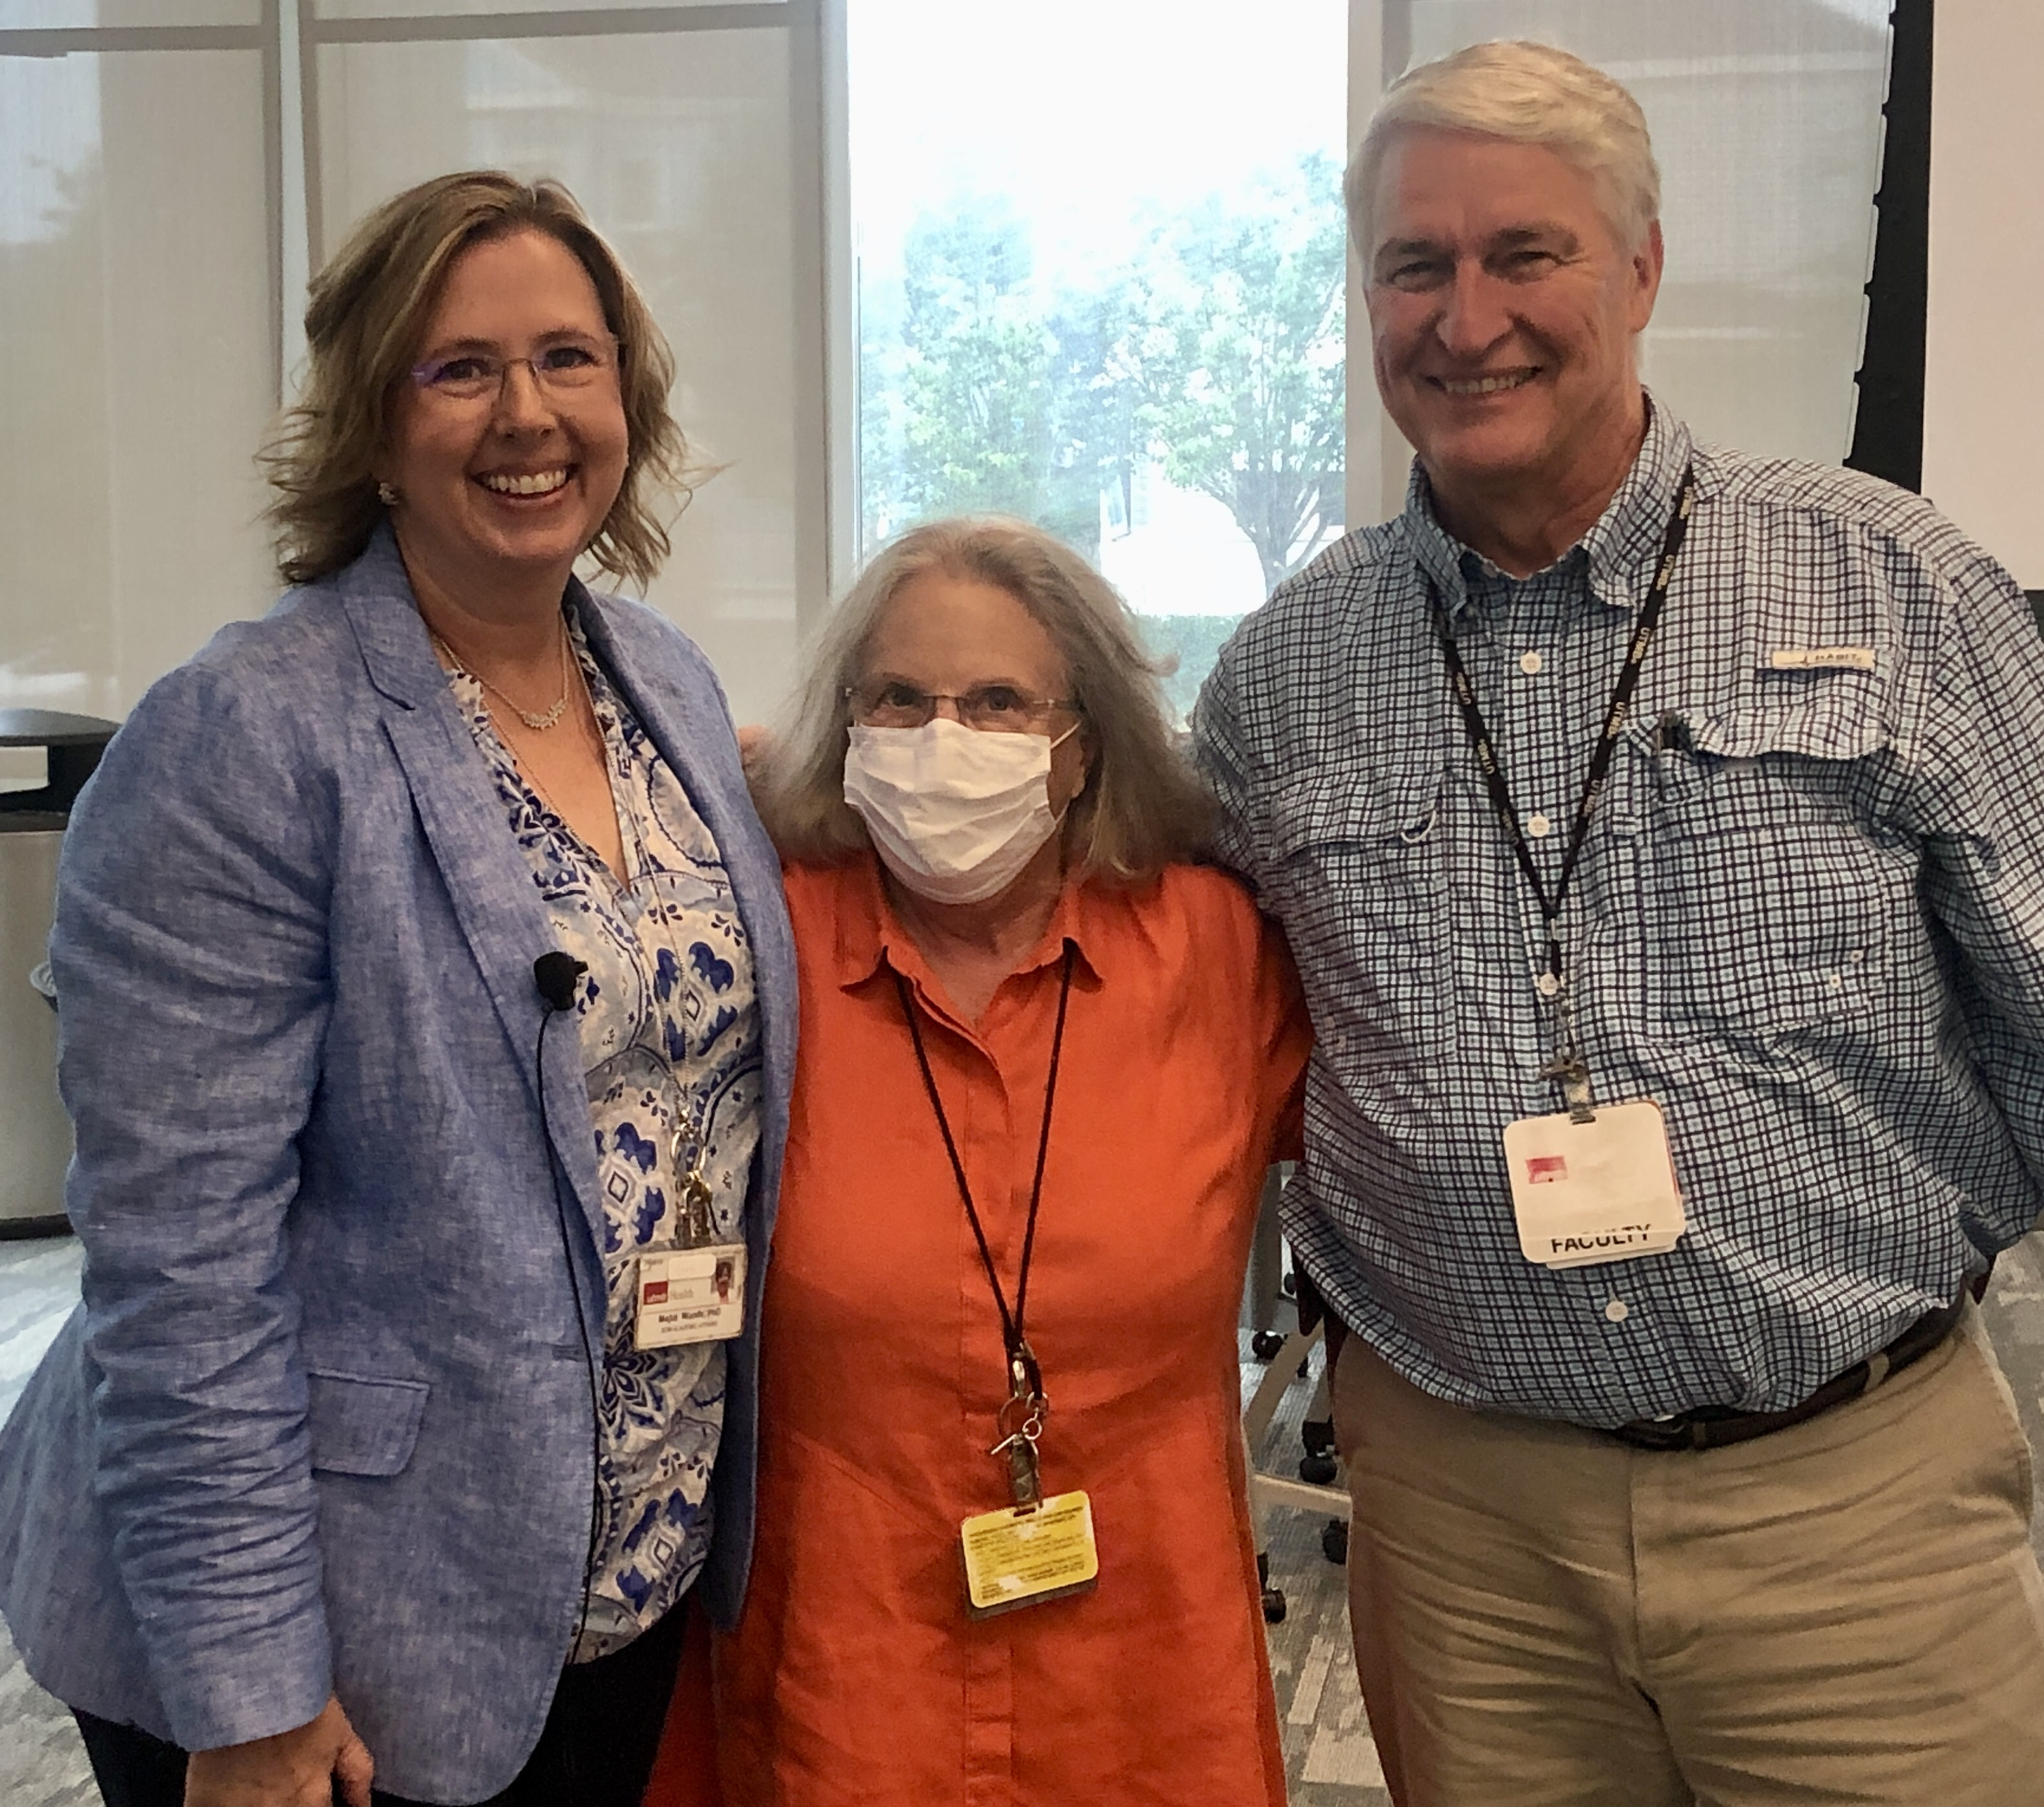  Shirley McGraw celebrated a 50-year work anniversary last February! |  |  | Access to non-UTMB email accounts to be blocked beginning July 6  To ensure data security and the integrity of our information resources, beginning July 6, UTMB will block direct access to non-UTMB email services (i.e., personal mail accounts hosted with services such as Gmail, Hotmail and Yahoo!) from UTMB-owned or -managed devices, and from UTMB’s protected networks. External mail services have the potential to circumvent or bypass existing UTMB security controls, creating risks. The new restrictions will 1) block web access to non-UTMB email services for any device on a protected UTMB network and 2) prevent the adding of these email services to Exchange/Outlook profiles on UTMB-managed devices. These new restrictions will not block access to these services from a personal device (such as a mobile phone or personal laptop) accessing the Internet via non-UTMB networks or the UTMB-Guest wireless network, and they will not block sending and receiving emails to or from these services. For more information, please visit www.utmb.edu/infosec/personalemail.  MONTHLY CYBERSECURITY UPDATE  How Are We Doing: During the month of June, 4.30% of recipients opened an attachment or revealed credentials in simulated phishing attacks that were initiated by the Office of Information Security. Our goal is less than 3%. A breakdown of department success and failure rates can be found at https://utmb.us/66g. Learn more about cybersecurity at https://www.utmb.edu/infosec. Report potential phishing to cirt@utmb.edu.  FY23 Official Holiday Schedule now available  Holidays are an important component of UTMB’s leave program. The new, standardized holiday schedule was developed as part of the myPTO program and will apply to all UTMB employees statewide, including Correctional Managed Care. It allows for better planning for everyone, as it minimizes fluctuations in holidays from year-to-year. Staff and faculty may observe approved alternate holidays in lieu of an official UTMB holiday with their supervisor’s approval. Speak with your supervisor if you plan to take an alternate holiday in lieu of an official UTMB holiday or if you have any questions regarding your department’s operations during official holidays and the Winter Break period. The FY23 Official Holiday schedule is now available online.  IN CASE YOU MISSED  UTMB experts discuss “Mommy Makeovers” and non-surgical cosmetic options during latest Houston Moms Blog chat  Recently Dr. Linda Phillips and Dr. Kathleen Kroger, physicians with UTMB’s Plastic Surgery and Aesthetics Clinic, joined Meagan Clanahan of Houston Moms Blog to discuss “Mommy Makeovers” and non-surgical cosmetic options for moms. To watch the full discussion, visit https://utmb.us/6uu.
OPICS  LEGEND | PATIENT CARE EDUCATION & RESEARCH INSTITUTIONAL SUPPORT CMC
AROUND UTMB (Use the legend above to quickly find items of interest to your team)
Announcing a professional, but more relaxed, dress code this summer at UTMB  Summer has arrived, and UTMB is pleased to announce a professional—but more relaxed—dress code starting Thursday, June 30, 2022. We will return to our full business dress code (ties—when applicable) on Monday, Oct. 3, 2022. We trust that employees will continue to dress appropriately for our professional workplace, and, thus, we are not providing an exhaustive list of what to and not to wear this summer at UTMB Health. Here are, however, some basic principles to follow:  - Collared shirts, both long- and short-sleeved, are acceptable; T-shirts are not.  - Flip flops, or any footwear that would not be considered business appropriate, are not allowed.  - Revealing attire—backless, low neckline or crop top—are not acceptable, nor are muscle shirts, tank tops, tube tops, leggings, sundresses (unless with a jacket) or shorts.  - Nice slacks, full-length or capri-length, are in, but clothes with holes are not.  - Skirt lengths should reflect good business taste and cover the thighs when seated.  - Ties are not required.  - Blue jeans are acceptable on Fridays year-round.  - Employees who wear uniforms should continue to do so.  On the days when you have a business meeting or are in the community representing UTMB Health, please consider wearing your normal business attire instead of the relaxed dress code. We’re confident that by using common sense and good judgment, we will all be able to enjoy a relaxed dress code for these hot summer months in Texas. As always, consult your manager with any questions regarding departmental dress code.  COVID-19 UPDATES  Quick Links  - Read UTMB’s June 24 Vaccination Task Force message for more information on vaccines for children 6 months to 5 years old.  - Read UTMB’s June 23 Clinical Task Force message on changes in testing policies for procedures and hospital admissions.  - Travel requirements and guidelines  - Safety Requirements  - Visitation Policy  - Sick or Exposed  - Schedule a vaccine or booster online  IH-45 Highway construction work scheduled July 5-8  TXDOT announced a lane closure next week in the I-45 northbound main lanes near Galveston. On Tuesday and Wednesday, July 5-6, from 9 a.m. to 3 p.m., two lanes will be closed on I-45 northbound near Galveston. The Tiki Island exit ramp lane and the outside travel lane will be closed from 9 a.m. to 3 p.m. on both days. On Thursday and Friday, July 7-8, there will be alternating single lane closures in these two lanes. The work is part of a project to replace the Santa Fe overpass bridge. Remember schedules can change. Please check road and traffic conditions before leaving the Galveston campus, and allow additional time as necessary. Please review the following sources for updates and road conditions, and allow additional time if needed to reach your destination:  - Houston Transtar Traffic Map*  - TxDOT Construction Schedule and Closures (filter on "IH-45 in Galveston County")  - Google Maps Live Traffic  - Waze Live Map  * If you are reviewing Transtar freeway cams, check the date stamp to ensure the image is live. Many cameras have been offline during construction.  Prepare for Epic Upgrade, July 10—Upgrade website available now  July 10 will bring changes to the UTMB EMR system. Start learning today about the changes, particularly those regarding scheduling. “Book It” is an entirely new way to schedule appointments within the Epic system. Go to the Epic Upgrade website to learn more about Book It and review all system enhancements by application and/or user role. The Epic EMR will be unavailable Sunday, July 10 from 10 a.m. to noon for this software upgrade. During the upgrade timeframe, clicking on the UTMB EMR icon will take the user to a READ ONLY version of Epic. All users should follow established downtime procedures for their area. Beginning the afternoon of Thursday, July 7, some functions performed in Epic on a daily basis will not be available. Once the system upgrade is complete, these features will be accessible.  Functions to be unavailable include:  - Changes to dashboards  - Creation of new work queues and report filters (impacts Charge Router Reconciliation Report); work queues with saved filters using existing rules continue to work  - Creation of personal Smart Phrases, Smart Forms; macros and personalization of the Ophthalmology exam form  - Creation or maintenance of personalized User Order Sets, Charge Review filers or In Basket Quick Actions  Please contact Epic Support at (409) 772-5200, option 4 with any questions. |  |  | Retail Dining - Independence Day Holiday Hours  Galveston  Health Education Center  - The HEC Grill will be closed.  John Sealy Hospital  - Sub Connection will be open from 10:30 a.m. to 8 p.m.  - Café on the Court, Chick-fil-A, and Starbucks will be closed.  Jennie Sealy Hospital  - Bistro 712 will be open from 6:30 a.m. to 2 p.m.  - Hospital Lobby vending machines will remain open 24/7.  Clinical Services Wing (CSW)  - Sixth Floor Staff Lounge Micro Market will remain open 24/7 with healthy options.  League City Campus  - Bayside Bistro grill will be open from 7 a.m. to 2 p.m.  - Vending machines will remain open 24/7.  Angleton Danbury Campus  - Bayou Café will be closed.  Clear Lake Campus  - The Grill will be open from 8 a.m. to 1 p.m.  - Starbucks will be closed.  - Vending machines will remain open 24/7.  PATIENT CARE  UTMB wins Gage Award for COVID-19 work  America’s Essential Hospitals has recognized the University of Texas Medical Branch for its work to craft and continuously maintain a compendium of expert interpretive commentary regarding SARS-CoV-2 testing and a novel supporting technology that applies these comments and delivers them to physicians and patients. For more about the Gage Award, read the full story at https://utmb.us/6um.  EDUCATION & RESEARCH  M. Chandler Self, MD, has been appointed Assistant Dean for Academic Support and Career Counseling in John Sealy School of Medicine  M. Chandler Self, MD, has been appointed Assistant Dean for Academic Support and Career Counseling in the John Sealy School of Medicine, effective July 1. Dr. Self earned her medical degree at UTMB and has served as an assistant professor in the Department of Psychiatry and Behavioral Sciences since 2018. She has been heavily engaged in medical education as a faculty member and has been a career advisor and mentor to first-year medical students. We look forward to her contributions in this new role.
DID YOU KNOW?
Various works produced and spearheaded by the UTMB Health Community Engagement and Marketing and Communications teams have recently earned recognition and awards from two industry organizations. Among the efforts recognized by the Healthcare Advertising Awards and the Hermes Creative Awards were the creative ways UTMB maintained a presence in the community throughout the COVID-19 pandemic, as well as campaigns promoting a variety of topics and service areas, including the new UTMB Health Plastic Surgery & Aesthetics clinic, COVID-19 vaccines, Primary Care and more. UTMB digital assets, such as the ever-evolving Find a Doc online directory and the new Plastic Surgery & Aesthetics website, also garnered top honors from both organizations. Both of those projects, and many of the others acknowledged, were possible thanks to the team’s ongoing collaboration with a variety of other UTMB departments and groups across the institution, including the Faculty Group Practice, Information Technology Services, the COVID-19 Clinical and Vaccination task forces and others. To learn more about these recent wins, visit https://utmb.us/6ut.

