Ben
Weekly Relays User Guide
TOPICS LEGEND
 |  | WEEKLY RELAYS |  | July 7, 2022
YOUR DEPARTMENT NEWS |  |  | UTMB NEWS
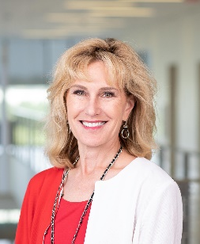  Welcome Dr. Ruth Bush, the new Associate Dean for the Office of Educational Affairs!  Dr. Bush hosted a “Meet & Greet” for the Office of Educational Affairs with Root Beer and Ice Cream floats!  Thank you for the sweet treat and we are excited to have you here!  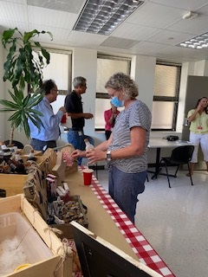  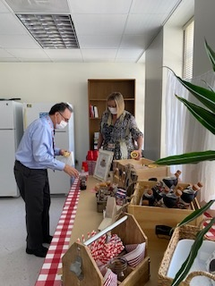  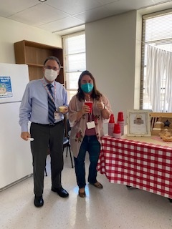  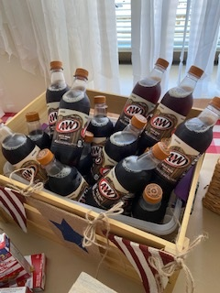  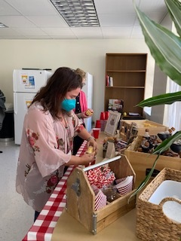  Michael White head July 12  Chantea Palmer July 22  Fadeke Okelola July 30  Brian Sullivan July 31 |  |  | COVID-19 UPDATES  Quick Links  - Read UTMB’s June 24 Vaccination Task Force message for more information on vaccines for children 6 months to 5 years old.  - Read UTMB’s June 23 Clinical Task Force message on changes in testing policies for procedures and hospital admissions.  - Travel requirements and guidelines  - Safety Requirements  - Visitation Policy  - Sick or Exposed  - Schedule a vaccine or booster online  IN CASE YOU MISSED IT  Space Center Houston’s June 30 Thought Leader Series  The June 30 Thought Leader Series explored how holoportation technology—an innovative 3D version of telemedicine—supports astronauts on the International Space Station and how it’s being used on Earth. UTMB Health presents the Thought Leader Series at Space Center Houston and, Dr. Christopher Haas of UTMB introduced the June 30 program. Haas is a NASA flight surgeon and Technical Integration lead for the Orion project, and he is also a UTMB Health Family Medicine professor and faculty member with the UTMB Health School of Public and Population Health. To view the full video, visit https://www.youtube.com/watch?v=Ub294Fy4_O0&t=43s.  Women’s Health takes center stage in regional magazine  UTMB’s expansive Women’s Health services was the July cover story of the Bay Area/Friendswood Living Magazine. The comprehensive piece explores and shares experiences a variety of women have had with UTMB providers and clinics. The coverage reinforces the message that UTMB Health is equipped to care for women throughout every season of life. To read the full story, visit https://utmb.us/6vk.  REMINDER  Epic Upgrade, July 10—Upgrade website available now  The Epic Upgrade will take place July 10 from 10 a.m. to noon. Visit the Epic Upgrade website to learn about “Book It,” the new way to schedule appointments at UTMB. Training for Book It is available now and can be found under the “Upgrade Shoutouts” button on Epic Upgrade website along with a review of all the system enhancements by application or user role. For information, contact Epic Support at (409) 772-5200, option 4.
OPICS  LEGEND | PATIENT CARE EDUCATION & RESEARCH INSTITUTIONAL SUPPORT CMC
AROUND UTMB (Use the legend above to quickly find items of interest to your team)
Supply Chain issues the FY23 fiscal year Blanket Purchase Order (BPO) processing instructions
- Departments may now begin entering BPOs in the amount of $15,000 and greater.
- All requisitions greater than $15,000 should include proper justification and supporting documentation to avoid delays or rejections.
- An approver can view comments provided in the “Approval Justification” box.
- Except for Correctional Managed Care (CMC), BPOs under $15,000 can be done as a “DEP” only after Sept. 1, 2022.
- All CMC BPOs must be entered as an ACQ requisition regardless of dollar amount.
- Please see the below links for additional information:
  - For more information about Purchasing processing times, click here.
- How to create a Requisition for Next Fiscal Year instructions
- How to create a “Blanket” Requisition instructions
- Training sessions on How to Properly Enter an NFY Requisition
For additional questions regarding New Fiscal Year (NFY) Blanket POs, please contact the Purchasing Helpdesk at prhlpdsk@utmb.edu.

EDUCATION & RESEARCH

UTMB designated a Center of Excellence by the Society for Obstetric Anesthesia and Perinatology (SOAP)
The Society for Obstetric Anesthesia and Perinatology (SOAP) designated UTMB as a Center of Excellence, recognizing the high-quality care provided in the Department of Anesthesiology’s Obstetric Anesthesia Division. The SOAP Center of Excellence program awards institutions that demonstrate excellence in obstetric anesthesia care and to set a benchmark of expected care to improve standards nationally and internationally. UTMB is one of 13 institutions selected this year for the designation, which is valid for four years. Learn more about the SOAP Centers of Excellence designation: https://soap.memberclicks.net/centers-of-excellence_program.

DID YOU KNOW?
People who commit violent crimes often show concerning behavior before the crime. The iWatch Texas Community Reporting System was created to enable Texans to report suspicious activities or behaviors that may indicate ongoing or future criminal activity. These activities or behaviors may be observed in person, be communicated by a third person, observed on social media, etc. Some of the non-emergency suspicious activity to be reported could include:
- Comments made by another regarding harming themselves or someone else
- Bullying, harassing, or stalking behaviors
- Aggressive behavior such as physical assaults, throwing objects, slamming doors, or storming out of a room when upset
- Psychotic or delusional speech or conversations designed to upset others such as descriptions of weapons or killing
- Persons attempting to enter buildings without proper credentials, i.e. walking in directly behind another person who is lawfully entering the facility.
- Strangers asking questions about building security features and procedures
- Briefcase, suitcase, backpack or package left behind
- People requesting sensitive information, such as blueprints, security plans or VIP travel schedules, without a need to know
- Purchasing supplies that could be used to make bombs or weapons, or purchasing uniforms without having the proper credentials.
- Taking photographs or videos of security features, such as cameras or entrances
You can report suspicious behaviors through the iWatch Texas program via a mobile app, online at www.iwatchtx.org or by calling (844) 643-2251. A confidential report usually takes fewer than five minutes to complete, and once submitted, each report is reviewed by law enforcement.

IMPORTANT: During emergencies, call 911 to contact UTMB Police. In less-urgent situations, call (409) 772-2691 to contact the UTMB Police non-emergency line.

