Ben
Weekly Relays User Guide
TOPICS LEGEND
 |  | WEEKLY RELAYS |  | August 18, 2022
YOUR DEPARTMENT NEWS |  |  | UTMB NEWS
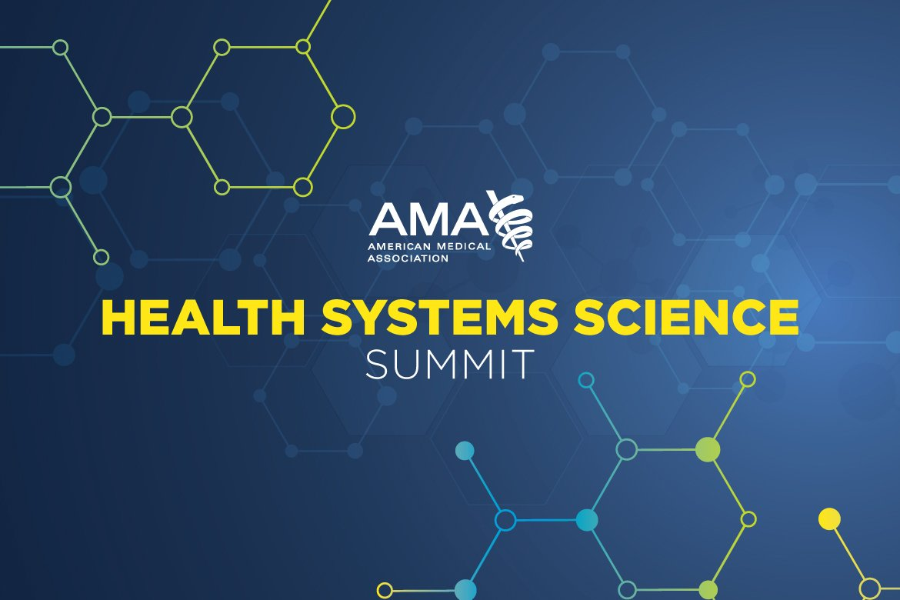  The American Medical Association (AMA) is hosting its inaugural Health Systems Science (HSS) Summit in December 2022. This national conference focuses on integration of HSS in medical education. The following works from UTMB will be presented at the conference including a new initiative developed and led by medical students called the Hospital to Home (H2H) Program. In this program, in collaboration with St. Vincent's clinic, students screen patients for unmet social needs at the bedside, address these needs, and facilitate the transition from hospital to primary care. The H2H Program will also be showcased in the 2022 Edition of AMA's Medical Students, Residents, Fellows Making an Impact.  “The Hospital to Home Program: Reinforcing Health Systems Science Concepts in a Value-Added Experience for Health Professions Students”  Abhijit Rao, BSA, Jacob Moran, BS, Shellie Wolf, LBSW, Grayson Jackson, BA, Emmanuel Nyong, BS, Martha Diaz, RN, Julian Quiceno, APRN, FNP-C, Sarah Siddiqui, MD, MPH, and N. Miles Farr, MD, MPH  "The Implementation of an Asynchronous, Longitudinal HSS Course with Service-Learning Component for Post-Clerkship Year of Medical School"  Sarah Siddiqui, MD, MPH, Kathleen Everling, PhD, Farah Kudrath, MD, MPH, N. Miles Farr, MD, MPH |  |  | Monthly Financial Update – Results as of July 31, 2022:  For the month of July, UTMB’s Adjusted Margin loss was $15.3 million, which was $14.1 million unfavorable to planned results. Year-to-date, UTMB’s Adjusted Margin loss was $10.3 million, which was $6.7 million unfavorable to planned results.  Thank you to everyone for your hard work and dedication throughout FY22. As we strive to manage end-of-year expenses, please do not use excess fund balances from FY22 to purchase supplies or other items not directly related to monthly operations. We look forward to ending FY22 in a strong position and beginning FY23 even better prepared to care for the people who depend on us for better health and better lives.  SharePoint Navigation Changes coming Aug. 29: With the expanding use of SharePoint at UTMB, Information Technology Service will be making changes to assist in the navigation to Department and Collaboration site dropdowns at https://sp.utmb.edu. Currently all sites are in a single dropdown. Changes are being made to break down the single dropdown into 3 separate dropdowns that will list the sites in alphabetical order. Along with the dropdown navigation settings, My Recent Sites will also be added to provide faster navigation to recently visited sites. For more information visit https://www.utmb.edu/o365/sharepoint/sharepoint-site-navigation-changes.  RESCHEDULED  Next Health Care Unmasked now set for Aug. 24: Dr. Ronak Shah, director for UTMB’s Aerospace Medicine division will join host TJ Aulds at noon on Wednesday, Aug. 24 to discuss the UTMB Aerospace Medicine program. The original Aug. 17 discussion had to be rescheduled due to a power outage. The full episode will air online at https://www.facebook.com/i45now.  In Case You Missed It:  UTMB School of Public and Population Health gets good press in recent Community Impact story: In a story that dropped earlier this month, Community Impact put the spotlight on UTMB’s newest addition to the institution’s Academic Enterprise. Leaders from the school including Dean ad interim Dr. Kristen Peek were interviewed for the piece which is available online at https://utmb.us/6zx.  COVID-19 UPDATES  QUICK LINKS  - Travel requirements and guidelines  - Safety Requirements  - Visitation Policy  - Sick or Exposed  - Schedule a vaccine or booster online
OPICS  LEGEND | PATIENT CARE EDUCATION & RESEARCH INSTITUTIONAL SUPPORT CMC
AROUND UTMB (Use the legend above to quickly find items of interest to your team)
REMINDER  Annual required training due:  The institutional deadline for all employees to complete their annual required training for FY22 is Aug. 31. Please log in to the UTMB Learn system today at https://learn.utmb.edu and complete any remaining courses and activities. Employees who do not finish their Compliance Department required training by the institutional deadline will be suspended without pay until all requirements are met. For questions or concerns about your assigned training, please contact your manager or the course owner listed in UTMB Learn. For technical issues, please contact the UTMB IS Service Desk at ishelp@utmb.edu.  EDUCATION & RESEARCH  SAVE THE DATE: Next Provost’s Lecture Series set for Sept. 9: The next Provost’s Lecture Series event is scheduled for Friday, Sept. 9, from noon to 1:30 p.m. In this talk, Samantha Bond, MS, CMI, a clinical assistant professor in the Biomedical Visualization graduate and undergraduate programs at the University of Illinois Chicago, will provide an overview of modern technologies in medical visualization, using examples from her research and career in medical interactive development. The talk will investigate the many avenues for VR research in medicine, and provide practical skills for applying these modern interventions to ongoing research. The in-person event will take place in the Health Education Center, room 2.220. Attendees can submit RSVPs to Kirk Nealy at kdnealy@utmb.edu. A livestream of the event will also be available at https://utmb.us/6y6.  PATIENT CARE  GISD nurses receive continuing education at UTMB: In an effort to support continuous engagement and involvement with our local community the UTMB NEAR Department collaborated with Galveston ISD to support their nurses that provide care to thousands of students across the district. On Friday, August 12th UTMB offered a full day of nursing professional development to 11 Galveston ISD nurses. The seminar included educational offerings covering AED usage, Human Trafficking, COVID-19 & Monkey Pox updates, TeamSTEPPS, and Stop the Bleed. The event was a huge success and we look forward to future collaborations with the district.  REMINDER  Friendly reminder that all staff that work directly with patients must follow the policies below regarding fingernails.  IHOP Policy 03.01.06 Guidelines for Personal Appearance: All staff with direct patient contact must maintain their fingernails in accordance with Healthcare Epidemiology Policy 01.14, Hand Hygiene for All Healthcare Workers. 5. Healthcare workers assigned to procedural areas must adhere to Healthcare Epidemiology Policy 01.47, Guidelines for Prevention of Surgical Site Infections, as applicable. View the full policy online at https://www.utmb.edu/policies_and_procedures/IHOP/Employee/General/IHOP%20-%2003.01.06%20-%20Personal%20Appearance.pdf.  Healthcare Epidemiology Policy 01.14, Hand Hygiene for All Healthcare Workers: Healthcare workers with direct patient contact shall adhere to CDC and UTMB epidemiology guidelines. They must maintain fingernails so that their natural nail tips should not extend past the ends of their fingers. Artificial nail enhancements are not to be worn. This includes, but is not limited to, artificial nails, tips, wraps, appliques, acrylics, gel, shellac, glue, and any additional items applied to the nail surface. Nail polish is permitted, but anything applied to natural nails other than polish is considered an enhancement. Chipped nail polish supports the growth of organisms on fingernails and is strictly prohibited. Individual departments can institute measures, in addition to those above, to comply with established standards of care in specialty areas. |  |  | Monkeypox Workplace Exposure Evaluation Process:  - Clinic or hospital staff will notify infection control for any case being investigated for monkeypox.  - All healthcare workers (HCWs), including clinical students, will be evaluated by infection control staff for monkeypox exposure after encounter with a suspect or confirmed case of monkeypox.  - If the index case is confirmed to have monkeypox, Employee Health will contact those with high, intermediate and low risk exposures for post-exposure symptom monitoring.  - Those with high-risk exposures and possibly other groups may be offered monkeypox vaccine through the health department which is subject to vaccine availability and prior approval.  - Those who develop any symptoms of monkeypox during the monitoring period will notify Employee/Student immediately, and will not report to work or study until monkeypox is excluded or, if confirmed, all of the skin lesions are completely healed.  - More details are at: Monkeypox (utmb.edu)  - Contact information:  - Employee Health: phone 409-747-9172; emphlthc@utmb.edu  - Student Health: phone 409-747-9508  - Infection Control & Healthcare Epidemiology: phone 409-772-3192, pager 409- 643-3133, healthcareepidemiology@utmb.edu
DID YOU KNOW?
UTMB Health and three UTMB physicians have been recognized in Living Magazine as winners of its “Best of the Bay Area and Friendswood” Readers’ Choice Awards. Readers of the magazine cast votes online to name the area’s best in a wide variety of categories, including multiple health care specialties. Congratulations to all who contribute to UTMB’s mission, helping make it the top hospital among Living readers, and to all UTMB’s honorees!

- Best Hospital: UTMB Health
- Best Pediatrician: UTMB Health Pediatric & Adult Primary Care
- Best Family Medicine Doctor/Practice: Susan Easley, MD
- Best Neurologist: Todd Masel, MD
- Best Internal Medicine Doctor: Sarah Siddiqui, MD

