Ben
Weekly Relays User Guide
TOPICS LEGEND
 |  | WEEKLY RELAYS |  | September 22, 2022
YOUR DEPARTMENT NEWS |  |  | UTMB NEWS
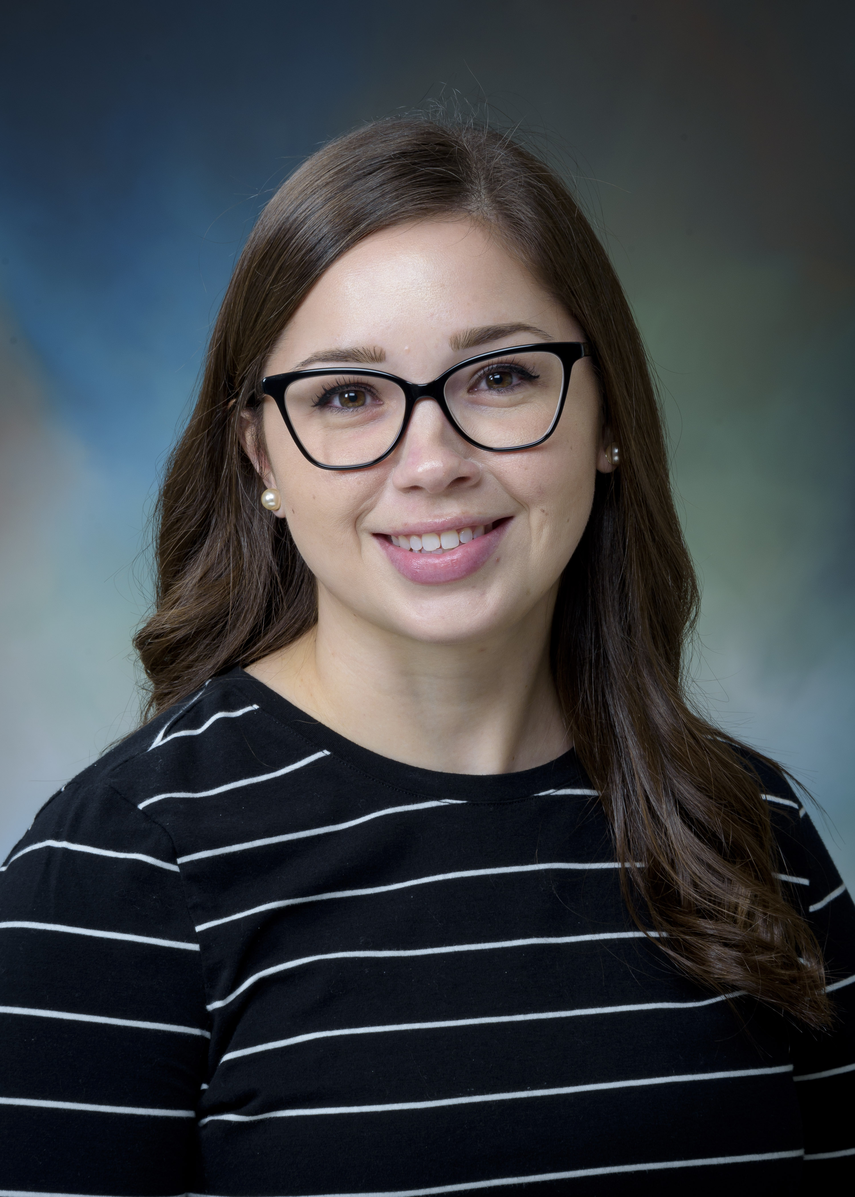  We are excited to announce that Kimberly Turner has won this National Award as the TTR Coordinator of the Year! The award will be presented at the TTR symposium on 10/11/22. We are lucky to have her as part of our team!!!  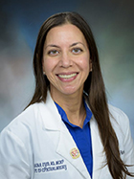  Join us in congratulating Dr. Syed on her acceptance into the John Hopkins Health Professions Educators program.  Way to go  Dr. Syed!  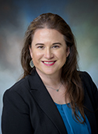  Holly West, DHEd, PA-C has been elected to serve as the Director-Elect for the Academy of Master Teachers (AMT) for AY22-23. Dr. Era Buck, PhD, as current Director, will pass the baton to Dr. West from AY23/24 through AY25/26. |  |  | Monthly Financial Update—Results as of August 31, 2022  For the month of August, UTMB’s Adjusted Margin was $11.7 million, which was $16.5 million favorable to planned results. Year-to-date, UTMB’s Adjusted Margin was $1.4 million, which was $9.8 million favorable to planned results. Overall favorable volumes, particularly surgical volumes and ER visits, saw August surpass budget and the annual average. These results can be attributed to your hard work and dedication in providing quality care as efficiently as possible. With continued focus, we can build on these positive trends to make FY23 a successful year. *The fiscal year-end results are considered preliminary, unaudited pending final annual financial audit.  Free flu shots for employees and volunteers  UTMB’s Flu Free vaccination program offers free flu shots to all employees and volunteers to help prevent the spread of seasonal influenza. Flu vaccinations will be available as listed below:  - Angleton Danbury Campus Hospital: Oct. 25-27  - Clear Lake Campus Hospital: Oct. 18-20  - Jennie Sealy Hospital: Oct. 4-6 and Oct. 10  - John Sealy Hospital: Oct. 11-12  - League City Campus Hospital: Monday through Friday, beginning Oct. 3  - UTMB Clinics and Inpatient Units: Monday through Friday, beginning Oct. 3  For details about the vaccination locations and UTMB’s vaccination requirements for health care workers, please see https://utmb.us/731.  Free Stop the Bleed and Ready to React course  UTMB Health Trauma Services in collaboration with Clear Lake EMS will host a free STOP the BLEED and Ready to React course on Sept. 24 from 10 a.m. to 1 p.m. at the UTMB Health League City Hospital Campus. Registration is limited. For more information and to register, visit https://utmb.us/73f.  Saturday Sports Injury Clinic offered in Texas City  Every Saturday through Nov. 5, UTMB Health offers a Saturday Sports Injury Clinic from 9 to 11 a.m. at UTMB Health Primary & Specialty Care Clinic, 10121 Emmett F. Lowry Expressway. The sports medicine team is trained to treat a full range of sports injuries, from strained muscles and twisted ankles to knee and shoulder pain. Walk-ins only; no appointments. For more information, visit https://utmb.us/72z.  $5,000 Employee Referral Bonus for Maternal Fetal Child Specialists  An employee referral bonus is now being offered for Maternal Fetal Child Specialists at the Regional Women’s Services & Pediatrics clinics in Beaumont and Conroe. If your referral is hired into a benefits-eligible position between Sept. 1, 2022, and March 31, 2023, you will receive $1,500 when they complete six months of service and $3,500 when they complete one year of service. For more information about the bonus, please see https://utmb.us/73g.
OPICS  LEGEND | PATIENT CARE EDUCATION & RESEARCH INSTITUTIONAL SUPPORT CMC
AROUND UTMB (Use the legend above to quickly find items of interest to your team)
SAVE THE DATE  Sept. 28 Health Care Unmasked will explore Aerospace Medicine  Dr. Ronak Shah, director for UTMB’s Aerospace Medicine division, will join host TJ Aulds at noon Sept. 28 to discuss the UTMB Aerospace Medicine program. To watch the discussion, visit https://www.facebook.com/i45now.  IN CASE YOU MISSED IT  Latest video with Houston Moms tackles the topic of vaccinations  Recently Dr. Lauren Raimer-Goodman, a pediatrician at UTMB’s Pediatric & Adult Primary Care clinic in Friendswood, joined Meagan Clanahan of Houston Moms to discuss the declining vaccination rates of children in our country, what illnesses are currently kept at bay with routine vaccinations, the schedule for these vaccines for children and why vaccines are so important. To watch the full chat, visit https://fb.watch/fI92VCsNN6/.  REMINDERS  Supply Chain Notice: Processing departmental FY23 Blanket Purchase Order (BPO) Invoices  - All invoices for FY23 Blanket Purchase Orders (BPO) are required to be ‘received’ within PeopleSoft FMS.  - When processing receipts, it is important to only receive the amount that is being invoiced at that time.  Employees may register for additional training on “Receiving on PeopleSoft” at: https://innovation.utmb.edu/TrainingGateway/#/. For questions, contact: prhlpdsk@utmb.edu.  Annual employee evaluations  The institutional deadline to complete employee evaluations for the FY22 performance review cycle is Oct. 31, 2022. An evaluation is required for all full-time, part-time and casual employees hired on or before Feb. 28, 2022. To prepare for your evaluation, please speak with your manager regarding any entity or department specific requirements. You may also visit https://utmb.us/737 for more information and resources. |  |  | Thank you Thursdays—Mammograms for UTMB Employees  As part of Breast Cancer Awareness Month in October, UTMB’s Department of Radiology is encouraging employees across the institution to get their mammogram screenings done—either in one of our Breast Centers at the Clear Lake and Angleton Danbury Campuses or on the mobile mammography van, which will be making stops in Galveston and League City. For more information and a full schedule, visit https://utmb.us/73y.  COVID-19 UPDATES  Quick Links  - Travel requirements and guidelines  - Safety Requirements  - Visitation Policy  - Sick or Exposed  - Schedule a vaccine or booster online  EDUCATION & RESEARCH  Pierre W. Banks, Ed.D., appointed to Assistant Dean for Admissions and Recruitment in the John Sealy School of Medicine  Pierre W. Banks, Ed.D., has accepted the position of Assistant Dean for Admissions and Recruitment in the John Sealy School of Medicine. Dr. Banks joined UTMB in August 2019 as a Senior Specialist in Learning and Career Counseling and was appointed Senior Director of Admissions and Recruitment in February 2021. Since June 2020, he has also held an appointment as Clinical Assistant Professor in the Department of Psychiatry and Behavioral Sciences. Dr. Banks has a wide variety of higher education experience, including academic advising, admissions, career counseling, orientation, international admissions, multicultural affairs, retention, student conduct and student activities.  Jacquelyn Svoboda, DNP, MSN, RNC, WHNP, honored as a recipient of the 2022 UT System Regents’ Outstanding Teaching Award (ROTA)  Congratulations to Jacquelyn Svoboda, DNP, MSN, RNC, WHNP, on being honored as a recipient of the 2022 UT System Regents’ Outstanding Teaching Award (ROTA). Dr. Svoboda is Director of Educational Innovations and an assistant professor in the School of Nursing. The ROTA program honors extraordinary classroom performance and innovation across UT System institutions. A video highlighting Dr. Svoboda’s achievement will be live streamed at the November Board of Regents meeting.
DID YOU KNOW?

This month, UTMB Health’s Osher Lifelong Learning Institute (OLLI) celebrates its 20th Anniversary. Osher Lifelong Learning Institutes (OLLI) are university programs across the nation that offer non-credit courses and activities to those 50 and older who are interested learning for the love of learning. In 2002, with a grant from the Bernard Osher Foundation, UTMB’s OLLI joined a nationwide network of lifelong learning institutes across the country. To learn more or enroll in OLLI at UTMB, visit www.utmb.edu/olli.

