Ben
Weekly Relays User Guide
TOPICS LEGEND
 |  | WEEKLY RELAYS |  | April 27, 2023
YOUR DEPARTMENT NEWS |  |  | UTMB NEWS
Congratulations Dr. Szauter!  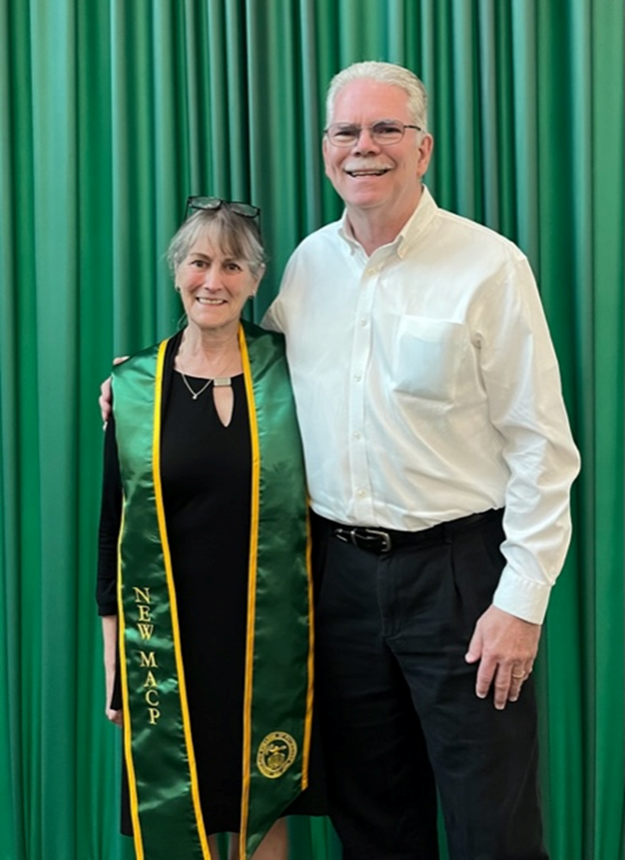  Dr. Karen Szauter & Dr. Michael Ainsworth  The American College of Physicians Convocation Ceremony was held April 27th. This included the recognition of new Masters of the College.  This was Dr. Szauter’s formal recognition of her election to Mastership. |  |  | Use caution when responding to or clicking on texts or emails:  UTMB’s Office of Information Security is reminding employees, staff and students to be wary of text messages that purport to be from leadership but are, in fact, phishing messages aimed at getting unsuspecting users to share their personal information. In recent days, there have been several reports of people receiving SMS text messages falsely indicating they are from UTMB leaders. Please DO NOT CLICK on the links supplied in these messages or return a text to these numbers as they are considered smishing (SMS phishing) attempts. For more information, visit https://utmb.us/8q1.  COVID-19 UPDATE  CDC simplifies COVID-19 vaccine recommendations:  Following the Food and Drug Administration’s (FDA) recent regulatory action, the Centers for Disease Control and Prevention has taken steps to simplify COVID-19 vaccine recommendations and allow more flexibility for people at higher risk who want the option of added protection from additional COVID-19 doses. To learn more read the April 24 message.  NATIONAL HOSPITAL & NURSES WEEK  National Hospital and Nurses Week is May 8-12:  Join us in celebrating Hospital & Nurse Week by wearing the appropriately themed clothing each day!  - Monday, May 8: “It’s Free to be Kind!” Free dress scrub/jean day. Clinical staff may wear any color/pattern scrubs. Non-clinical staff may wear jeans.  - Tuesday, May 9: “Nacho Average Employee” Let’s taco ‘bout it! Wear your favorite fiesta shirt/top or accessories with appropriate uniform pants.  - Wednesday, May 10: “Winners in the House!” Favorite sports team jersey. Wear your favorite sports team’s jersey/shirt with appropriate uniform pants.  - Thursday, May 11: “Guardians of Health care” Superhero Day. Wear your favorite superhero shirt/top with appropriate uniform pants.  - Friday, May 12:  - “We Luau to Work for UTMB” Hawaiian Day. Create and wear your own lei! Wear your favorite tropical shirt with appropriate uniform pants along with your very own lei.  - “Happy Birthday to Florence Nightingale” In honor of Florence Nightingale’s birthday, we invite you to wear historic/vintage nursing clothing/garb.
TOPICS  LEGEND | PATIENT CARE EDUCATION & RESEARCH INSTITUTIONAL SUPPORT CMC
AROUND UTMB (Use the legend above to quickly find items of interest to your team)
REMINDERS  The Osher Lifelong Learning Institute (OLLI) releases summer semester course catalogue:  The Osher Lifelong Learning Institute (OLLI) at UTMB released its Summer Semester Course Catalogue, which includes evening classes for working professionals. OLLI provides learner-led, college-level courses to those age 50+ regardless of previous education. No credits, no exams, no grades—just learning for the love of learning—and for the fun of it. To learn more about our spring program, visit https://www.utmb.edu/olli. Call OLLI to register at Galveston: (409) 763-5604 or at Angleton: (979) 848-9120.  May 10 Osher Lifelong Learning Institute (OLLI) to host Gardening Symposium:  You’re invited to OLLI’s first-ever Gardening Symposium from 8 a.m. to 4 p.m., May 10 at the OLLI Building at 1200 Market St. This daylong program will provide a variety of gardening opportunities that address health and wellness, education, and quality of life and will focus on the impacts of Galveston’s changing environmental conditions, as well as practical suggestions on how to create an eco-friendly landscape. For more information, visit https://utmb.us/8ot.  IN CASE YOU MISSED IT  New UTMB Health blog post “Are tummy aches a sign of IBS? How to find out”:  April is irritable bowel syndrome (IBS) awareness month and children, not just adults, can experience symptoms of the condition that include repeated pain in the abdomen and changes in bowel movements that could cause diarrhea or constipation or both. In a recent blog post, UTMB Health pediatric gastroenterologist Dr. Annie Goodwin shares some helpful information on what to do if you suspect a child in your life is experiencing discomfort and needs to see a specialist.  PATIENT CARE  Linda Venzke selected as Outstanding Texas Nurse for 2023:  Linda Venzke, RN, nurse auditor in the UTMB Office of Institutional Compliance, has been selected as one of 25 Outstanding Texas Nurses for 2023 by the Texas Nurses Association. The Texas Nurses Association is committed to recognizing those who go above and beyond. The TNA Awards Committee vetted more than 70 submissions and the TNA Board of Directors approved their selection. Linda was nominated by Meredith Hartzog. Linda also was awarded the Daisy Award for Extraordinary Nurses in April 2022. |  |  | EDUCATION & RESEARCH  Congrats to the 2023 Excellence in Clinical Teaching Awardees:  The John P. McGovern Academy of Oslerian Medicine has announced the 2023 Excellence in Clinical Teaching Awardees. These faculty members were selected based on their demonstration of the fundamental concept, exemplified by Sir William Osler, that the development of outstanding physicians occurs primarily in clinical settings (ambulatory or in-patient). Congratulations to the honorees!  - Dr. Marie Dawlett, Department of Pediatrics  - Dr. Amy Gonzalez, Department of Pediatrics  - Dr. Anita Mercado, Department of Internal Medicine  - Dr. Alexander Perez, Department of Surgery  REMINDER: Register today for the 2023 Research Day—May 4:  The 2023 Research Day will be held on the Galveston Campus in the Health Education Center (HEC), Rooms 1.200/1.202. This year’s keynote speaker, Dr. Alonzo Plough, PhD, MPH, chief science officer and vice president research-evaluation-learning for the Robert Woods Johnson Foundation, will discuss “Fundamental Assumptions and Practices in the Academic Health Sciences: Necessary Paradigm Shifts to Improve Health Equity.” The event will also feature panel discussions regarding brain health and DEIA in research. Plus, a Core Showcase will be open 9:30 a.m. to 2 p.m. adjacent to the Research Day discussions. The Core Showcase will feature representatives from the various cores and centers on campus, providing an opportunity to learn about the innovative resources available to the UTMB research community. Box lunches will be provided at noon for those registered and attending the keynote presentation. Register for all of the Research Day activities at https://utmb.us/8o0.
DID YOU KNOW?
UTMB School of Nursing held its commencement ceremony on April 25 at Moody Gardens Convention Center, with graduates’ families and friends invited to celebrate in person or view via livestream. Dr. Jessica Peck, UTMB School of Nursing alumna, delivered a commencement address that provided inspiration and motivation to the graduates. Dr. Adrian Juarez, assistant professor, served as macebearer. Congratulations to all the graduates! This school awarded the following degrees and certificates to its class of 2023:
- Adult Gerontologic Acute Care Nurse Practitioner – 44
- Adult Gerontologic Primary Care Nurse Practitioner – 4
- Clinical Nurse Leader – 6
- Doctor of Nursing Practice – 23
- Executive Nurse Leader – 12
- Family Nurse Practitioner – 84
- Neonatal Nurse Practitioner – 18
- Nurse Educator – 15
- RN-BSN – 23
- Traditional BSN – 298
- Certificates – 17

